**THE ELECTROLYSIS OF WATER**

From *Chemistry through Hydrogen, Heliocentris Energiesysteme, 1998*

# LAB ELEC.5 INTRODUCTION

‘Electrolysis’ means the breaking-up (‘-lysis’) of substance by passing electricity through it.

There is a great difference between ordinary metallic conduction, in which there is no observable change in the metal except that it may get hot and even melt, and electrolytic conduction, in which the substance, which is doing the conducting, is chemically broken up.

In conventional electrolysis, the electrolyte must be molten or in solution in water, so that ions in the electrolyte are able to move through the liquid to the electrodes.

The conductivity of pure water is normally low, and the electrolysis of water using conventional methods is not possible. Both the electrolyser and the fuel cell use a solid polymer membrane, with the reactions at the electrodes being catalyzed by very fine particles of precious metals, usually platinum.

# PURPOSE

To find the relative volumes of gases produced during the electrolysis of water. To positively identify the gases produced.

To observe how the fuel cell uses these gases.-optional

To use the fuel cell apparatus and learn how it works.-optional

# SAFETY

Follow all instructions explicitly Wear protective goggles

Keep all ignition sources at a distance

Keep the lamp a safe distance away from the solar module (20cm). The module could overheat and be destroyed.

# MATERIALS

Solar module or other energy device Electrolyser

Fuel Cell-optional Load measurement box or multi-meter

Connecting leads Lamp 100-150 Watt -optional

Tubes and tube stoppers wooden splints

2 small test tubes Distilled water (100 cm3) Bunsen burner

This lab can be done in several different ways. If using a battery pack instead of a solar module attaché the battery pack in the same manner to the Electrolyser. If using a multi-meter, connect it to the fuel cell in same manner as the load measurement box is attached. Disconnect the multi- meter during the “purging” phase of the procedures. Figure 1 is the Set-up for using solar energy to electrolyze the water and a PEM fuel cell to operate a load measuring box. Figure 2 shows the apparatus for using a power supply with no fuel cell to electrolyze the water. A 6 V battery and a multi-meter could also be used. Remember to be careful about the polarity of the Electrolyser and fuel cell.

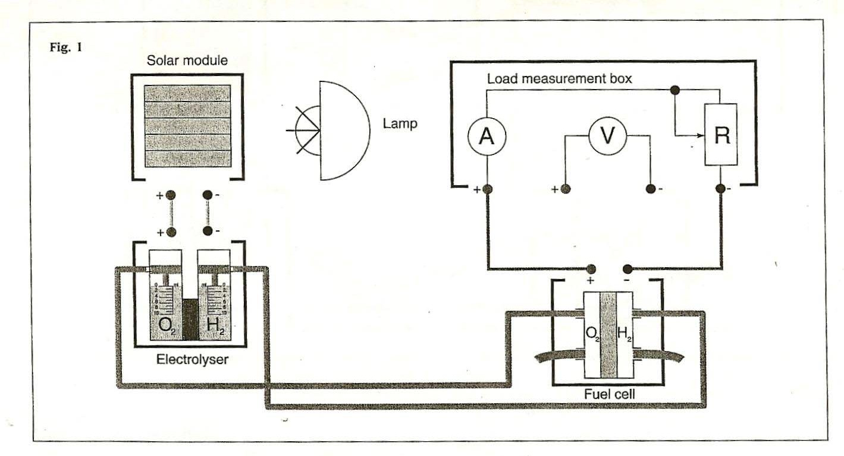

**FIGURE 2**

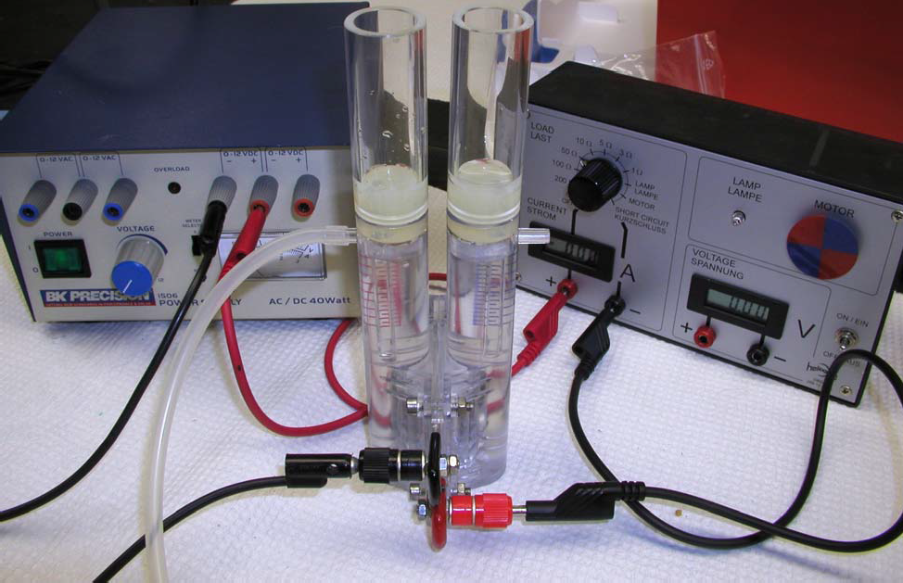

# PROCEDURES

1. Assemble the apparatus as shown in the appropriate figure. All the connections must be correctly made; the polarity of the electrolyser and fuel cell must be correct. Check with the teacher before proceeding.
2. Purge the apparatus of air for 5 minutes by using the gases generated in the electrolyser, with the switch on the load-measuring box at the “OPEN” position. Then switch to ‘3’ for 3 minutes, then purge another 3 minutes with the switch ‘open’.
3. Collect the gases in the gas storage cylinders in the electrolyser. Note the volume ratio.
4. When one of the storage cylinders is full (10 ml) disconnect the solar modular (or power supply) and set the switch on the load-measuring box to 1. The fuel cell will consume the gases.

# QUESTIONS

1. What conclusions can you draw from your results?
2. Can you devise a safe method to collect and identify each gas?
3. Write an equation for the process occurring at each electrode.
4. Explain what is meant by “oxidation” and Reduction”.
5. Which process is occurring at each electrode in the electrolyser and the fuel cell?
6. How does this experiment demonstrate the conversion of energy from one form to another?
7. Can you explain the following terms: electrolyte, electrode, and catalyzed?