ELECTROMYOGRAM ANALYSIS OF MUSCLE FUNCTION

STANDARDS:
- 3.3.10.B - Explain cell functions and processes in terms of chemical reactions and energy changes.
- 3.3.12.B - Evaluate relationships between structure and functions of different anatomical parts given their structure.

INTRODUCTION

Westminster College

The muscles of the forearm are important for movement of both the wrist and the fingers and thumb. These muscles are attached to the bones at the elbow and the wrist and fingers by tendons. There are two basic types of muscle groups; flexors, which decrease the angle at the joint and extensors, which increase the angle of a joint. In the forearm, these are opposing muscle groups. When one group is flexed, the other group is completely relaxed.

Voluntary movement of muscles requires electrical activity produced by the body. Muscle tissues maintain electrical imbalances, or potentials, across cell membranes by concentrating positive or negative charges on opposite sides of those membranes. These potentials are a form of stored energy. With activation (such as from a nerve impulse), the ions are allowed to cross the muscle cell membranes, generating electrical activity and resulting in muscle contraction.

An electromyogram, or EMG, is a graphical recording of electrical activity within muscles. It is useful in the diagnosis of disorders affecting muscles and the nerves that supply them.
Inherited and acquired disorders of muscles (such as the muscular dystrophies), and disorders of the central and peripheral nervous systems (such as Huntington’s disease and diabetic neuropathy) result in abnormal EMG readings.

EMG studies are also useful for investigating normal muscle function. In this experiment, you will analyze electrical activity in the extensor muscles of the forearm. These muscles

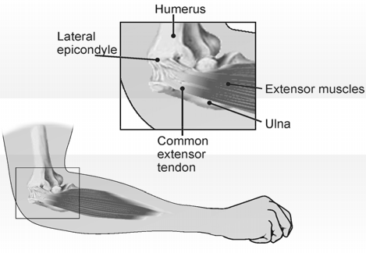

Figure 1

originate in tendons of the proximal dorsal forearm (upper outside of the forearm) in the region of the lateral epicondyle (bone at the outer elbow joint) and attach distally to tendons which control extension of the hand and fingers (see Figure 1).

Inflammation of the tendons at the elbow is common and can result from repetitive motions used in sports, hobbies, and in the workplace. This experiment will demonstrate the rationale behind treating tennis elbow with a wrist splint.

GUIDING QUESTIONS
  - What are two muscle groups involved in joint movement?
  - What activity triggers muscle contraction?
  - What does an EMG measure? How is it used in medical diagnosis?
  - How would you design an experiment to test the flexor muscles of the forearm?

SAFETY
Do not attempt this experiment if you suffer from tennis elbow or other disorders of the arm or hand. Inform your instructor of any possible health problems that might be exacerbated if you participate in this exercise.

MATERIALS

Vernier LabQuest w/ power supply | electrode tabs
Vernier EKG Sensor | Metric ruler
1–2 kg (3 lb) weight (barbell or similar) | Flash drive/Memory stick (optional)

PRE-LAB ACTIVITY

Before attaching the electrode tabs, observe the movement of the muscles when you flex your wrist backward and forward.
  - Which muscles are the extensors?
  - Which muscles are the flexors?

PROCEDURE
Select one person from your lab group to be the subject. The other students in the lab group are responsible for setting up the EMG electrodes, managing the LabQuest and recording the data.

1. Plug the EKG Sensor into one of the channel ports on the top of the LabQuest as shown in
Figure 2. Turn the LabQuest on by pushing the power button on the top left corner.

2.
Fig. 2. Diagram of Vernier EKG Probe connected a LabQuest. A
Channel
port Leads
.

Power button

red (+)

LabQuest Power supply

LabQuest

black (ground)
green (-)

blank screen will appear (Figure 3a). In the top left corner of the screen you will see an icon
, indicating that you are in the Meter Mode.

- The LabQuest does not automatically identify the EKG probe. To do this manually, stay in the Meter mode and select Sensors → Sensor Setup….→. A sensor set-up screen will appear showing all the available probe ports (Fig. 3b). Select the channel that the EKG probe is plugged into (ex. CH1 for channel 1), and tap the arrow to the side of the channel box. A list of compatible probes will appear in alphabetical order. Scroll down the list and select “EKG”. Select 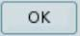 to return to the Meter mode screen. A red box will now be in this window displaying the channel the EKG probe is plugged into (Fig. 3c). The LabQuest is reading electrical potential in mV.

Figure 3. Example of LabQuest Screens and Sensor Set-Up

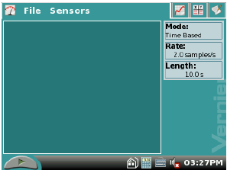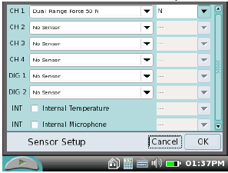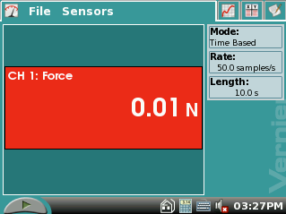
CH 1: Potential

1.99 mV

  - Blank start up screen b. Sensor set-up screen
c. Meter mode screen
4.

The parameters for data collection must also be set while still in the Meter mode . Select Sensors → Data Collection… A screen will appear that allows you to select the Mode and Timing for the experiment (Fig. 4). At the top of the screen, the mode selected will be Time Based. Below that is a window that indicates the length of the data collection. Tap this window with the stylus and a touch keyboard will appear.

Use the keyboard to change the length of data collection to 25 s. (The seconds should already be set.) Select when you are finished.

Part I: Collect data while flexing and relaxing the extensor muscle.
Figure 4. Data collection screen.

- 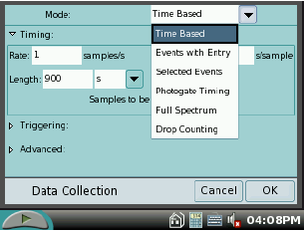Attach three electrode tabs to your dominant arm, as shown in Figure 4. Two tabs
should be placed on the dorsal forearm, 5 cm and 10 cm from the lateral epicondyle along an imaginary line connecting the epicondyle and the middle finger. A third electrode tab should be placed on the upper arm.

- 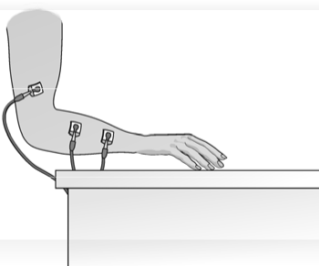Connect the EKG clips to the electrode tabs as shown in Figure 4. The red (+) and green (-) leads are interchangeable for this experiment. Stand facing your table or lab bench so that your arm is angled down toward the surface (Fig. 5).
Red & green
electrodes

- Select the graph tab at the top of the screen. If the experimental parameters are set correctly, a graph will appear. The X-axis will display Time from 0 to 25 seconds(s) and the Y-axis will show Potential from 0 to 4 millivolts (mV).

Fig. 5 Electrode attachment and resting hand position

- 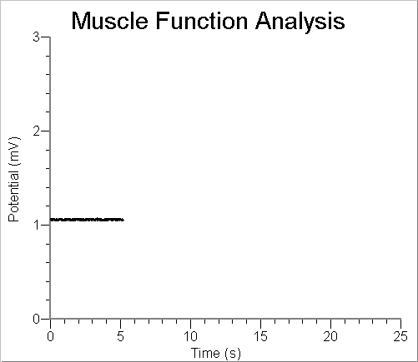Rest your fingertips on the table, with your palm above the surface and in line with your forearm, as shown in Figure 3. Click to begin data collection. If your graph has a stable baseline (see Fig. 5), click Stop and continue to Step 9. If your graph has an unstable baseline, click and try
again until you have a stable baseline for 5 s.

- Click to start collecting data. After recording a stable baseline for 5 sec, gently cock your hand back as far as you can (Figure 7). Hold this position for 5 sec. Return your hand to its relaxed position, with fingertips resting on the table surface, for a period of 5 sec.

Figure. 6. Example of a stable baseline.

Repeat the extension and relaxation action for one more full cycle–5 sec with the hand cocked, followed by 5 sec with the hand in a resting position. The student operating the LabQuest is responsible for telling the test subject when to switch from extension to relaxation. Data will be collected for a total of 25 sec.

- Store this run by choosing Save… from the File menu. At the top of the Save as screen, the run will be untitled. Tap this window with the stylus and the keyboard will appear. Create a name that you will recognize. You may have to retrieve the data at later time.

- Using the stylus, click and drag to highlight the first 5 sec of data collected. To obtain statistics for this run, select Analyze → Statistics → Potential. Two brackets will appear on the graph, and numerical statistics are found at the right of the screen. Record the minimum and maximum values displayed in the Data Table provided at the end of this lab, rounding to the nearest 0.01 mV.

- 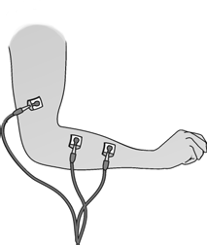Before analyzing another 5 s of data, select Analyze →
Figure 7
Statistics → Potential again. This will clear the previous data.

- Repeat Steps 11 and 12 to highlight each of the next 5 s intervals until you reach 20 sec (5–10 sec, 10–15 sec, 15–20 sec). Record the minimum and maximum values displayed in the Statistics boxes in the Extensor Data Table.

Note: You may have to slightly adjust the time parameters for the data selected, as flexion and relaxation times may not conform strictly to the 5-second time periods.

Part II: Ergonomics and Muscle Protection

- You are going to collect a similar set of data on the extensor muscle, this time holding a small weight in your hand and lifting it both overhand and underhand. For the best results, this data should be collected from the same student who performed the previous trial.
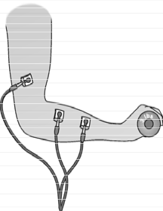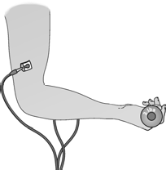
A. Overhand grip
B. Underhand grip
Figure 8 Extensor muscle with hand gripping weight

- Obtain a 1-2 kg (3 lb) weight from your instructor. Place your relaxed hand on the weight, with your palm facing downward. Tap the Start button to begin collecting data. If your graph has a stable baseline (see Fig. 5), click Stop and continue to Step16. If your graph has an unstable baseline, click and try again until you have a stable baseline for 5 s.

- Click to start collecting data. After recording a stable baseline for 5 sec, grip the weight with your hand. Using only the action of your wrist, lift the weight to a height of 5- 10 cm off the surface of the table (Figure 8A). Hold this position for 5 sec.

- Gently lower the weight to the table and rest for 5 sec. Repeat the extension and relaxation action for one more full cycle–5 sec with the weight lifted, followed by 5 sec with the hand in a resting position. Data will be collected for a total of 25 sec.

- Store this run by choosing Save… from the File menu. At the top of the Save as screen, the run will be untitled. Tap this window with the stylus and the keyboard will appear. Create a name that you will recognize. You may have to retrieve the data at later time.

- Collect the statistical data for the extensor muscle with the weight using the same method outlined in Steps 11-13. Record this information in the Extensor Muscle data table in the With weight- overhand section.

- Repeat Steps 15 – 19, this time holding the weight in the underhand position as shown in Fig. 8B. Record the resulting data in the table provided under With weight – underhand.

- Calculate the change in millivolts (ΔmV):

Max. mV – min. mV = ΔmV

Record the results in the column provided in the table.

REFERENCES
Diana Gordon and Steven L. Gordon, M.D. 2005. Human Physiology with Vernier. Experiment 8: Blood Pressure and Exercise. Vernier Software & Technology. Beaverton, OR. Pp 8-1 – 8-4, 8-1T – 8-2T.

Elaine N. Marieb, R.N., Ph.D. 2004. Human Anatomy & Physiology. Chpt. 19, The Cardiovascular System: Blood Vessels. Pearson Education, Inc. Sixth Ed. San Francisco, CA. pp. 722-723.

CREDITS
Special thanks to Dr. Marosh Furimsky of the Westminster College Biology Department who has supplied knowledge and background reference material for this lab. The lab was adapted and revised by Dr. Stephanie Corrette-Bennett.

DATA SHEET

Name: Group: Date:

Actual distance between lateral epicondyle and the positive (red) and negative (green) leads:
Lateral epicondyle: 0 cm (+) red lead: cm (-) green lead: cm

EXTENSOR MUSCLES

Condition | Interval (approximate) | Min (mV) | Max (mV) | ΔmV
Fingers resting on table | 0-5 s
Hand cocked back | 5-10 s
Fingers resting on table | 10-15 s
Hand cocked back | 15-20 s
With weight - overhand
Fingers loosely gripping weight on table | 0-5 s
Hand cocked back | 5-10 s
Fingers loosely gripping weight on table | 10-15 s
Hand cocked back | 15-20 s
With weight - underhand
Fingers loosely gripping weight on table | 0-5 s
Hand flexed upward | 5-10 s
Fingers loosely gripping weight on table | 10-15 s
Hand flexed upward | 15-20 s

QUESTIONS:

- Review the collected data.
  - On average, when do you have the smallest difference in potential (ΔmV)?

  - When do you have the largest difference in potential?

  - What do these results indicate about the relationship between strength of muscle contraction and the amplitude of electrical activity generated?

- What do the results in the Data Table show about the relationship between hand and wrist position and muscle activity when lifting an object?

- After performing this experiment, what advice would you give to a friend with tennis elbow about how she should lift a frying pan onto the stove or a can of paint onto a work bench? How should she hold these objects to reduce any aggravation to her injury?

- Explain why a wrist brace is an effective treatment for tennis elbow, based on the data obtained from this experiment.

- Some people keyboard with their wrists resting on the table or on a wrist support. In light of what you have learned, would you recommend this practice as a way of preventing injury to the extensor muscles of the forearm? Why or why not?

- Pitcher’s elbow is a repetitive use injury of the medial epicondyle (bone at the outer elbow joint).
  - Which muscles of the forearm attach to the medial epicondyle?

  - What is the function of these muscles?

  - How would you adapt this experiment to test these muscles?

