**TEACHER NOTES**



Westminster College

**ENTHALPY CHANGES**

**GUIDED INQUIRY VERSION**

From *Vernier Investigating Chemistry through Inquiry*

**LAB 9**

**OVERVIEW**

In the Preliminary Activity, your students will gain experience using a Temperature Probe and a calorimeter as they determine the enthalpy change as a hydrochloric acid solution is neutralized by excess sodium hydroxide solution.

During the subsequent Inquiry Process, your students will first learn about heat, enthalpy, enthalpy changes, and calorimetry using the course textbook, other available books, and the Internet. They will hten generate and investigate researchable questions involving enthalpy changes. In Guided Inquiry approach, students will plan and conduct investigations of the researchable questions assigned by you.

**Figure 1**

**LEARNING OUTCOMES**

In this inquiry experiment, students will

* Identify variables, deisgn and perform the experiment, collect data, analyze data, draw a conclusion, and formulate a knowledge claim based on evidence from the experiment.
* Learn how to determine enthalpy changes.
* Apply this technique in new situations.

**CORRELATIONS**

**IB Topic and Sub-Topic**

Topic 5—Energetics

Sub-Topic 5.1 – Endothermic and Extrothermic Reactions

Sub-Topic 5.2—Calculation of Enthalpy Changes

**THE INQUIRY PROCESS**

**Suggested Time to Complete the Experiment**

See the section Doing Inquiry Experiments for more information on carrying out each phase of an inquiry experiment.

|  |  |  |  |
| --- | --- | --- | --- |
|  | Inquiry Phase | Open Inquiry | Guided Inquiry |
| I | Preliminary Activity | 30 minutes | 30 minutes |
| II | Planning | 15 minutes | 15 minutes |
| III | Carrying Out the Plan | 40 minutes | 35 minutes |
| IV | Organizing the Data | 10 minutes | 10 minutes |
| V | Communicating the Results | 15 minutes | 10 minutes |
| VI | Conclusion | 10 minutes | 10 minutes |

**MATERIALS**

LabQuest or LabPro ring stand

Temperature Probe utility clamp

Styrofoam Cup 1.00M HCl

400 mL beaker 1.05M NaOH

Two 50 mL graduated cylinders stirring rod

*Others as requested by students*

1. **Preliminary Activity**

This inquiry begins with an activity to reinforce prior knowledge of the use of Vernier data collection technology and to introduce a method for collecting temperature dtat.

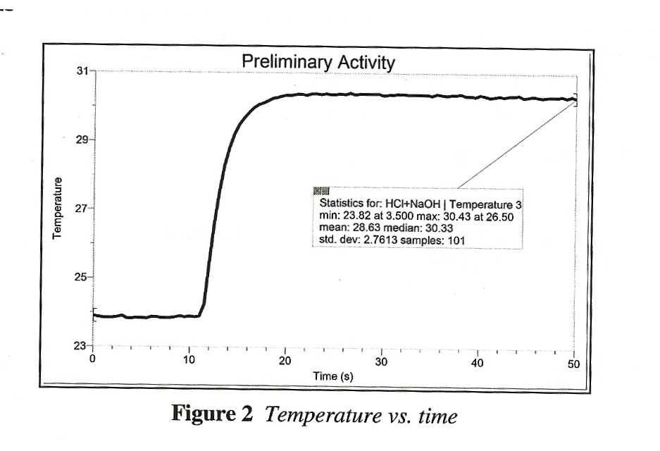**Sample Results**

|  |  |  |  |  |  |
| --- | --- | --- | --- | --- | --- |
| Table 1: Preliminary Activity Data | | | | | |
| Volume HCl  (mL) | Conc. HCl  (mol/L) | Volume NaOH  (mL) | Conc. NaOH  (mol/L) | *tinitial*  (°C) | *tfinal*  (°C) |
| 50.0 | 1.00 | 50.0 | 1.05 | 23.8 | 30.4 |

**Answers to the Questions**

1. Subtract the initial temperature from the final temperature to determine the temperature change, Δ*t*, for the process.

*Answers will vary. In the Sample Results above, Δt = 30.4°C – 23.8°C = 6.6°C.*

1. Determine the total mass of the product solution (assume its density is 1.00 g/mL).

*(100 mL) (1.00 g/1.00 mL) = 100 g – total mass of the product solution*

1. Use the equation below to calculate the amount of heat energy, *q*, produced in the reaction.

*Cp = 4.18 J/g°C. q = Cp*•*m۰Δt*

*Answers will vary. q= 4.18 J/g°C) (100 g) (6.6°C/0 – 2760 J (or 2.76 kJ)*

1. Find Δ*H* (Δ*H = -q).*

*Answers will vary.* Δ*H= -q = -2.76 kJ*

1. Calculate moles of HCl used in the reaction.

*Answers will vary. (1.00 mol/L) (0.0500 L) = 0.500 mol HCl*

1. Use the results of the Step 4 and Step 5 calculations to determine Δ*H/*mol HCl.

*Answers will vary. -2.76 kJ/0.500 mol =+55.2 kJ mol/HCl*

1. (Optional) An accepted value for Δ*H* of neutralization for HCl is -55.8 kJ/mol. Calculate the percent difference between this value and your experimental value.

*Answers will vary. [0.6 kJ/mol ÷55.8 kJ/mol] x 100 = 1.1% difference*

1. **Generating Researchable Questions**

**Note:** Researchable Questions are assigned by the instructor. See the Doing Inquiry Experiments section for a list of suggestions for generating researchable questions. Some possible researchable questions for this experiment are listed below.

**Recommended for Open or Guided Inquiry (sample results provided)**

* What is the trend among the enthalpies of solution of LiCl, NaCl, and KCl, (NaCl, NaBr, and NaI; KCl, KBr, and KI)?
* How do the enthalpies of solution for anhydrous CuSO4 and the hydrate of CuSO4•2H2O, MgSO4 and MgSO4•7H2O) compare?
* How do the enthalpy of neutralization of HCl (a strong acid) by NaOH (a strong base) and the enthalpy of neutralization for HC2H3O2 ( a weak acid) by NH3 ( a weak base) compare?

**Recommended for Open or Guided Inquiry (no sample results provided)**

* How do the enthalpies of neutralization of HCl, H3PO4 and HC2H3O2 by NaOH compare?
* How do the enthalpies of solution for substances commonly found in instant hot packs, anhydrous calcium chloride and anhydrous magnesium sulfate, compare?
* How do the enthalpies of solution for substances commonly found in instant cold packs, urea and ammonium nitrate, compare?
* How does the enthalpy of reaction for the reaction of hydrochloric acid with magnesium compare to the enthalpy of reaction of the reaction of hydrochloric acid with zinc?

**Recommended for Advanced Students (no sample results provided)**

* Can the procedure introduced in the Preliminary Activity be used to verify Hess’s Law?
* Can the procedure introduced in the Preliminary Activity be used to determine the enthalpy of reaction for the combustion of magnesium?

There are many more possible researchable questions. Students should choose a researchable question that addresses the learning outcomes of your specific standards. Be sure to emphasize experimental control and variables. (Instructors using Guided Inquiry select the researchable questions to be investigated by their students. We encourage you to assign multiple researchable questions because this strategy enhances student interaction and learning.)

1. **Planning**

During this phase students should formulate a hypothesis, determine the experimental design and setup, and write a method they will use to collect data. Circulate among the student groups asking questions and making helpful suggestions.

1. **Carrying Out the Plan**

During this phase, students use their plan to carry out the experiment and collect data. Circulate among the student groups asking questions and making helpful suggestions.

1. **Organizing the Data**

See the Doing Inquiry Experiments section for suggestions concerning how students can organize their data for the inquiry presentations.

1. **Communicating the Results**

See the Doing Inquiry Experiments section for a list of inquiry-presentation strategies.

1. **Conclusion**

See the Doing Inquiry Experiments section for a list of suggestions concerning assessment and ways to utilize the results in subsequent instruction.

**SAMPLE RESULTS**

Students results will vary depending on experimental design.

**Trends Among Enthalpies of Solution**

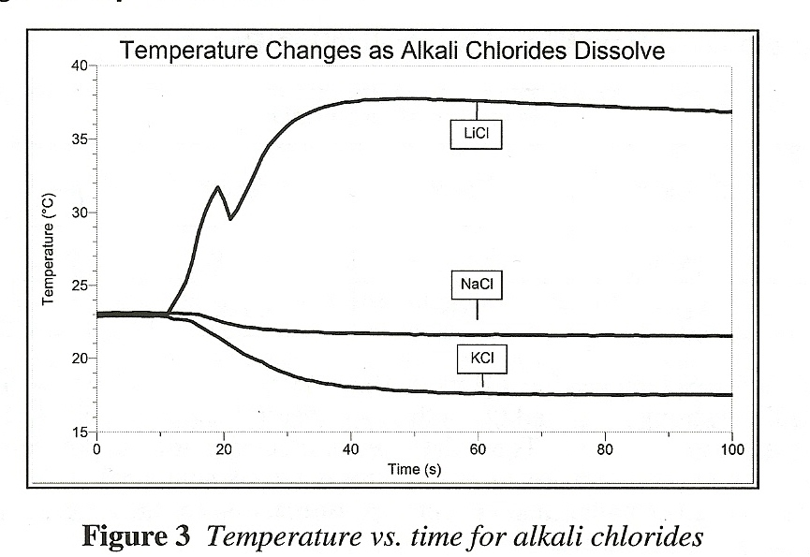

|  |  |  |  |  |  |  |
| --- | --- | --- | --- | --- | --- | --- |
| Table 2: Enthalpy Data for an Alkali Chloride Series | | | | | | |
| Solute | Mass of Solute  (g) | Mass Water  (g) | *tinitial*  (°C) | *tfinal*  (°C) | *Δt*  (°C) | *ΔH*  (°C) |
| LiCl | 5.00 | 50.0 | 22.9 | 37.8 | 14.9 | -29.1 |
| NaCl | 5.00 | 50.0 | 23.2 | 21.5 | -1.7 | 4.57 |
| KCl | 5.00 | 50.0 | 22.9 | 17.5 | -5.4 | 18.5 |

This investigation addresses the question, “What is the trend among the enthalpies of solution of LiCl, NaCl, and KCl?” Enthalpy of solution increases from top to bottom of the series, from -29.1 kJ/mol for LicL to 18.5 kJ/mol for KCl.

**Comparing the Enthalpies of Solution of Anhydrous and Hydrated Compounds**

|  |  |  |  |  |  |  |
| --- | --- | --- | --- | --- | --- | --- |
| Table 3: Enthalpy Data for a CuSO4 and CuSO4•5H2O | | | | | | |
| Solute | Mass of Solute  (g) | Mass Water  (g) | *tinitial*  (°C) | *tfinal*  (°C) | *Δt*  (°C) | *ΔH*  (°C) |
| CuSo4 | 5.00 | 50.0 | 22.6 | 30.6 | 8.0 | -58.7 |
| CuSO4•5H2O | 5.00 | 50.0 | 22.6 | 21.4 | -1.2 | 13.8 |

This investigation addresses the question, “How do the enthalpies of solution for anhydrous CuSO4 and the hydrate CuSO4•5H2O compare? The dissolving of an anhydrous CuSo4 is exothermic (Δ*Hsolution*= -58.7 kJ/mol), whereas the dissolving of CuSO4•5H2O is endothermic (Δ*Hsolution* = 13.8 kJ/mol).

**Comparing the Enthalpies of Reaction of Neutralization Reactions**

|  |  |  |  |  |  |
| --- | --- | --- | --- | --- | --- |
| Table 4: Neutralization Data | | | | | |
| Acid | Strength | Base | Strength | Δ*t*  (°C) | Δ*H*  (kJ/mol) |
| HCl | Strong | NaOH | Strong | 6.6 | -55.2 |
| HC2H3O2 | Weak | NH3 | Weak | 5.5 | -46.0 |

This investigation addresses the question, “How do the enthalpy of neutralization of HCl (a strong acid) by NaOH (a strong base) and the enthalpy of neutralization of HC2H3O2 (a weak acid) by NH3 ( a weak base) compare?” These data were collected using the procedure introduced in the Preliminary Activity. The enthalpy of reaction for the weak acid/weak base combination (Δ*Hreaction* =-46.0 kJ/mol), is smaller than the enthalpy of reaction for the strong acid/strong base combination (Δ*Hreaction*= -55.2 kJ/mol).

**TIPS**

1. Preparation of Preliminary Activity solutions:
   1. M HCl: 85.6 mL of concentrated HCl per 1.00 L of solution.

1.05 M NaOH: 42.0 G of solid NaOH per 1.00 L of solution.

1. Preparation of other solutions:
2. M HC2H3O2: 57.5 mL of concentrated HC2H3O2 per 1.00 L of solution.

1.05 M NH3: 70.9 mL of concentrated NH3 per 1.00 L of solution

1. **Hazard Alerts:**

Hydrochloric Acid: Highly toxic by ingestion or inhalation, severely corrosive to skin and eyes. Hazard Code: A—Extremely hazardous.

Sodium Hydroxide: Corrosive solid; skin burns are possible; much heat evolves when added to water; very dangerous to eyes; wear face and eye protection when using this substance. Wear gloves. Hazard Code: B—hazardous.

Acetic Acid: Corrosive to skin and tissue; moderate fire risk (flash point: 39°C); moderately toxic by ingestion and inhalation. Hazard Code: A—Extremely hazardous.

Ammonia: Both liquid and vapor are extremely irritating—especially to eyes. Dispense in a hood and be sure an eyewash is accessible. Toxic by ingestion and inhalation. Serious respiratory hazard. Hazard Code: A—Extremely hazardous.

Copper (II) Sulfate, anhydrous: Skin and respiratory irritant; moderately toxic by ingestion and inhalation. Hazard Code: C—Somewhat hazardous.

Copper (II) Sulfate, pentahydrate: Skin and respiratory irritant; moderately toxic by ingestion and inhalation. Hazard Code: C—Somewhat hazardous.

Lithium Chloride: Moderately toxic by ingestion. Hazard Code: C—Somewhat hazardous.

Potassium Chloride: Slightly toxic by ingestion. Hazard Code: C—Somewhat hazardous.

1. There are several assumptions made in Preliminary Activity. One is that the specific heat capacity, *Cp,* for the aqueous solutions is assumed to be the same that of pure water, 4.18 J/g°C. They are, in fact, very nearly the same. The second assumption is that the density of the aqueous solutions is 1.00 g/mL. Since this is very nearly the case, we can use a mass of 100 g for 100 mL of solution. A third assumption is that the initial HCl solution and NaOH solution temperatures are the same. If you make up the solutions at least one day in advance and store them together, the two temperatures will be the same or nearly the same.
2. Your students may use a magnetic stirrer and stirring bar to achieve more precise results, but they should get good results with the stirring the reactions with the Temperature Probe.
3. We recommend placing the Styrofoam cup in a 400 mL beaker, as shown in Figure 1, because it stabilizes the cup and provides extra insulation.
4. For more precise results, your students may calibrate their foam cup calorimeters.
5. Tips for determining **enthalpy of solution**

* Use a Styrofoam cup seated in a 400 mL beaker.
* Use 2.00 to 5.00 g of solute
* Dissolve the solute in 50.0 mL of distilled water
* Consider the specific heat capacity, *Cp*, for the aqueous solution to be the same that of pure water, 4.18 J/g°C.
* Consider the mass to be the sum of the mass of the water plus the mass of the solute.

Here is an example of the enthalpy of solution calculations using LiCL data from Table 2.

*qsur*=(4.18 J/g°C) (55.00g) (14.9°C) – 3430 J (or 3.43kJ)

*qsolution*= - *qsur* –3.43 kJ

(5.00 g) (1 mol/42.40 g) = 0.118 mol LiCl

Δ*Hsolution*= -3.43 kJ/0.118 mol = -29.1 kJ/mol LiCl

1. Lithium chloride is a deliquescent substance with fair to poor shelf life. It is one the most hygroscopic substances commonly found in chemical storerooms, and this property may cause enthalpy of solution values determined by your students to be lower than expected.
2. Getting anhydrous CuSO4 into solution is tricky. To get it to dissolve properly, drizzle the solid into water that is already being stirred, much like you would prepare a gelatin or corn starch mixture. If you add anhydrous CuSO4 solid to water without stirring, it will form large lumps that are difficult to dissolve.
3. The plans that your students submit for approval should list laboratory safety concerns, including chemical safety concerns, and specify how they will address these safety concerns during their investigations.