Exploring the Properties of Gases

**LAB COMP 30**

From *Advanced Chemistry with Vernier,* Vernier Software & Technology, 2004

**INTRODUCTION**

The purpose of this investigation is to conduct a series of experiments, each of which illustrates a different gas law. You will be given a list of equipment and materials and some general guidelines to help you get started with each experiment. Four properties of gases will be investigated: pressure, volume, temperature, and number of molecules. By assembling the equipment, conducting the appropriate tests, and analyzing your data and observations, you will be able to describe the gas laws, both qualitatively and mathematically.

OBJECTIVES

In this experiment, you will

* Conduct a set of experiments, each of which illustrates a gas law.
* Gather data to identify the gas law described by each activity.
* Complete the calculations necessary to evaluate the gas law in each activity.
* From your results, derive a single mathematical relationship that relates pressure, volume, temperature, and number of molecules.

MATERIALS

|  |  |
| --- | --- |
| Vernier computer interface | large-volume container for water bath (at least |
| computer | 10 cm in diameter and 25 cm high) |
| Vernier Gas Pressure Sensor | 125 mL Erlenmeyer flask |
| Temperature Probe | hot-water supply (up to 50°C) or hot plate |
| 20 mL gas syringe | ice |
| plastic tubing with two Luer-lock connectors | 100 mL graduated cylinder |
| rubber stopper assembly with two-way valve |  |

PRE-LAB EXERCISE

Review each of the four parts of this experiment before starting your work. You will need to decide the best way to conduct the testing, so it is wise to make some plans before you begin. You may wish to conduct a test run without collecting data, in order to observe how the experiment will proceed.

In each part of the experiment, you will investigate the relationship between two of the four possible variables, the other two being constant. In this pre-lab exercise, sketch a graph that describes your hypothesis as to the mathematical relationship between the two variables; e.g., direct relationship or inverse relationship.

**Part I** Pressure, P, and volume, V (temperature and number of molecules constant).

**Part II** Pressure, P, and absolute temperature, T (volume and number of molecules constant).

**Part III** Volume, V, and absolute temperature, T (pressure and number of molecules constant).

**Part IV** Pressure, P, and number of molecules, n (volume and absolute temperature constant).

PROCEDURE

Part I Pressure and Volume

1. Obtain and wear goggles.

2. Position the piston of a plastic 20 mL syringe so that there will be a measured volume of air trapped in the barrel of the syringe. Attach the syringe to the valve of the Gas Pressure Sensor, as shown in Figure 1. A gentle half turn should connect the syringe to the sensor securely. **Note:** Read the volume at the front edge of the inside black ring on the piston of the syringe, as indicated by the arrow in Figure 1.

figure 1 gas pressure sensor setup illustration

Figure 1

3. Connect the Gas Pressure Sensor to Channel 1 of the Vernier computer interface. Connect the interface to the computer using the proper cable.

4. Start the Logger *Pro* program on your computer. Open the file “30a Gases” from the *Advanced Chemistry with Vernier* folder. This file allows you to collect pressure data from the Gas Pressure Sensor, using Events with Entry mode. For each pressure reading you take with a Keep1 button, this mode lets you enter a volume value.

5. Measure the pressure of the air in the syringe at various volumes. Print a copy of the graph and data. The best results are achieved by collecting at least six data points.

Part II Pressure and Absolute Temperature

In this experiment, you will study the relationship between the absolute temperature of a gas sample and the pressure it exerts. Using the apparatus shown in Figure 2, you will place an Erlenmeyer flask containing an air sample in a water bath and you will vary the temperature of the water bath.

6. Connect the Gas Pressure Sensor to Channel 1 and a Temperature Probe to Channel 2 of the interface.

7. Assemble the apparatus shown in Figure 2. Be sure all fittings are airtight. Make sure the rubber stopper and flask neck are dry, then twist and push hard on the rubber stopper to ensure a tight fit.

8. Set up water baths in the large-volume container as you need them, ranging from ice water to hot water.

9. Open the file “30b Gases” from the *Advanced Chemistry with Vernier* folder. This file is set up to collect pressure and temperature data from the attached sensors, using Selected Events mode. This mode allows you to collect a data pair simultaneously from the Gas Pressure Sensor and Temperature Probe by clicking on the Keep1 button.

figure 2 sensor and water bath setup illustration

Figure 2

10. Collect pressure data at several different temperatures. Print a copy of the graph and data.

Part III Volume and Absolute Temperature

In this experiment, you will study the relationship between the volume of a gas sample and its absolute temperature. Using the apparatus shown in Figure 3, you will place an Erlenmeyer flask containing an air sample in a water bath and you will vary the temperature of the water bath. Keep some of these factors in mind as you plan your procedure.

* If you are starting with a cold-water bath, set the piston at the 0 mL mark on the syringe. This will allow the gas volume to be increased in warmer water baths.
* The temperature of the water bath cannot be increased by more than 30-40 degrees from your starting temperature.
* Even though you are not plotting pressure, it is important to monitor pressure in the Meter to ensure that it remains constant.
* It is important to know the *total* volume of air in the flask *and* the syringe. The volume of the flask, up to the bottom of rubber stopper, can be accurately measured using a graduated cylinder. For the estimated volume of the tubing (from the rubber stopper to the Gas Pressure Sensor box), as well as in the valve below the bottom of the syringe, use a value of ~4 mL.

11. Connect the Gas Pressure Sensor to Channel 1 and the Temperature Probe to Channel 2 of the interface. Connect the interface to the computer using the proper cable.

12. Assemble the apparatus shown in Figure 3. Be sure all fittings are air-tight. Make sure the rubber stopper and flask neck are dry, then twist and push hard on the rubber stopper to ensure a tight fit. Be sure the water level is at least as high as the confined air in the syringe.

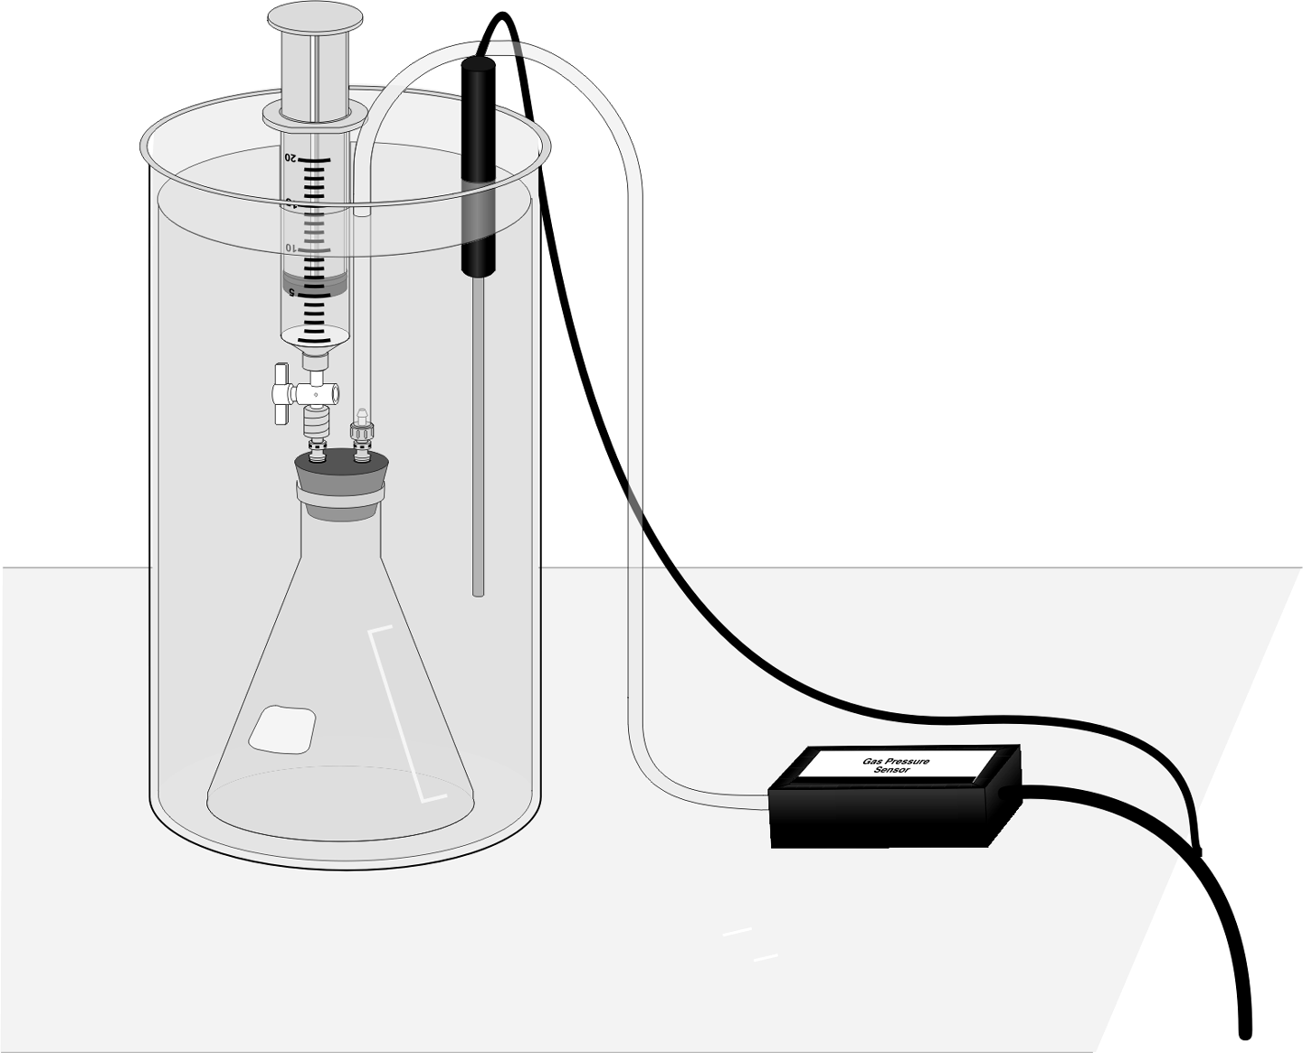

Figure 3

13. Open the file “30c Gases” from the *Advanced Chemistry with Vernier* folder. This file is set up to collect pressure and temperature data from the attached sensors, using Events with Entry mode. This mode allows you to collect a data pair simultaneously from the Gas Pressure Sensor and Temperature Probe by clicking on the Keep1 button and entering a value for the volume. Even though the pressure reading will not be plotted on the graph of volume *vs.* temperature, it is important for pressure to be monitored so that it can be kept constant.

14. Set up water baths in the large-volume container as you need them, ranging from ice water to hot water.

15. Collect volume data at several different temperatures. Print a copy of the graph and data.

Part IV Pressure and Number of Molecules

In this experiment, you will study the relationship between the number of molecules in a gas sample and the pressure it exerts.

* You can use the same setup as in the previous trial, although the water bath and Temperature Probe are optional. (Temperature must be constant, so choose a convenient temperature to run the experiment.)
* You might be wondering how you are going to count molecules for this section. Here is a hint. Avogadro’s hypothesis states that, “Equal volumes of gases, at the same temperature and pressure, contain equal numbers of molecules.” Therefore, *if* you keep the temperature and volume constant during the experiment, you can assume that gas volumes are proportional to numbers of molecules. Instead of entering a total number of molecules, you could enter a total *volume* of gas that has been compressed into the flask. For example, 120 mL worth of molecules could be entered as 120 molecules, 140 mL worth of molecules would be entered as 140 molecules.)

16. Connect the Gas Pressure Sensor to Channel 1 of the interface.

17. Open the file “30d Gases” from the *Advanced Chemistry with Vernier* folder. This file allows you to collect data from the Gas Pressure Sensor by clicking on the Keep1 button and entering a value for the number of molecules.

18. Collect pressure data with several different numbers of molecules introduced into the system. Print a copy of the graph and data.

DATA ANALYSIS

1. For each of the four parts of the experiment, write an equation using the two variables and a proportionality constant, *k* (e.g., for Part I, *P* = *k* × *V* if direct, or *P* = *k*/*V* if inverse).

2. Calculate the constant, *k*, for each of the four gas laws that you tested. This value can be an average for each of the data pairs in each part of the experiment.

3. Based on the mathematical relationship and equation that you obtained in Step 1 above for each part of the experiment, combine all four variables into a final equation. This “combined equation” will contain *P*, *T*, *V*, and *n*, as well as a new proportionality constant, *K*. Be sure to explain how you obtained your result (how you combined the equations).

4. Name the specific gas law associated with each part on this lab.