FOSSILWORKS

OBJECTIVE
Fossilworks is an exciting activity that will help to foster awareness and appreciation of the Earth’s history. When finished students should be able to:
explain, in simple term, how fossils are formed

Westminster College

identify six different fossils and retain some knowledge of each reproduce fossil replicas of their own

MATERIALS:
Information on the development of fossils Instructions for producing fossil casts Suggested exercises and projects Suggested reading list
6 Fossil molds:
Ammonite Cave bear tooth Crinoid
Deinonychus Claw Sharks Tooth Trilobite
Casting plaster for 36 casts (6 casts per fossil mold) (WARNING: Do not discard left over mixture in sink, it will plug up the plumbing.)
Small containers from which to mix and pour casting material (paper/plastic cups) Plastic/wooden spoon for mixing (tongue depressor/popsicle stick works well) Small scoops or spoons for measuring
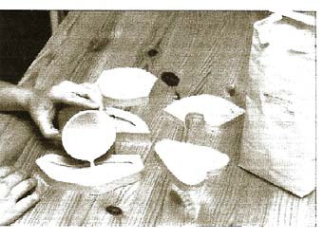
Tap water

HOW TO CAST FOSSIL REPLICAS

GETTING STARTED:
- Divide your class into 6 groups.
- Each group should find an area with a flat and level, stable working surface, like a countertop, desktop or table. Make sure the surface is waterproof, because some excess water may spill out of your container.
- Set out the rubber molds, bag of casing plaster, measuring scoops, mixing containers, and tap water. Provide each group with a portion of casting material, a small bowl or cup, and a mixing stick or spoon. To each student, pass out copies of the exercise sheet and the sheet describing fossils to be cast.
- Each group will be able to cast at least two items in an hour. While they are waiting, they can study the material about the fossil being poured and fill out the exercise sheet.

CASTING FOSSILS:
  - Place the mold on the flat, stable surface.
  - Mix 4 tablespoons of plaster with 1 ¾ tablespoons water for each mold.
  - Stir the plaster/water mixture with a spoon or mixing stick until it is evenly mixed (about 1 ½ minutes). There should be no lumps.
  - Fill the mold to the top with the plaster mixture. Try not to overfill or spill the plaster over the side of the mold.
  - Shake the mold lightly, taking care not to spill any plaster over the side. This will help to remove air bubbles from the mixture. (WARNING: Do not pour excess material in sink.)
  - Let the filled mold sit for 20-30 minutes or until cast is warm and hard.
  - After the mixture hardens, separate the sides of the mold from the contents and carefully remove the cast. The cast is a plaster replica of a genuine fossil.
  - To finish a cast, paint it with an earth tone such as brown, orange, black, gray or green.
  - Instruct the groups to exchange molds with other groups to create different casts.

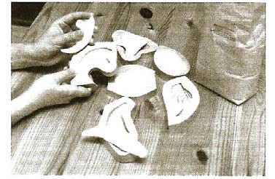

GENERAL INFORMATION ABOUT FOSSILS
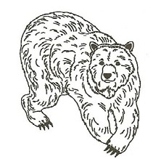
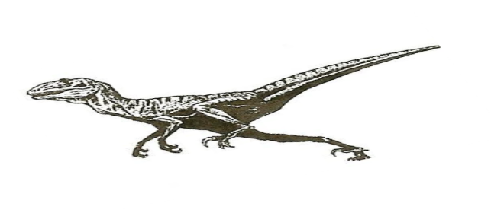
What is a fossil? A fossil is any trace of a once-living organism preserved in rock, a relic of the Earth’s past. Much of what we know of our planet’s history comes from fossilized plants and animals, some of which may be 600 million years old or even older. The tooth of an extinct bear, the claw of a dinosaur, and a flower from a prehistoric plant preserved in amber are all fossils.

When living things die, their bodies usually decompose in a short time. But sometimes a plant or animal’s body parts become buried out of reach of the factors that cause disintegration, and transform into a durable, rock-like substance that survives for millions of years. This is how fossils form. Generally, a living creature’s soft parts do not fossilize: just the harder, more durable parts are preserved. So you are much more likely to see the skeleton or teeth of an animal in fossil form, instead of all the muscles, internal organs or skin.

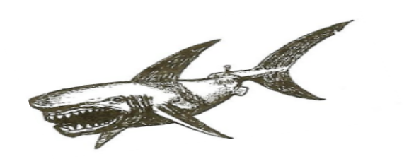
Animal fossils are divided into two basic groups: Invertebrates and vertebrates. The invertebrate category consists of animals with no internal spinal column.
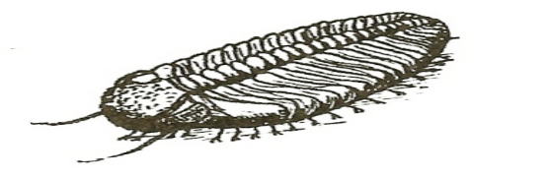
Some animals from this category are worms, snails, coral, insects and shell fish. The vertebrate category, on the other hand, consists of animals with an internal spinal column. These are considered to be more advanced than the invertebrates. Fish, reptiles, birds and mammals are some of the animals considered to be vertebrates. Because vertebrates have an rigid internal skeleton, fossilized remains have been found for many specimens.

Scientists who study fossils are known as paleontologists. Over the past two or three centuries, they have learned much about the Earth’s
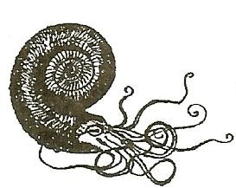
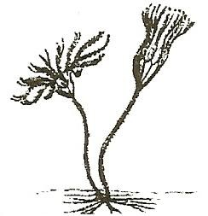
past by studying fossils. For example, they often find fossils of sea creatures in rocks that today are on dry land, far from any bodies of water. Sometimes such fossils occur high up on mountain slopes. This tells paleontologists that hundreds of millions of years ago, what is now dry land and mountains was once water—perhaps beneath a river delta, or bottom of a lake or sea.

Studying fossils from different places around the world, paleontologists have also helped to confirm that the Earth’s continents slowly change their positions over millions of years of time. Pretty neat, huh? Fossils teach us that the plants and animals of Earth’s past were very different from those we see alive around us today. We also know that there were once dinosaurs alive on Earth, and roughly when humans first appeared
on Earth, and how long ago sabertooth cats lived. No people existed to see these things; we know about them just from fossils. It is amazing what fossils can teach us!

AMMONITE

Ammonites were ancient marine mollusks belonging to the cephalopod class, related to today’s squid and octopus. Each ammonite produced a hard, multi- chambered shell to protect its soft tissue. They existed on Earth for about 330 million years, becoming extinct at the end of the Cretacious Period, 65 million years ago.
Fossil ammonite shells are common in North America. Such shells are virtually the only ammonite remains available for study; soft body parts are very rarely preserved. Scientists study how a living ammonite might have lived by examining its closest living relative, the hard-shelled chambered nautilus. Like the nautilus, ammonites probably used their shell for flotation as well as protection, becoming buoyant by replacing fluid inside the shell’s chambers with gas. This enabled them to maneuver through ocean waters.

Because they are plentiful and occur in great variety, ammonites help paleontologists to date the Earth’s rocks. When the same kinds of ammonites are found in rocks at different places, we know that those rocks were created at about the same time, millions of years ago, regardless of how far apart the places might be.

CAVE BEAR
The Cave Bear (scientific name: Ursus spelaeus) was a very large bear that thrived about 80,000 years ago and became extinct about 10,000 years ago. Cave bear skeletal remains have been found in caves throughout the mountainous regions of Europe. By studying these fossils, paleontologists have determined the bear’s size, behavior and diet. Cave bears were large compared with the most modern bears, about the same size as the largest Grizzlies and Brown Bears but
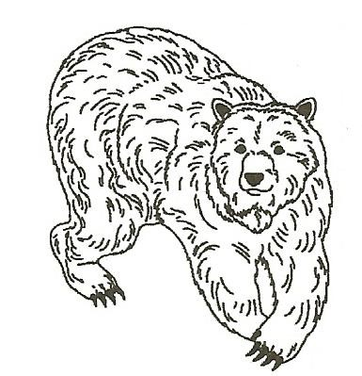
perhaps stouter and more heavily build. By measuring its fossil leg bones, paleontologists calculate that Cave Bears weighed about 900 to 1000 lbs. The structure of their leg bones shows that Cave Bears were slow-moving animals possessing great strength. Cave Bears belonged to the vertebrate class.

Although bears belong to the order Carnivora (meat eating mammals), they eat a wide range of meat and vegetable matter. Because they consume both animals and plants, bears are classified as omnivores. Studies of Cave Bear teeth show, however, that they were primarily vegetarians: The large teeth (molars) in the back of the mouth were used to grind fibrous vegetable matter.

Cave Bears’ powerful claws were designed to dig up and forage for food. Although Cave Bears dined on succulent plants, berries, roots and tubers, they did have occasion to eat the carcasse3s of animals killed by other carnivores. Thus, like modern bears, Cave Bears are also considered omnivorous.

The Cave Bear tooth replica that you are casting is an upper canine—the same kind of tooth as the long sabers of the Saber Tooth Cat.

CRINOID
Crinoids are flower-like marine animals belonging to the echinoderm phylum. Fossil crinoids are abundant at various sites around North America. They lived from the Ordovician Period to the present, with large numbers living during the
Paleozoic Era. Crinoids varied greatly in size and shape and may have been beautifully colored. Although most species lived on the ocean bottom, attaching themselves to material on the deep sea floor, some ancient forms were able to crawl or swim.

A crinoids, or “sea lily” is made up of a root, a stem, a body and arms, and looks very much like an ocean flower. It possesses no internal spinal cord and is considered an invertebrate. The root attaches to an object on the sea floor and helps to keep the crinoids from being moved. The stem is
generally the longest part of the crinoids; fossil crinoids have been found with stems up to 50 feet long. The body contains the vital organs, including the mouth, the anus, the gonads, the podia and the water inlet. The arms or tentacles, spread like an opening flower to catch passing food. Crinoids resisting extinction since their appearance more than 500 million years ago.

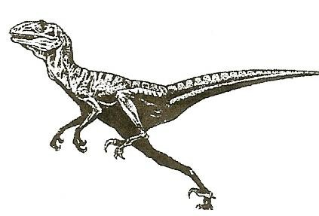
DEINONYCHUS CLAW
The Deinonychus is a spectacular but rather small dinosaur. It stood only three and a half feet tall and was about eight feet long. Large individuals may have been 10 feet long. Fully grown, it probably weighed about 150-175 lbs. The most
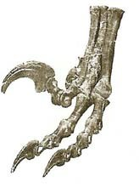
remarkable feature of the Denonychus was the large claw on the second toe of each hind foot. This long thin, sharply curved, sickle-like talon is
the source of the dinosaur’s name Deinonychus,
which means “terrible claw”. This claw is on the inside toe contained a long, thin and sharply curved sickle-like claw. The two joints on the claw’s toe were equally amazing. Unlike the joints of other toes, they allowed the claw to be retracted— pulled sharply back from the normal position for an ordinary toe—to keep well

clear of the ground. Deinonychus is a member of the vertebrate family.

Deinonychus probably used its lethal claws to bring down prey and also for defense. To attack, Deinonychus could have stood on one foot and slashed with the claw on the other foot, or it could have jumped with both feet off of the ground and slashed with both claws at once. The tail was stiffened for balance during an attack, and the hands were also equipped with claws for holding the prey. These ferocious dinosaurs probably hunted in groups, killing much larger dinosaurs with slashing blows of the deadly foot claws.

Remains of Deinonychus were discovered in Montana by John Ostrom and Grant Meyer during a Yale University expedition in 1964. The skeleton of this small but deadly dinosaur is on permanent exhibition at the Peabody Museum of Natural History at Yale University in New Haven, Connecticut.

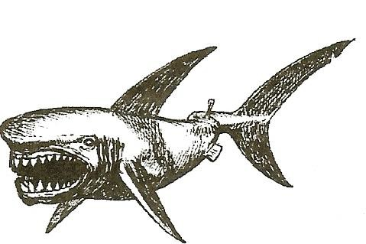
SHARK
Shark skeletons are made of cartilage, not bone, so they usually decompose before burial and leave nothing behind for fossilization. But shark teeth are bone, not cartilage, and great numbers of these little the fossil record. Sharks generally have triangular, serrated teeth set in numerous rows. As they wear out, the teeth in the front row fall out and another row of new, razor-sharp teeth takes their place from behind. A single shark might thus have generated many fossil teeth.

The largest shark teeth, up to 7 inches long, belong to the species Carcharodon megalodon; almost everything we know about Carcharodon megalodon derives from these huge fossilized teeth. It would have dwarfed it smaller relative, the dreaded great white shark of today. Once thought to have reached a length of more than 80 fet, this warm-water monster of the Tertiary Period would have been 3 or 4 times the size of a great white. But more recent estimates make it only about half this size—still a very formidable marine predator. The shark is a member of the vertebrate family.

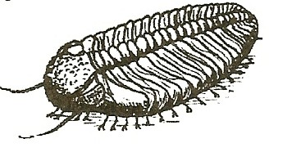
TRILOBITE
Trilobites were ancient sea creatures that roamed the ocean’s depths from the beginning of the Cambrian Period (570 million years ago) to the end of the Permian Period (245 million years ago). They belong to the most abundant and diverse phylum of all time, Arthropoda.
Among the arthropods that exist today are insects, lobsters and crabs, spiders and scorpions.

The word “trilobite” reminds us that the trilobite body was divided longitudinally into three lobes: the axial lobe down the middle and two pleural lobes on either side. The front of trilobite is called the “cephalon,” or head; the rear is called the pygidium,” or tail; and in between lies the “thorax” or chest, to which were attached its numerous legs. An exoskeleton, or skeletal shell, covered the entire body and supported and protected the muscles and internal organs.

To protect its underside, a trilobite could roll itself up; many are found fossilized in this state. As it grew, a trilobite shed its exoskeleton many times. Thus, a single trilobite could have left many suck exoskeletons behind for fossilizations.

Trilobites were among the earliest life forms to possess vision. A trilobite usually had two crescent-shaped eyes that gave it a 360-degree visual field on the ocean floor. The amazing preservation of the eyes in some specimens has enabled scientists to dissect these ancient sensory organs and study their structure.

Trilobites existed for more than 300 million years, during which time they evolved into over 10,000 species. Their fossils come in a multitude of interesting shapes and sizes, from the tiny Shumardia, less than 5mm long, to the giant.
Uralichas, more than 700mm long. Some were spiny and rough, whereas others were almost perfectly smooth.

EXERCISE FOR EACH FOSSIL

Note to Teachers:
There is only one copy of each lesson plan. We suggest keeping the original pages as masters and passing out copies to your students, so you can reuse the Fossilworks activities page.

- Divide your class into 6 groups.

  - Pass a fossil mold, the corresponding written information, a timeline, and an exercise sheet out to each group.
  - Tell each group to follow the instructions on page 3 explaining how to make a fossil cast.
  - Ask each group to examine their replica. Have the students pay close attention to its shape and feel.
Steps 4-8 may be done while groups wait for their casts to set:
  - Ask the students to read about their fossil replica.
  - Ask them to enter the name of their fossil in the correct space on their exercise sheet.
  - Ask them to find a picture of their fossil on their timeline, and then to write in the space provided the time period in which their fossil existed and whether it was a vertebrate or invertebrate.
  - Ask them to find other plants and animals on their timeline that were alive during the same period as their fossil. Have them enter two or three examples in the correct spaces on their exercise sheet.
  - Ask each member of the group to draw a picture showing what life may have been like during the time when their fossil was alive. Have them use other plants and animals from this period to illustrate their picture.

- Questions for each group to discuss:

  - In what time period did their fossil appear last? If the fossil represents an extinct group, ask the students to explain why they think this kind of animal failed to survive.
  - In what form, if any, does their fossil exist today?
  - Ask the students to name animals alive today that look like their fossil casts, and to draw pictures of these animals. What parts of their drawings resemble fossil cast?

- Instruct the groups to exchange their molds for ones they have not yet cast, and to repeat steps A1-B3.

