FREEZING TEMPERATURE OF FRESH WATER STANDARDS

• 3.1.7.B, 3.1.10.B, 3.1.7.E, 3.1.10.E
• 3.2.7.C, 3.2.10.C
• 3.4.7.A, 3.4.10.A

INTRODUCTION

Westminster College

Freezing temperature is the temperature at which a substance turns from a liquid to a solid. During winter in the northern hemisphere, Arctic air temperatures often dip below what we normally think of as the freezing point of water. Freshwater lakes freeze over, but underneath the ice most of the water remains in a liquid state. The freezing temperature of water has importance to the organisms that live in it. Did you ever wonder why lakes and ponds do not freeze from the bottom up? If this occurred, organisms that spend the winter in the mud or water at the bottom of a lake might freeze completely and die. Also, how do organisms continue to get oxygen to breathe when they are trapped under the ice? Water has some special properties that allow organisms to survive in these conditions.

Figure 1. Fall Turnover

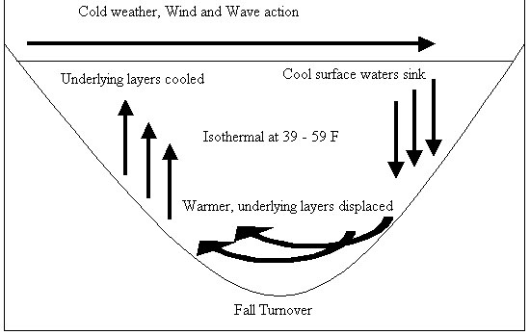

A unique property of water is that its density increases at 4°C (39°F), just before it hits freezing temperature. This causes water at this temperature to sink to the bottom of the pond or lake. When water molecules do freeze, the ice is less dense than the 4°C water, causing it to float on the surface. The differences in density start mixing the top and bottom layers of water. This mixing of the water layers as air temperatures become colder is called fall turnover (Fig. 1).

Another important property is that as water becomes colder, it is able to hold an increased amount of dissolved oxygen. As the air temperature cools, it initiates the fall turnover in the water. Warmer, less oxygenated water is brought to the surface of the pond or lake where it cools and is able to acquire more dissolved oxygen as it is exposed to the air.
This cycle of water cooling, obtaining more dissolved oxygen and mixing continues until the pond or lake is frozen over. The end result of this process is water just above the freezing temperature with a high concentration of dissolved oxygen trapped under a layer of ice. This allows many organisms to survive under the ice during the winter months.

In this experiment, you will use a temperature sensor to study the freezing of water and find its freezing point. You will collect temperature data as you freeze fresh water and determine its freezing temperature.

GUIDING QUESTIONS
- At what temperature does fresh water freeze?
- As fresh water becomes colder, what happens to the dissolved oxygen content?
- Why don’t lakes and ponds freeze from the bottom to the top?

SAFETY
Do not try to pull the temperature sensor out of the ice at the end of the experiment. You will risk breaking the test tube. Use warm tap water to melt the ice before removing the sensor.

MATERIALS
Lab Quest with power supply | 10 mL graduated cylinder
Temperature sensor | Water
20 x 150 mm Test tube | 400 mL beaker
Salt | Ice
Spoon | Warm water

PROCEDURE

Part I – Freezing Fresh Water
- Connect the Temperature Probe to LabQuest and choose New from the File menu. If you have an older sensor that does not auto-ID, manually set up the sensor.
  - To manually identify the sensor, stay in the Meter mode and select Sensors → Sensor Setup…..
  - A sensor set-up screen will appear showing all the available probe ports (Screen a, below). Select the channel that the sensor is plugged into

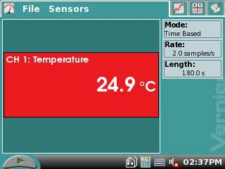Figure 1. LabQuest Meter Screen

(ex. CH1 for channel 1), and tap the arrow to the side of the channel box.

  - A list of compatible probes will appear in alphabetical order. Scroll down the list and select “Temperature” and “Stainless Steel”. Do the same for the second temperature sensor. Select to return to the Meter mode screen.
  - A red box will now be in this window displaying a real time temperature in degrees
Celsius (Fig. 1).

- To the right of the main screen, tap the gray Rate box. Change the data-collection rate to 0.1 samples/second and the data-collection length to 900 seconds (15 minutes).

- Fill a 400 mL beaker 1/3 full with ice, then add 100 mL of water as shown in Figure 2.

- Put 5 mL distilled water into a test tube and place a Temperature Probe into the water inside the test tube (Fig. 2).

- When everything is ready, start data collection by pressing the Start icon at the lower left hand corner of the screen. The LabQuest will automatically switch to a graph screen with Time(s) as the x-axis and Temperature (°C) as the y-axis. Then lower the test tube into the ice-water bath.

- About 15 seconds after lowering the test tube, add 5 heaping teaspoons of salt to the beaker and mix the salt and ice together by stirring the whole test tube around the beaker. This will also keep the water in the test tube
Figure 2. Set-up for Freezing Temperature of Water

Temperature sensor

Test tube with water

Beaker with ice and salt water

mixing so that it cools evenly. Continue to stir the ice-water bath like this for the first 10 minutes of the experiment for best results.

- When 10 minutes have gone by, stop moving the test tube and allow the water in it to freeze into ice. Continue to stir the ice-water bath with a spoon. Add more ice cubes as the original ice cubes get smaller.

- Make and record observations as the water freezes. Does anything unusual happen to the temperature of the water as it freezes?

- When 15 minutes have passed, data collection on the LabQuest will automatically stop.

- Determine and record the freezing temperature of water.

  - Identify the flat portion of the graph that represents freezing.
  - Tap and drag your stylus across the region that represents the freezing to select the region. A gray shaded area will appear indicating the portion of the graph that will be analyzed.
  - Choose Statistics from the Analyze menu. The statistics for the highlighted section will appear to the right of the graph.
  - Record the mean (average) temperature (to the nearest 0.1°C) in your data table. This is your value for the freezing temperature of water.

- Sketch or print the graph as directed by your teacher. Label the freezing temperature on your graph.

- Do not attempt to remove the Temperature sensor from the ice! Place the test tube into a beaker of warm water to melt the ice, then remove the Temperature Probe.

REFERENCES
Robyn L. Johnson, Gretchen Stahmer De Moss and Richard Sorensen. Earth Science with Calculators. (2002) Vernier Software & Technology, 13797 SW Millikan Way, Beaverton, OR. p.p. 17-1 to 17-3, 17-1T to 17-2T.

Donald L. Volz and Sandy Spartka. Middle School Science with Vernier. (2007) Vernier Software & Technology, 13797 SW Millikan Way, Beaverton, OR. p.p.14-1 to 14-3, 14-1T to 14-2T.

- Karl, Lake Turnover, On the Lake, October 19, 2008.

http://www.onthelake.net/fishing/turnover.htm

Keith C. Heidorn, PhD, THE WEATHER DOCTOR, Fall/Spring Lake Turnover © 2003, 2005. All Rights Reserved. Correspondence may be sent via email to: see@islandnet.com.

http://www.islandnet.com/~see/weather/elements/turnlakes.htm

CREDITS
The lab was adapted and revised from the references above by Dr. Stephanie Corrette- Bennett.

DATA SHEET

Name: Group: Date:

DATA ANALYSIS

  - Sketch a picture of your graph. Identify the portion of the graph that corresponds to the freezing temperature of the water.

30

25

20
Temperature
(°C) 15
10
5

0
150 300 450 600 750 900
Time (seconds)

  - What is the actual freezing temperature of the fresh water?

  - What is happening to the water during the flat portion of the graph?

  - At which point on the graph do you think the water could have held the most dissolved oxygen?

  - In some areas, icy roads are “salted” to make them safer for drivers. What do you think the salt does to the freezing temperature of the water? Could you design an experiment to test your hypothesis?

