GENERAL INFORMATION ON FORENSIC CHEMISTRY

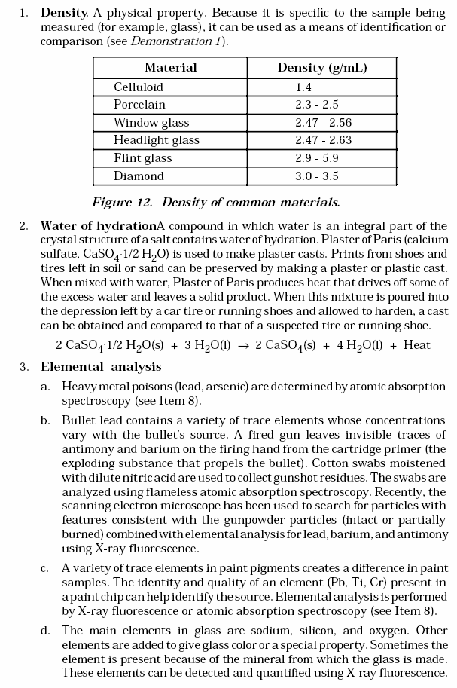

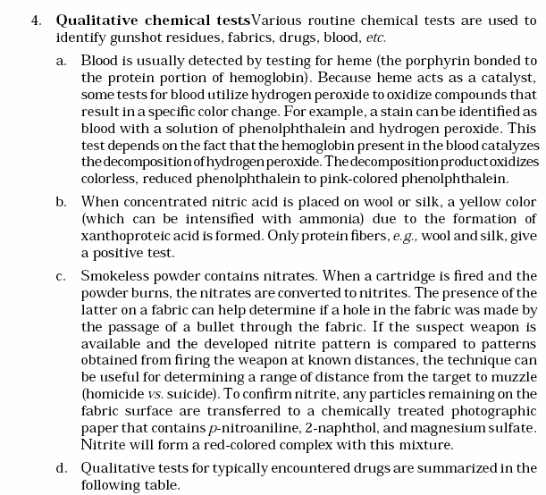

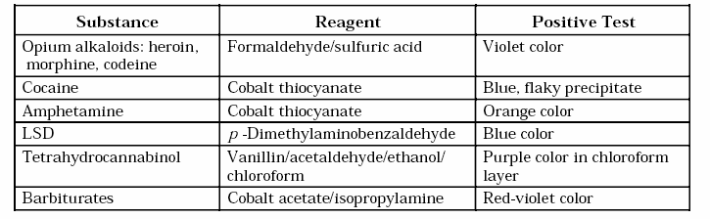

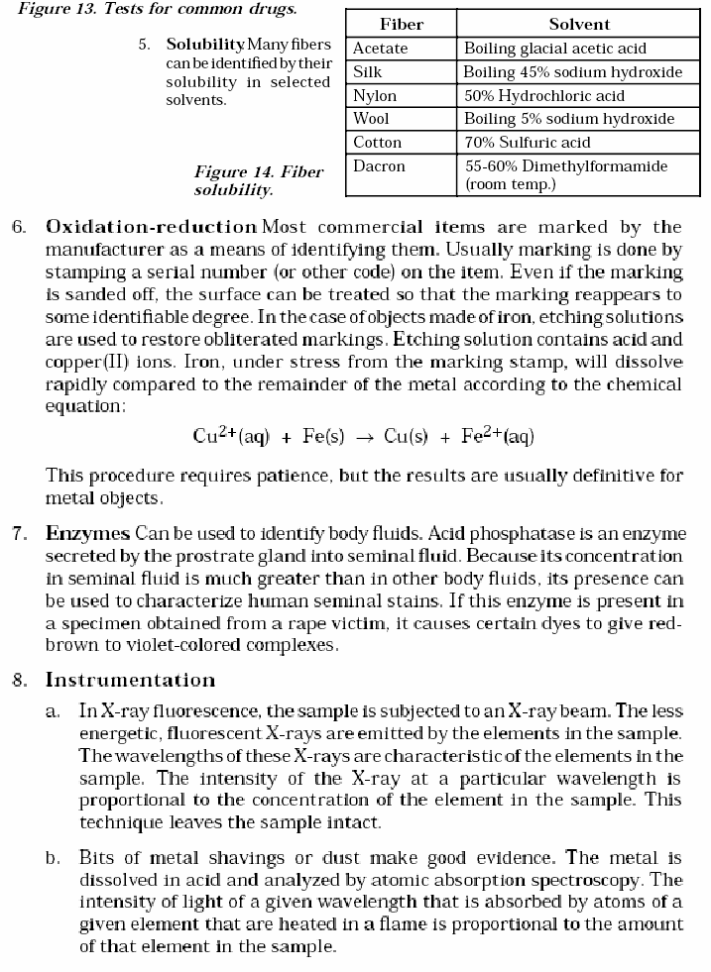

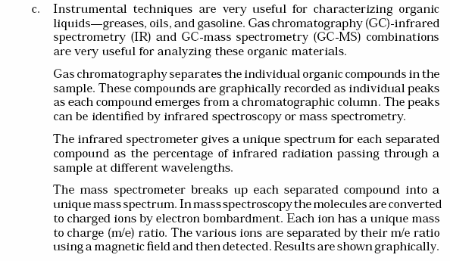

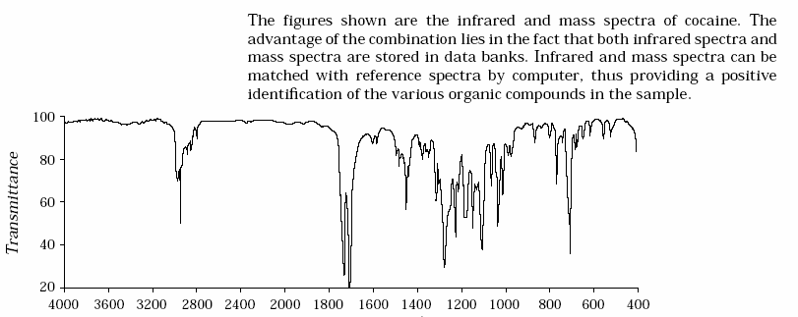

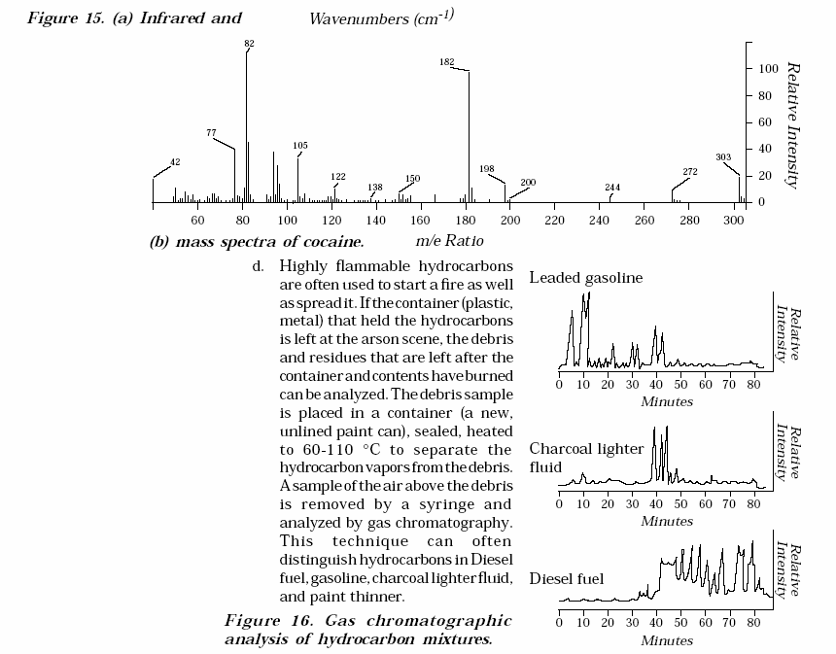

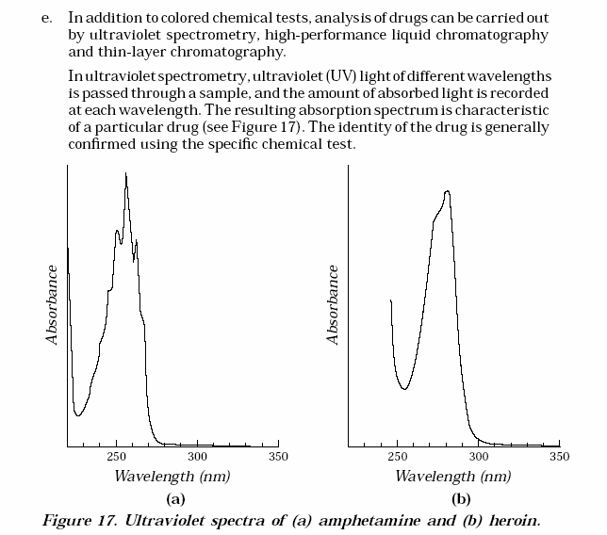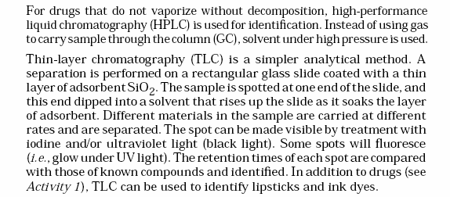

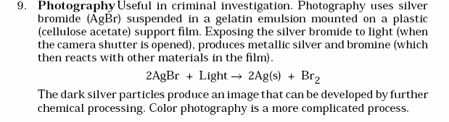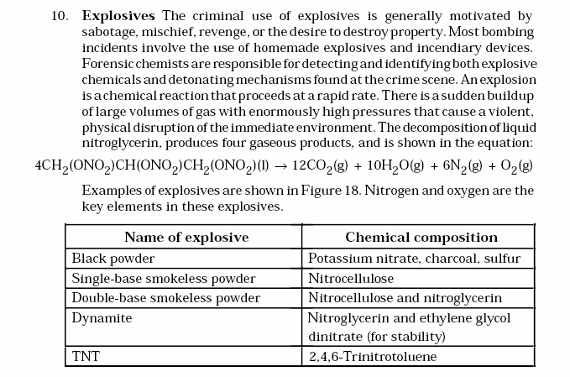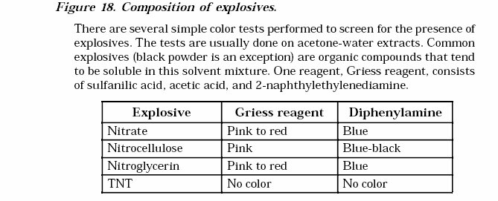

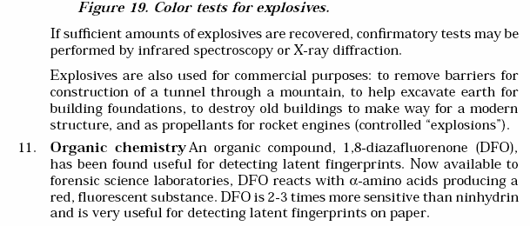

BETWEEN CHEMISTRY AND OTHER DISCIPLINES

l. Physics In addition to color and density, refractive index ls a usef ul way for identifying glass. Refractive index ls the degree towhich a beam of light bends as It passes from air Into a solid or liquid .

Glass | Index of refraction
PyrexTM glass | 1.47
Headlight glass | 1.47 - 1.49
Television glass | 1.49 - 1.51
\i\lindow glass, bottles | 1.51 - 1.52
Ophthalmic lenses | 1.52 - 1.53
Light flint glass | 1.6
Figure 20. Refr active incfices f or glasses.

2. GeologySoil lsaconunon form of physical evidence.Soilsamples areanalyzecl to determine If they have a conunon origin.The methods include a density profile and settling ratecurve.For example, asoilsample lsdried and sieved .
(Sievescontaining 200 wires per ln2 = 200 mesh; 50 wires per ln2 = 50 mesh,
etc. The higher the mesh size, the finer the particles.) A small amount of a desirecl mesh size(usually 30-45g) lsplaced on the top of acolwnn containing layersoflmmlsclble liquids of different densities. Heavy particles will settle to their level In a few minutes.Ligh t particles may take a few hours to stop moving.Thesoil profile at the scene ls then compared to the soil profile from the suspect . (The same technique can be used to determine the density of small glass fragments.)

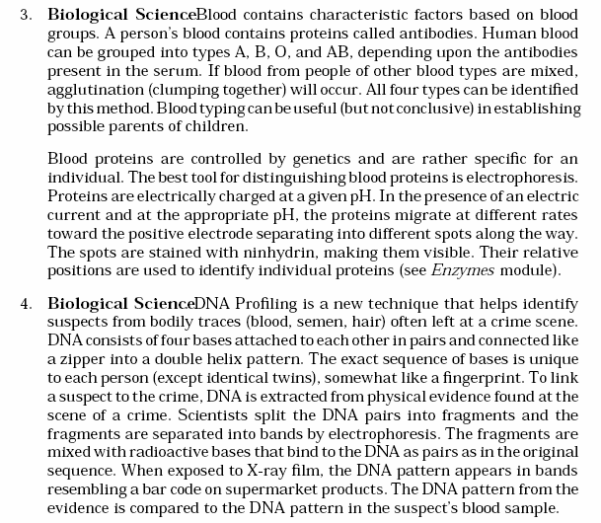

TO THE CONTEMPORARY WORLD

