GLO GERM – GRADE 1

Hand Washing Lessons

Educational Innovations, Inc., Norwalk, CT

General Information
- Germs are everywhere.
- Germs are so small that you cannot see them.
- Germs can make you sick.
- You can get rid of germs by washing your hands.

How to Wash Your Hands
- Use warm, running water.
- Use liquid or pump soap whenever possible.
- Rub hands together for at least 10 seconds.
- Scrub underneath the fingernails.
- Rinse and then dry.

When to Wash Your Hands
- After using the toilet.
- Before eating or touching food.
- After playing with animals.

Westminster College

Teaching Idea:
Use a spray bottle filled with clean water. Spray water on children’s hands. Explain that the water on their hands represents germs that come out of their mouths when they cough and sneeze. Now have the children touch and object (ie-table, chair, etc.) Ask them what happened to the object they touched (it became damp). Explain that this is what happens when we sneeze into our hands and then touch and object (the germs on our hands get on the object). Discuss what might happen if one of their friends touches the object while it is moist (they might pick up the germs and get sick). Explain that if you wash your hands after sneezing or coughing in them the germs will be washed away and there will be less of a chance for people to get sick.

Miscellaneous Information:
- Hand washing message needs to be reinforced several times throughout the day, especially before lunch and after using the restroom.
- Teach by example.
- The activity asks each student to write his/her name on the bottom of the page pledging to wash their hands. You may want to post one or all of the activity sheets in the classroom to serve as a reminder of the pledge.
- Please copy the activity sheet for the children to complete.

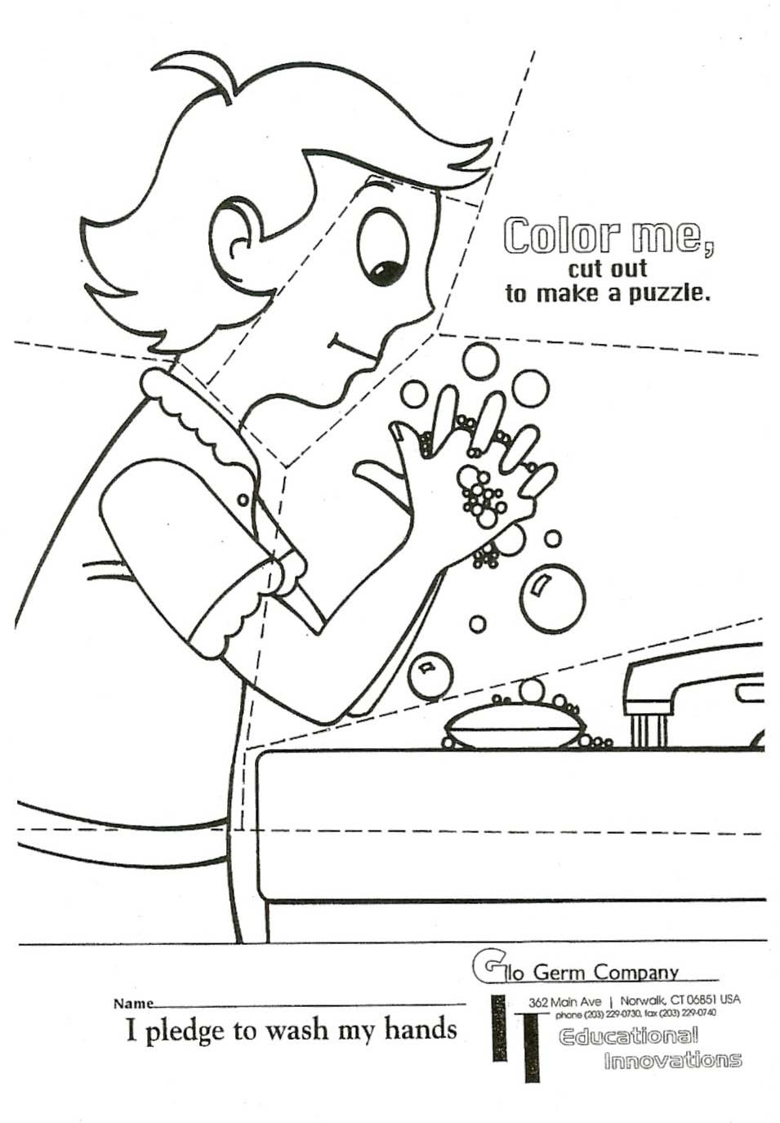
Glo Germ-1

