GLO GERM – GRADE 3

Hand Washing Lessons

Educational Innovations, Inc., Norwalk, CT

Westminster College

OBJECTIVE
Describe how daily health practices make a difference in their appearance, health, and feelings of well-being.

When to Wash Your Hands:
- After using the toilet.
- Before preparing, touching or eating food.
- After playing with animals.
- After touching money.
- After coughing, sneezing, or blowing your nose.

How to Wash Your Hands:
- Use warm, running water.
- Use liquid or pump soap whenever possible.
- Rub hands together vigorously for at least 10 to 20 seconds.
- Scrub underneath the fingernails.
- Rinse thoroughly and dry with paper towel or hand dryer.

Importance of Hand Washing:
- Germs are so small that you cannot see them and they can be found almost everywhere.
- Washing your hands cal help to get rid of germs. Germs can make you sick.
- There are many types of germs (ie-bacteria, viruses).
- Bacteria and viruses cause illness and disease.
- Some illnesses and diseases that are caused by bacteria and viruses are very serious.
- Some examples of illnesses and diseased caused by bacteria and viruses are: colds, flu, pneumonia, hepatitis and Shigellosis.
- Washing your hands is the best way to prevent these illnesses and diseases.

Miscellaneous Information:
- Hand washing message needs to be reinforced several times throughout the day, especially before lunch and after using the restroom.
- Teach by example.
- The activity asks each student to write his/her name on the bottom of the page pledging to wash their hands. You may want to post one or all of the activity sheets in the classroom to serve as a reminder of the pledge.
- Please copy the activity sheet for the children to complete.

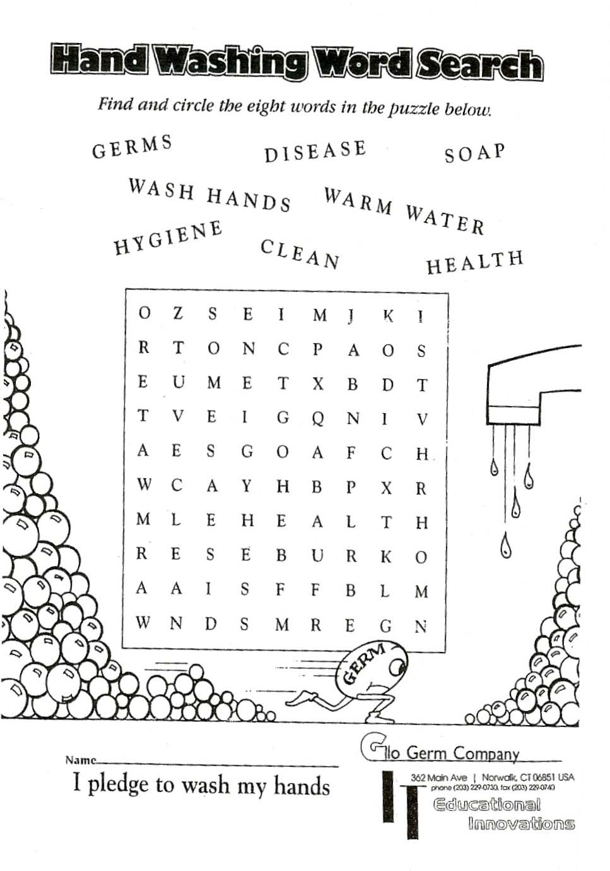
Glo Germ-3

