GRAPH MATCHING

LAB MECH 6.COMP.
From Physics with Computers, Vernier Software & Technology, 2000.
Mathematics Teacher, September, 1994.

STANDARDS
3.2.9-12.X Communicate technical information about how some technological
Devices use the principles of wave behavior and wave interactions with matter to transmit and capture information and energy.
3.2.3.A Make and communicate observations and/or measurements of an objects motion to provide evidence that a pattern can be used to predict future motion.
3.2.6-8.H Plan an investigation to provide evidence that the change in an object’s motion depends on the sum of the forces on the object and the mass of the object.
3.2.9-12.I Analyze data to support the claim that Newton’s second law of motion describes the mathematical relationship among the net force on a macroscopic object, its mass, and its acceleration.

INTRODUCTION
One of the most effective methods of describing motion is to plot graphs of distance, velocity, and acceleration vs. time. From such a graphical representation, it is possible to determine in what direction an object is going, how fast it is moving, how far it traveled, and whether it is speeding up or slowing down. In this experiment, you will use a Motion Detector to determine this information by plotting a real time graph of your motion as you move across the classroom.
The Motion Detector measures the time it takes for a high frequency sound pulse to travel from the detector to an object and back. Using this round-trip time and the speed of sound, you can determine the distance to the object; that is, its position. Logger Pro will perform this calculation for you. It can then use the change in position to calculate the object’s velocity and acceleration. All of this information can be displayed as either a table or a graph. A qualitative analysis of the graphs of your motion will help you develop an understanding of the concepts of kinematics.

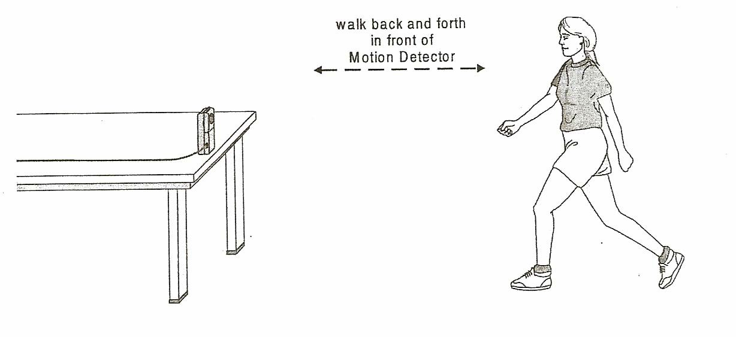

PURPOSE
The purpose of this experiment is to use a Motion Detector to study the basic concepts of kinematics by graphically describing your motion as you move across the room. Graphs of position vs. time and velocity vs. time will be predicted, sketched and tested.

Graph Matching
PRELIMINARY QUESTIONS
- Use a coordinate system with the origin at far left and positive distances increasing to the right. Sketch the distance vs. time graph for each of the following situations:
  - An object at rest
  - An object moving in the positive direction with a constant speed
  - An object moving in the negative direction with a constant speed
  - An object that is accelerating in the positive direction, starting from rest
- Sketch the velocity vs. time graph for each of the situations described above.

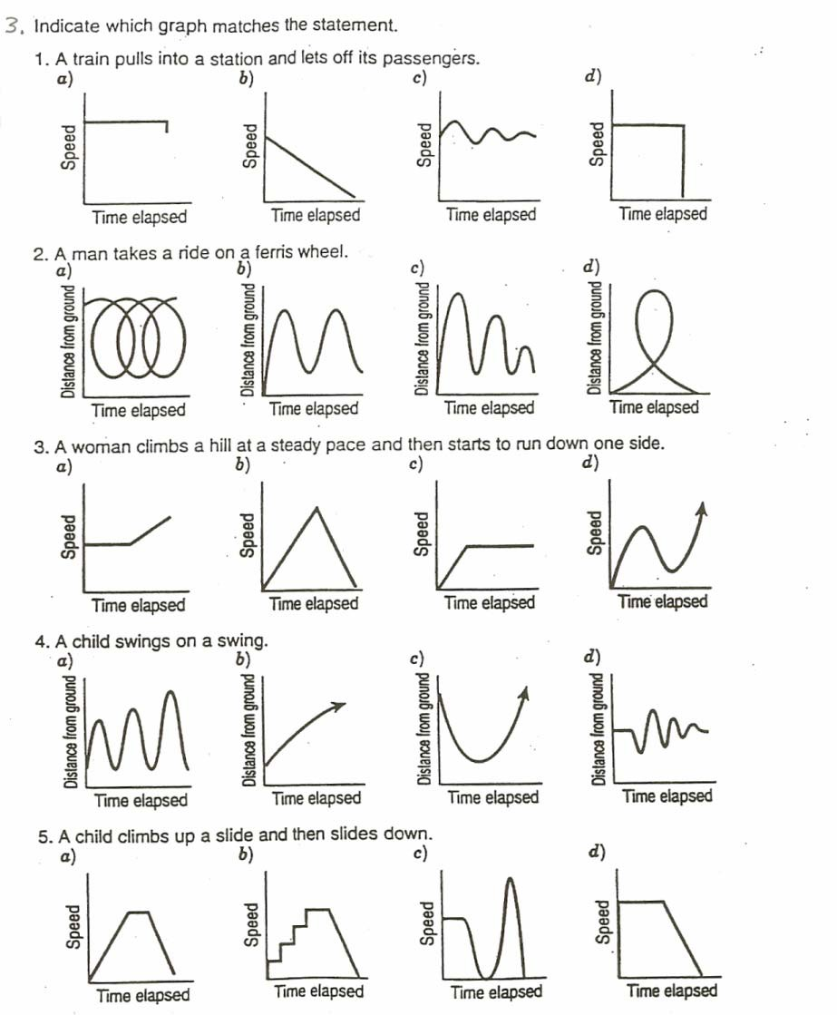

PROCEDURE

Part l Preliminary Experiments
- Connect the Motion Detector to the DIG/SONIC 1 channel of the interface.
- Place the Motion Detector so that it points toward an open space at least 4 m long. Use short strips of masking tape on the floor to mark the 1 m, 2 m, 3 m, and 4 m positions from the Motion Detector.
- Open the file “01a Graph Matching” from the Physics with Computers folder.
- Using Logger Pro, produce a graph of your motion when you walk away from the detector with constant velocity. To do this, stand about 1 m from the Motion Detector and have your lab partner click . Walk slowly away from the Motion Detector when you hear it begin to click.
- Sketch what the position vs. time graph will look like if you walk faster. Check your prediction with the Motion Detector.
- Try to match the shape of the position vs. time graphs that you sketched in the Preliminary Questions section by walking in front of the Motion Detector.

Part Il Position vs. Time Graph Matching
- Open the experiment file “01b Graph Matching.” A position vs. time graph will appear.
- Describe how you would walk to produce this target graph.
- To test your prediction, choose a starting position and stand at that point. Start data collection by clicking . When you hear the Motion Detector begin to click, walk in such a way that the graph of your motion matches the target graph on the computer screen.
- If you were not successful, repeat the process until your motion closely matches the graph on the screen. If a printer is attached, print the graph with your best attempt.
- Open the experiment file “01c Graph Matching” and repeat Steps 8–10, using a new target graph.
- Answer the Analysis questions for Part II before proceeding to Part III.

Part IIl Velocity vs. Time Graph Matching
- Open the experiment file “01d Graph Matching.” A velocity vs. time graph will appear.
- Describe how you would walk to produce this target graph.

- To test your prediction, choose a starting position and stand at that point. Start by clicking . When you hear the Motion Detector begin to click, walk in such a way that the graph of your motion matches the target graph on the screen. It will be more difficult to match the velocity graph than it was for the position graph.
- Open the experiment file “01e Graph Matching.” Repeat Steps 14-15 to match this graph.

- Remove the masking tape strips from the floor.

ANALYSIS

Part II Distance vs. Time Graph Matching

- Describe how you walked for each of the graphs that you matched.
- Explain the significance of the slope of a position vs. time graph. Include a discussion of positive and negative slope.

- What type of motion is occurring when the slope of a position vs. time graph is zero?
- What type of motion is occurring when the slope of a position vs. time graph is constant?

- What type of motion is occurring when the slope of a distance vs. time graph is changing? Test your answer to this question using the Motion Detector.

- Return to the procedure and complete Part III.

Part III Velocity vs. Time Graph Matching

- Describe how you walked for each of the graphs that you matched.
- Using the velocity vs. time graphs, sketch the position vs. time graph for each of the graphs that you matched. In Logger Pro, switch to a position vs. time graph to check your answer. Do this by clicking on the y-axis label and selecting Position. What does the area under velocity vs. time graph represent? Test your answer to this question by using the Motion Detector.

- What type of motion is occurring when the slope of a velocity vs. time graph is zero?
- What type of motion is occurring when the slope of a velocity vs. time graph is not zero? Test your answer using the Motion Detector.

EXTENSIONS
- Create a graph-matching challenge. Sketch a position vs. time graph using the prediction feature of Logger Pro: Choose Draw Prediction from the Analyze menu, and use the mouse to draw a new target graph. Challenge another student in the class to match your graph. Have the other student challenge you in the same way.

- Create a velocity vs. time challenge in a similar manner.
- Create a position vs. time graph by walking in front of the Motion Detector. Store the graph by choosing Store Latest Run from the Experiment menu. Have another student match your run.

- Create a velocity vs. time graph by walking in front of the Motion Detector. Store the graph by choosing Store Latest Run from the Experiment menu. Have another student match your run.

