GRIP STRENGTH AND MUSCLE FATIGUE

STANDARDS
- 3.2.7B, 3.2.10B, 3.2.12B – Evaluate experimental information; describe and interpret information using qualitative and quantitative skills.
- 3.3.7B, 3.3.10B, 3.3.12B – Describe and examine the chemical and structural basis of living organisms.
- 3.1.9-12.B- Develop and use a model to illustrate the hierarchical organization of interacting systems that provide specific functions within multicellular organisms.
- 3.1.9-12.C- Plan and conduct an investigation to provide evidence that feedback mechanisms maintain homeostasis.
- 3.1.6-8.H- Gather and synthesize information about how sensory receptors respond to stimuli by sending messages to the brain for immediate behavior or storage of memories.
- 3.5.9-12.J (ETS)- Synthesize data and analyze trends to make decisions about systems and processes.

INTRODUCTION

Skeletal muscle is composed of bundles of individual muscle fibers (see Figure 1) and has unique properties which allow it to respond to stimuli by contracting. Individual muscle fibers respond to a stimulus (e.g., nerve impulse) with an all or none response, meaning the muscle fiber contracts to its maximum potential or not at all. Once a muscle has contracted, relaxation must occur before it can contract again. There are three basic types of muscle fibers: slow fibers, fast fibers, and intermediate fibers. Fast fibers contract quickly but for a relatively short duration. Slow fibers respond less rapidly, but are capable of a more sustained contraction. The strength of contraction of a whole

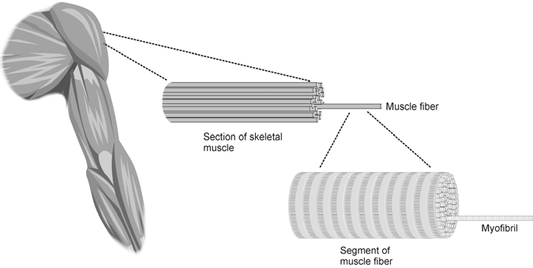

Figure 1
muscle is dependent on the number of muscle fibers involved.

Muscle fatigue occurs with prolonged or repetitive use of a muscle group, and is familiar to anyone who has ever carried a heavy suitcase or walked up a long flight of stairs. With fatigue, there is a sense of weakness and even discomfort, which eventually leads one to discontinue the activity that is causing it. The mechanism of fatigue is multifactorial and not fully understood, but is felt to involve the central nervous system, peripheral nervous system, muscle units and individual muscle fibers. At the level of muscle cells, depletion of energy stores may be important.

Regular exercise improves muscular function and delays the onset of fatigue, thus increasing the amount and duration of work that can be performed. Exercise is important for optimal athletic performance, prevention of injury in athletes and non-athletes, and the maintenance of good general health.

In this experiment, you will examine the effect of fatigue on muscle action by performing sustained and repetitive isometric contractions of muscles of the arm and hand using a Vernier Hand Dynamometer.

GUIDING QUESTIONS

- What does the graph of force exerted by your hand tell you about your hand grip strength?
- Do you observe a change in hand strength when you exert a continuous grip over time?
- Do you observe a change in hand strength during rapid, repetitive gripping?

SAFETY
Do not attempt this experiment if you have arthritis, or other conditions of the hand, wrist, forearm, or elbow. Inform your instructor of any possible health problems that might be exacerbated if you participate in this exercise.

MATERIALS
Vernier LabQuest LabQuest Application
Vernier Hand Dynamometer

PROCEDURE

There should be 3 students in each lab group. One person will be the subject, another will operate the LabQuest (the operator) and the third will read the lab instructions (the director) and coordinate the subject and operator. You may have to do a few practice rounds of each part of the lab before taking data.
Part I Muscle Strength with Continuous Grip

- 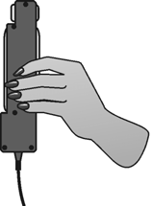Connect the power supply and the Hand Dynamometer to the LabQuest. Turn on the LabQuest by pressing the oval button at the top left of the device. Choose

Figure 2
New from the File menu.

- On the Meter screen , tap the gray Length box to the right of the screen. Highlight the length box with the blue stylus. Change the data-collection length to 100 seconds. Select OK.

- Zero the readings for the Hand Dynamometer. Hold the Hand Dynamometer along the sides, in an upright position (see Figure 2). Do not put any force on the pads of the Hand Dynamometer. When the readings
stabilize, tap the red Force box and choose Zero from the menu. The readings for the sensor should recalibrate to be close to zero.

- Have the subject sit with his/her back straight and feet flat on the floor. The Hand Dynamometer should be held in the dominant hand. The elbow should be at a 90° angle, with the arm unsupported (see Figure 3).

- Have the subject close his/her eyes, or avert them from the screen.

- 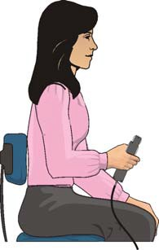Instruct the subject to grip the sensor with full strength and start data collection. The subject should exert maximum effort with each grip throughout the duration of the experiment.

- The gray Time box at the lower right of the screen will display the time of the experiment. At 90 s, the lab partner(s) should encourage the subject to grip even harder. Data will be collected for 100 s. The LabQuest will automatically stop taking data at this time, and the graph will autoscale to fit the data. You should have a graph that looks similar to Figure 4.

- Determine the maximum force exerted during different time intervals.
  - Tap and drag across the data from 0 s to 10 s. The gray Time box at the lower right of the screen

Figure 3

will display the time point in the experiment.
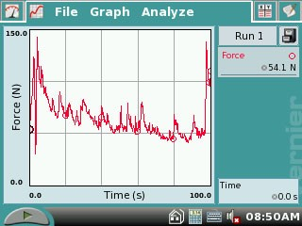

Figure 4. Hand grip strength over 100 s

  - Choose Statistics from the Analyze menu.
  - Record the maximum force in Table 1, rounding to the nearest 0.1 N.
  - Choose Statistics → Force from the Analyze menu to turn off statistics.
- Repeat Step 8 for the remaining 10 second intervals: 20−30 s, 40−50 s, 60−70 s, and 80−90 s.

- Calculate the difference between each maximum value and the next and record these values in Table 1.

a. (20-30s) – (0-10s) = Δ Max. force (N)

-
= N

b. (40-50s) – (20-30s) = Δ Max. force (N)

-
= N

c. (60-70s) – (40-50s) = Δ Max. force (N)

-
= N

d. (80-90s) – (60-70s) = Δ Max. force (N)

-
= N

- Tap and drag to highlight 0−90 s on the graph. Choose Curve Fit from the Analyze menu. Select Linear as the Fit Equation and record the slope (round to the nearest 0.01) in Table 3. Select OK.

- Store the data from the first run by tapping the File Cabinet icon . This will hold the data until you are sure you have recorded the information you need in Tables 1-3.

Part II Muscle Strength with Repetitive Grip

- Have the subject sit with his/her back straight and feet flat on the floor. The Hand Dynamometer should be held in the dominant hand. The elbow should be at a 90° angle, with the arm unsupported (see Figure 2).

- Have the subject close his/her eyes, or avert them from the screen.

- Zero the readings for the Hand Dynamometer. Hold the Hand Dynomometer along the sides, in an upright position. Do not put any force on the gray pads of the Hand Dynamometer. When the readings stabilize, choose Zero from the Sensors menu. The readings for the sensor should be close to zero.

- Instruct the subject to rapidly grip and relax his/her grip on the sensor (approximately twice per second). Start data collection. The subject should exert maximum effort throughout the duration of the experiment.

- At 90 s, the lab partner(s) should encourage the subject to grip even harder. Data will be collected for 100 s. At 90 s, the lab partner(s) should encourage the subject to grip even harder. Data will be collected for 100 s. The LabQuest will automatically stop taking data at this time, and the graph will autoscale to fit the data. You should have a graph that looks similar to Figure 5.

- 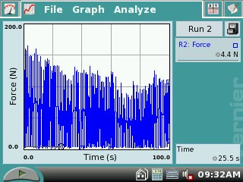Determine the maximum force exerted during different time intervals.

  - Tap and drag across the data from 0 s to 10 s.
  - Choose Statistics from the Analyze menu.
  - Record the maximum force in Table 2, rounding to the nearest 0.1 N.
  - Choose Statistics → Force from the Analyze menu to turn off statistics.
Figure 5. Repetitive grip strength over 100 s.

- Repeat Step 17 for the remaining 10 second intervals: 20−30 s, 40−50 s, 60−70 s, and 80−90 s.

a. (20-30s) – (0-10s) = Δ Max. force (N)

-
= N

b. (40-50s) – (20-30s) = Δ Max. force (N)

-
= N

c. (60-70s) – (40-50s) = Δ Max. force (N)

-
= N

d. (80-90s) – (60-70s) = Δ Max. force (N)

-
= N

- Calculate the difference between each maximum value and the next and record these values in Table 2.

- Tap and drag to highlight 0−90 s on the graph. Choose Curve Fit from the Analyze menu. Select Linear as the Fit Equation and record the slope (round to the nearest 0.01) in Table 3. Select OK.

- Store the data from the second run by tapping the File Cabinet icon . This will hold the data until you are sure you have recorded the information you need in Tables 1- 3.

REFERENCES
Diana Gordon and Steven L. Gordon, M.D. 2005. Human Physiology with Vernier.
Experiment 8: Blood Pressure and Exercise. Vernier Software & Technology. Beaverton, OR. Pp 17-1 – 17-5, 17-1T – 17-2T.

CREDITS
The lab was adapted and revised by Dr. Stephanie Corrette-Bennett.

DATA SHEET

Name: Group: Date:

Table 1−Continuous Grip
Time interval | Maximum force (N) | ∆ Maximum force (N)
0–10 s
20–30 s
40–50 s
60–70 s
80–90 s

Table 2−Repetitive Grip
Time interval | Maximum force (N) | ∆ Maximum force (N)
0–10 s
20–30 s
40–50 s
60–70 s
80–90 s

Table 3
Slope
Part I–Continuous gripping
Part II–Repetitive gripping

DATA ANALYSIS

- Examine your graph and the data in Table 1. What conclusion can you draw about the number of individual muscle fibers that are firing in the last 10 s compared with the first 10 s?

- Is the change in number of muscle fibers that contract occurring at a constant rate?

- Use your knowledge of fast, slow, and intermediate skeletal muscle fibers to hypothesize which fibers are contracting in the first, third, and final 10 s intervals.

- How might you explain the subject’s response to coaching? This should be evident in the last 10 s of data for Parts I and II of the exercise. Discuss the possible involvement of the central nervous system, in addition to the muscle fibers.

- Compare the slopes recorded in Table 3. Give a possible explanation for the difference, if any, in muscle fatigue rates seen in continuous versus repetitive gripping.

