HEAT OF COMBUSTION: MAGNESIUM
LABQUEST 19 Westminster College
From Vernier Software & Technology

In Experiment 18, you learned about the additivity of reaction heats as you confirmed Hess’s Law. In this experiment, you will use this principle as you determine a heat of reaction that would be difficult to obtain by direct measurement—the heat of combustion of magnesium ribbon. The reaction is represented by the equation
(4) Mg(s) + 1/2 O2(g) ⎯⎯→ MgO(s)
This equation can be obtained by combining equations (1), (2), and (3):
- MgO(s) + 2 HCl(aq) ⎯⎯→ MgCl2(aq) + H2O(l)
- Mg (s) + 2 HCl(aq) ⎯⎯→ MgCl2(aq) + H2(g) (3) H2(g) + 1/2 O2(g) ⎯⎯→ H2O(l)
The pre-lab portion of this experiment requires you to combine equations (1), (2), and (3) to obtain equation (4) before you do the experiment. Heats of reaction for equations (1) and (2) will be determined in this experiment. As you may already know, ⊗H for reaction (3) is –285.8 kJ.

OBJECTIVES
In this experiment, you will
- Combine three chemical equations to obtain a fourth.
- Use prior knowledge about the additivity of reaction heats.
- Determine the heat of combustion of magnesium ribbon.

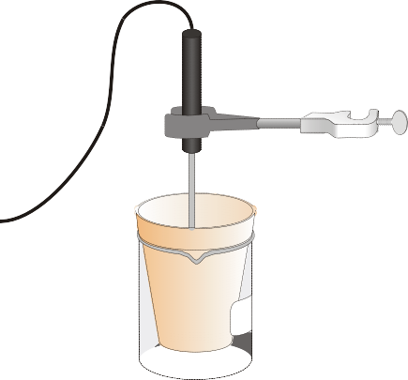

MATERIALS
Figure 1

LabQuest | 250 mL beaker
LabQuest App | Styrofoam cup
Temperature Probe | ring stand
1.00 M HCl | utility clamp
magnesium oxide, MgO | stirring rod
magnesium ribbon, Mg | balance
100 mL graduated cylinder

PROCEDURE
- Obtain and wear safety glasses and an apron.

- Connect the Temperature Probe to LabQuest and choose New from the File menu. If you have an older sensor that does not auto-ID, manually set up the sensor.

- On the Meter screen, tap Rate. Change the data-collection rate to 1 sample/second and the data-collection length to 480 seconds. Data collection will last 8 minutes. Select OK.

- Use a utility clamp to suspend the Temperature Probe from a ring stand as shown in Figure 1.

Reaction 1
- Place a Styrofoam cup into a 250 mL beaker as shown in Figure 1. Measure out 100.0 mL of 1.00 M HCl into the Styrofoam cup. Lower the Temperature Probe into the solution. CAUTION: Handle the HCl solution with care. It can cause painful burns if it comes in contact with the skin.

- Weigh out about 1.00 g of magnesium oxide, MgO, on a piece of weighing paper. Record the exact mass used in your data table. CAUTION: Avoid inhaling magnesium oxide dust.

- Start data collection and obtain the initial temperature, t1. Monitor temperature (in °C) on the screen. It may take several seconds for the Temperature Probe to equilibrate at the temperature of the solution. After three or four readings at the same temperature (t1) have been obtained, add the white magnesium oxide powder to the solution. Use a stirring rod to stir the cup contents until a maximum temperature has been reached and the temperature starts to drop. Record the maximum temperature, t2.
- Data collection will stop after 8 minutes (or stop before 8 minutes have elapsed).

- To confirm the initial (t1) and final (t2) values you recorded earlier, examine the data points along the curve on the displayed graph. As you tap each data point, the temperature and time values are displayed to the right of the graph.
- Discard the solution as directed by your teacher.

Reaction 2
- Repeat Steps 5–10 using about 0.50 g of magnesium ribbon rather than magnesium oxide powder. The magnesium ribbon has been pre-cut to the proper length by your teacher. Be sure to record the measured mass of the magnesium. CAUTION: Do not breathe the vapors produced in the reaction!

PROCESSING THE DATA
- In the spaces provided, calculate the change in temperature, ⊗t, for Reactions 1 and 2.
- Calculate the heat released by each reaction, q, using the formula
q = Cp•m•⊗t
Cp = 4.18 J/g°C, and m = 100.0 g of HCl solution. Convert joules to kJ in your final answer.
- Determine ⊗H. (⊗H = –q)
- Determine the moles of MgO and Mg used.
- Use your Step 3 and Step 4 results to calculate ⊗H/mol for MgO and Mg.

- Determine ⊗H/mol Mg for Reaction 4. (Use your Step 5 results, your pre-lab work, and ⊗H = -285.8 kJ for Reaction 3).

- Determine the percent error for the answer you obtained in Step 6. The accepted value for this reaction can be found in a table of standard heats of formation.

PRE-LAB EXERCISE
In the space provided below, combine equations (1), (2), and (3) to obtain equation (4).
(1)
(2)
(3)
(4)

DATA AND CALCULATIONS

 | Reaction 1 (MgO) | Reaction 2 (Mg)
1. Volume of 1.00 M HCl | g | g
2. Final temperature, t2 | °C | °C
3. Initial temperature, t1 | °C | °C
4. Change in temperature, ⊗t | °C | °C
5. Mass of solid | g | g

6. Heat, q | kJ | kJ
7. ⊗H | kJ | kJ
8. Moles | mol MgO | mol Mg
9. ⊗H/mol | kJ/mol | kJ/mol
10. Determine ⊗H/mol Mg for reaction (4)*.
(1)

(2)

(3) (4)*
11. Percent error kJ/mol

