Name --------- -------------
Using a microscope

-
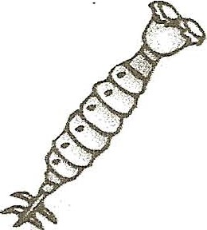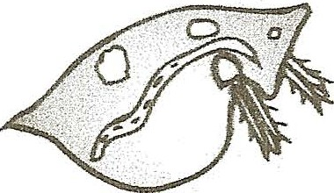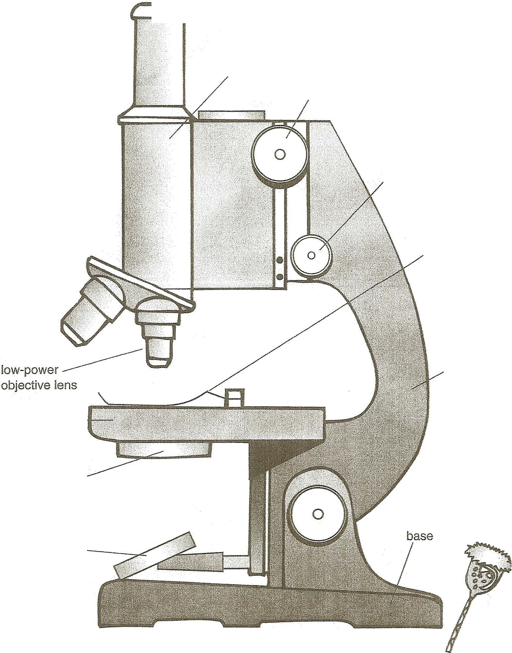How To Use fi Simple Compoond Microscope
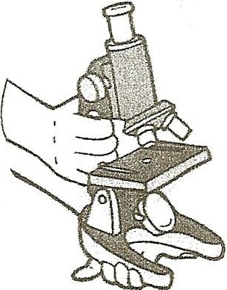
- Handle with care! When carrying the microscope,

grasp the arm with one hand while supporting the base
with the other.
- Position the microscope on a steady
table near a good source of light. If possible, tilt the ocular tube so that you can get a clear
view through the microscope without leaning over the
eyepiece.
3. While lookiri'g at the microscope from the side, practice turning the coarse and fine adjustment knobs to see how they move the lens up and down. Raise the lens as far as possible.
4. Turn the objective lenses so that the microscope is set at the lowest power (probably 10X). Always start your observations with this lens. It allows you to see more of the object so that you can locate the part you want to observe more closely.
5. If the microscope has an aperture, open it fully. While looking through the eyepiece, tilt the mirror to reflect the maximum amount of light
through the lens.You should see a white circle.
6. Place a prepared slide on the stage so that the part you want to look at is positioned over the hole and under the lens. Hold the slide in place with the stage clips.
- While looking at the microscope from the side, turn the coarse adjustment knob to bring the lens down very close to-but not touching-the slide.
**Never lower the lens while looking through the eyepiece . You could hit the slide, breakin it or breakin the lens itself .
- Looking through the eyepiece, slowly raise the lens by turning the coarse adj ustment knob. After the object comes into focus, fine-tune the picture by slowly turning the fine adjustment knob.
- Slowly move the slide around until you find the part of the image you wish to observe.
- To look at the image in more detail, change to a higher-power
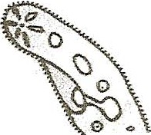objective lens. First raise the lenses. Tum the nosepiece to select the higher-power lens. Lower the !ens as explained in step 7, and refocus as in step 8.
G •

nosepiece

h;ghi)OWO\
objectis

stage ----,

aperture
(or diaphragm)

mirror
.....-,>----eyepiece

ocular tube

coarse adjustment knob

fine adjustment knob

stage clip

arm

I . •o ©The Education Center,Inc.• THE MAILBOX" • Intermediate• Ocl/Nov 1$95
-----;"/ _,,.,.- o f ----------------,.;.._ ----------------------------------- ·
,,Note To The Teacher: Use this page with "Take A Closer Look!:' on page 38.

