IDENTIFYING AN UNKNOWN ANALGESIC BY MELTING TEMPERATURE AND THIN-LAYER CHROMATOGRAPHY
From Organic Chemistry with Vernier

EXPERIMENT 4 INTRODUCTION

Westminster College

Thin-layer chromatography (TLC) is an important technique in organic chemistry. TLC uses the different affinities a compound has for the mobile and stationary phases to achieve separation of mixtures of organic compounds. TLC can also be used to identify compounds by comparison with known samples, check the relative purity of a compound, and monitor the progress of a reaction.

In thin-layer chromatography, the stationary phase is the adsorbent (usually silica or alumina) coated on a sheet of glass, metal, or plastic. The sample is applied as a spot near the bottom of the plate. The TLC plate is then placed in a developing chamber containing a shallow layer of solvent where the mobile phase (solvent) slowly rises by capillary action.

Under a given set of conditions, a specific compound will travel a fixed unique distance relative to the solvent front. Different compounds generally move at different rates. As a result, if the sample is a mixture of compounds it will separate into a series of spots at varying distances up the plate (see Figure 1). If the sample is pure, then only one spot will result. A UV light source is used to visualize the spots on the TLC plate. Under UV light, the chemical deposits will appear as dark spots against a bright background.

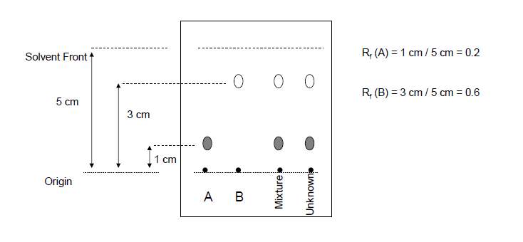
TLC separation results are expressed in terms of Rf (retention factor) values. The Rf is a ratio calculated by dividing the distance traveled by the sample by the distance traveled by the solvent at the end of the experiment.

Figure 1 Example TLC plate at the end of the experiment

In this experiment, TLC and melting temperature will be used to identify the active ingredients in an unknown over-the-counter medicine tablet. The tablet you will test contains one or more of the following: acetylsalicylic acid (aspirin), acetaminophen (the active ingredient in Tylenol®), caffeine (ingredient in Excedrin®), and/or ibuprofen (the active ingredient in Advil®). The structures of these compounds are shown here.

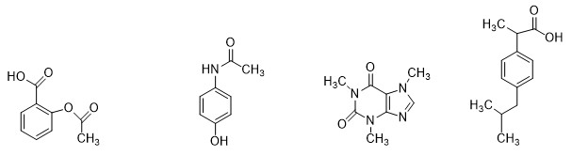
Acetylsalicylic acid Acetaminophen Caffeine Ibuprofen (aspirin)
Figure 2 Structure of analgesics

OBJECTIVES
In this experiment you will
- Calculated the Rf values of acetylsalicylic acid, acetaminophen, caffeine, and ibuprofen.
- Determine the melting temperature of each of these analgesics.
- Identify the solvent system for good separation.
- Use TLC and melting temperature to identify your unknown analgesic.

MATERIALS

Part I Thin-Layer Chromatography

Acetaminophen in ethyl acetate | 10 mL graduated cylinder
Acetylsalicylic acid in ethyl acetate | UV lamp (shortwave)
Caffeine in ethyl acetate | Ethyl acetate
Ibuprofen in ethyl acetate | n-hexane
Three TLC plates (5 x 10 cm) | Spotting capillary tubes
Three 400 mL beakers | Five 10 x 75 mm test tubes
Three 9 cm watch glasses | Test tube racks
Cotton plug | Unknown sample
Disposable Pasteur pipets and bulb | Mortar and pestle
Pencil | Filter paper
Ruler

Parts II and III Melting Temperature

LabQuest or computer interface | Acetaminophen
LabQuest App or Logger Pro | Acetylsalicylic acid
Vernier Melt Station | Caffeine
Glass capillary tubes, one end closed | Ibuprofen
Tissues (preferably lint-free) | Unknown sample
Mortar and pestle

PROCEDURE
Part I Thin-Layer Chromatography
- Obtain and wear goggles. Protect your arms and hands by wearing a long-sleeve lab coat and gloves. Conduct this reaction in a fume hood

- Obtain your unknown analgesic sample and dissolve approximately 50 mg in 2 mL of ethyl acetate. Filter the solution through a pipet containing a cotton plug into a test tube.

- Transfer approximately 1−2 mL of each pure compound to test tubes. Be sure to label each test tube. Solutions of the pure compounds will be available in an ethyl acetate solution.
- Prepare three development chambers using the 400 mL beakers and watch glasses.
  - Label the chambers 1−3. These will contain ethyl acetate, hexane, and 1:1 ethyl acetate/hexane, respectively.
  - Place a piece of filter paper against the side of the beaker. The filter paper will help saturate the beaker with solvent vapors.
  - Fill each beaker with 5−10 mL of the developing solvent and cover with the watch glass.
- Prepare the TLC plates.
  - Obtain three TLC plates and number the plates 1−3. Handle them carefully and by the edges so that the adsorbent does not flake off.
  - Using a pencil (NOT an ink pen), lightly draw a line across the plate, approximately 1 cm from the bottom. Across this line, evenly mark five places indicating the location where the sample will be spotted, making sure they are not too close to the edge of the plate (see Figure 1). Do this for all three TLC plates.
  - Under each mark, lightly label each spot starting left to right as Ac, As, C, I, and
U. Repeat this step on the other TLC plates.
  - Dip one end of a spotting tube into the ethyl acetate solution containing acetaminophen. Capillary action will draw the liquid into the tube.
  - Lightly tap the tube on the mark for acetaminophen on all three TLC plates. Only a small amount of sample needs to be delivered. The spot should be 1−2 mm in diameter.
  - Repeat Steps d−e for the aspirin, caffeine, ibuprofen, and unknown sample on all three TLC plates.

- Place each of the TLC plate in the chamber and cover with the watch glass. The solvent level must not be above the spots on the plate or your samples will dissolve into the solvent.

- When the solvent has risen to within 1 cm from the top of the plate, remove the plate from the chamber and with a pencil, gently draw a line to mark the position of the final solvent front.

- After the plate has dried, observe the TLC plate under a UV lamp. Lightly outline the spots with the pencil. CAUTION: Do not allow skin or eyes to come in contact with UV light. Wear gloves, a lab coat, and UV resistant eye protection.

- Identify the solvent mixture that gave the best separation and use that TLC plate to calculate the Rf value for each spot. Record the values in your data table.

Part II Test the Melting Temperature of Analgesic Standards
- Obtain a small amount of acetaminophen. The solid should be in a powdered form. If it is not, use a mortar and pestle to carefully grind the solid to a powder. Pack a capillary tube 3−4 mm (~1/8 inch) deep with your sample.

- Check the control dial on the Melt Station to confirm that it is in the Off position. Connect the Melt Station power supply to a powered electrical outlet.

- Connect the Melt Station to LabQuest or a computer interface. Choose New from the File menu of the data-collection program.

- Carefully insert the capillary tube of solid into one of the sample holders of the Melt Station.
- Begin collecting melting temperature data using the Melt Station.

- Adjust the control dial in order to determine the approximate melting temperature range for the sample. When the temperature is within approximately 10ºC of the lowest possible melting temperature of your sample, turn the control knob to a temperature setting corresponding to the expected melting temperature provided in the table below.

Analgesic | Melting temperature range  (℃)
Acetaminophen | 168 – 172
Acetylsalicylic acid (aspirin) | 134 – 136
Caffeine | 234 – 236.5
Ibuprofen | 77 – 78

- When finished, stop data collection and turn the dial to the Fan/Cooling setting. Record the melting temperature range in your data table.
- Store the run and collect a second run, if desired.

- Prepare a new sample and repeat Steps 14−17 for samples of aspirin, caffeine, and ibuprofen.

Part III Test the Melting Temperature of Unknown Sample
- Obtain a small amount of your unknown analgesic compound. The solid should be in a powdered form. If it is not, use a mortar and pestle to carefully grind the solid to a powder. Pack a capillary tube 3−4 mm (~1/8 inch) deep with your sample.

- In the first trial, you will want to observe the melting process and make a rough estimate of the melting temperature of your unknown sample.

- When you have determined the approximate melting temperature range for the sample, stop data collection and turn the dial to the Fan/Cooling setting. Record the melting temperature range in your data table.
- Now that you have a rough idea of the melting temperature, a more accurate determination of the melting temperature can be made. Prepare a sample in a capillary tube and determine the melting temperature of the sample.

- When finished, stop data collection and turn the dial to the Fan/Cooling setting. Record the melting temperature range in your data table.

- At the end of the experiment turn the control dial on the Melt Station to Off. Dispose of the capillary tubes as directed by your instructor.

- Complete the Data Analysis section before exiting Logger Pro or LabQuest App. Print a copy of your graph and/or save your data, as directed by your instructor.

DATA TABLE

Part I Thin-Layer Chromatography

Solvent mixture that gave the best separation

Calculated Rf
Acetaminophen
Acetylsalicylic acid
Caffeine
Ibuprofen
Unknown

Part II Melting Temperature of Analgesic Standards

Measured melting temperature
range (℃)
Acetaminophen
Acetylsalicylic acid
Caffeine
Ibuprofen

Part III Melting Temperature of Unknown Sample

Measured melting temperature
range (℃)
Unknown analgesic

DATA ANALYSIS
- Draw your TLC plate. Label each analgesic and show the calculation of the Rf value.

- Based on your melting temperature data and the Rf value of the unknown, identify your unknown analgesic.
- What would happen if the solvent level is above the level of the spots?
- How do you properly record information obtained from a TLC?
- Are Rf values unique to a compound?

