INTERFERENCE IN THIN FILM

LAB LIGH 7 INTRODUCTION
Light travels through empty space at the ultimate speed of 3.00 x 108 m/s (rounded to 3 significant digits). Its speed in a light transparent material is its speed in empty space
divided by the index of refraction, n, of the material. With λ the wavelength of the light in empty space, the wavelength in a material λn can then be expressed by λn=λ/n.

Now consider a light ray incident nearly perpendicular on a thin film of thickness t, as shown in figure 1. The ray partially reflects from the upper film surface yielding ray 1 and partially transmits to the lower film surface and again partially reflects and then partially transmits at the upper film surface yielding ray 2. All these directions are so nearly normal to the film surfaces that the length of rays in the film will be considered equal to the film thickness t. Consider the index of refraction, n, of an electromagnetic light wave traveling in air to be n1 and traveling in the film n2. Now n1 is very nearly equal to 1.00, that of empty space, and n2 is somewhat larger. That a 180° phase change occurs for a reflected wave traveling towards a medium of greater index of refraction and no phase change towards a medium of lesser index of refraction, results in a 180° phase change for reflected ray 1 in relation to ray 2.
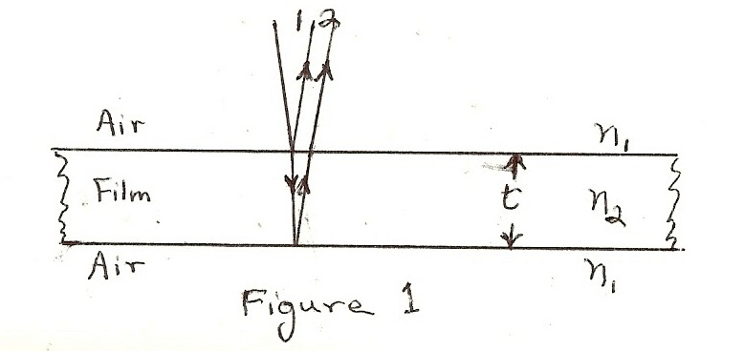

With λn=λ/n representing the wavelength in the film and film thickness t corresponding to a quarter wavelength in the film, that is t =λn/4, then ray 2 leaving the upper film surface will have traveled 2t or λn/2 farther than ray 1 and with the half-wavelength 180°reflection phase shift results in ray 2 in relation to ray 1 having a full wavelength shift and thus constructive interference. So with 2t = λn/2 and with m as an integral number of wavelengths, we write the condition for constructive interference as

2t = (m + 1 )λ ;
2 n

m=0,1,2,….

That λn=λ/n, we can express this relationship as

2nt = (m + 1 )λ;
2
m=0,1,2,…(eq.1).

For the two waves to combine out of phase, thus destructive interference, we change the path difference of the two rays and eq.1 by one-half wavelength or λ/2 and obtain

2nt = mλ;
m=0,1,2,…(eq.2).

For this experiment two very flat rectangular glass plates forming a thin wedge air film between them (see figure 2) will serve to form the thin film interference pattern when illuminated perpendicularly with parallel light of single wavelength, of quite a narrow range of wavelengths, or of a strongly prominent wavelength. One looks for a pattern of light and dark lines that cross the glass plate. The lines ought to be rather equally spaced and quite parallel to each other with glass plane enough. When crests of different reflected waves or rays line up, there forms a light band or fringe and when crests falls on troughs a dark band or fringe is seen.
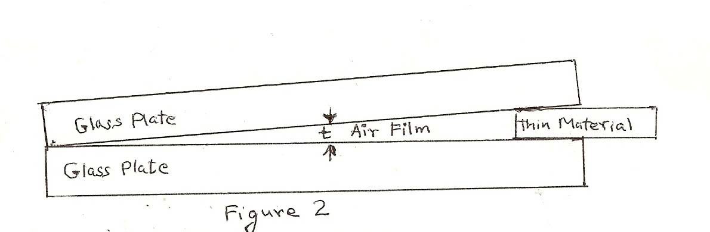

Figure 3 shows a section of Figure 2, detailing with rays the interference behavior involving the thin film of air. For this case eq.1 and eq. 2 hold as well recognizing that here no phase change occurs for reflected ray 1 with n2<n1 and what becomes ray 2, involving reflection at the lower air surface with n1>n2 undergoes a 180° or λ/2 phase shift. For this case the index of refraction n in eq. 1 and eq. 2 can be set equal to 1 since the index of refraction of the thin film of atmospheric air is very nearly equal to the 1 of empty space.
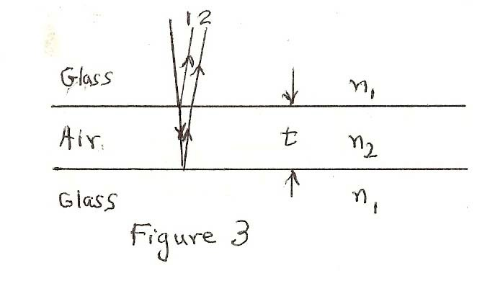

In experimentally obtaining the separation space or distance over a number of constructive or destructive interference fringes Δχ and knowing the approximate wavelength of the light, a Δt film thickness difference can be computed corresponding to a Δm count of the fringes spacings involved in the separation distance measured.
Applying eq.1 or eq. 2 over the space of fringes being measured yields the relationship,
Δt = Δm • λ / 2; (eq.3). Note that the difference in travel distance, 2Δt from one fringe to the next is one wavelength, λ. Now with a value for Δt based on experiment, the tilt angle of the two glass plates, θ, can be computed according, θ = tan-1(Δt/Δχ);(eq.4).

PURPOSE

The purpose of the experience is to study and understand the physical light wave dynamics involved in the formation of light line constructive interference and dark line destructive interference resulting from the upper surface and from the lower surface light reflections of a transparent thin film.

MATERIALS

mercury light source or fluorescent lamp light source mounting (such as “compact fluorescents”) ruler
plastic light filters thin spacer materials
two rectangular glass plates rubber bands

PRELIMINARY QUESTIONS

- From an understanding of the light phenomena behavior in forming the colored arcs of a rainbow, discuss the probability of finding the proverbial “pot of gold” at the rainbows end.
- Explain the physical basis of color patterns sometimes observed as day-light is reflected from a thin film of oil floating on water.
- Describe the physics involved in such as binocular or telescope lens coatings for reducing reflection of light by the lens components as light passes through the instrument.

PROCEDURE

- Thoroughly clean both sides of each glass plate. Place the plates together and bind one end with several turns of a rubber band about 1/8 or 1/4 inch from one end; insert a piece of thin material between the glass plates at the ends opposite and also bind this end with a rubber band.

- Using a fluorescent bulb or a mercury light source, direct the light perpendicular so as to reflect the light from the plates. So with the light source shining on the glass plates in a well-darkened room, look for a pattern of light and dark lines that “cross” the glass plate. You might, with colored filters intercepting the light directed to the glass plate, restrict the light wavelength to test for more distinct interference fringes.
- Now count out a number of light bands or fringe spaces, Δm, to be considered for analysis. Measure the overall distance, Δχ, perpendicular to the fringe fronts over which these fringes are spread. Record this data.

ANALYSIS

- With a wavelength that you should be given (the green line of mercury is 546.nm) and by eq.3, compute the thin film thickness increment, Δt, corresponding to interval of fringe spaces counted.

- From these results, compute the angle of the tilt between the two glass plates;(eq.4).

