INVESTIGATING GAS CHROMATOGRAPHY
From Organic Chemistry with Vernier

EXPERIMENT 8 INTRODUCTION

Westminster College

Gas Chromatography is a technique widely used to separate complex mixtures of substances. Compounds present in a volatile liquid or gaseous solute are isolated after traveling through a coated column based on the substance’s size and intermolecular interactions. If a compound tends to bind to the column through intermolecular interactions, it takes a longer time to emerge compared with a compound that does not tend to stick onto the column. The level of binding experienced between the substances and the column is determined based on the number and strength of intermolecular interactions between the two species. Substances that pass quickly through the column exhibit fewer intermolecular interactions with the column.

The Vernier Mini GC uses a metal column with a nonpolar coating, called the stationary phase. A sample, consisting of one or more compounds, is injected into the column and is carried through the stationary phase by atmospheric air, which acts as the mobile phase. The nonpolar coating of the stationary phase most strongly retains solutes of the same polarity. Organic compounds flowing out of the chromatography column are then detected by a chemical sensor that produces electrical responses proportional to the concentration of the compounds. The presence of such a chemical at the detector is seen as a peak on a chromatogram, as shown in Figure 1. The unique time it takes for a compound to exit the column after it is injected is called the retention time. With a gas chromatograph, a compound can be identified from a mixture by its retention time.

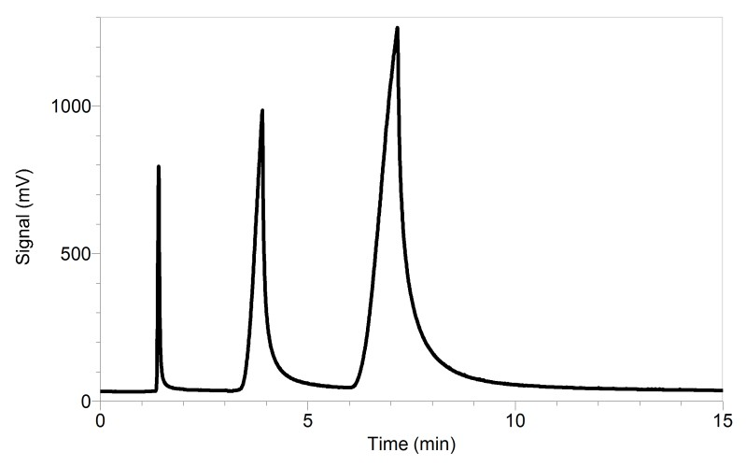
Figure 1 Samples gas chromatogram
Several factors can affect a compound’s retention time. More volatile compounds
(i.e., compounds with a lower boiling point) will move through the column faster because they are flowing in the mobile phase and not strongly bonded with the stationary phase.

The surface functional groups present on the compound are also a factor. For example, alcohols may weakly bond with a polar stationary phase more than esters because alcohols are capable of forming hydrogen bonds. The molecular weight of a compound may also play a role to a slight extent, although it is not a direct relationship that the heavier the molecule, the slower it will travel through a GC column.

As you will discover in this experiment, the instrument settings also affect a compound’s retention time. When separating compounds with a wide range of boiling points and polarities, it helps to raise the column temperature during the separation. Temperature programming reduces elution times of highly retained compounds. Adjusting the pressure will have a similar affect; higher pressures cause greater strain on the intermolecular interactions between the compound and stationary phase, ultimately reducing the retention time.

In this experiment, you will gain experience with the Vernier Mini GC by injecting a known sample into the device. The sample contains five compounds that will separate under the proper conditions. You will test this one mixture of compounds repeatedly and vary the profile of the Mini GC operation to obtain the best possible separation of this mixture.

OBJECTIVES
In this experiment you will
- Measure and analyze the chromatogram of a mixture of five compounds as they pass through a Vernier Mini GC.
- Vary the temperature-pressure profile of the Mini GC and observe how the chromatogram is affected by such changes.
- Determine the best temperature-pressure profile to obtain clear separation of all five compounds.

MATERIALS

LabQuest or computer | One vial of a mixture containing:
LabQuest App or Logger Pro | Methanol
Vernier Mini GC | Propyl acetate
1 µL glass syringe | Butyl acetate
Kimwipes® or paper towel | 2-butanone
Vial of methanol for cleaning | 4-methyl-2-pentanone

PRE-LAB EXERCISE
Complete the table below.

Compound | Boiling point (℃) | Molar mass (g/mol) | Bonding functional group
Methanol
Propyl acetate
Butyl acetate
2-butanone
4-methyl-2-pentanone

PROCEDURE
- Obtain and wear goggles. Protect your arms and hands by wearing a long-sleeve lab coat and gloves. Conduct this reaction in a fume hood or a well-ventilated room.

- Obtain a glass syringe, a vial of methanol, and a vial containing the mixture to be tested. The methanol will be used to clean the syringe.
- Prepare the Vernier Mini GC for data collection.
  - Turn on the Mini GC.
  - Connect the USB cable of the Mini GC to the USB port on your computer or LabQuest.
  - Start the data collection program, and then choose New from the File menu.
  - Click Collect in Logger Pro, or tap ► in LabQuest, to bring up the Temperature- Pressure profile.
  - Set the Temperature-Pressure values according to the settings listed for Run 1:

 | Run 1 | Run 2 | Run 3
Start temperature (℃) | 120 | 120 | 80
Hold time (min) | 10 | 10 | 10
Ramp rate (℃/min) | 1 | 1 | 1
Final temperature (℃) | 120 | 120 | 80
Hold time (min) | 0 | 0 | 0
Total length (min) | 10.0 | 10.0 | 10.0
Pressure (kPa) | 18.0 | 10.0 | 10.0

  - Select Done to initiate the Mini GC warm up. When the Mini GC is ready for injection in Step 7, the message will read, “Inject and select Collect simultaneously”, and the LED will turn to green. Continue with Step 4 during warm up.

- Follow the steps below to clean and flush the syringe with methanol. Important: The glass syringe is fragile. Be careful not to bend the needle or bend the plunger. Never pull the plunger back more than 50% of its total volume. Be careful not to bend the plunger as you press it down.
  - Depress the plunger fully.
  - Submerge the tip of the syringe needle into the vial of methanol.
  - Pull back the plunger to fill the barrel about 1/3 full of methanol. Examine the barrel of the syringe and estimate the amount of methanol in the barrel.
  - Expel the liquid onto a Kimwipe or a paper towel.
  - Repeat Steps 4a–d at least two times, until you are comfortable pulling up a liquid into the syringe and measuring the volume in the syringe barrel. Use a Kimwipe or a paper towel to carefully pat around the tip of the syringe needle.
- Follow the process in Step 4 to clean and flush the syringe with the mixture.
- Collect a volume of the mixture for injection.
  - Submerge the needle into the vial of mixture one last time.
  - Draw up 0.30 μL of liquid. It is important that the volume be very close to 0.30 μL and that you inject the same volume for each test.
  - After collecting your sample, gently wipe the needle from barrel to tip, with a Kimwipe.
- Prepare for injection and the start of data collection.

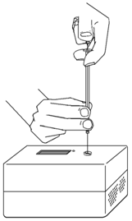
  - The Mini GC should now have reached the correct start temperature and pressure and the LED turned to green.
  - To insert the needle of the syringe into the injection port of the Mini GC, hold the syringe with one hand and steady the needle with your other hand. Insert the needle into the injection port until the needle stop is fully seated. Do not force the needle into the injection port. If the needle sticks, rotate it slightly while inserting. Do not move the plunger yet (see Figure 2).
  - Simultaneously, depress the syringe plunger and select Collect to begin data collection. Pull the needle out of the injection port immediately.

- While the data collection proceeds, repeat Step 4 to thoroughly clean the syringe and needle. It may take more than three flushes to feel the syringe plunger move smoothly again, which is your indicator that the syringe and needle are both suitably clean.
- Data-collection will end after 10 minutes.

Figure 2

- Analyze your chromatogram and write your comments in your data table. Consider these points when you make your comments.
- How many distinct peaks appeared?
- How well are the peaks separated from each other?
- To store the data, choose Store Latest Run from the Experiment menu in Logger Pro
or tap the File Cabinet icon in LabQuest.
- Change the Temperature-Pressure profile for the next run.
  - Click Collect in Logger Pro, or tap ► in LabQuest, to bring up the Temperature- Pressure profile. Change the parameters to match the information for Run 2, given in Step 3. Click Done to initiate the Mini GC profile.
  - While the Mini GC adjusts to its new Temperature-Pressure profile, repeat Step 6.
  - After the Mini GC is ready, repeat Steps 7–11 using your sample.
- Repeat Step 12 for Run 3.

- Devise your own operating conditions to optimize the performance of the Mini GC with your mixture. Write these new settings in your data table. The chart below shows the available range for each setting.

Parameter | Range
Temperature | 30 – 120℃
Ramp | 0 – 10℃/min
Pressure | 1 – 21 kPa

- Repeat the necessary steps to conduct your test. Time permitting, you may wish test a different set of parameters to further optimize your results.

- When you have completed your final data-collection run, turn off the Mini GC and clean up your lab area as directed.

DATA TABLE

Run | Observations of the chromatogram
1
2
3
4
5
6
7
8

ADDITIONAL RUNS

 | 4 | 5 | 6 | 7 | 8
Start temperature (℃)
Hold time (min)
Ramp rate (℃/min)
Final temperature (℃)
Hold time (min)
Total length (min)
Pressure (kPa)

DATA ANALYSIS
- What parameter had the greatest effect on peak shape and separation of the peaks?
- Of all your runs, which two runs showed the most significant differences? Explain.

- Based on the information collected during your pre-laboratory exercise, as well as the Pressure-Temperature profile that resulted in the clearest chromatogram, predict the order of elution of the tested compounds. Justify your response.

