A Chinese Legend and the History of Silk

Appendix A

A Chinese Legend
Reading Selection
There are several different legends about how silk was discovered, yet they all begin the same way. Thousands of years ago, a young woman (some say a princess) was walking in a beautiful garden. There she spied a curious object
stuck on a mulberry twig. It was fuzzy, white, and rounded in shape. She broke off the twig and took the strange object home.
Some legends say the young woman accidentally dropped the fuzzy object into a cup of hot tea. Others say she dropped it in her hot bath water. In any case,
when the fuzzy object became soaked with hot liquid, it began to unravel. When it was completely unwound, what had been a wet lump was now a beautiful, shiny strand 3,000 feet long. The woman had discovered silk.
Although she didn’t know it at the time, the young woman had also discovered an important insect. At the center of the tangled silk strand was a strange brown shape. According to one legend, the woman kept this strange brown shape and was surprised one day to see it turn into a hairy white moth. Today, this insect is known as the silkworm moth.

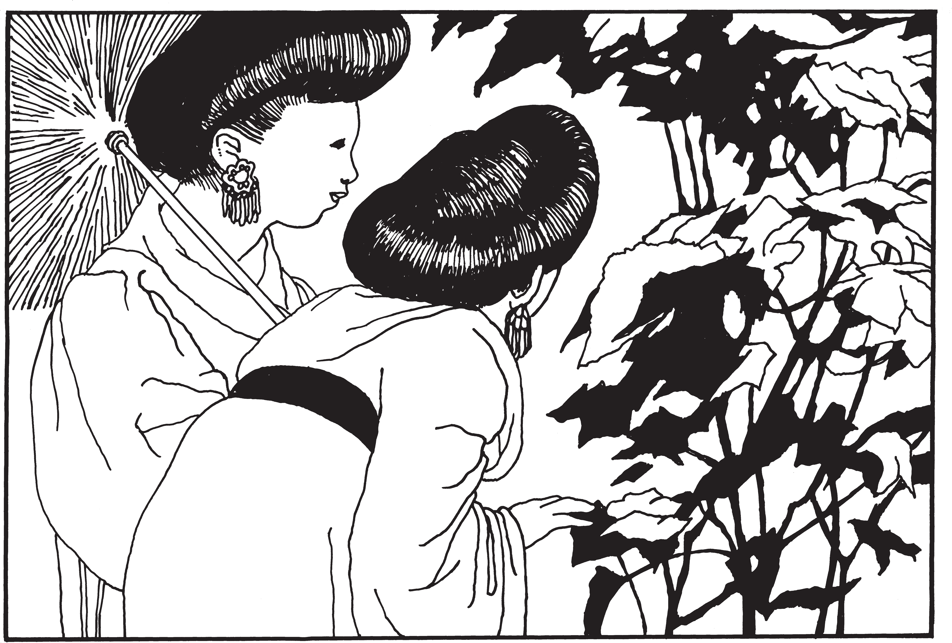

Appendix A / A Chinese Legend and the History of Silk
97

APPENDIX
A

The protective covering that these moth caterpillars spin soon became an elegant garment for Chinese royalty. During the next centuries, silk became very valuable. It was used as currency, as a reward for service to the emperor, as a ceremonial garb, and as a gift to foreign rulers. People around the world marveled at the rare fabric and wondered how it was made.
The Chinese kept the source of the beautiful cloth a secret. Chinese fabric makers were threatened with death if they told how the silk was made. But, finally, the secret got out. One story says that in the 6th century B.C., monks smuggled silkworm eggs from China to Constantinople in hollow walking sticks.

The History of Silk
Silk is produced in many places today, but the countries of China, Japan, India, and Italy are most famous for their silk. At one time, people wanted to raise
the caterpillars and produce silk in the United States. But there was a problem:
Mulberry trees don’t grow as well in the United States as they do in China, and silkworms only eat mulberry leaves—lots of them!
The first person to bring silkworms and mulberry trees to the United States was James Oglethorpe, founder of Savannah, Georgia. But, he had trouble growing enough mulberry trees to feed the caterpillars. Then, in 1869, a scientist near Boston brought some gypsy moths from Europe. He wanted to mate gypsy moths, which eat the leaves from many kinds of trees, with silkworm moths and get a silk-producing insect that would not be a picky eater. Unfortunately, the experiment became a disaster when the gypsy moths escaped from the laboratory.
Hungry gypsy moth caterpillars have been gobbling up the leaves on our forest trees ever since.
Today, no silkworms live in the wild. They are domesticated and kept in cages in spotless silkworm factories. After mating, one female moth may lay 300
to 500 eggs. These eggs can be kept in a refrigerator over the winter and then brought out to hatch in the spring.
Several times each day, workers give the caterpillars fresh, tender mulberry leaves. The caterpillars grow and molt four times.

STC™ / The Life Cycle of Butterflies
98

When they are ready to pupate, the caterpillars spin a silk cocoon, inside which they can become pupae.
Some of the pupae are allowed to turn into moths and mate and lay eggs for the next generation. But, most of the cocoons are soaked in hot water to
dissolve the sticky substance that cements the silk together. The silk unravels in a continuous thread and is wound onto spools to be spun, dyed, and woven. This all must be done before the pupa turns into a moth because, if the insect emerges from the cocoon, the strand of thread is broken into many pieces.
Many cocoons are needed to make cloth: 110 for a necktie, 630 for a blouse, and about 3,000 for a long kimono. Imagine how many worms it would take to spin the silk for a whole rack of dresses.
Notes: Some children may be upset by the fact that pupae are killed by the boiling water during the silk production process. Silkworm eggs or larvae can be purchased from biological supply houses. You may raise them in your classroom using fresh mulberry leaves or a synthetically produced food.

Appendix A / A Chinese Legend and the History of Silk
99

