The Life Cycle of Butterflies
Formative Assessment

Tab 5 / Formative Assessment 23

Q u e s t i o n 1 . 1
___ |  | DISCUSSION
nee  e lin | d  es | is  bel | o w | ,
nd | gr o | w.

Nam e____________________________ _ D_ _a_t _e_ _ _ _ _ _ _ ___________

All living things need things to liv e and gr o w. One a place w her e it is not too hot or too cold. On th list thr ee mor e things a cater pillar needs to liv e a

– – – – – – – – – – – – – – – – – – – – – – – – – – – – – – – – – – – – – – – – – – – – – – – – – – – – – – – – –
1.

– – – – – – – – – – – – – – – – – – – – – – – – – – – – – – – – – – – – – – – – – – – – – – – – – – – – – – – – –
2.

– – – – – – – – – – – – – – – – – – – – – – – – – – – – – – – – – – – – – – – – – – – – – – – – – – – – – – – – –
3.

Cater pillar s r epr esent one stage of a butter fly’ s lif e c ycle.
STC™ / The Life Cycle of Butterflies S u b c o n c e p t 1 / Q u e s t i o n

Question 1.2
Name

Date
DISCUSSION

Write the letter or letters of the caterpillar body part next to what that body part does.

- Prolegs

- Mouth

- True Legs

- Spiracles

- Simple Eyes

- Bristles

STC™ / The Life Cycle of Butterflies

Caterpillars represent one stage of a butterfly’s life cycle.
- helps the caterpillar move

- lets the caterpillar see dark and light

- chews food and spins silk

- keeps birds from eating the caterpillar

- lets the caterpillar breathe

- helps the caterpillar hold on to smooth surfaces

Subconcept 1 / Question 2

Question 1.3
Name

Date
DISCUSSION

Look at the caterpillar in the box. Label as many body parts as you can. Use the Word Bank to help you.
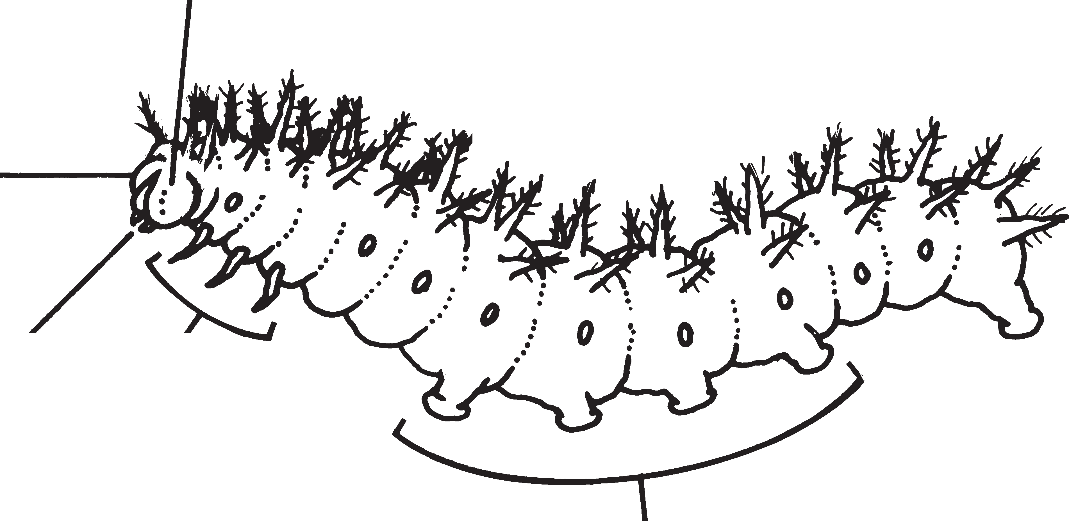
simple eyes
prolegs
mouth
spiracles
bristles
head
Word Bank:
true legs

Caterpillars represent one stage of a butterfly’s life cycle.
STC™ / The Life Cycle of Butterflies Subconcept 1 / Question 3

Q u e s t i o n 1 . 4
___ |  | DISCUSSION
.

Nam e____________________________ _ D_ _a_t _e_ _ _ _ _ _ _ ___________

T ell w h y the cater pillar m ust molt in or der to gr o w Then, tell ho w molting ha ppens .

– – – – – – – – – – – – – – – – – – – – – – – – – – – – – – – – – – – – – – – – – – – – – – – – – – – – – – – – –

– – – – – – – – – – – – – – – – – – – – – – – – – – – – – – – – – – – – – – – – – – – – – – – – – – – – – – – – –

– – – – – – – – – – – – – – – – – – – – – – – – – – – – – – – – – – – – – – – – – – – – – – – – – – – – – – – – –

– – – – – – – – – – – – – – – – – – – – – – – – – – – – – – – – – – – – – – – – – – – – – – – – – – – – – – – – – –

– – – – – – – – – – – – – – – – – – – – – – – – – – – – – – – – – – – – – – – – – – – – – – – – – – – – – – – – –

– – – – – – – – – – – – – – – – – – – – – – – – – – – – – – – – – – – – – – – – – – – – – – – – – – – – – – – – –

Cater pillar s r epr esent one stage of a butter fly’ s lif e c ycle.
STC™ / The Life Cycle of Butterflies S u b c o n c e p t 1 / Q u e s t i o n

Question 1.5
Name

Date
DISCUSSION

Why does a caterpillar spin silk? Circle the letter of any correct answer.
- To make a bridge or pathway for crawling
- To protect itself
- To prepare for molting
- To make a place to rest

Caterpillars represent one stage of a butterfly’s life cycle.
STC™ / The Life Cycle of Butterflies Subconcept 1 / Question 5

Question 2.1
Name

Date
DISCUSSION

Read the steps for a caterpillar’s change into a chrysalis. Then, put them in the correct order by writing the letters on the lines below.
- The larva crawls to the lid of the cup.
- The silk splits along the caterpillar’s back.
- The larva stops eating.
- The larva spins a button on the lid.
- The larva hangs head-down in a J-shape.
- The chrysalis forms and hardens.

Step 1:

Step 2:

Step 3:
Step 4:

Step 5:

Step 6:

As a part of its life cycle, the butterfly forms and emerges from a chrysalis.
STC™ / The Life Cycle of Butterflies Subconcept 2 / Question 1

Question 2.2
Name

Date
 |  | DISCUSSION
hrysalis | .

Inside the chrysalis, the caterpillar is changing into a butterfly.
The picture shows the parts of a butterfly that can be seen
in the chrysalis. Use the Word Bank below to label the picture.
Word Bank: proboscis wings abdomen antennae eyes

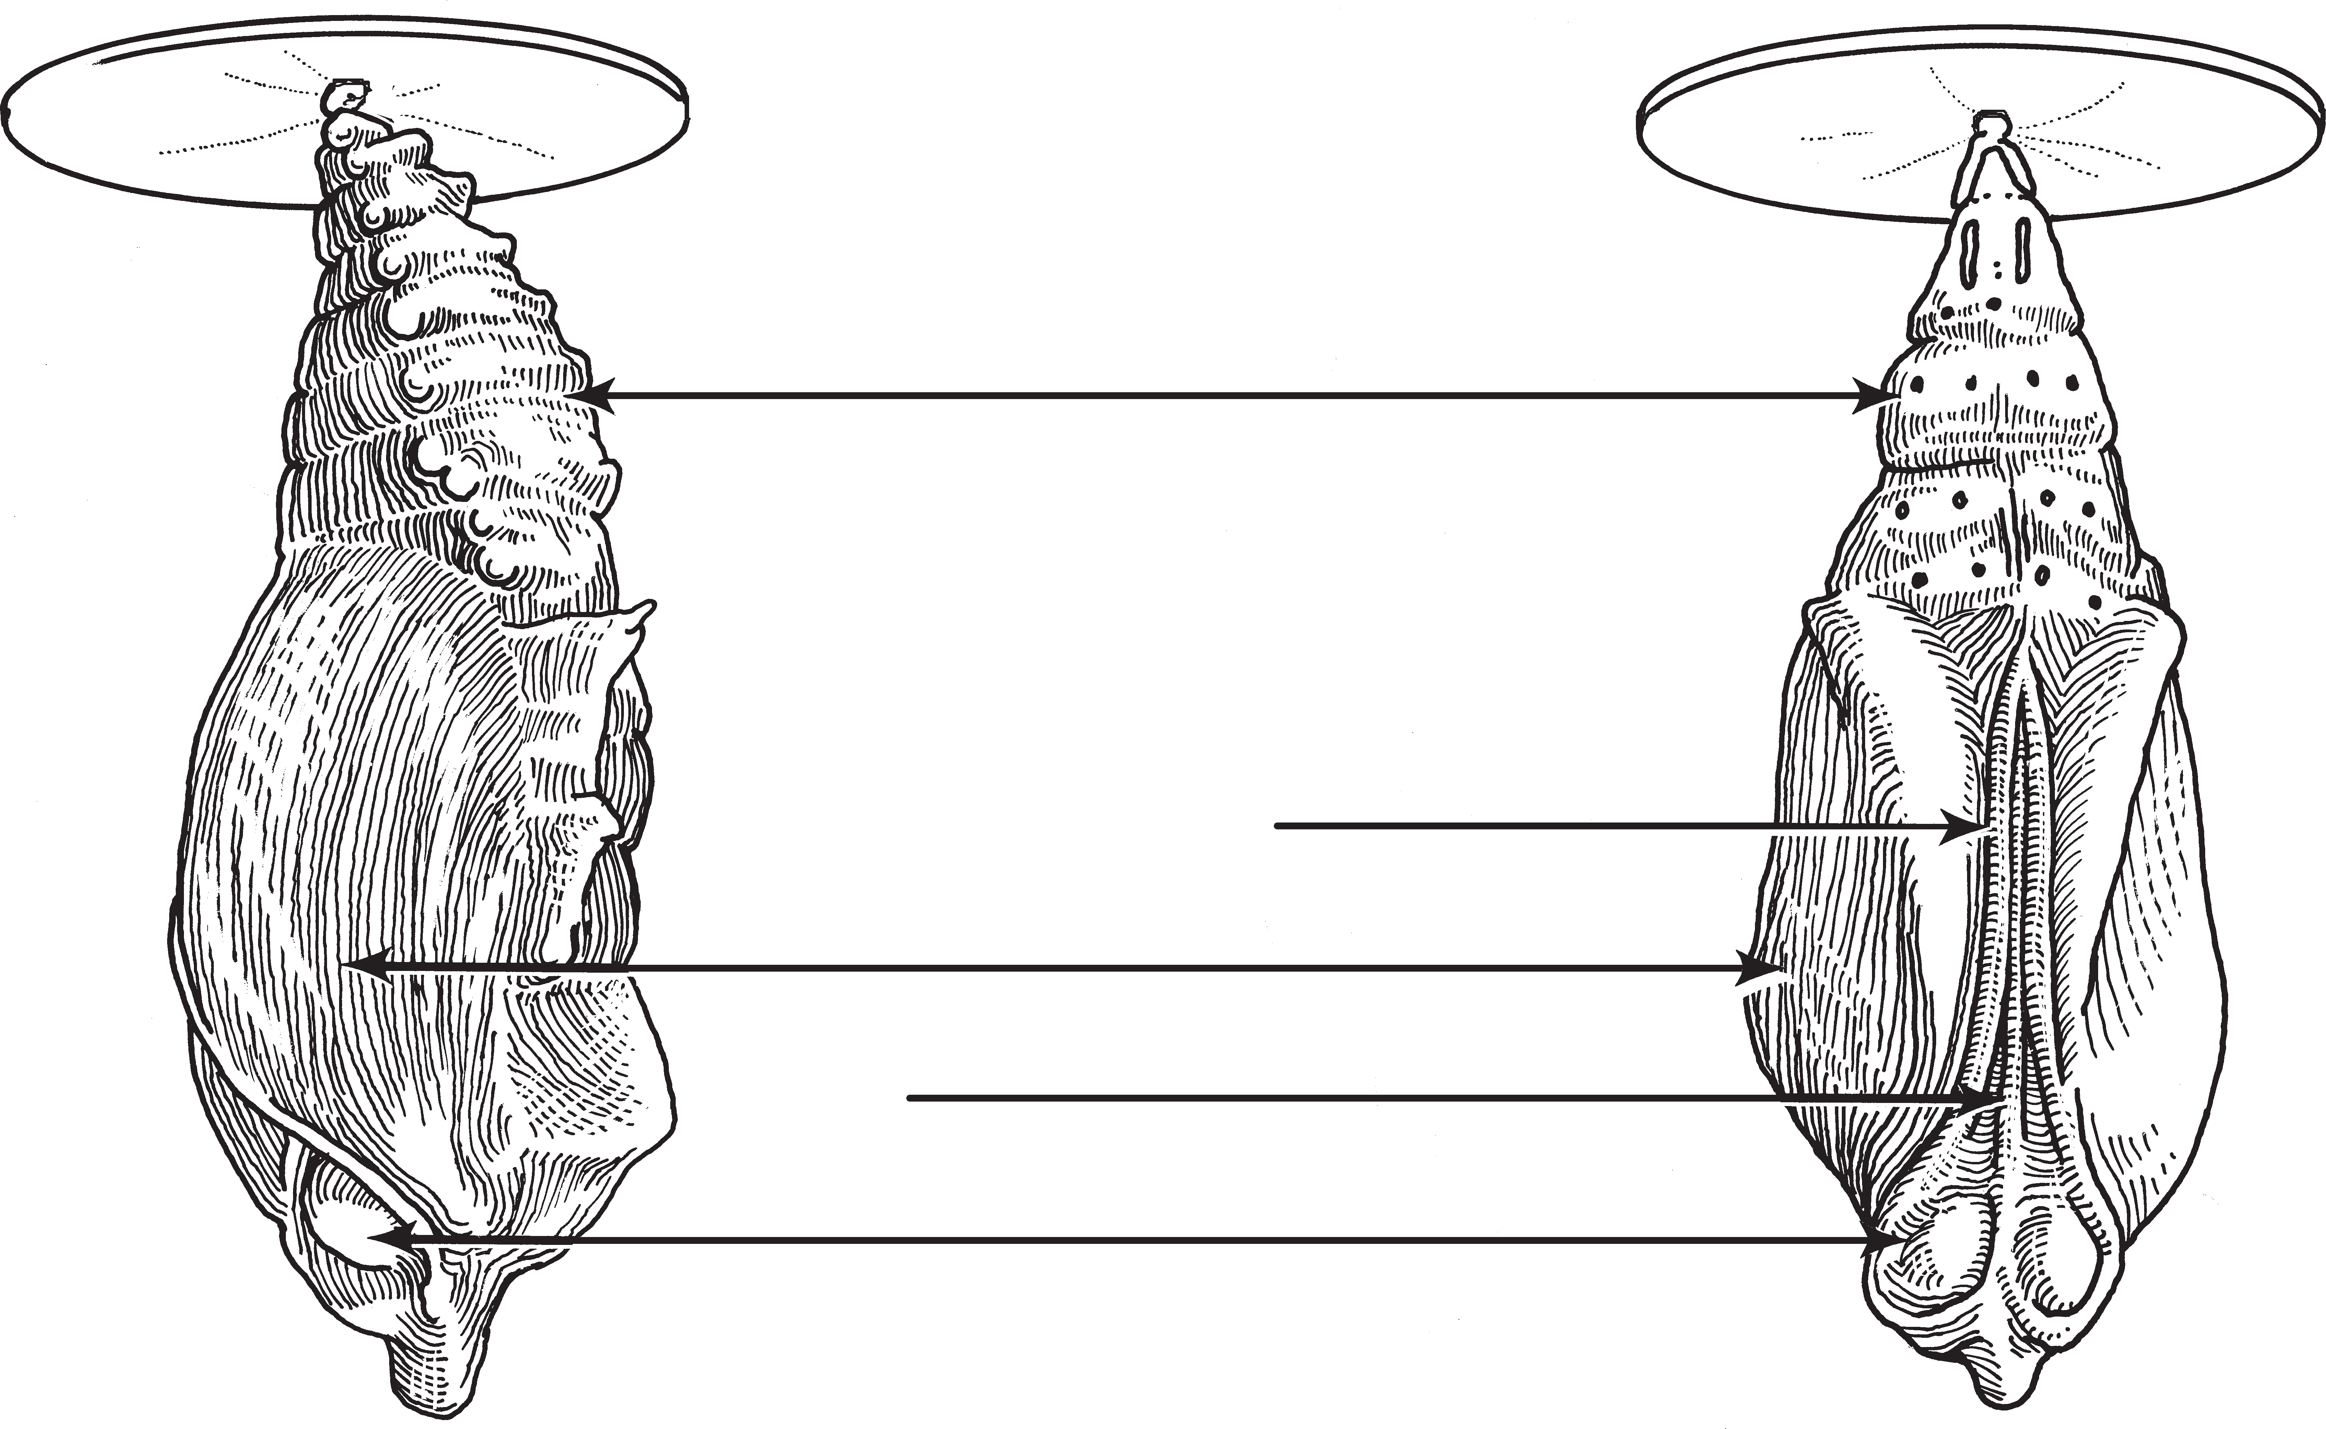

c

As a part of its life cycle, the butterfly forms and emerges from a

STC™ / The Life Cycle of Butterflies Subconcept 2 / Question 2

Question 2.3
Name

Date
DISCUSSION

Put the pictures in the correct order to show the butterfly’s life cycle.
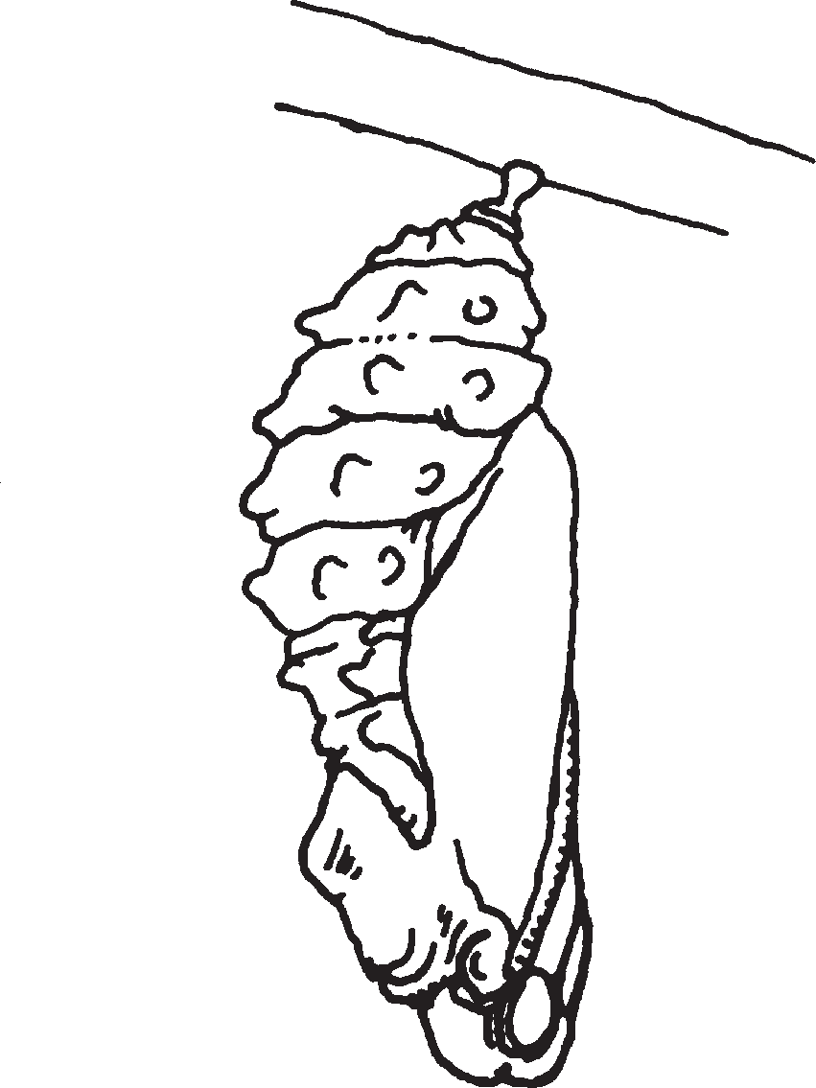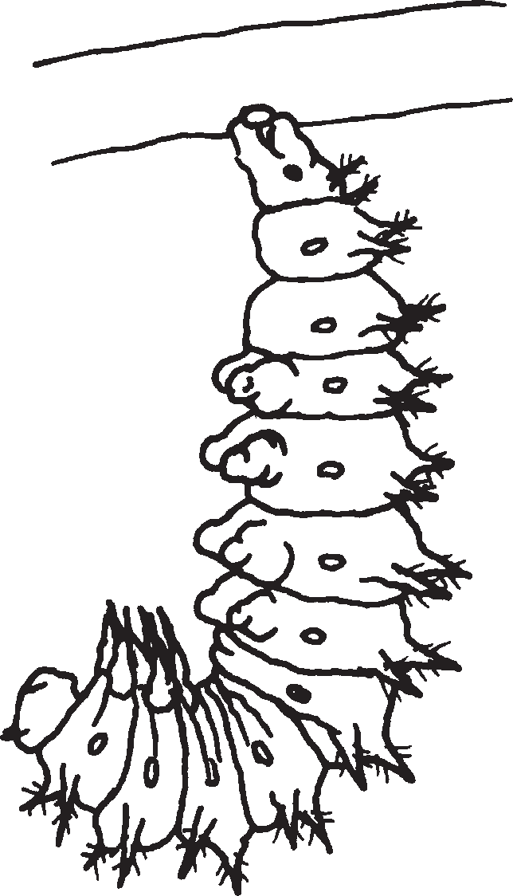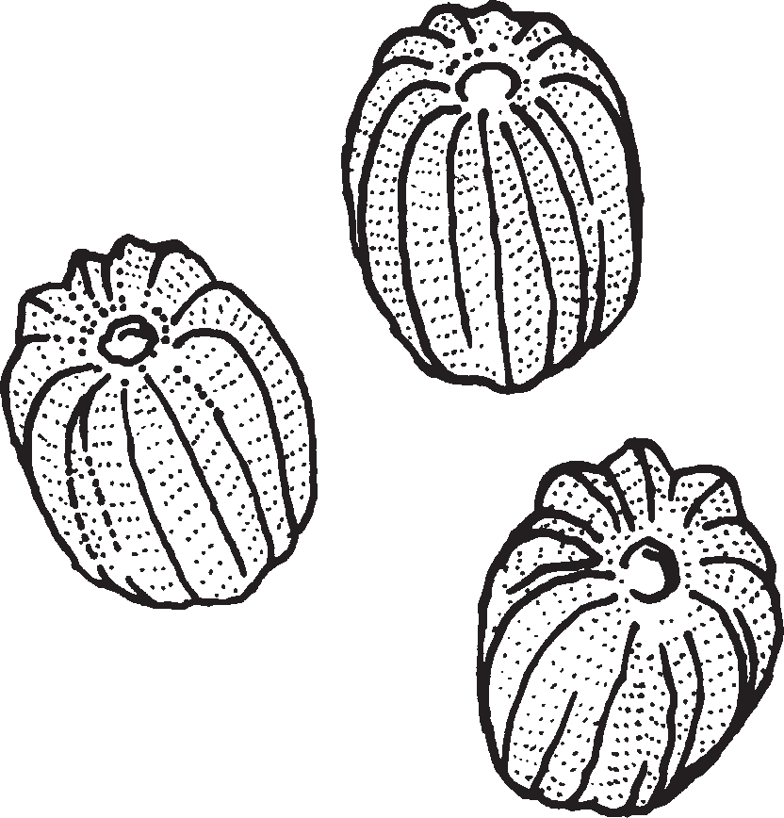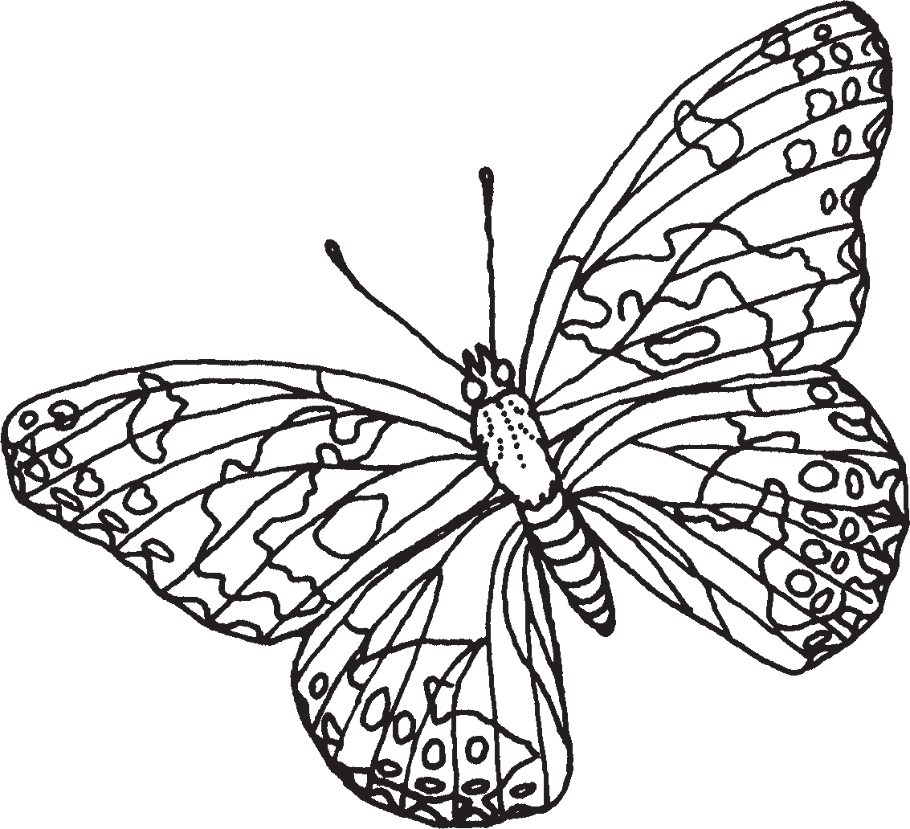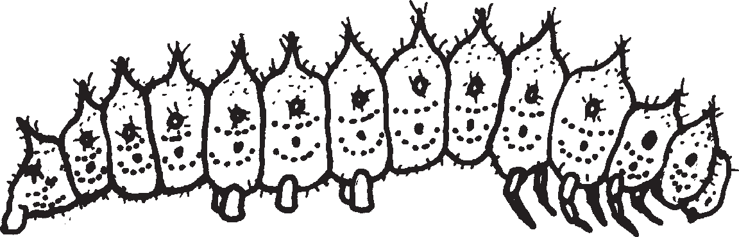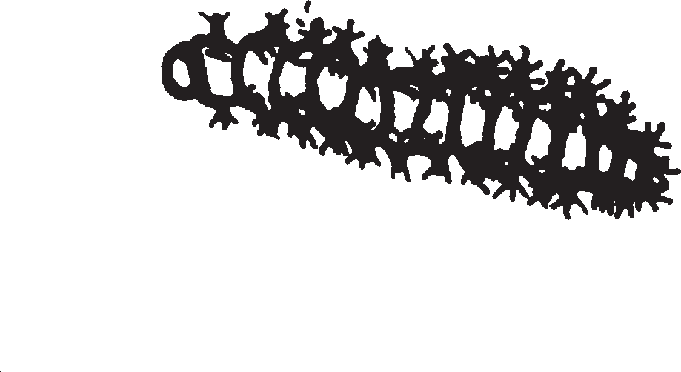

A

B

C

D

E

F

Step 1:

Step 2:

Step 3:
Step 4:

Step 5:

Step 6:

As a part of its life cycle, the butterfly forms and emerges from a chrysalis.
STC™ / The Life Cycle of Butterflies Subconcept 2 / Question 3

Question 2.4
Name

Date
DISCUSSION

The chrysalis stage of your butterfly’s life cycle lasted about
- one day.
- one week.
- one month.
- one year.

As a part of its life cycle, the butterfly forms and emerges from a chrysalis.
STC™ / The Life Cycle of Butterflies Subconcept 2 / Question 4

Q u e s t i o n 2 . 5
___ |  | DISCUSSION
st  w h | y
hr ys | alis | .

Nam e____________________________ _ D_ _a_t _e_ _ _ _ _ _ _ ___________

When a butter fl y comes out of the chr ysalis , it m u stay still f or a f e w hour s . Wr ite a sentence telling the butter fl y m ust stay still.

– – – – – – – – – – – – – – – – – – – – – – – – – – – – – – – – – – – – – – – – – – – – – – – – – – – – – – – – –

– – – – – – – – – – – – – – – – – – – – – – – – – – – – – – – – – – – – – – – – – – – – – – – – – – – – – – – – –

– – – – – – – – – – – – – – – – – – – – – – – – – – – – – – – – – – – – – – – – – – – – – – – – – – – – – – – – –

– – – – – – – – – – – – – – – – – – – – – – – – – – – – – – – – – – – – – – – – – – – – – – – – – – – – – – – – –

– – – – – – – – – – – – – – – – – – – – – – – – – – – – – – – – – – – – – – – – – – – – – – – – – – – – – – – – –

a c

As a par t of its lif e c ycle, the butter fl y f or ms and emer ges fr om

STC™ / The Life Cycle of Butterflies S u b c o n c e p t 2 / Q u e s t i o n

Q u e s t i o n 3 . 1
___ |  | DISCUSSION
ings
oo
utte | r fl | y
e fun | ctio | ns .

Nam e____________________________ _ D_ _a_t _e_ _ _ _ _ _ _ ___________

Lik e the cater pilla r , the butter fl y needs cer tain th to liv e. One is a place w her e it is not too hot or t cold. On the lines belo w, list thr ee mor e things a b needs to liv e.

– – – – – – – – – – – – – – – – – – – – – – – – – – – – – – – – – – – – – – – – – – – – – – – – – – – – – – – – –
1.

– – – – – – – – – – – – – – – – – – – – – – – – – – – – – – – – – – – – – – – – – – – – – – – – – – – – – – – – –
2.

– – – – – – – – – – – – – – – – – – – – – – – – – – – – – – – – – – – – – – – – – – – – – – – – – – – – – – – – –
3.

lif

The str uctur es of a butter fl y pr o vide the means f or its essential

STC™ / The Life Cycle of Butterflies S u b c o n c e p t 3 / Q u e s t i o n

Question 3.2
Name

Date
DISCUSSION

Write the letter or letters of the butterfly body part next to what the body part does to help the butterfly live.
- Legs 1. helps the butterfly find food
- Antennae 2. helps the butterfly move
- Proboscis 3. lets the butterfly see colors
- Wings 4. lets the butterfly eat
- Compound Eyes 5. lets the butterfly touch and smell
6. lets the butterfly taste

The structures of a butterfly provide the means for its essential life functions.
STC™ / The Life Cycle of Butterflies Subconcept 3 / Question 2

Question 3.3
Name

Date
DISCUSSION

Look at the side-view picture of a butterfly in the box. Label as many parts as you can. Use the words in the Word Bank to help you.
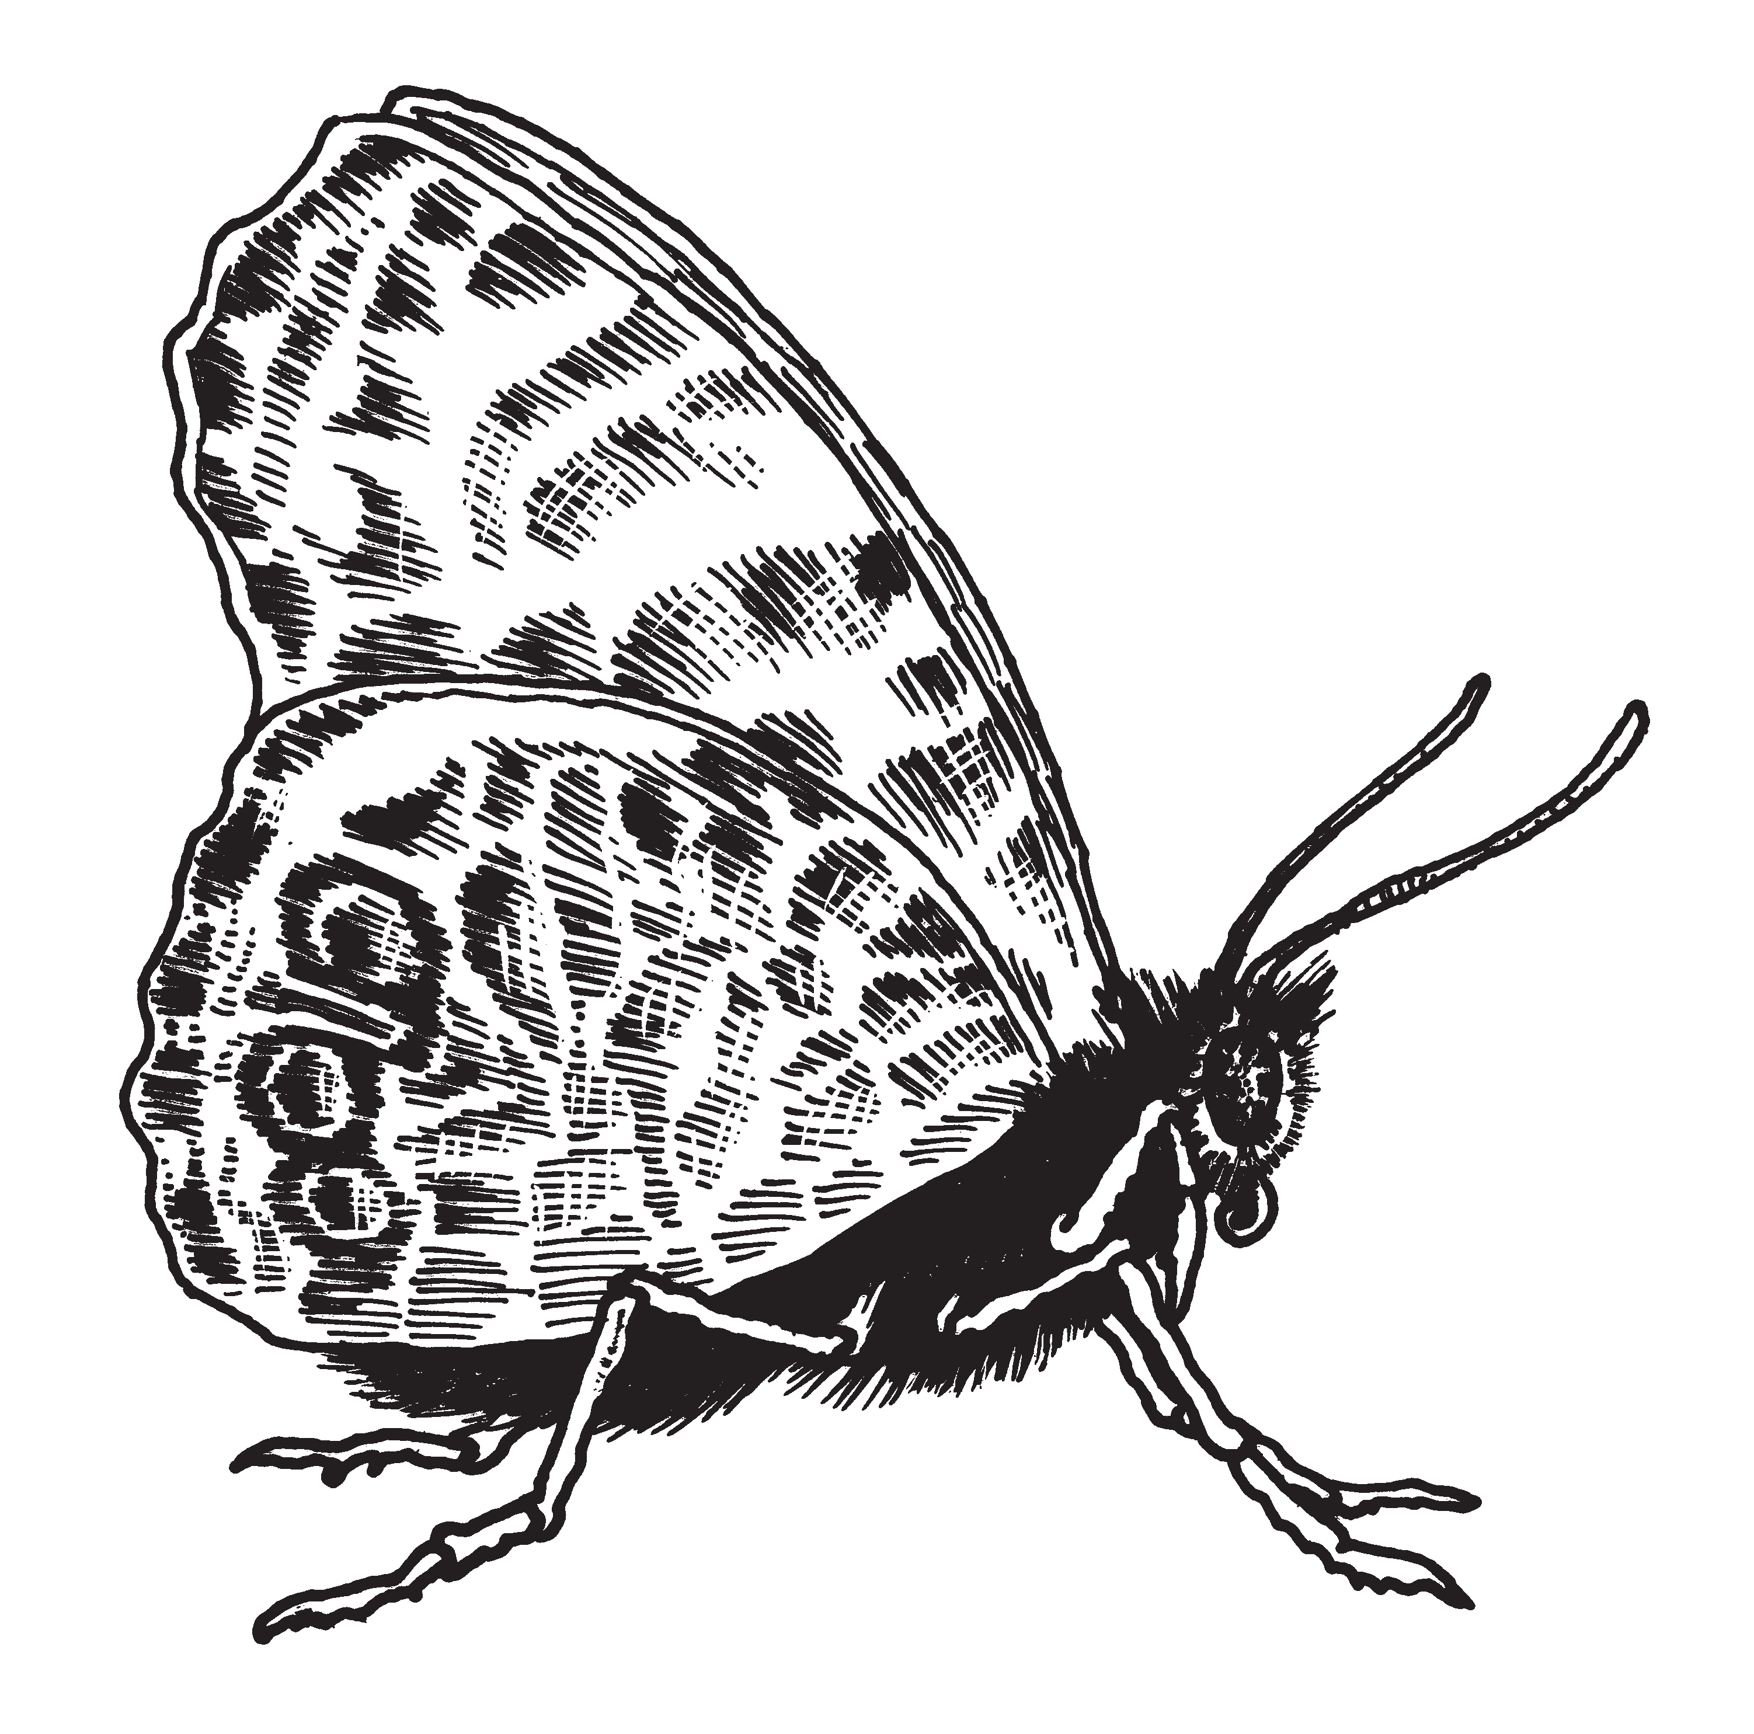
Word Bank: abdomen antennae thorax head
compound eyes legs
proboscis wings

The structures of a butterfly provide the means for its essential life functions.

STC™ / The Life Cycle of Butterflies Subconcept 3 / Question 3

Question 3.4
Name

Date
DISCUSSION

Draw the proboscis of a butterfly on both drawings. Draw the proboscis in each picture in the correct position for eating or not eating.

Butterfly NOT eating Butterfly Eating
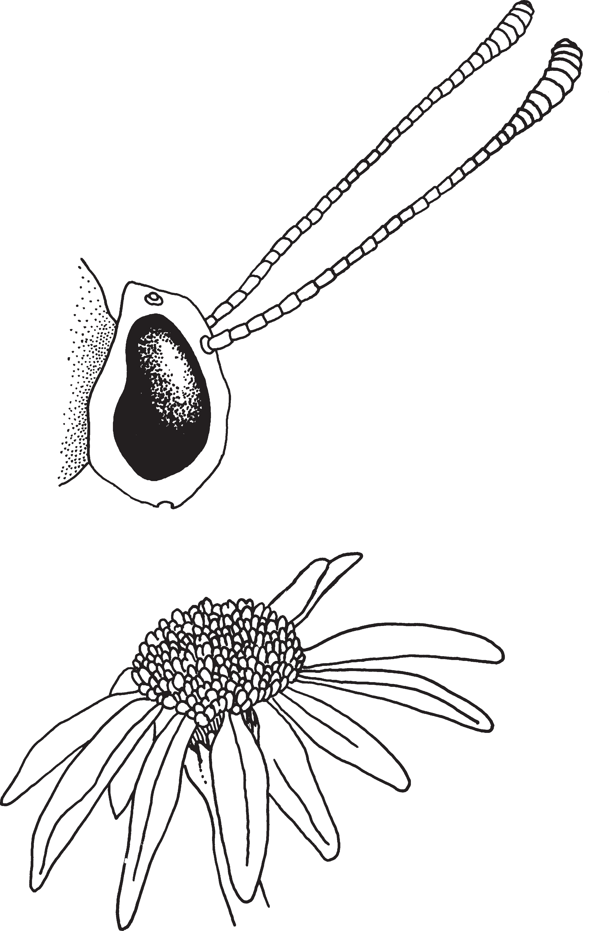

The structures of a butterfly provide the means for its essential life functions.
STC™ / The Life Cycle of Butterflies Subconcept 3 / Question 4

Question 3.5
Name

Date
DISCUSSION

Fill in the blanks to complete the sentences.

Word Bank: | plants | mouth | compound eyes | fluid
antennae | move | leaves | spiracles | eat
simple eyes | eyes | legs | eliminate waste | nectar

- A caterpillar and butterfly both have .

- A caterpillar and butterfly are also alike because they both can .
- The caterpillar and butterfly are different because the caterpillar’s food is and the butterfly’s food is .
- The caterpillar and butterfly are different because the caterpillar sees with and the butterfly sees with .

The structures of a butterfly provide the means for its essential life functions.
STC™ / The Life Cycle of Butterflies Subconcept 3 / Question 5

Question 4.1
Name

Date
DISCUSSION

Circle the letter of any true sentence.
- The larva stage (caterpillar) lasts 12 days.
- The adult stage (butterfly) lasts 2 weeks.
- The shortest stage in a butterfly’s life cycle is for the egg to become a caterpillar.
- The longest stage is the pupa (chrysalis) stage.
- The larva stage (caterpillar) and the pupa stage (chrysalis) are about the same length of time.

Scientists use data on organisms’ structures and life cycles to understand and classify living things.
STC™ / The Life Cycle of Butterflies Subconcept 4 / Question 1

Question 4.2
Name

Date
DISCUSSION

Complete the following sentences by filling in the blanks.

  - Butterflies and spiders are different because butterflies belong in a group called .
  - People and butterflies have a different number of legs. People have
legs, while butterflies have legs.

  - Butterflies and people are alike because they both can .

  - Insects and people are alike because they both have .

  - Insects have legs, while spiders have legs.

  - Insects and spiders are alike because they both have .

  - Insects and spiders are different because insects have main body sections, while spiders have main body sections.
  - Butterflies, spiders, and people are alike because each
needs and .

  - People, butterflies, and spiders are alike because each has
.

  - Spiders, people, and butterflies are alike because each is able to
.
Scientists use data on organisms’ structures and life cycles to understand and classify living things.
STC™ / The Life Cycle of Butterflies Subconcept 4 / Question 2

Question 4.3
Name

Date
DISCUSSION

About how long is the drawing of the caterpillar shown below, in millimeters?
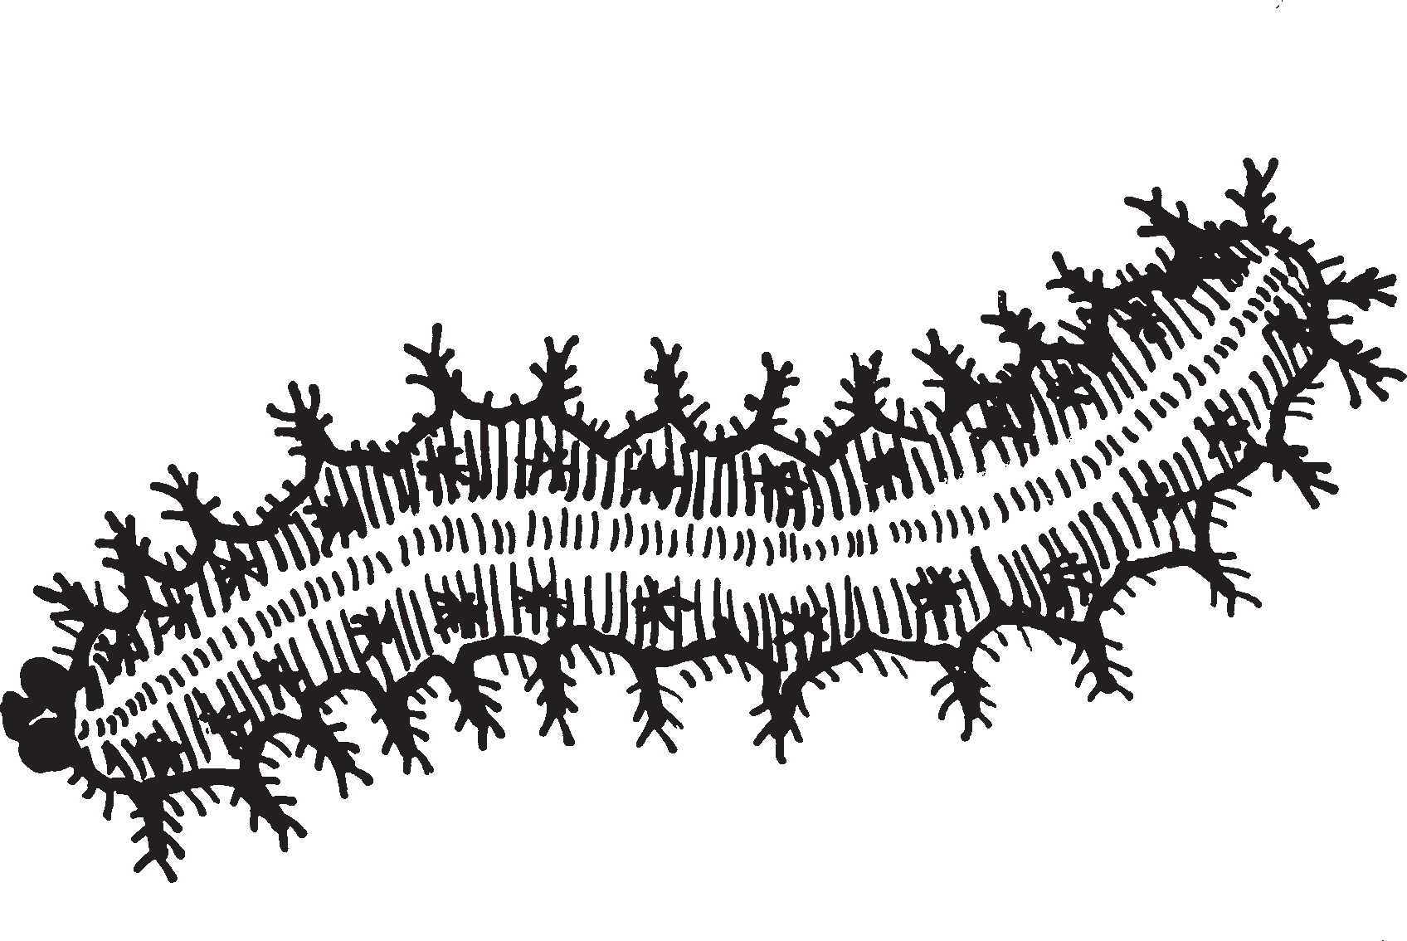

The caterpillar is about millimeters long.

Scientists use data on organisms’ structures and life cycles to understand and classify living things.
STC™ / The Life Cycle of Butterflies Subconcept 4 / Question 3

Question 4.4
Name

Date
DISCUSSION

On the blanks, write T for sentences that are true and F for sentences that are false.

1. Living things have a life cycle.

2. Living things need food and water.

3. Insects have 8 legs.

4. All living things have the same life cycle.

5. All living things can be grouped by structures (parts).

6. All living things have a mouth.

7. Some insects spin silk from the head body section.

8. Caterpillars have 15 segments.

9. Butterflies have simple eyes.

10. Insects have antennae.

Scientists use data on organisms’ structures and life cycles to understand and classify living things.
STC™ / The Life Cycle of Butterflies Subconcept 4 / Question 4

Question 4.5
Name

Date
DISCUSSION

A caterpillar starts its life cycle as an egg and ends as an adult. Think of another living thing that starts as an egg or seed. In the box, draw the life cycle of that living thing and put its name on the line.

The living thing whose life cycle I am drawing is

.

Scientists use data on organisms’ structures and life cycles to understand and classify living things.
STC™ / The Life Cycle of Butterflies Subconcept 4 / Question 5

