Lesson 10
Activity Sheet 9

– – – – – – – – – – – – – – – – – – – – – – – – – – – – – – – – – – – – – – – – – –
Name

– – – – – – – – – – – – – – – – – – – – – – – – – – – – – – – – – – – – – – – – – –
Date

67

Butterflies Need Food

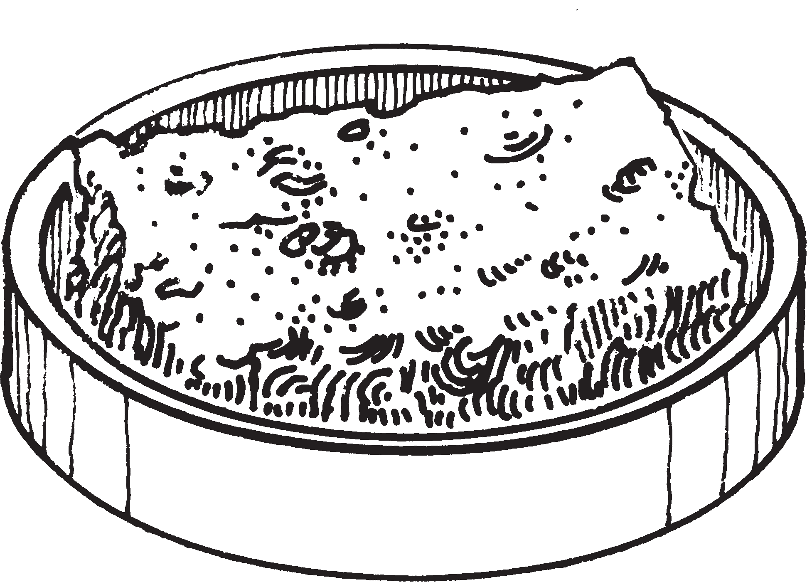
The butterflies will want to eat
They will stand on the sponge and drink the sugar water The sponge will get dry
Add more sugar water to the sponge every day

What will the butterflies eat outside?

– – – – – – – – – – – – – – – – – – – – – – – – – – – – – – – – – – – – – – – – – – – – – – – – – – – – – – – – – – – – – – – – – – – –

– – – – – – – – – – – – – – – – – – – – – – – – – – – – – – – – – – – – – – – – – – – – – – – – – – – – – – – – – – – – – – – – – – – –

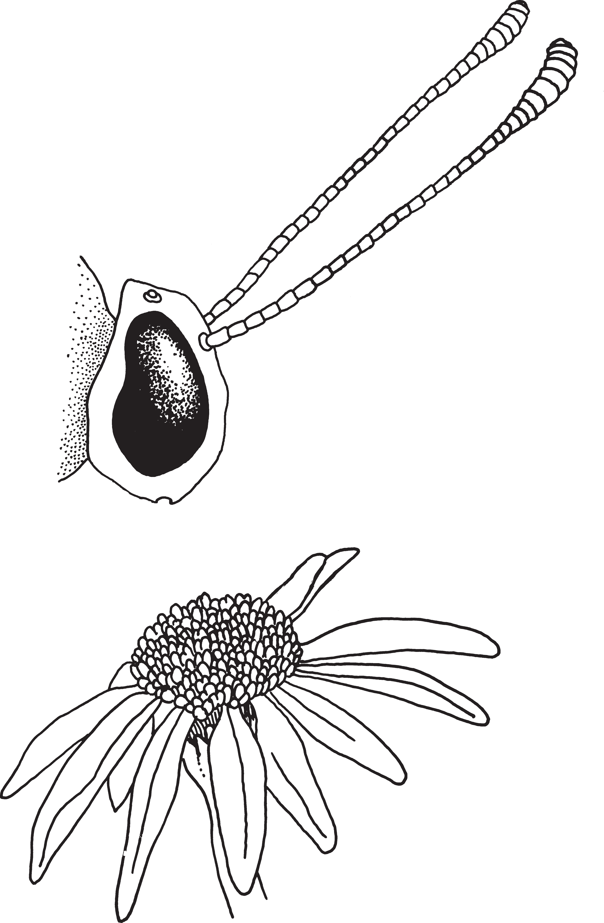
The butterfly has a long tube for a mouth The tube is called a proboscis
Draw the proboscis on this butterfly

Lesson 10 / Feeding the Butterflies

