# Lesson 14

**Activity Sheet 12**

– – – – – – – – – – – – – – – – – – – – – – – – – – – – – – – – – – – – – – – – – –

Name

– – – – – – – – – – – – – – – – – – – – – – – – – – – – – – – – – – – – – – – – – –

Date

## Look at this drawing of a butterfly Count how many a butterfly has:

Legs

Antennae

Wings

Main body sections

**Are Butterflies Insects?**

**Head**

**Thorax**

**Wings**

**Legs**

**Eye**

**Proboscis Antennae**

**Abdomen**

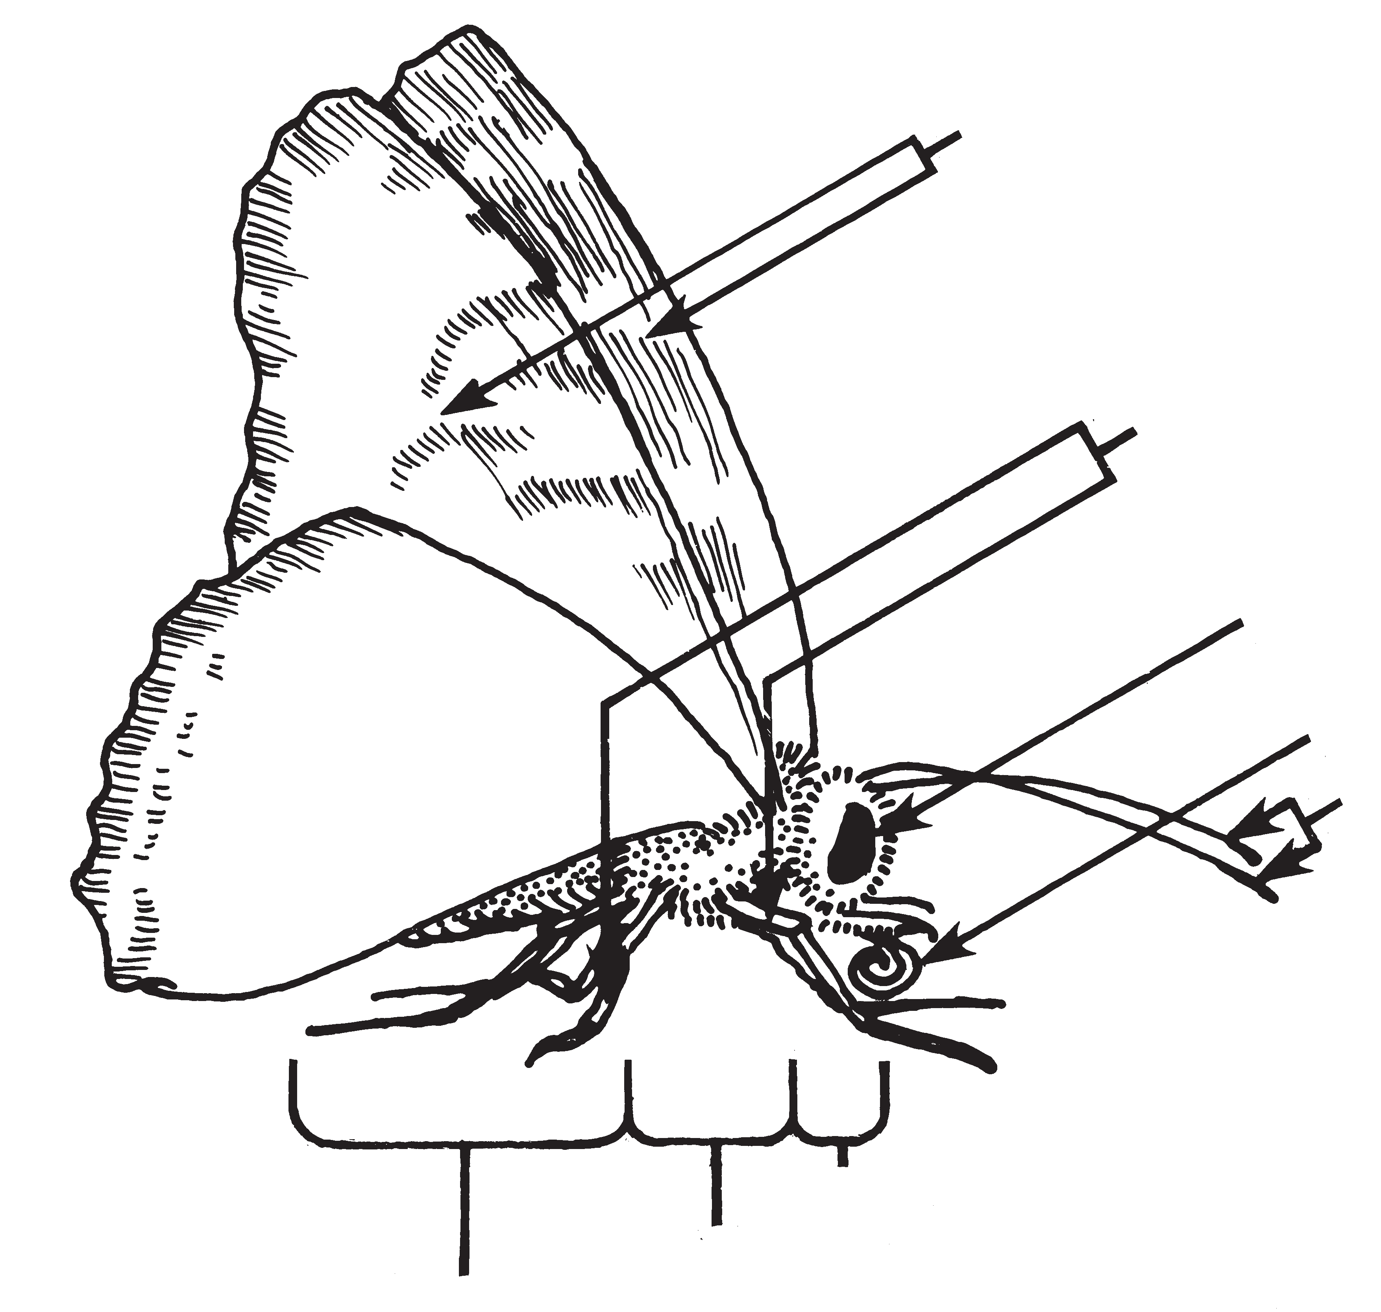 – – – – – – – – – – – – – – – – – – – – – – – – – – – – –

## Is the butterfly an insect?

Look at this drawing of a spider Count how many a spider has:

Legs

Antennae

Wings

Main body sections

**Head and Thorax**

**Abdomen**

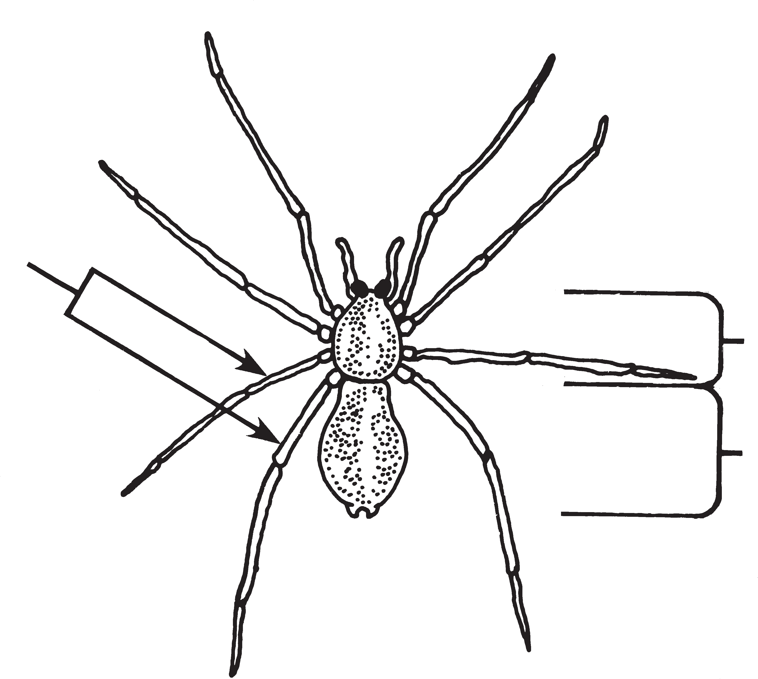

**Legs**

**88**

– – – – – – – – – – – – – – – – – – – – – – – – – – – – –

## Is the spider an insect?

STC™ / The Life Cycle of Butterflies