Lesson 2
Activity Sheet 1 Caterpillar Food

– – – – – – – – – – – – – – – – – – – – – – – – – – – – – – – – – – – – – – – – – –
Name

16

– – – – – – – – – – – – – – – – – – – – – – – – – – – – – – – – – – – – – – – – –

Write the date the caterpillars arrived:

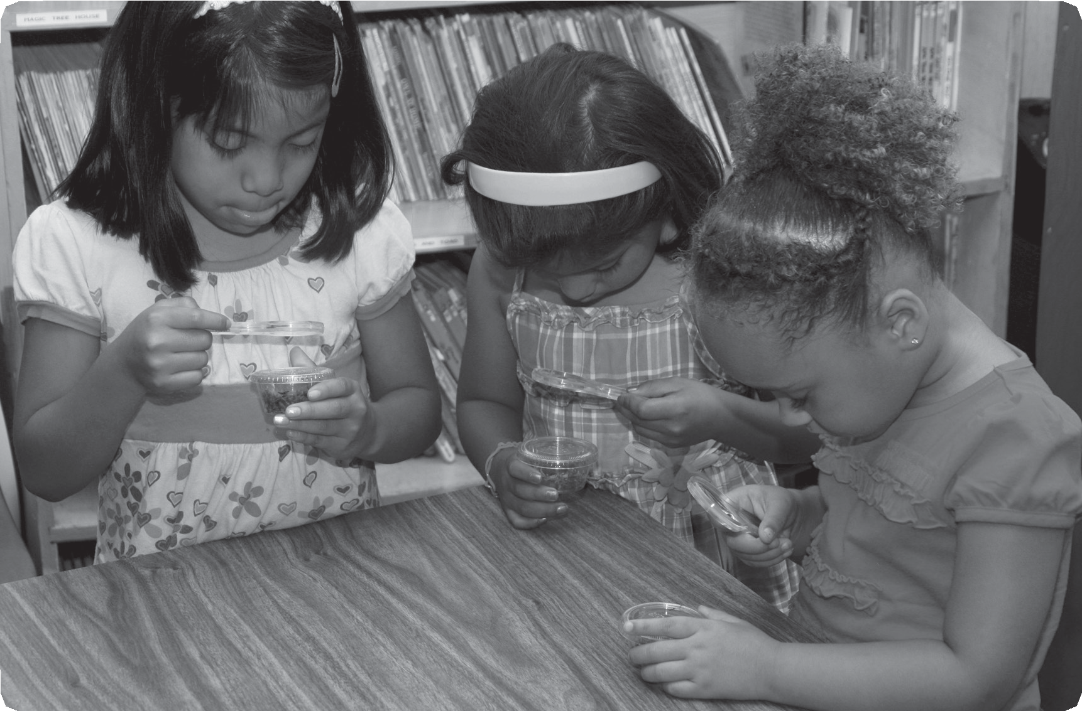
Look closely at the caterpillar’s food Then answer the questions below

How does the food feel?

– – – – – – – – – – – – – – – – – – – – – – – – – – – – – – – – – – – – – – – – – – – – – – – – – – – – – – – – – – – – – – – – – –

How does the food smell?

– – – – – – – – – – – – – – – – – – – – – – – – – – – – – – – – – – – – – – – – – – – – – – – – – – – – – – – – – – – – – – – – – –

How does the food look?

– – – – – – – – – – – – – – – – – – – – – – – – – – – – – – – – – – – – – – – – – – – – – – – – – – – – – – – – – – – – – – – – – –

STC™ / The Life Cycle of Butterflies

Lesson 2
17
Activity Sheet 1

The food is made from a plant called mallow
This is a mallow plant It has green leaves and light purple flowers You can color the mallow plant

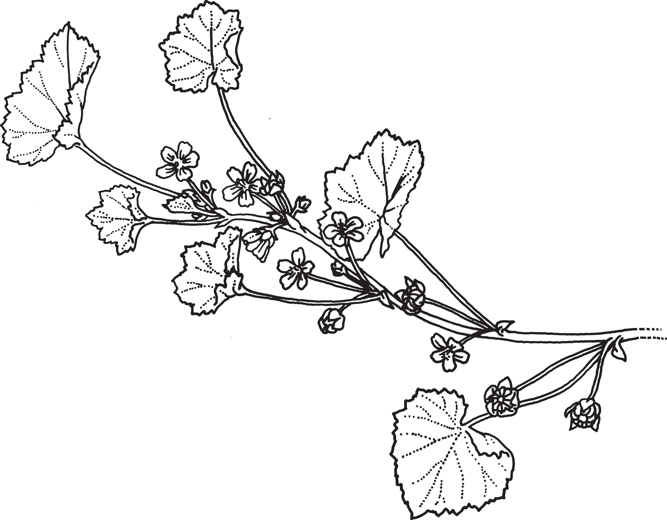

Lesson 2 / Caring for Caterpillars

