Lesson 7
Activity Sheet 6

– – – – – – – – – – – – – – – – – – – – – – – – – – – – – – – – – – – – – – – – – –
Name

– – – – – – – – – – – – – – – – – – – – – – – – – – – – – – – – – – – – – – – – – –
Date

45

What Happens to the Caterpillar?

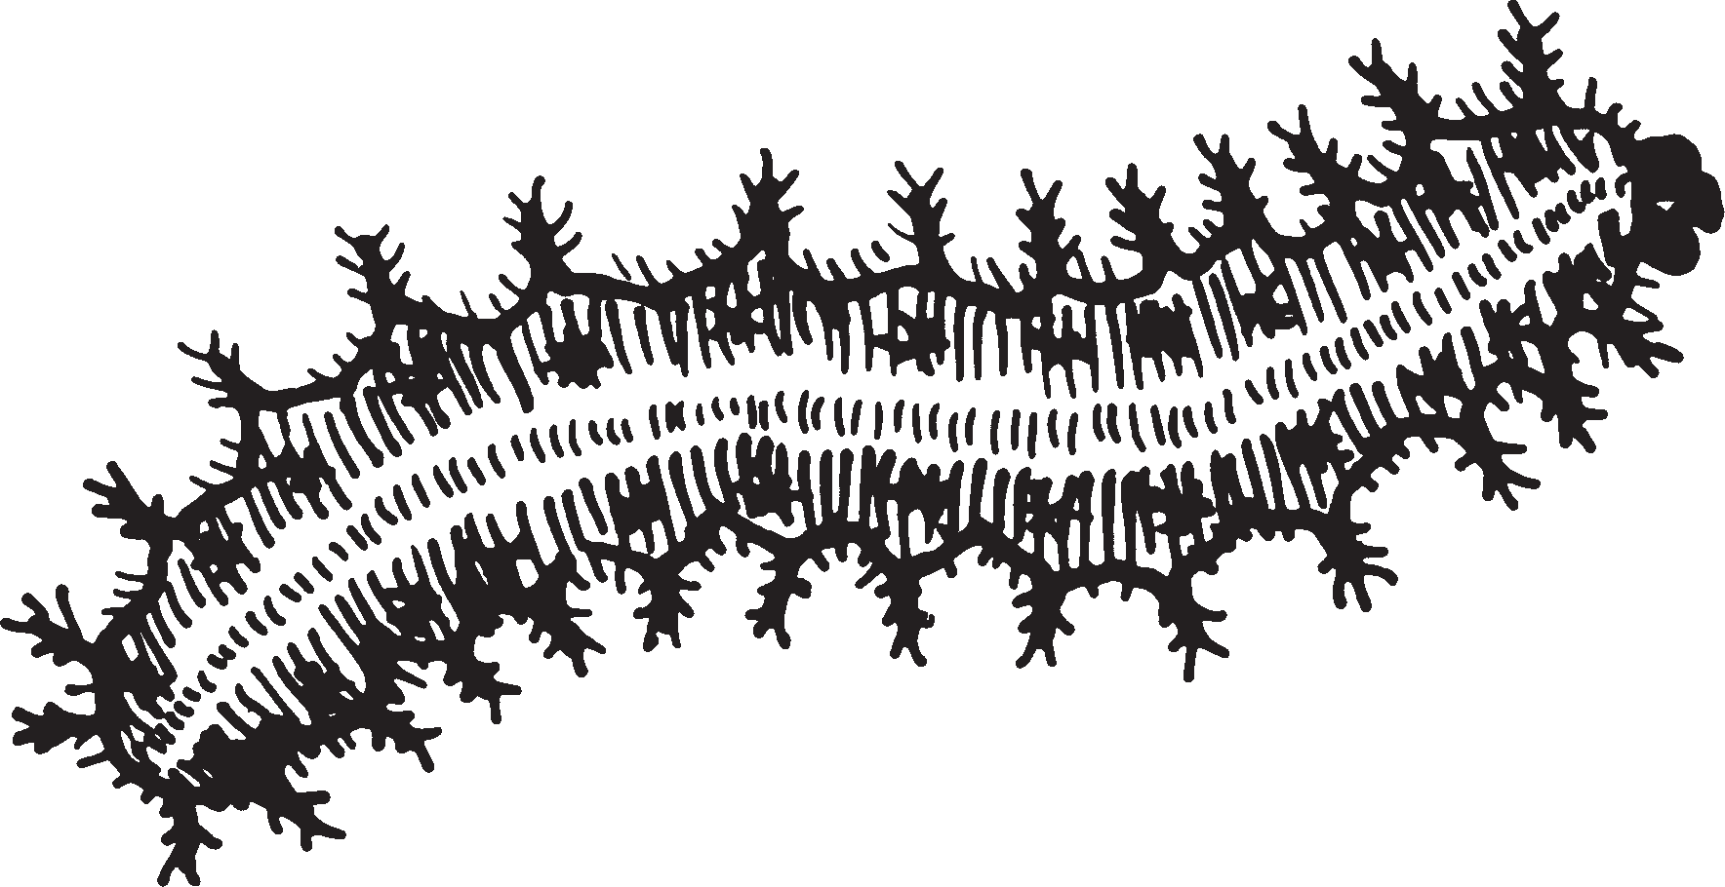Watch your caterpillar carefully when it gets to be this big

The caterpillar will crawl to the top of the cup and spin a strong silk button Then it will hang upside down from the button It will hang in a J-shape Draw your caterpillar hanging in a J-shape

Next, the silk splits along the caterpillar’s back After the last molt, you will see the chrysalis

Soon the chrysalis will become hard Then it is time for you to put your chrysalis in a new cage Write the date when the chrysalis appeared:

– – – – – – – – – – – – – – – – – – – – – – – – – – – – – – – – – – – – – – – –

Lesson 7 / From Caterpillar to Chrysalis

