LIGHT QUANTA AND THE PHOTOELECTRIC EFFECT

LAB LIGH 8

From: Institute of Chemical Education LED Color Strip Kit, 2002 PASCO Physics Catalog and Equipment Guide, 2005

INTRODUCTION
The photoelectric effect occurs when a light beam is incident on a metal surface causing electrons to be ejected from the surface. The long held wave theory of light; even for light of high intensity, was inadequate to explain the phenomenon. In 1905 Albert Einstein, a little known patent office clerk, published a paper on the photoelectric effect postulating a “quantum” explanation in which light can be considered as a stream of particles called photons. This extended Planck’s quantization of energy hypothesis, which he had proposed for understanding and interpreting the experimentally obtained blackbody spectral-distribution curves of radiation power versus wavelength.

These photons were to be understood as individually interacting with the electrons of the metal surface of incidence and having energy, proportional to their frequency given by Planck’s constant h and times the frequency f, (hf). With enough photon energy, that is high enough frequency to remove electrons from the metal—energy exceeding the metal’s work function; the photoelectric effect occurs with electrons being ejected from the metal.

The source of photons analyzed in this experiment are emitted by light emitting diodes (LEDs), which are devices made from a class of solids called semiconductors—with electrical conductivity between that of a metal and an insulator. These light emitting diodes have p-n junctions which involve energy bands and gaps in solids. The carriers (electrons and holes) are injected across the junctions producing the light. Rather than light commonly produced from thermal excitation, the photons are emitted having rather specific energies corresponding quite closely to the energy difference, Egap,
involved between the higher to lower energy bands of transition for the particular LED.

Theoretically, the photoelectric effect with light incident on a metal surface and electrons ejected can be expressed by

Ek = eV0 = hf
− W0
(1)

where Ek is the kinetic energy of the electrons, e is the electron unit charge, V0 is the stopping potential or voltage, h is Planck’s constant, f is the light photon frequency, and W0 is the metal work function.

For this experiment with LEDs used as the source of the light photons, the energy gap of the semiconductor in an LED is related to the threshold voltage of the LED and to the energy of the light emitted by it. The relationship can be approximately expressed as

eVthreshold
= Egap
= Elight

(2)

where e is again the electron unit charge, Vthreshold is the voltage needed for light emission, Egap is the value of the transition energy gap, and Elight is the energy of the brightest light emitted by the LED. Since these energies are actually approximately equal (expressed as equal in equation (2)) an “equality” constant, Ε0, will now be included, note equation (3). Also that the energy of a photon (Elight) is related to its frequency, f, by the “Planck- Einstein equation” thus

Elight
= hf light
= eVthreshold − E0
(3)

where h is again Planck’s constant. The frequency of the light emitted is related to its wavelength as

flight
= c / λlight
(4)

where c is the speed of light (3.00 x 108 m/s) and λ is the light wavelength. We can now write

Elight
= hc / λlight
(5)

or eVthreshold
= hc / λlight + E0

and
eVthreshold
= hf light + E0
(6).

Planck’s constant can then be expressed as
h = (eVthreshold − E0 ) / flight

(7).

The experimental data is obtained from the LED Color Strip Kit (Institute for Chemical Education) in which voltage is supplied by a 9-volt battery applied to a circuit containing six LEDs, each emitting light of a different rather confined range of wavelengths or frequencies. The circuit is designed to provide the appropriate Vthreshold to each LED for light emission.

PURPOSE
This experiment enables the determination of Planck’s constant fundamental to Einstein’s explanation of the Photoelectric Effect.

MATERIALS
LED Color Strip Kit 9-volt battery
Multimeter (DC volts)
Diffraction angle measurement arrangement Meter stick

PRELIMINARY QUESTIONS
- What about the black body spectral-distribution curves of radiation power versus wavelength that motivated Planck to come up with his quantization idea?
- What further about our understanding of the nature of light resulted with Einstein’s treatment of the photoelectric effect?

- How are wavelength, frequency, and speed related to each other for an electromagnetic wave?

PROCEDURE
Plug the battery contact snap of the LED Color Strip onto a 9-volt battery terminals. You will see five of the LEDs glowing in different colors. The one of the six not seen glowing actually is emitting invisible infrared radiation.

The LED Color Strip also has test posts for measuring the voltage at which each of the LEDs operates. A post is next to each LED, with an additional “common” post between the blue LED and the mounted resistors. The resistors limit the electrical current to the LEDs thus protecting them from damage. (Touching the LEDs will not hurt one.) Disconnect the battery observing any continuing glow.

Again, connect the LED Color Strip to the 9-volt battery. Set the multimeter to measure a few volts DC. Measure and record in the tables provided the voltage, Vthreshold for each LED. (Record in the table(s) according to which option A, option B, or both as performed—note these options for obtaining the LED wavelengths, below under ANALYSIS/QUESTIONS #3). Disconnect the battery.

ANALYSIS/QUESTIONS
- Describe and explain your sense in touching the glowing LEDs. Comment on the interest in using LEDs for energy efficient lighting and implications for the approximate equality expressed by equation (2).

- Did you note any glow after disconnecting the battery? Actually, the cylindrical object about two centimeters high and part of the circuit is a capacitor; comment on how it might relate to any “afterglow”.

- (Option A) From the emission spectrum of the six LEDs of the Color Strip as shown in Figure 1, note and record in TABLE—Option A the representative wavelength, λlight, corresponding to the maximum intensity for each of the five colors and the IR radiation. Note that these wavelengths are actually marked on the figure with their values given.
(Option B) As an alternate option, the LED wavelengths can more fundamentally be obtained by actual light diffraction measurement.
  - Note Figure 2 where the LED Color Strip is placed a distance L, such as 60 cm, perpendicularly behind the diffraction grating. The observed position distance, X, of each of the diffracted LED colors as eyed from close in front of the grating and looking from through the center of the grating off to the side; is observed. Indictate these positions thus obtaining the diffracted distance X for the approximate maximum intensity position of each color. Record these diffraction distances, Xs, in the TABLE—Option B. Compute and record in the table the X/L values and then compute

and record the diffracted angles Θ by taking the inverse tangents of the X/Ls (tan-1X/L). Now compute and record the sin Θ value for each of the colors.
  - For the diffraction first order maximum position, the distance X from the strip LED is such that the distance difference between each adjacent diffraction slit to the observed position is one wavelength λ thus arriving in phase, hence an intensity maximum. The relation between the angle and the pathlength difference is then

sin Θ = nλ / d
(8)

where Θ is the angle at which the observed maximum is seen as deviated from the grating perpendicular, λ is the wavelength of a particular LED light emission, d is the grating slit separation, and n is the diffraction order which is 1 for one wavelength path differences between adjacent grating slits and 2 for second order or two wavelengths path differences,….With the given number of grating slits or grooves/mm, d the distance between adjacent slits is computed.

With the determined: sin Θ values; n values, and d value; The wavelength λlight for each of the five visible colors is now obtained by solving equation (8) for wavelength λ. Record these values as λlight in the table.

- Compute by equation (4) and record in the table the frequency of the radiation,
flight, for each LED emission color.

- Calculate Planck’s constant h*, essentially by equation (2), in assuming Elight=eVthreshold=h*flight and record the values in the table. From the h*values compute and record the average h* result. How does this value compare with the accepted value—comment (the accepted value is given in the next step 6).

- Plot in Figure 3 the threshold potential, Vthreshold, versus frequency, flight, values recorded in the table. Determine Planck’s constant h by computing the slope of the plot according to equation (6). Comment on your value obtained with respect to the accepted value for Planck’s constant.
The accepted value of Planck’s constant is h=6.626 x 10-34J·s or 4.136eV·s.

TABLE—Option A

LED  Color | Measured  Vthreshold (V) | Wavelength  λlight  (nm) | Frequency  flight  (Hz) | Planck’s Constant, h*  (eV·s)
Blue
Green
Yellow
Orange
Red
IR

TABLE—Option B

LED  Color | Measured Vthreshold (V) | Deviation  X  (cm) | X/L | Tan- 1  X/L  Θ(deg) | Sin  Θ | Wavelength λlight (nm) | Frequency flight (Hz) | Planck’s Constant, h*  (eV·s)
Blue
Green
Yellow
Orange
Red

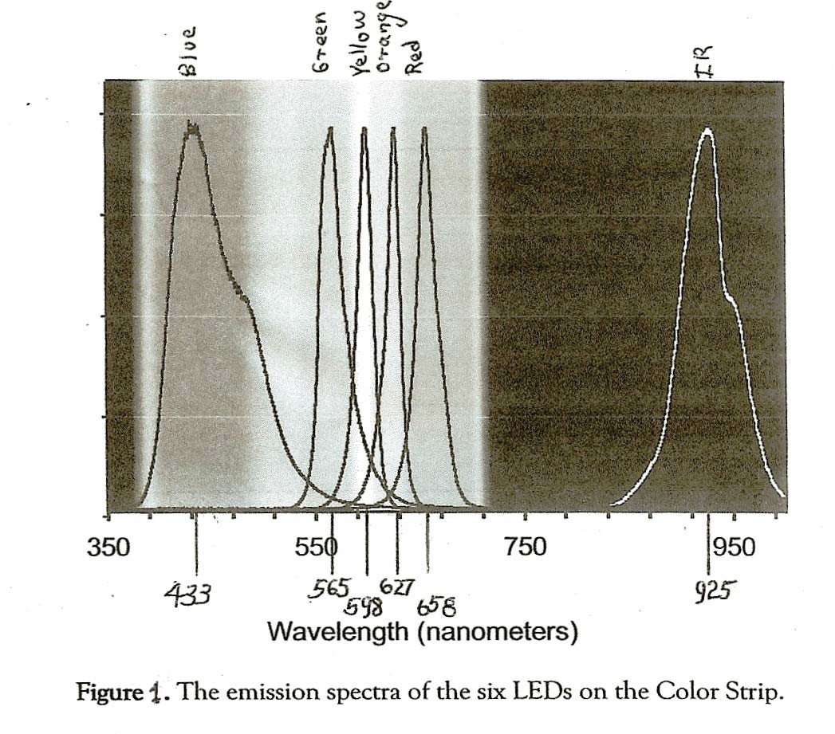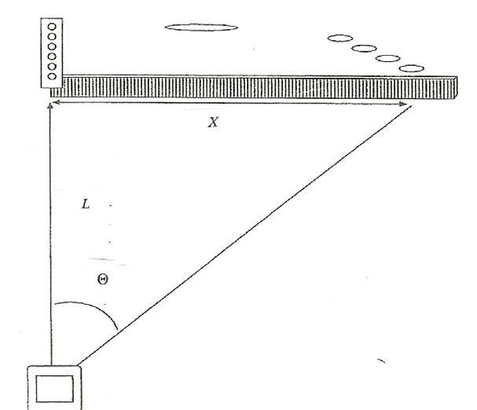

Figure 2. Measurement of the LEDs light diffraction.

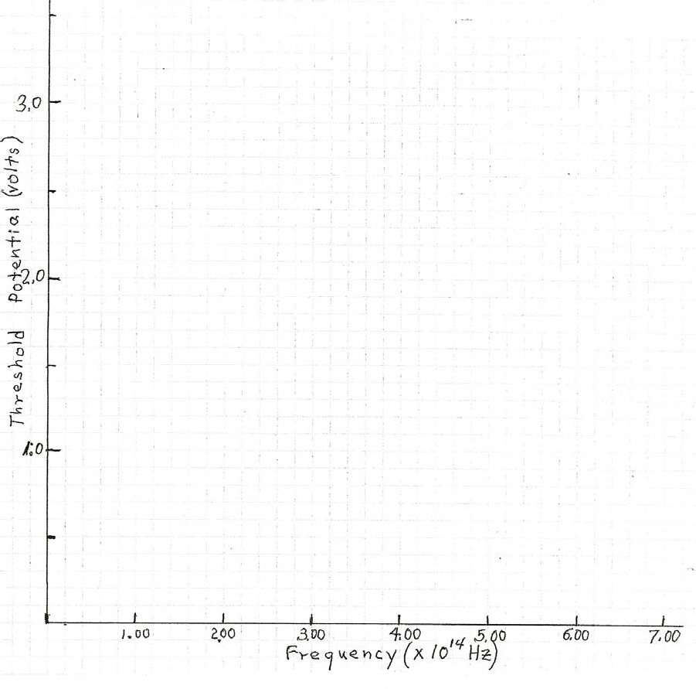

Figure 3. Plot of Threshold Potential versus Frequency.

