Limiting Reagent, Stoichiometry and the Mole

Ref: University of Pittsburgh College in High School Lab Manual, 1998.

Introduction

In this lab you will investigate the react ion between the aqueous copper (II) ion and the chelating agent ethylenediaminetetraacetic acid (EDTA) to form a complex ion, a complex in which a transition metal ion is bonded to 1 or more ions. The formation of complex ions by transition metal ions is a very interesting and useful feature of inorganic chemistry. For instance, hemoglobin is a very useful complex ion which occurs in human blood and contains iron (II) bound to a protein; without hemoglobin, breathing would do us no good.

You will study the reaction of Cu²⁺ and EDTA by preparing several mixtures of varying amounts of the two reactants, and then measuring their absorbance using a spectrophotometer. The complex ion is formed in the reaction below and absorbs light at a wavelength of 320 nm.

xCu²⁺ (aq) + y EDTA⁻⁴ (aq) Cu_{x}(EDTA)_{y} ^{z}

The structure of EDTA is:
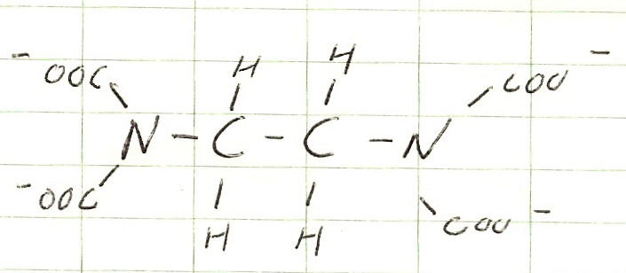

Your results will allow you to determine the mole ratio and the formula of the product complex ion in this reaction.

Materials

Spectrophotometer cuvettes
Two 50 ml Burettes 0.00500 M H₄EDTA
0.0100 M copper (II) sulfate 7 100ml beakers
Stirring rod Distilled water

Procedure

Each lab group will prepare several different solutions.

Solution A: 0.00500M H₄EDTA Solution B: 0.0100M Copper (II) Sulfate

From a burette, deliver 10.00 ml of solution A into the designated reaction vessel and then add the assigned volume of solution B from a second burette. Add enough distilled water to make the total volume 20.00ml. Thoroughly mix the solutions.

Suggested arrangement of groups

Lab group volume of solution B (ml)
1 0.40 1.60 2.80 4.60 5.20 6.40 7.60
2 0.80 2.00 3.20 4.40 5.60 6.80 8.00
3 1.20 2.40 3.60 4.80 6.00 7.20 8.40
4 1.60 2.80 4.00 5.20 6.40 7.60 8.80

In order to determine the Stoichiometry of this equation, read absorbance data for each of your seven solutions. Sharing data with the other lab groups will give 28 readings for which you should plot Absorbance vs. Volume of Reagent B.

Set the wavelength to 320 nm.
Zero the instrument with the blank (distilled water)
Successively read and record the absorption values for your seven solutions.

Questions

- Write the balanced equation for the reaction.

- Explain how the value of x for this reaction was determined.

- What is the mole ration for this reaction?

- Interpret the graph of Absorbance vs. Volume of Reagent B. Explain why the graph plateaus.

