MACHINES AND MOTION
GLOSSARY

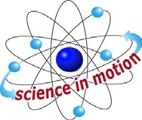
Westminster College

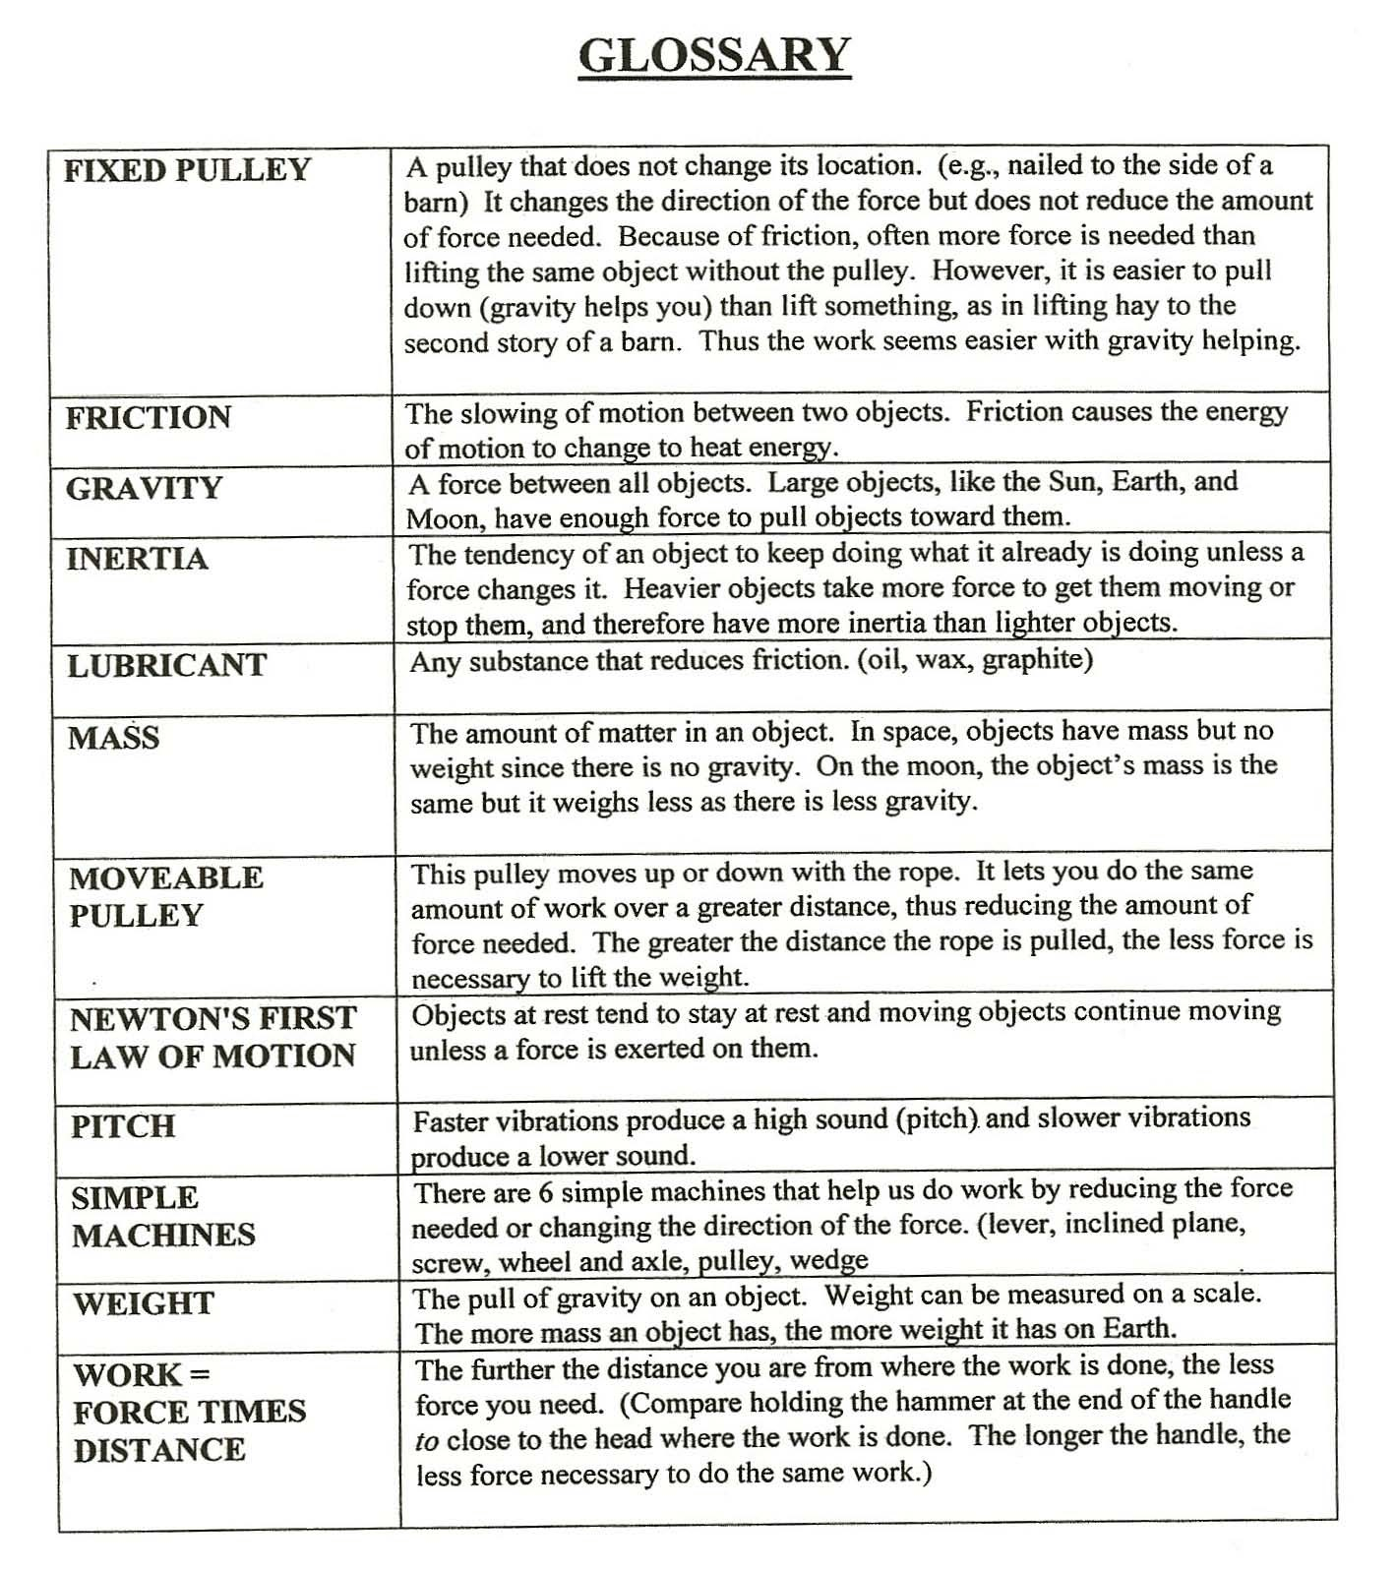

Westminster College SIM Page 1

