MITOSIS IN ONION ROOT TIP CELLS: AN INTRODUCTION TO LIGHT MICROSCOPY
Adapted from “Foundations of Biology I; Lab 6 – Introduction to Microscopy” Dr. John Robertson, Westminster College Biology Department, Fall 2001.

Information on mitosis from: “Starr, Cecie. Biology: Concepts and Applications. Section
II. Principles of Inheritance. Brooks/Cole-Thomson Learning, Inc. Fifth Edition.
©2003. p. 130-134.”

INTRODUCTION

Light Microscope

Microscopes are among the most important tools a biologist has for observation.
The effective use of a microscope depends upon the proper operation and maintenance of
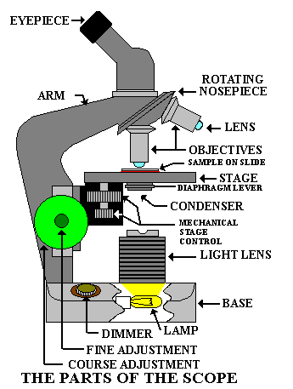the instrument. Therefore it is important to become familiar with the parts of the microscope and how they relate to function. Your instructor will go over the following major parts of the light microscope (see Fig. 1).1
Figure 1.

specimen.
Light source. Depending on the model, the level of illumination may be adjusted at the source using a rheostat, filters, or an iris diaphragm.
Course and fine focus knobs. These knobs are used to focus on the specimen.
Condenser lens. Some light microscopes will have iris diaphragms or accessory lenses associated with the condenser for adjusting illumination. In some models, the position of the condenser may be adjustable for proper focusing of light onto the

1Microscope diagram taken from: http://www.middleschoolscience.com/scope.htm

Specimen stage. Includes a mechanical system for holding slides in place and allowing precise movement of the slide in two planes.
Objective lenses. Housed on a rotating turret, common objectives on student instruments include 4X scanning , 10X low, and 40X high power; and 100X oil- immersion lenses. Never touch the objective lenses with anything but lens paper; even a slight scratch may permanently impair the optics and function of the lens
Ocular lens. Typically a 10X magnifying lens. Micrometers, graticules and pointers are often incorporated into the eyepiece for measuring or referencing.

Theory of Light Microscopy
The series of three glass lenses of the light microscope produce three real images with light from the specimen in focus at a particular spot. The first real image is inverted and produced within the tube, the second within the ocular, and the third just above the ocular lens. Your own eye lens sees this third real image and focuses it onto your retina as an inverted virtual image. The virtual image is inverted by optic nerves entering the brain.

Resolution. Resolution is the ability to distinguish between two points. The resolving power of the human eye is about 0.2 mm (200 μm). Two points closer together than 0.2 mm usually cannot be distinguished from each other by the naked eye. The resolving power of the best light microscope can be as great as 0.00017 mm (0.17 μm or 170 nm). The resolution of a microscope is far more important than its magnification. Two points very close together will appear as one when magnified, unless they also are resolved by the lenses.

Magnification. Magnification is calculated by multiplying the magnifying power of the ocular lens by the magnifying power of the objective lens. Usually the ocular lens has a magnification of 10X and the objective lenses are 4X, 10X, 40X, and 100X. Thus, when using the 40X objective, the total magnification of the image viewed is 10 x 40 = 400X. The 100X objective is an oil immersion lens. (We will not be using this lens.)

Contrast. One of the most important considerations in optimizing images in light microscopy involves make fine adjustments with the light. For example, a small translucent object must have less light than a thicker dark object, and the light must be focused onto the specimen precisely.

To control light intensity, turn your rheostat knob up or down to regulate the intensity of the light. In addition, you may need to change the iris diaphragm that is below the stage and above the condenser lens.

Mitosis

Mitosis is the nuclear division of a eukaryotic cell which produces two daughter cells identical to the dividing parent cell. In your body, mitosis is important for growth,

replacing old cells and tissue repair. For single-celled, and some multi-cellular eukaryotes, mitosis is part of asexual reproduction.

Mitosis is a one portion of the cell cycle. In eukaryotic cells, one complete cell cycle is broken into interphase, mitosis and cytoplasmic division. The cell spends most of its time in interphase, during which the cell synthesizes cytoplasmic and nuclear components (e.g. proteins, carbohydrates). DNA replication also occurs in interphase. This process involves the precise duplication of all the DNA in the nucleus, in preparation for mitosis. Mitosis is the physical division of the nucleus, creating two identical nuclei, one for each daughter cell. Cytoplasmic division results in the partitioning of the cytoplasmic components and the physical separation of the two new daughter cells.

Figure 2.

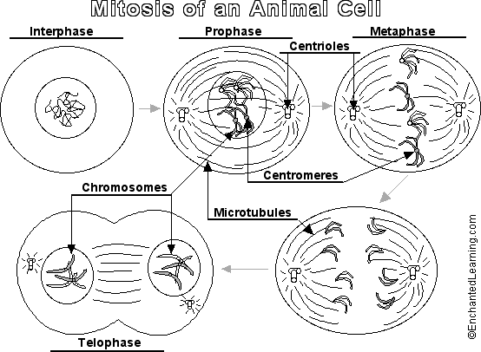

Mitosis itself is broken into four basic stages: prophase, metaphase, anaphase and
telophase. These are diagrammed in Figure 2.2

Prophase – The replicated chromosomes condense into compact rods. Each rod consists of two sister chromatids joined at the centromere or the chromosome. The spindle apparatus, made of microtubules and centrioles at opposite poles of the cell, is

2 Mitosis diagram taken from: http://www.enchantedlearning.com/subjects/animals/cell/mitosis/label/

formed. Microtubules attached at the centromere of each chromosome connect the chromosomes to the spindle apparatus. During these changes within the nucleus, the nuclear membrane breaks up.

Metaphase – The chromosomes, in their most condensed form, line up at the spindle equator.

Anaphase – The two sister chromatids break their attachment to each other. As separate chromosomes, they are pulled to opposite spindle poles by the microtubules.

Telophase – The cell now has two clusters of chromosomes at opposite poles. A new nuclear membrane begins to form around each of these clusters, resulting in two new nuclei, one for each new daughter cell. DNA synthesis (replication) during interphase ensures that each daughter cell receives a full chromosomal complement of 46 chromosomes. Cytoplasmic division is started at this point in mitosis. In plants, a cell plate is formed by vesicles filled with cell wall material. These vesicles combine at the former site of the spindle equator. Cellulose deposits accumulate at this plate, and eventually, a new cell wall is formed, separating the parent cell into two daughter cells.

MATERIALS
COMPOUND LIGHT MICROSCOPES
PRACTICE SLIDES
PREPARED ONION ROOT SLIDES

PROCEDURES:

Important general rules for use of a compound light microscope are:

- Always carry the microscope with two hands (one holding the neck, the other under the base) and set it down gently. It is an expensive precision instrument and should be treated as one.
- When starting to use or putting away a scope, be sure there is no slide on the stage, the lowest power objective is in place, and the power cord is neatly wrapped alongside the instrument.

Select a microscope, take it to your table, and set it down gently. Remove the plastic hood (if present), unwrap the power cord, and plug in the light source.

Learning to Use the Microscope

- You will practice proper illumination and focusing using a slide of the letter “e”. First look at your objective lenses and make certain that you use the lowest power lens, the 4X one. Now use the coarse adjustment to bring the objective lens as close as you
can to the stage. Look at the slide and determine where the letter “e” is located, and place it in the center of the hole on the stage.

- Adjust the width of the two ocular lenses to fit your eyes. This is obviously not necessary if your microscope has only one eyepiece. If you wear glasses, you may take them off or leave them on; however, if you have astigmatism, leave them on. Now use your right eye and look through the right ocular only. Using the coarse adjustment, focus away from the specimen until it is clear and sharp, using the fine adjustment as needed. Notice that by turning the fine adjustment back and forth, you will focus on different depths of the specimen. This will be more apparent with higher magnification objective lenses. Now it is time to focus the left ocular lens. If the right ocular is in focus, look with your left eye only and rotate the ocular lens adjustment until the specimen is clear and sharp. This corrects for any focusing differences between your left and right eyes.

Using the mechanical stage, pick out a portion of the letter “e” to see in more detail. Center it in the field of view and rotate the objective nose-piece to bring the next higher powered objective (10X) into position. Notice three things here:

  - The image will nearly be in focus without touching the focus knobs. Objectives matched like this are said to be parfocal.

  - The distance between the objective lens and the slide is shorter than with the previous lens. This loss of working distance increases as the power of the lens increases. It is possible to easily lower a high power lens right through a slide. The slides aren’t such a big loss, but the objective lenses can cost hundreds of dollars. Therefore, be careful.

  - The image doesn’t appear as brightly illuminated with the higher power lens. Stronger lenses need more light, so turn up your rheostat and adjust your sub-stage diaphragm accordingly.

The above procedure should be followed with every slide you examine. In
fact, the best way to look at a slide is first against a white background with no lens, and then proceed with the lowest power lens. Avoid the natural tendency to use the highest power objective (40X) immediately. With a little practice, you’ll be surprised at what you can see with the low power lenses.

Mitosis in Onion Root Tip Cells

You will be given a slide containing stained onion root tips. The cells in this slide will be in various stages of mitosis. Using the techniques you have just learned on the “e”, bring your onion cells into focus at 4x, then proceed to the 10x and 40x stages. At 40x magnification, you should be able to visualize the chromosomes inside the onion cell.
For this exercise, use the Data and Observations sheet provided to record your results.

DATA AND OBSERVATIONS

- In the space below, draw and describe what you see at each power of magnification.
- Draw the cells at the different stages of mitosis. These pictures should be large enough to label parts of the cell.
- Label the important features of each stage of mitosis.
- Are there other features of the cell that you can distinguish?

Student: Date:

QUESTION SHEET

- What is the difference between resolution and magnification on a light microscope? Which is more important?

- If the ocular lens has a power of 10x and the objective lens a power of 4x, what is the total power of magnification?

- What are the two parts of a microscope that help control the contrast of the specimen?

- What are the four major stages of mitosis?

- How many chromosomes are present in each daughter cell after mitosis is complete? What might happen if DNA replication during interphase has not been completed properly?

- In an onion, what cellular part must form to fully complete mitosis and cell division?

