The Molar Mass of a Volatile Liquid
LAB ADV COMP 3
From Advanced Chemistry with Vernier, Vernier Software & Technology, 2004

INTRODUCTION

One of the properties that helps characterize a substance is its molar mass. If the substance in question is a volatile liquid, a common method to determine its molar mass is to use the ideal gas law, PV = nRT. Because the liquid is volatile, it can easily be converted to a gas. While the substance is in the gas phase, you can measure its volume, pressure, and temperature. You can then use the ideal gas law to calculate the number of moles of the substance. Finally, you can use the number of moles of the gas to calculate molar mass.

OBJECTIVES
In this experiment, you will
- Evaporate a sample of a liquid substance and measure certain physical properties of the substance as it condenses.
- Determine the molar mass of an unknown liquid.
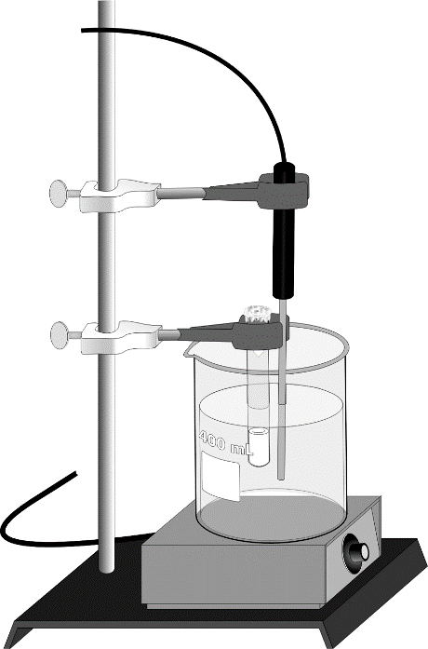
Figure 1

MATERIALS
Vernier computer interface | unknown volatile liquid
computer | fume hood
Temperature Probe | test tube, 13 × 100 mm, and holder
(optional) Vernier Gas Pressure Sensor | needle
ring stand | hot plate
two utility clamps | analytical balance
aluminum foil | two 400 mL beakers

PRE-LAB EXERCISE
Before beginning the experiment, make sure that you have a way to measure the barometric pressure in the room. A conventional barometer or a Vernier Gas Pressure Sensor may be used.

PROCEDURE
1. Obtain and wear goggles. Conduct this experiment in a fume hood or well-ventilated area.
2. Trim a piece of aluminum foil so that it just covers the top of a small, 13 × 100 mm, test tube. Use a needle to make a small hole in the foil. Use a sensitive balance to measure the mass of the test tube and foil.
3. Prepare a hot-water bath by warming about 300 mL of tap water in a 400 mL beaker. Keep the beaker on a hot plate or above a lab burner once the water is warm.
4. Use a second 400 mL beaker to prepare an ice-water bath.
5. Connect a Temperature Probe to Channel 1 of the Vernier computer interface. Connect the interface to the computer with the proper cable.
6. Start the Logger Pro program on your computer. Open the file “03 Molar Mass” from the Advanced Chemistry with Vernier folder.
7. Obtain a liquid sample of an unknown volatile compound. Pour about 0.5 mL of the liquid into the test tube and quickly cover the test tube with the aluminum foil. Place the test tube in the hot-water bath. Make sure that the foil is above the water level (see Figure 1).
8. Immerse the Temperature Probe in the hot water bath as shown in Figure 1. Do not allow the tip of the probe to touch the beaker. This will give you a more accurate reading of the water bath temperature.
9. Click to begin data collection.
10. Heat the beaker of water to boiling and maintain the boiling as your sample of liquid vaporizes. Note that some of your sample will escape the test tube through the needle hole in the foil. This process also serves to flush the air out of the test tube.
11. Keep the test tube in the boiling water bath for at least three minutes after all of the liquid in the test tube has vaporized, and then click . Examine your temperature graph and record the temperature of the boiling-water bath, which will be used in the ideal gas law calculations.
12. Use a test-tube holder to quickly transfer the test tube to the ice water bath. Cool the test tube for about one minute, then remove it and dry it completely. Measure the mass of the test tube and the aluminum foil top.
13. Record the room barometric pressure.
14. Rinse out the test tube and fill it to the top with tap water. Cover the test tube with aluminum foil. Measure and record the mass of the test tube, water, and foil.

DATA TABLE
 | Trial 1 | Trial 2
Mass of test tube and foil cover (g)
Temperature of water bath (ºC)
Mass of test tube and foil and gas sample (g)
Barometric pressure (kPa)
Mass of test tube and foil and water (g)

DATA ANALYSIS
1. Determine the mass of the condensed portion of the unknown that you placed in the test tube.
2. Use the mass of the water in the test tube from Step 14 of the procedure and its density to calculate the volume of the test tube.
3. Use the calculations from Questions 1 and 2 above, along with the temperature of the boiling water bath and the barometric pressure of the room, to calculate the molar mass of your unknown compound.
4. Identify the unknown liquid substance that you tested.

5. How did you use the ideal gas law in your calculations?
6. Was the vapor really “ideal”? If not, how were your calculations affected? Explain.
7. If all of the vapor had not condensed to a liquid when you cooled the test tube, how would your calculations have been affected?
8. How would your experiment have been affected if you had used a different initial amount of the unknown compound?

