MONITORING EKG

LAB HMP 2.COMP
From Biology with Computers, Vernier Software & Technology, 2000. Also: Monitoring EKG, Susquehanna University, Science in Motion

INTRODUCTION
An electrocardiogram, or EKG, is a graphical recording of the electrical events occurring within the heart. A typical EKG tracing consists of five identifiable deflections (peaks). Each deflection is noted by one of the letters; P, Q, R, S, or T, as labeled in Figure 1. The P wave is the first waveform in a tracing and represents the depolarization of the heart’s atria. The depolarization causes the atria to contract, forcing blood into the ventricles. An electrochemical signal is also passed to special tissue in the ventricles.
This signal triggers the next waveform, a complex that consists of the Q, R, and S deflection. The QRS complex represents the depolarization of the heart’s ventricles. The deflection that represents the repolarization of the atria is usually undetectable because of the intensity of the QRS waveform. This repolarization prepares the atria for the next heartbeat. The final waveform is the T wave and it represents the repolarization of the ventricles. The terms depolarization and repolarization refer to a regulated flow of
sodium (Na+), calcium (Ca2+) and potassium (K+) ions across the cardiac muscle cell
membranes. This ion flow is an essential part of conducting the electrical impulses which stimulate the heart to beat.

Because an EKG is a recording of the heart’s electrical events, it is valuable in diagnosing diseases or ailments that damage the conductive abilities of the heart muscle. When cardiac muscle cells are damaged or destroyed, they are no longer able to conduct the electrical impulses that flow through them. This causes the electrical signal to terminate at the damaged tissue or directed away from the signal flow. The termination or redirection of the electrical signal will alter the manner in which the heart contracts. A cardiologist can look at a patient’s electrocardiogram and determine the presence of damaged cardiac muscle based on the waveform as well as the time interval between electrical events.
In this activity, you will use the EKG sensor to make a five-second graphical recording of your heart's electrical events. From this recording, you will identify the previously mentioned waveform components and determine the time intervals associated with each.

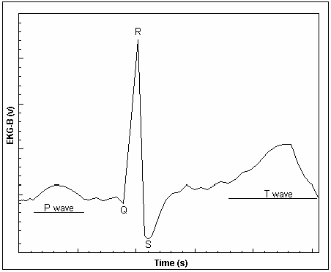

Figure 1. Electrocardiogram of the electrical activity of a single beat of the heart.

OBJECTIVES

- Use the EKG Sensor to graph your heart’s electrical activity.
- Determine the time interval between EKG events.
- Calculate heart rate based on your EKG recording.

MATERIALS
LabQuest
LabQuest App
EKG Sensor
disposable electrode tabs

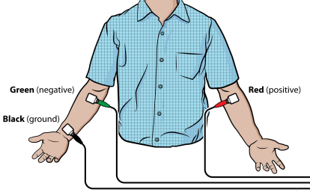

PROCEDURE
- Connect the EKG Sensor to LabQuest and choose New from the File menu.
- On the Meter Screen, tap Duration. Change the data-collection duration to 5 seconds. Select OK.
- Attach three electrode tabs to your arms, as shown in Figure 2. A single tab should be placed on the inside of the right wrist, on the inside of the right upper forearm (below elbow), and on the inside of the left upper forearm (below elbow).
- Connect the three sensor leads to the electrode tabs as shown in Figure 2. Sit in a reclined position in a chair or lay flat on top of a lab table. Your arms should be hanging at the side unsupported.
- Another member of the lab group should start data collection.
- Once data have been collected, a graph will be displayed. To examine the data pairs on the displayed graph, tap any data point. As you tap each data point, the voltage and time values of each data point are displayed to the right of the graph.
- For at least two heartbeats, identify the various EKG waveforms using Figure 1 and determine the time intervals listed below.
- Record the average for each set of time intervals in Table 2.

Table 1
Waveform | Time interval
P-R interval | Time from the beginning of P wave to the start of the QRS complex
QRS complex | Time from Q deflection to S deflection
Q-T interval | Time from Q deflection to the end of the T

- Calculate the heart rate in beats/min using EKG data. Remember to include the time between the end of the T wave and the beginning of the next P wave. Use the total number of seconds for one full heart cycle in the equation. Record the heart rate in Table 2.

- If your EKG was unsatisfactory, repeat Steps 4-6.

- (optional) Print a copy of your EKG graph. Identify and label the various waveforms on the graph.
DATA
Table 2
Interval | Time (s)
P - R
QRS
Q - T
Heart rate: ___________ beats/min

DATA SHEET Name
Period Class
Date

MONITORING EKG

Table 1: “Resting” State
P-R | Seconds at Q: | Seconds at start | Elapsed Seconds | Normal Range:  0.12 to 0.20 s
 |  | of P wave: | (Q sec – P sec)
 | Beat 1 | Beat 1 | Beat 1
 | Beat 2 | Beat 2 | Beat 2
 | Beat 3 | Beat 3 | Beat 3
 |  |  | Avg.
QRS | Seconds at S: | Seconds at Q: | Elapsed Seconds | Normal Range: less than 0.10 s
 |  |  | (S sec – Q sec)
 | Beat 1 | Beat 1 | Beat 1
 | Beat 2 | Beat 2 | Beat 2
 | Beat 3 | Beat 3 | Beat 3
 |  |  | Avg.
Q-T | Seconds at end | Seconds at Q: | Elapsed Seconds | Normal Range: 0.30 – 0.40 s
 | of T wave: |  | (TS sec – Q sec)
 |  |  | Beat 1
 | Beat 1 | Beat 1 | Beat 2
 | Beat 2 | Beat 2
 |  |  | Beat 3
 | Beat 3 | Beat 3
 |  |  | Avg.

Heart rate (# beats per 5 seconds):

Heart rate (beats per min):

Table 2: Post-Exercise
P-R | Seconds at Q: | Seconds at start | Elapsed Seconds | Normal Range:  0.12 to 0.20 s
 |  | of P wave: | (Q sec – P sec)
 | Beat 1 | Beat 1 | Beat 1
 | Beat 2 | Beat 2 | Beat 2
 | Beat 3 | Beat 3 | Beat 3
 |  |  | Avg.
QRS | Seconds at S: | Seconds at Q: | Elapsed Seconds | Normal Range: less than 0.10 s
 |  |  | (S sec – Q sec)
 | Beat 1 | Beat 1 | Beat 1
 | Beat 2 | Beat 2 | Beat 2
 | Beat 3 | Beat 3 | Beat 3
 |  |  | Avg.
Q-T | Seconds at end of T wave: | Seconds at Q: | Elapsed Seconds (TS sec – Q sec) | Normal Range:
 |  |  | Beat 1
 | Beat 1 | Beat 1
 |  |  | Beat 2 | 0.30 – 0.40 s
 | Beat 2 | Beat 2
 |  |  | Beat 3
 | Beat 3 | Beat 3
 |  |  | Avg.

Heart rate (# beats per 5 seconds):

Heart rate (beats per min):

NOTE: If your EKG data does not fall in the “Normal Range”, it is not necessarily a cause for concern. This equipment is not sensitive enough to produce reliable data on the health and fitness of your heart. If you are truly concerned by your results, you should consult a medical doctor.

Name: Date:

QUESTIONS

- The electrocardiogram is a powerful tool used to diagnose certain types of heart disease. Why is it important to look at time intervals of the different waveforms?

- What property of heart muscle must be altered in order for an EKG to detect a problem? Explain.

- Why can’t an EKG be used to diagnose all diseases or defects of the heart?

- Name and describe a cardiovascular problem that could be diagnosed by a cardiologist using a electrocardiogram recording.

- Examine your “resting” and post-exercise heart rate. How do they differ? What is the effect on the heart muscle? Why should someone with a known heart problem be cautious about performing this part of the experiment?

Name: Date:

Pre-Lab Quiz for “Monitoring EKG” Lab

- What is being recorded by an electrocardiogram (EKG)?

- An EKG can detect when cardiac muscle cells are damaged or destroyed.

  - What is disrupted by the damaged or destroyed cells?

  - What changes in the EKG graph help a cardiologist detect the damage?

- When the atria or ventricles depolarize, what is happening to the heart muscle?

- When analyzing the EKG data, why is it important to record data from at least three different heartbeats?

- What are the three (3) ions that are important for transmitting the signal for the heart to beat?

- Why are you unable to detect the repolarization of the atria on an EKG trace?

