Ocean Floor Mapping

LAB 12
From Vernier Middle School Science, Vernier Software and Technology

Westminster College

Oceanographers, marine geologists, and archeologists use sound to investigate objects below the surfaces of bodies of water. A signal is sent out and bounces back from a submerged surface. Scientists use the speed of sound in water and the time it takes for the signal to bounce back to calculate the depth of the object. Sonar is the name given to this system. The Vernier Motion Detector works in a similar manner. In this activity, you will use a Motion Detector to map objects on a simulated ocean floor.

OBJECTIVES
In this experiment, you will
- Use a Motion Detector to measure distances.
- Map simulated ocean floors.
- Analyze graphs to find the heights of objects on a simulated ocean floor.

MATERIALS

LabQuest | 1 m board
LabQuest App | masking tape
Motion Detector | 2 or more boxes

PROCEDURE

Part I Ocean Floor 1
Figure 1

- Prepare the Motion Detector for data collection.
  - Get the board that will act as the support for your Motion Detector.
  - Tape or clamp the Motion Detector to one end of the board. Make sure that the round screen of the Motion Detector is not covered and is pointing downward.
  - Place the board with the Motion Detector flat on your table as shown in Figure 1.
- Prepare the ocean floor for data collection.
  - Place the box on the floor underneath the Motion Detector. Note: The Motion Detector must be at least 40 cm from the top of the box.

  - Line up the Motion Detector so that when it is moved along the table edge it will pass over the box.

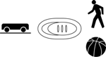
- If your Motion Detector has a switch, set it to Normal. Connect the Motion Detector to DIG 1 of LabQuest and choose New from the File menu. If you have an older sensor that does not auto-ID, manually set up the sensor.

- On the Sensor screen, tap Rate. Change the data-collection rate to 4 samples/second and the data-collection length to 15 seconds.

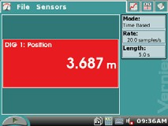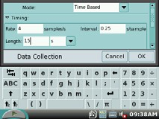
Rate
Rate
Length
- Collect distance data.
  - Move the board to position the Motion Detector to the left of the box.
  - When everything is ready, start data collection.

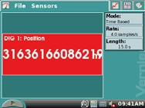
Start
  - After data collection starts, slowly slide the board across the tabletop so that the Motion Detector passes over and past the box.
- Determine and record the distance to the floor.
  - Identify a flat portion of the graph that represents the floor.
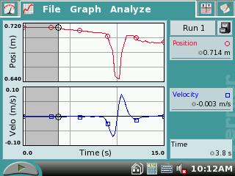
  - Tap and drag your stylus across the region that represents the floor to select the data. Floor

  - Tap on the word ‘Analyze’ on the menu bar. Choose Statistics and tap the Position square.

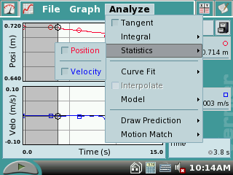
Analyze

  - Locate the statistics data on the LabQuest screen. Scroll down the data list to mean (average) and record the mean (average) distance to the floor in meters in your data table.

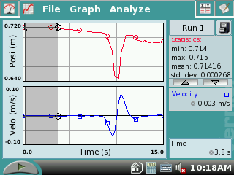
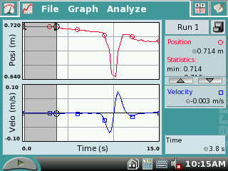
Statistics

  - Tap on the word ‘Analyze’ on the menu bar. Choose Statistics and tap the Position square to turn off statistics.
Mean

- Determine and record the distance to the box.
  - Identify the flat portion of the graph that represents the bottom of the box.
  - Tap and drag your stylus across the region that represents the bottom of the box to select the data.

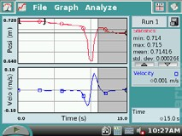
Bottom of Box

  - Tap on the word ‘Analyze’ on the menu bar. Choose Statistics and tap the Position square.
  - Locate the statistic data on the LabQuest screen. Scroll down the data list to mean (average) and record the mean (average) distance to the box floor in meters in your data table.
  - Locate the statistic data on the LabQuest screen. Scroll down the data list to mean (average) and record the mean (average) distance to the floor in meters in your data table.Record the mean (average) distance to the box in meters.
  - Tap on the word ‘Analyze’ on the menu bar. Choose Statistics and tap the Position square to turn off statistics.
- Sketch and label your graph.

Part II Ocean Floor 2
- Prepare Ocean Floor 2.
  - Set up two boxes in the shape of steps. The tallest box must be at least 40 cm from the Motion Detector.
  - Repeat Steps 5–8. Be sure to record all three distances.

Part III Hidden Ocean Floor
- Your teacher will have a hidden ocean floor for you to measure. Repeat Steps 5–8 for the concealed object or objects.

DATA

 | Distance to floor (m) | Distance to box (m) | Box height (m)
Ocean floor 1 single box
Ocean floor 2
box 1
Ocean floor 2
box 2
Hidden ocean floor box 1
Hidden ocean floor box 2
Hidden ocean floor box 3

GRAPH SKETCHES
Ocean Floor 1 Ocean Floor 2 Hidden Ocean Floor

PROCESSING THE DATA
- In the space provided in the data table above, find the height of each box. Do this by subtracting the distance to the box from the distance to the floor.

- Which was your best result? Why do you think it was better than your other results?

- How did the shape of your graph compare to the actual object(s) in each case? Explain.

- What factors might affect the accuracy of real ocean-floor mapping?

EXTENSIONS

- Try other hidden ocean-floor arrangements.

- Research the sonar process and compare it to what you did in this activity.

