
OWL PELLET
Westminster College
STRUCTURED LAB EXERCISE #2

- Pre-Lab Discussion

The bodies of animals such as reptiles, birds, mammals, and humans contain skeletons that consist of several types of very similar bones. The bones in the back and tail are called vertebrae while those in the head are collectively called the skull. Bones in the legs, shoulder, and hip are referred to as long bones. Long bones associated with the front leg include the scapula and humerus while those associated with the back leg and called the ilium, femur and tibia.

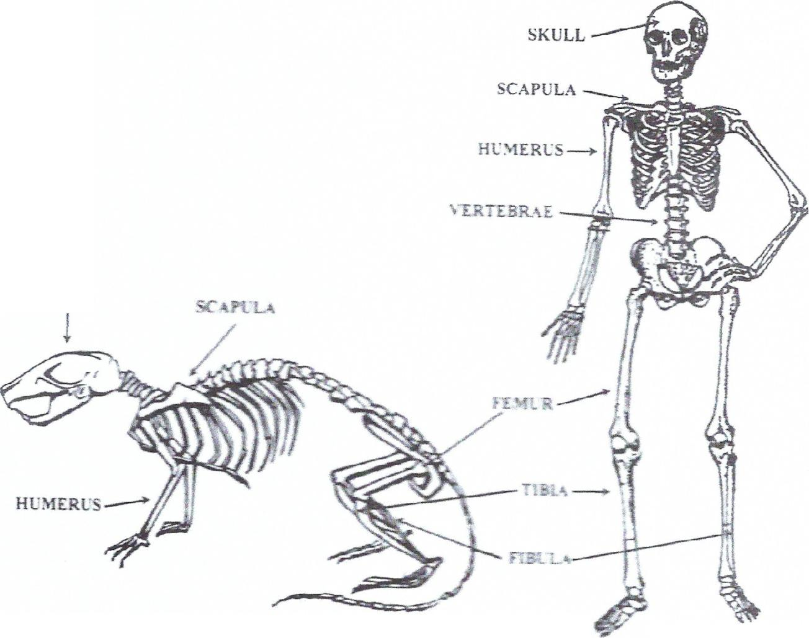

In this laboratory exercise, you will dissect pellets produced by Barn Owls and examine the bones of the small mammals they eat. You will identify the bones, determine their appropriate locations in the skeleton, and compare them to the bones found in the skeleton of a human.
- Problem
What are the terms used to name the bones in skeletons?

- Materials
Barn Owl Pellet
Dissecting tools
Magnifying glass or dissecting microscope
White glue

- Safety

The barn owl pellet has been sterilized and contains no harmful or disease-carrying organisms. The pellets can be dissected with bare hands but be certain to wash your hands after the laboratory exercise has been completed.

- Procedures

- Place a pellet on a piece of white paper.

- Using dissecting tools, separate bones in the pellet from fur, feathers, and other debris.

- Clean the bones of debris as completely as possible and sort them according to their types (e.g., skulls, vertebrae, femurs, etc.) using the diagrams of skeletons as a guide.

- Clean the skulls as thoroughly as possible. Identify the animals the skulls belonged to using a magnifying glass and the diagrams of skeletons as a guide. Examine the teeth, especially the incisors and molars, and compare them to the illustrations to help with this identification. Count the number of individuals of each species of animal in the pellet.

- Option #1-Combine the bones you found with those found by other students. Using the diagrams, arrange the bones according to their position in the natural skeleton. Glue the bones to the paper and label all the different bones using the diagrams of skeletons as a guide.

- Option #2- combine the bones you found with those found by other students. Using diagrams of skeletons, glue the bones together to form a complete, free-standing skeleton. Compare the bones in your skeleton to those found in the skeletons of boles, birds, and humans.

7. Observations

Types of animals found in your pellet.

Species Number

____________________________ _______

____________________________ _______

____________________________ _______

____________________________ _______

8. Analysis and Conclusions

- Name the different types of animals whose bones you found in the pellet.

- How many animals were in the pellet?_______________________________

- Complete the blanks in the following diagram of a human skeleton.

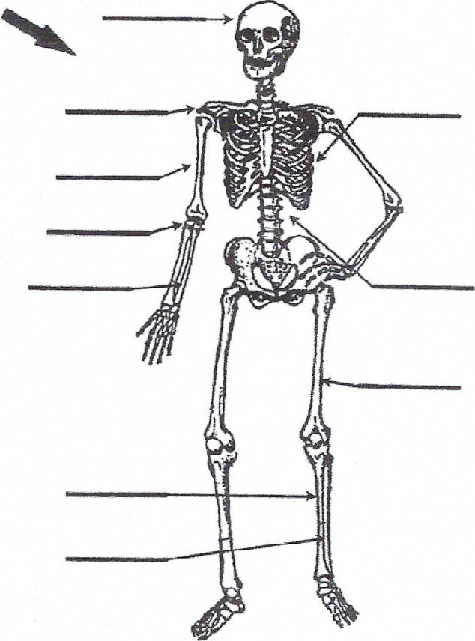
- In what ways do the skeletons of humans differ from those of animals like voles?

