OWL PELLET TEACHER’S GUIDE

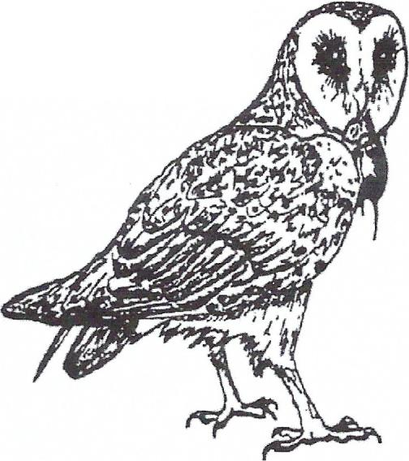
BACKGROUND INFORMATION

The Barn Owl

The Barn Owl (Tyto alba) is a cosmopolitan species found in Europe, Africa, India, southeast Asia, Australia, as well as North, Central, and South America. The original habitats of Barn Owls may have been quite different from those now utilized. Barn Owls were originally cliff-haunting birds where their light plumage coloration matched their backgrounds. Now the birds are largely associated with countrysides having an abundance of open fields for hunting and numerous old buildings for roosting and nesting.

Barn Owls are nocturnal in their habits and hunt using continuous flights. As a consequence, they prey on any a number of species of small mammals that live in open habitats such as grasslands, farmlands, and marshes and are either crepuscular (morning and evening active) or completely nocturnal. Prey commonly include voles, shrews and mice, but a variety of other animals including bats, rats, birds, and insects such as moths are also eaten. Regardless of their location in the U.S., voles followed by mice and shrews are consistently the most common prey species found in the diets of Barn Owls.

During the day, Barn Owls roost in trees, rocky cliffs, and buildings around farms. They have a distinct tendency to roost in buildings, hence the derivation of their name. As is true of many owls, Barn Owls nest in dark places such as natural cavities in trees and rocky cliffs but they also commonly nest in dark rafters and lofts of barns, silos and sheds.

Pellets

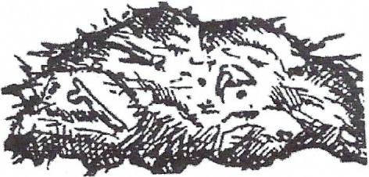
Pellets are the undigestible remains of food eaten by owls which, instead of being excreted with other waste materials, are regurgitated through the mouth as a compact mass of hair, bones, teeth, claws, bird’s beaks, and chitinous remains of insects. Over 300 species of birds have been found to produce pellets. And all birds of prey such as hawks, eagles and falcons, and owls produce them. Undigestible materials are compacted in the stomach, or gizzard, and later passed into the expended area of the esophagus called the proventriculus where they remain until being regurgitated.

The rate of pellet egestion is variable and to some degree, under voluntary control. Observations on captive owls indicate that a pellet is produced whenever the owl perceives another meal is imminent. The minimum time required for an owl to produce a pellet is 6.5 hours after its last meal. The usual number of pellets produced in a day or two but an owl is capable of producing as many as four pellets in a 24-hour period.

The diets of pellet-producing birds can be determined through the dissection of their pellets and identification of prey remains such as the bones that are found in them. In general, this analysis is most reliable for owls. Hawks, eagles, and falcons are less suitable for a number of reasons including the fact that many dismember their prey prior to swallowing and may not ingest all portions of them. Also, hawks and eagles digest bones to a greater extent that do owls so small skeletal parts are frequently not found in their pellets.

Skulls and Jaws

The skulls and lower jaws of small mammals found in the diet of Barn Owls can be readily identified to their genus based on the unique features of their teeth. The large, ever-growing incisors of rodents such as voles and mice are distinctly different from those of insectivorous species like shrews. Rodents are also unique in that both the upper and lower tooth rows have a wide gap, or diastema, between the incisors and molars due to their lack of canine teeth. The molars of different types of small mammals are also unique. Those of shrews, for instance, have reddish brown cusps or tips while those of the vole are much larger and noticeably angular with the chewing surface worn flat to give a pattern of loops and variable numbers of triangular shapes in them. The molars of mice, on the other hand, are smaller in size and the chewing surface is much more rounded and there is a distinct absence of triangular shapes.
Notes

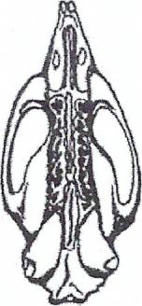
Upper Palate

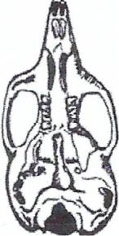
Upper Palate

VOLE SKULL

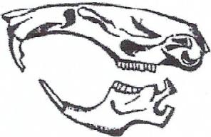
Side view w/lower mandible
MOUSE SKULL

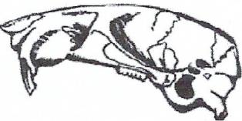
Side view w/o lower mandible

SHREW SKULL

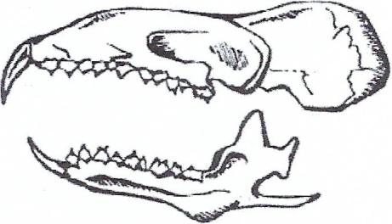
Side view w/lower mandible

PREY SPECIES
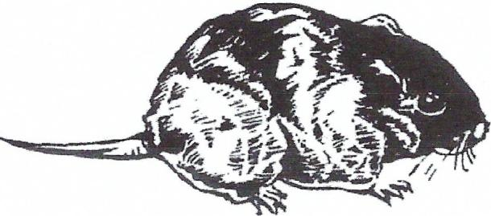
Voles are small rodents that belong to the genus Microtus. They are medium-sized rodents with blunt snouts and stout chunky bodies. Their legs, fur-covered tails, and ears are short and their small black eyes are bead-like in appearance. The fur is soft and dull colored. Voles are found in habitats ranging from meadows to marshy areas, forests, dry plains, prairies, and even ocean beaches. Voles eat chiefly green vegetation but seeds, nuts, bark, fungi, and some insects are also included in their diets. They are active both day and night and the presence of voles is revealed by the typical runways in the turf which are usually in or below the dead grass mat. Voles are closely related to lemmings which are found in arctic latitudes. Lemming populations are cyclic with peaks in lemming numbers occurring every 3-4 years. This probably causes subsequent cycles in populations of arctic owls such as the Snowy Owl (Nyctea scandiaca).
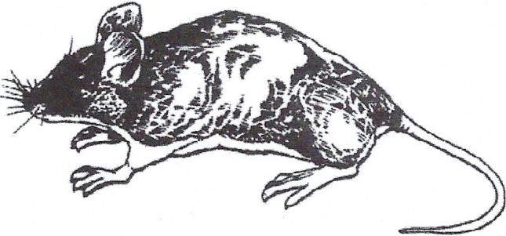
The deer mouse, or Peromyscus maniculatus, is one of the most abundant and widely distributed rodents in North America. It is found almost every place where there is cover of brush, trees, or rocks. As their name implies, deer mice have a deer-like pelage that is characterized by its brown upper parts and contrasting light or white under parts. Nocturnal for the most part, deer mice do not hesitate to enter cabins, tents, or other human habitations and, like voles, eat green vegetation as well as seeds, nuts, and some insects. Deer mice and prolific breeders bearing two to four litters of young from February through November. They have a gestation period of 21 days and litters range from three to four young. Young deer mice disperse six weeks after birth and sexual maturity may be reached in females six to seven weeks after birth.

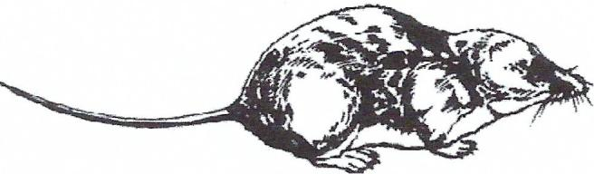
Shrews belong to the genus Sorex and are the smallest of all mammals. They have thick, soft coats except for their tails which are nearly hairless. Their snouts are sharply pointed, their eyes small, and their legs, though short, can carry them about very rapidly. Shrews have a sharp row of teeth extending on each side of the jaw from the incisors continuously to the molars with no intervening space as found in rodents. Because they are so small, shrews have very high metabolic rates and accordingly must always be in search of food. Shrews are mostly insectivorous but their diet consists of a variety of invertebrates such as beetle larvae, centipedes, caterpillars, and snails. They can also eat small mice and amphibians. Tiny and secretive, shrews are seldom seen, though they are widespread. They are usually found in relatively dense vegetation where cover and shelter is readily available. Their preference for insects and other small invertebrates ties them closely to moist areas.

PELLET ANALYSIS

Mountain Home Biological pellets have been heat sterilized which has been confirmed to kill bacteria. We also conduct monthly random sample testing through an independent laboratory to ensure safety. Wearing gloves and washing hands is good practice and will also teach proper laboratory safety habits.

On rare occasions students who are allergic to pets may have a reaction to Owl pellets. The pellets do contain animal hair, so it is a good idea to ask if any students are allergic to pets before dissection.

It is recommended that all students wear masks and gloves to prevent allergic reactions.

The identification of remains of prey in pellets can provide both qualitative and quantitative information about owl diets. The method selected for analyzing pellets depends on the number of pellets that are used and the objectives of the analysis. The simplest method of pellet analysis is to dissect each pellet individually by hand. Hair and feathers are teased from bones, teeth, and other identifiable remains. Any instruments available such as forceps, dissecting needs, and even toothpicks are helpful with such a dissection.

A magnifying glass or dissecting microscope is necessary to examine the fine structures of teeth for final identification. Together with the illustrations included in this handbook, students should be able to identify prey remains with a little practice. Skulls and lower jaws are the most useful remains both for the identification and counting of small mammalian prey species. Limb bones and pelvic girdles are helpful in counting prey but the best method is to count the number of skulls and pairs of lower jaw bones.

Clothes moth larvae are frequently found in pellets. They feed on the fur and feathers in pellets. Due to this, pellets often contain numerous tiny black spheres that are the droppings of larvae that lived in the pellets before they were collected.

Optional Method…..

If proper facilities are available, hair and feathers can be removed more completely from bones by dissolving the pellets with sodium hydroxide (NaOH).

For this technique:
- 50gm of NaOH crystals are dissolved in 500ml of water. If more solution is needed, increase the amounts used to make 10% solution of NaOH.
- Pellets are placed in a beaker containing this solution for two to four hours with occasional stirring.

This process will sufficiently dissolve hair so that washing the solution through a kitchen strainer completely free the bones of fur and debris. Washing should be done over a pan to catch any fragments that may pass through the screen. Every very small, delicate bones are unharmed by this process but care should be taken to stop this digestion procedure before teeth begin to be dislodged from skulls and jaws. As in the dissection technique, bones and teeth are sorted by species and are later examined using a magnifying glass, hand lens, or dissecting microscope and reference material to identify the specimens to the genus level.

CLASSROOM USES OF OWL PELLETS

OWL PELLETS CAN BE USED FOR A VARIETY OF TEACHING OBJECTIVES
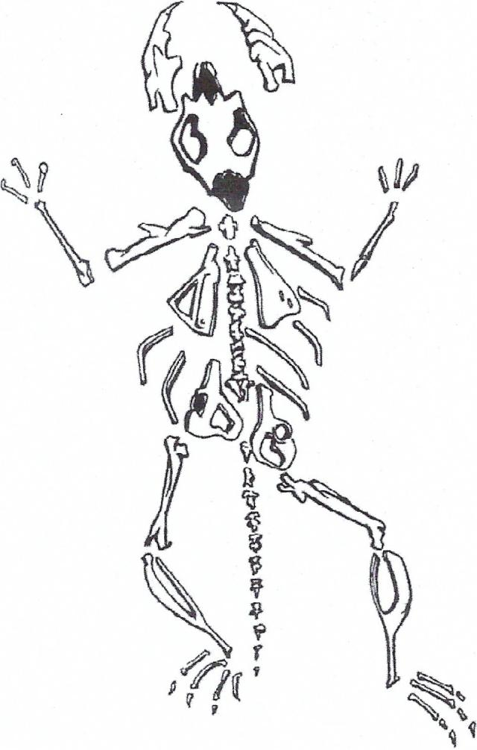
- Skeletal anatomy- One of the most common uses of owl pellets is to teach students the names of the different bones that make up the typical skeleton of a mammal such as a mouse or a human. Since each pellet contains the remains of a meal, each pellet should contain the complete skeleton of a small rodent such as vole. As an exercise, teachers can ask students to dissect pellets and sort the bones by type using materials provided in this handbook as a guide. After sorting the bones, the class can then combine all of the bones they have found to reassemble a complete vole skeleton. The bones may be laid out on a piece of paper in their appropriate positions in the mammalian skeleton or, they may be glued together with wire attached to a small piece of wood to form a free standing skeleton.

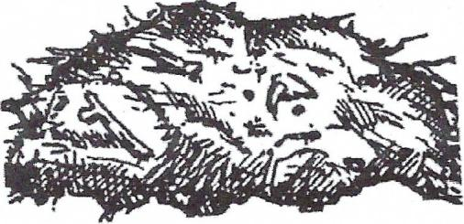
Students may also be asked to compare the different types of bones found in the vole skeleton to those of a human. Materials provided in this handbook can be used to demonstrate the similarities between the bones in rodent and human skeletons and the similar terminology used to name the bones in the two skeletons.

- Owl food habits – An exercise for students in higher grades is to dissect all of the owl pellets provided and sort the bones by type. The skulls and lower jaws of small mammals are unique to each species so all of these prey remains should be identifiable to the genus level using the reference materials provided in this handbook. Once skuls and lower jaws are identified, they can be sorted by genus and students can then calculate the frequency of each species in the diet by dividing the total number of each prey species in the pellets by the total number of all prey species found. Assuming that a typical owl produces two pellets each day, the total number of prey consumed on a daily or yearly bases can then be calculated. Classes have estimated the yearly consumption of a single owl to be approximately 1,000 voles, 500 deer mice, 250 shrews, 5 rates, 2 moles, and 2 birds.

- Ecological food webs-Students can dissect the pellets in the kit and identify the prey remains in them using the reference materials included in this handbook. The class can then draw a food web on the blackboard to illustrate the different feeding relationships in the Barn Owl’s habitat. By constructing such a food web, students can visualize the trophic structure within a Barn Owl’s habitat and the potential for harmful chemicals like pesticides to be taken up by all trophic levels of an ecosystem. To construct the food web, students must learn, not only the dietary habits Barn Owls, but those of their prey as well. Groups of students can be assigned different prey species to do research using the reference materials suggested in this handbook. The groups can then construct a class food web for the Barn Owl’s habitat.

FOOD WEB

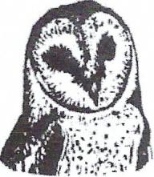

OWL

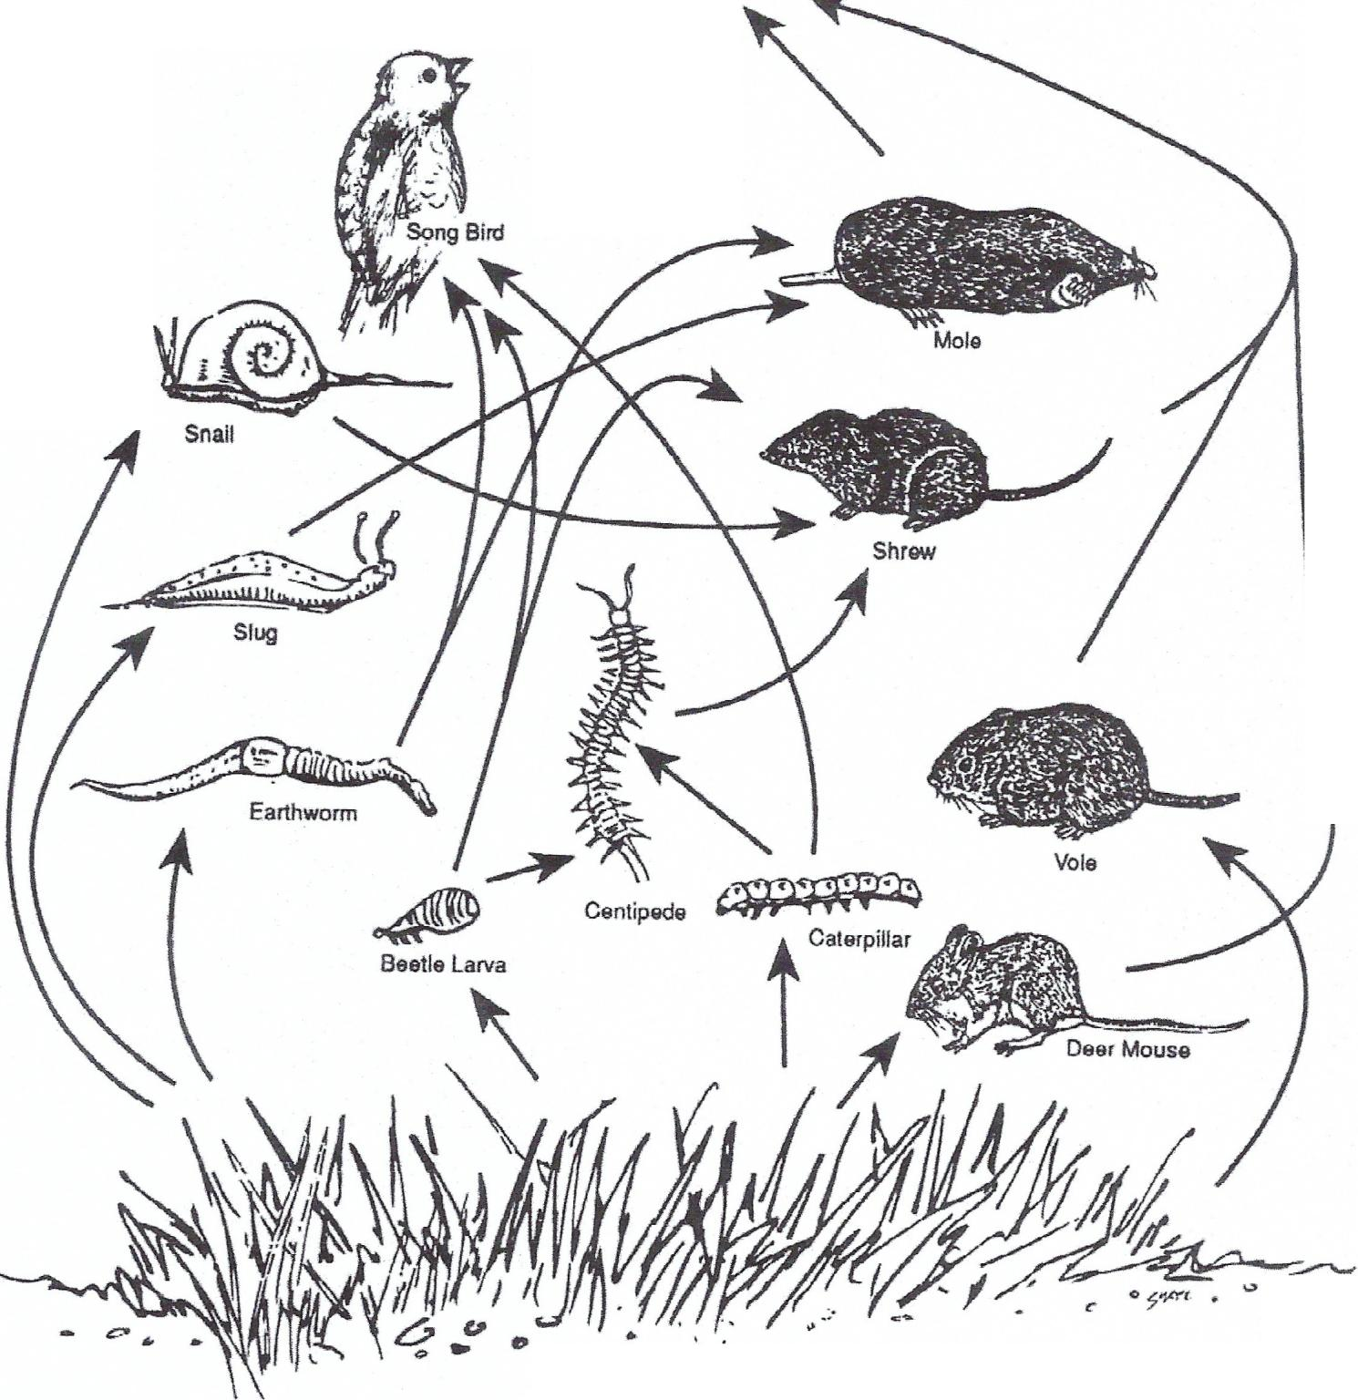

TEACHING METHODS

- Inquiry Method – Students are told nothing about the pellets and no background information is provided. Teachers can have students record characteristics of the pellets and then dissect them. Using the classroom materials provided in this handbook, students can then sort and identify the types of bones found in the pellets and, using skulls, jaws, and teeth, they can identify the animals whose bones they have found. After pooling all the observations from the class, students can make inferences about:
- The origin of the pellets
- The type of animal that made them
- Why the animal made the pellets
- The types of bones found in the pellets and where they fit in a typical mammalian skeleton
- Number of species of animals whose bones are found in the pellets
- The daily habits of the animals found in the pellet

By questioning students and discussing their results, the teacher can help direct their observations. If possible, it is best to have reference materials on owls, their prey, and mammalian anatomy available.

- Structure Lab Method- Give two students a pellet and have them separate the bones in it from the fur and feathers. Or, place all of the pellets in NaOH solution and digest the hair and fur from the bones in the pellets. This can be done by assigning students to work in groups that digest four or five pellets, or it can be done by the teacher as a demonstration. Since it takes several hours to thoroughly digest pellets, this step should be done prior to the laboratory period. After the pellets have been dissected or the bones have been thoroughly rinsed of NaOH, students should sort the bones according to their types. Using the classroom materials provided with this handbook, teachers can have students name the different types of bones and identify the animals whose skulls, teeth and lower jaws they have found. Students can also be asked to sort the bones by type and to arrange them into their appropriate skeletal positions on a piece of paper, or they can glue them together to make an articulated skeleton of the prey animal.

Students should count the number of each type of animal found in the pellets by counting the number of skulls and pairs of jaws of each species of mammal found in pellets.

Results of this enumeration can be used to construct a dietary chart on the blackboard or on the chart provided in the handbook to summarize the composition of the owl’s diet. Students might also be asked to construct a complete food web with the Barn Owl at the top and with all the prey species identified in pellets included in the food web below. To help students, teachers should introduce information about the daily habits of the prey species such as their daily activity periods, their typical habitats, and the kinds of food the prey themselves eat.

Prey S12ecies | Number | Frequency
Townsend's water vole | 112 | 73.6%
(Microtus townsendii)
Deer mouse | 12 | 7.7%
(Peromyscus maniculatus)
Northern pocket gopher | 12 | 7.7%
(Thomomys talpoides)
Vagrant shrew | 8 | 5.5 %
(Sorex vagrans)
Unknown rodent | 2 | 1.1%
Unknown songbird | 2 | 1.1%
Unknown insect | 5 | 3.3%
Total | 153 | 100.0 %

REFERENCE MATERIALS
Bunn, o.s .. AB. Warburton. and RD.S. Wilson. 1982. The Barn Owl. Buteo
Books. 3130 Laurel Rd, Shipman. VA 22971. 264pp
Burt. W.H .• and R.P. Grossenheider. 1964. Afield guide to the mammals.
Houghton Mifflin Company, Boston.
Heintzelman. D.S. 1979. Hawks and Owls of North America. Universe Books. New
York. 197pp.
Johnsgard, PA 1988. North American Owls: Biology and Natural History. Smithsonian
Institution Press. Washington. D.C. 295pp.
Larison. EJ. 1976. Mammals of the Northwest. Seattle Audubon Society. Seattle.
Wasington. 256pp.
Marti. CD: 1992. Bam Owl. North American Birds. Museum of Natural History.
Philadelphia, PA and Amencan Omithologists' Union. Washington. D.C 16pp. Available
through Buteo Books. 3130 Laurel Rd. Shipman. VA 22971.
Marti. C.D .• MJ. Bechard. F.M. Jaksic. 2007. Food habits. Pages 129·154 ill Raptor
research and management techniques (D.M. Bird and K.L. Bildstein, Eds.). Hancock
House Publishers, Blaine, W A.
Sparks. J .• and T. Soper. 1970. Owls: Their Natural and Unnatural History. Taplinger
Publishing Co .• New York. 206pp.

