PARALLEL AND SERIES CIRCUITS USING FUEL CELLS
From Physics through Hydrogen, Heliocentris Energiesysteme, 1998

INTRODUCTION

A hydrogen fuel cell produces an electromotive force (emf) by combining hydrogen and oxygen chemically. A conventional battery supplies electrical energy in the same way except that the reactants are eventually used up and the battery is disposed of or recharged. A fuel cell will provide energy so long as hydrogen and oxygen are supplied to it. The current and voltage output will depend on the load applied to the fuel cells and whether they are connected in series or parallel.

PURPOSE

To investigate the behavior of fuel cells connected in series or parallel.

SAFETY

- As always follow the operating instructions explicitly.
- Be sure solar module does not become hot.
- Wear protective goggles and keep ignition sources at a distance.
- The system must be fully purged before taking readings.

MATERIALS

Fuel Cell (at least 2) Solar module and lamp (150 Watt)
Distilled water Load measurement box or multi-meter
Connecting leads 4 long tubes
2 short tubes 2 tubing stoppers
Electrolyser

PRE-LAB QUESTIONS

- Devise and draw a circuit that allows you to measure the emf generated by two fuel cells connected in series and driving a current through a series of load resistors. Show an ammeter in the circuit that will measure the current.

- Devise and draw a similar circuit on two fuel cells connected in parallel.

- Explain what you plan to do in order to obtain appropriate data.

- What is meant by a characteristic curve?

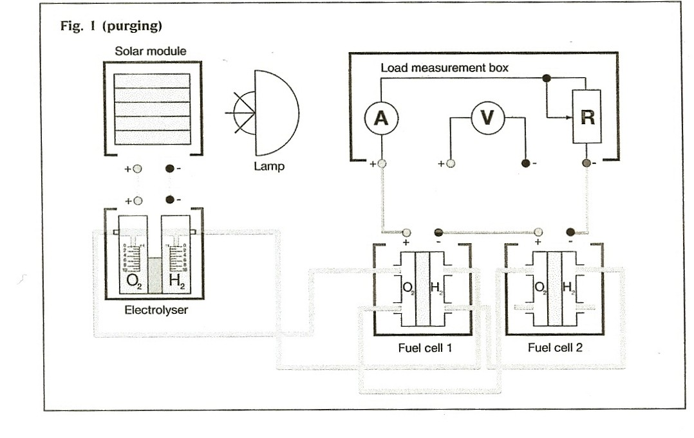

PROCEDURE
  - In order to use the fuel cell as a power source they must be supplied with a constant flow of Hydrogen and Oxygen. This may have been done in advance or by an alternative method. Otherwise proceed as follows.
  - Set up the apparatus as in figure one. Be sure to check the polarity of the electrolyser.
  - Ensure that the gas tubes between the electrolyser and the fuel cells are correctly connected. Set switch on load measurement box to “Open”.
  - With both gas storage cylinders filled to the 0 ml mark illuminate the solar module so as to set a constant current of 200-250 mA as indicated on the load measurement box. The lamp must be positioned towards the lamp in order to produce gas that can be clearly observed but not close enough to over heat the module. (> 20cm)
  - Purge the system for 10 minutes with the gases produced. Then set the switch to 3Ω for 3 minutes. Then set switch to “Open” and purge for another 5 minutes.
  - Stop the power supply to the electrolyser and stopper the two short tubes at the gas outlets of fuel cell 2.

Westminster College SIM

  - Reconnect the power supply and store gases in the cylinders of the electrolyser. When the hydrogen cylinder reaches the 10 ml mark disconnect the power supply.
  - Disconnect the leads between the solar module and the electrolyser and use them to connect the voltmeter of the measurement box to the fuel cell. You can now record the characteristic curve of two fuel cells in series.
  - Construct the circuit as designed previously using the fuel cells in series as the voltage source (with the outlets of the electrolyser supplying gas to the fuel cells). Check that the apparatus gives readings over a suitable range.
  - Vary the value of the load resistor and investigate how the emf and current vary as the value of the resistance is changed. Also take measurements using the motor and lamp as loads.
  - Record your data in a suitable table either on paper or in a computer spreadsheet.
  - Repeat the entire investigation for two fuel cells connected in parallel.

QUESTIONS

- Plot the characteristic curve for the fuel cells in series and for the fuel cells in parallel. Comment on the shape of the curves. Also comment on the values obtained for the motor and lamp.

- Did you make any changes to your original plan and, if so, why?

- A lamp cannot be lit using a singe fuel cell but lights when supplied by two fuel cells in series. It does not however light when supplied by two fuel cells connected in parallel. Why?

- Can you suggest any improvements for this experiment?

