

**Appendix C**

**Blackline Masters**

|  |  |  |  |  |  |  |  |  |  |  |  |  |  |  |  |  |  |
| --- | --- | --- | --- | --- | --- | --- | --- | --- | --- | --- | --- | --- | --- | --- | --- | --- | --- |
|  |  |  |  |  |  |  |  |  |  |  |  |  |  |  |  |  |  |
|  |  |  |  |  |  |  |  |  |  |  |  |  |  |  |  |  |  |
|  |  |  |  |  |  |  |  |  |  |  |  |  |  |  |  |  |  |
|  |  |  |  |  |  |  |  |  |  |  |  |  |  |  |  |  |  |
|  |  |  |  |  |  |  |  |  |  |  |  |  |  |  |  |  |  |
|  |  |  |  |  |  |  |  |  |  |  |  |  |  |  |  |  |  |
|  |  |  |  |  |  |  |  |  |  |  |  |  |  |  |  |  |  |
|  |  |  |  |  |  |  |  |  |  |  |  |  |  |  |  |  |  |
|  |  |  |  |  |  |  |  |  |  |  |  |  |  |  |  |  |  |
|  |  |  |  |  |  |  |  |  |  |  |  |  |  |  |  |  |  |
|  |  |  |  |  |  |  |  |  |  |  |  |  |  |  |  |  |  |
|  |  |  |  |  |  |  |  |  |  |  |  |  |  |  |  |  |  |
|  |  |  |  |  |  |  |  |  |  |  |  |  |  |  |  |  |  |
|  |  |  |  |  |  |  |  |  |  |  |  |  |  |  |  |  |  |
|  |  |  |  |  |  |  |  |  |  |  |  |  |  |  |  |  |  |
|  |  |  |  |  |  |  |  |  |  |  |  |  |  |  |  |  |  |
|  |  |  |  |  |  |  |  |  |  |  |  |  |  |  |  |  |  |
|  |  |  |  |  |  |  |  |  |  |  |  |  |  |  |  |  |  |
|  |  |  |  |  |  |  |  |  |  |  |  |  |  |  |  |  |  |
|  |  |  |  |  |  |  |  |  |  |  |  |  |  |  |  |  |  |
|  |  |  |  |  |  |  |  |  |  |  |  |  |  |  |  |  |  |
|  |  |  |  |  |  |  |  |  |  |  |  |  |  |  |  |  |  |
|  |  |  |  |  |  |  |  |  |  |  |  |  |  |  |  |  |  |
|  |  |  |  |  |  |  |  |  |  |  |  |  |  |  |  |  |  |

Wisconsin Fast Plants™ Growth Graph

Height of Plant in Centimeters

0

11

12

13

14

15

16

17

18

19

20

|  |  |  |  |  |  |  |  |  |  |  |  |  |  |  |  |  |  |  |
| --- | --- | --- | --- | --- | --- | --- | --- | --- | --- | --- | --- | --- | --- | --- | --- | --- | --- | --- |
|  |  |  |  |  |  |  |  |  |  |  |  |  |  |  |  |  |  |  |
|  |
|  |  |  |  |  |  |  |  |  |  |
|  |
|  |  |  |  |  |  |  |  |  |  |
|  |
|  |  |  |  |  |  |  |  |  |  |
|  |
|  |  |  |  |  |  |  |  |  |  |
|  |
|  |  |  |  |  |  |  |  |  |  |
|  |
|  |  |  |  |  |  |  |  |  |  |
|  |
|  |  |  |  |  |  |  |  |  |  |
|  |
|  |  |  |  |  |  |  |  |  |  |
|  |
|  |  |  |  |  |  |  |  |  |  |
|  |
|  |  |  |  |  |  |  |  |  |  |
|  |
|  | 1 |  |  |  |  |  |  |  |  |
|  |
|  | 9 |  |  |  |  |  |  |  |  |
|  |
|  | 8 |  |  |  |  |  |  |  |  |
|  |
|  | 7 |  |  |  |  |  |  |  |  |
|  |
|  | 6 |  |  |  |  |  |  |  |  |
|  |
|  | 5 |  |  |  |  |  |  |  |  |
|  |
|  | 4 |  |  |  |  |  |  |  |  |
|  |
|  | 3 |  |  |  |  |  |  |  |  |
|  |
|  | 2 |  |  |  |  |  |  |  |  |
|  |
|  | 0 1 |  |  |  |  |  |  |  |  |
|  |
|  | | |  |  |  |  |  |  |  |  |  |  |  |  |  |  |  |  |

# Day #

Age of Plant in Days

**Pistil**

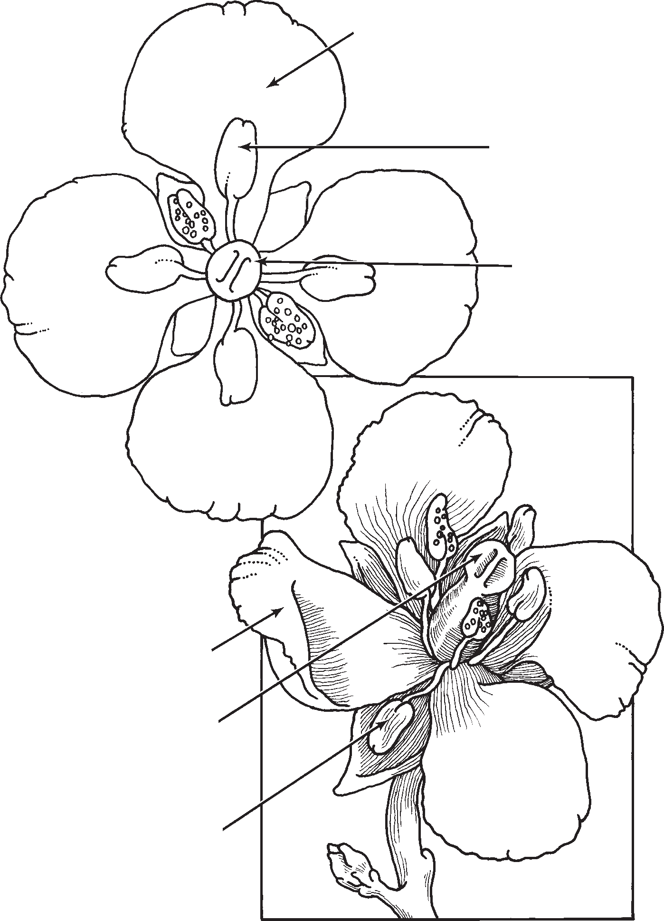

**Petal**

**Anther**

**Stigma**

**Petal**

**Stigma**

**Anther**