Plant Growth and Development
Formative Assessment

Tab 5 / Formative Assessment 25

DISCUSSION

Multiple Choice: Circle the letter of the best answer or answers to the question.

Which of the following does not go through a life cycle?
- A bee
- Wisconsin Fast Plant
- A bean
- A rock

DISCUSSION

The figure below shows stages in the life cycle of a Wisconsin Fast Plant.
Which stage is missing from this life cycle of the Wisconsin Fast Plant?
- 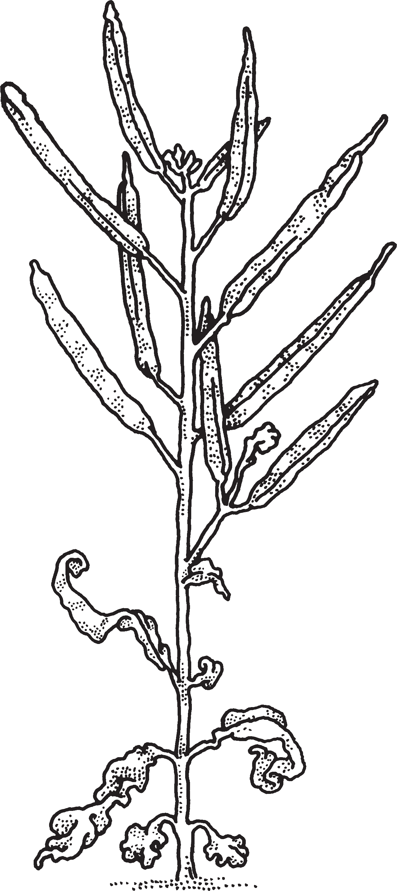A plant with pods
- A flowering plant and bees
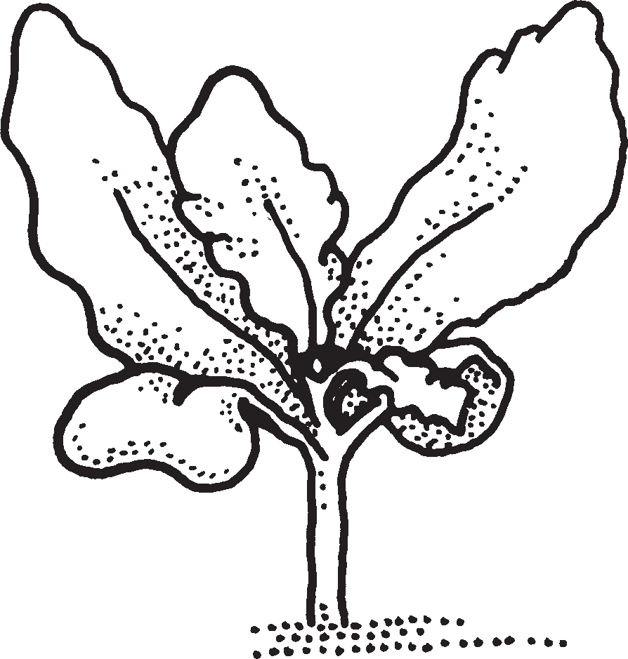
- A seed
- 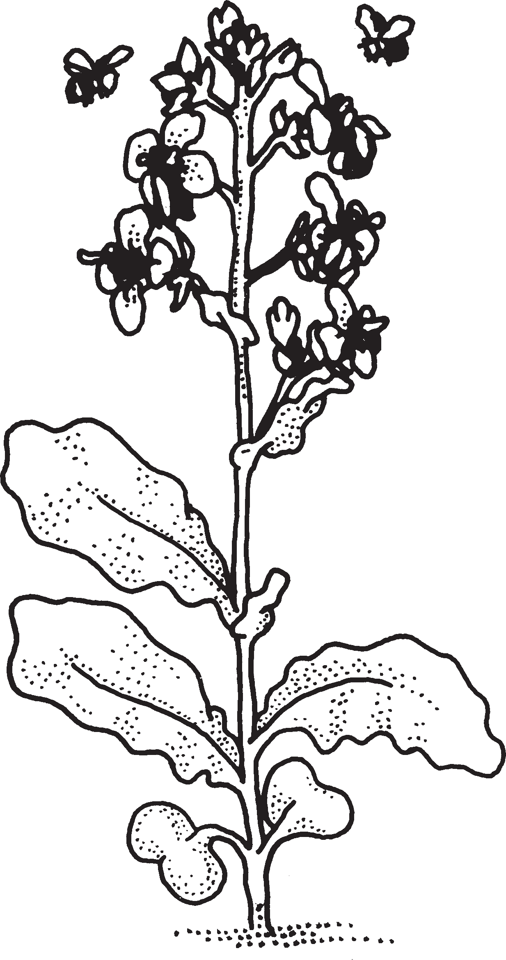A plant with flower buds

DISCUSSION

Multiple Choice: Circle the letter of the best answer or answers to the question.

Measure the line below with a centimeter ruler or centimeter cubes.

Choose the length that best matches that of the line.
- 17 cm
- 70 cm
- 7 cm
- 700 cm

DISCUSSION

Dr. Paul Williams developed the Wisconsin Fast Plant that you are studying. It took him 15 years to make the plant grow as fast as it does! How long does it take the Wisconsin Fast Plant to go through its life cycle?
- 2 weeks
- 6 months
- 2 years
- 6 weeks

DISCUSSION

On the lines below, write sentences that tell about what you used to help your Fast Plants grow. Try to use words from the Word Bank in your sentences.

Word Bank: | fertilizer pellets | potting mix | planter quad
light label | wick  Brassica | seeds toothpick | water mat

DISCUSSION

What is the purpose of pollination?
- It helps the plant make seeds.
- It helps the plant get moisture.
- It helps feed the bee.
- It makes the plant grow taller.

Living things are interdependent; for example, plants depend on bees for pollination.

DISCUSSION

Multiple Choice: Circle the letter of the best answer or answers to the question.

The Wisconsin Fast Plant is a member of a group of plants called crucifers. Crucifer might remind you of the word crucifix, or cross.
How many petals are on a Fast Plant flower?
- 2
- 3
- 4
- 5

Living things are interdependent; for example, plants depend on bees for pollination.

DISCUSSION

What attracts a bee to a flower?
- The flower’s smell.
- The flower’s height.
- The flower’s color.
- The flower’s sound.

Living things are interdependent; for example, plants depend on bees for pollination.

DISCUSSION

Read these steps for making a bee stick. Then put them in the correct order by writing the letters on the three lines below:
- Glue the underside of the bee to the toothpick.
- Let the glue dry for a few minutes.
- Put a very small drop of glue on the end of the toothpick.

Step 1 Step 2 Step 3

Living things are interdependent; for example, plants depend on bees for pollination.

DISCUSSION

On the lines below, describe how you used the bee sticks to pollinate your Brassica plants. Tell why this was an important step in the life cycle of the plants. What might have happened if you did not pollinate the plants?

Living things are interdependent; for example, plants depend on bees for pollination.

DISCUSSION

Multiple Choice: Circle the letter of the best answer or answers to the question.

What is one purpose of a plant’s roots?
- To protect the plant from harm
- To anchor the plant to the ground
- To help the plant get moisture
- To attract bees

Models can be used to identify the structures, functions, and behaviors of living organisms.

DISCUSSION

The diagram below shows the parts of a flowering plant. Label as many of its parts as you can. Use the words from the Word Bank.
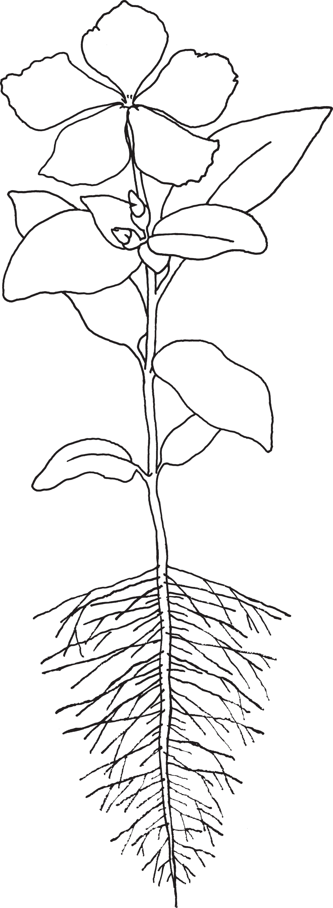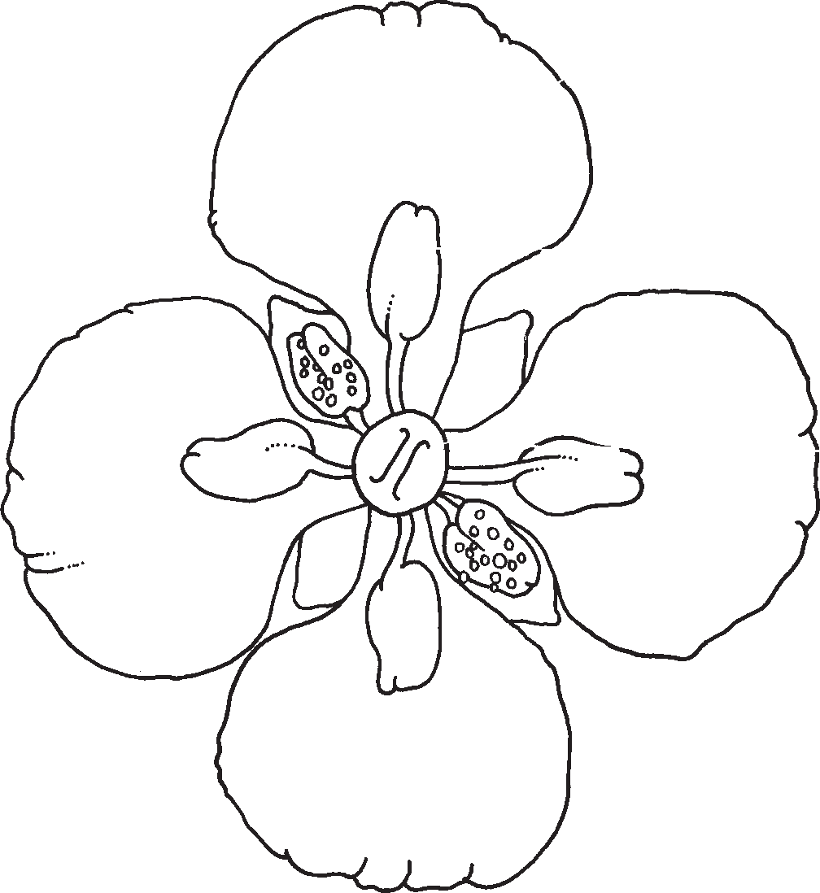
Word Bank:
petal anther
pistil stigma
stem leaf
root pollen
bud seed pod

Models can be used to identify the structures, functions, and behaviors of living organisms.

Question 3.3
Name Date
 |  | DISCUSSION
ctions, | an | d | beh | avior | s

The diagram below shows the body parts of a bee. Use the Word Bank to help you to label all the bee’s body parts.

Word Bank: | head | thorax | abdomen | antenna
 | eyes | legs | wings

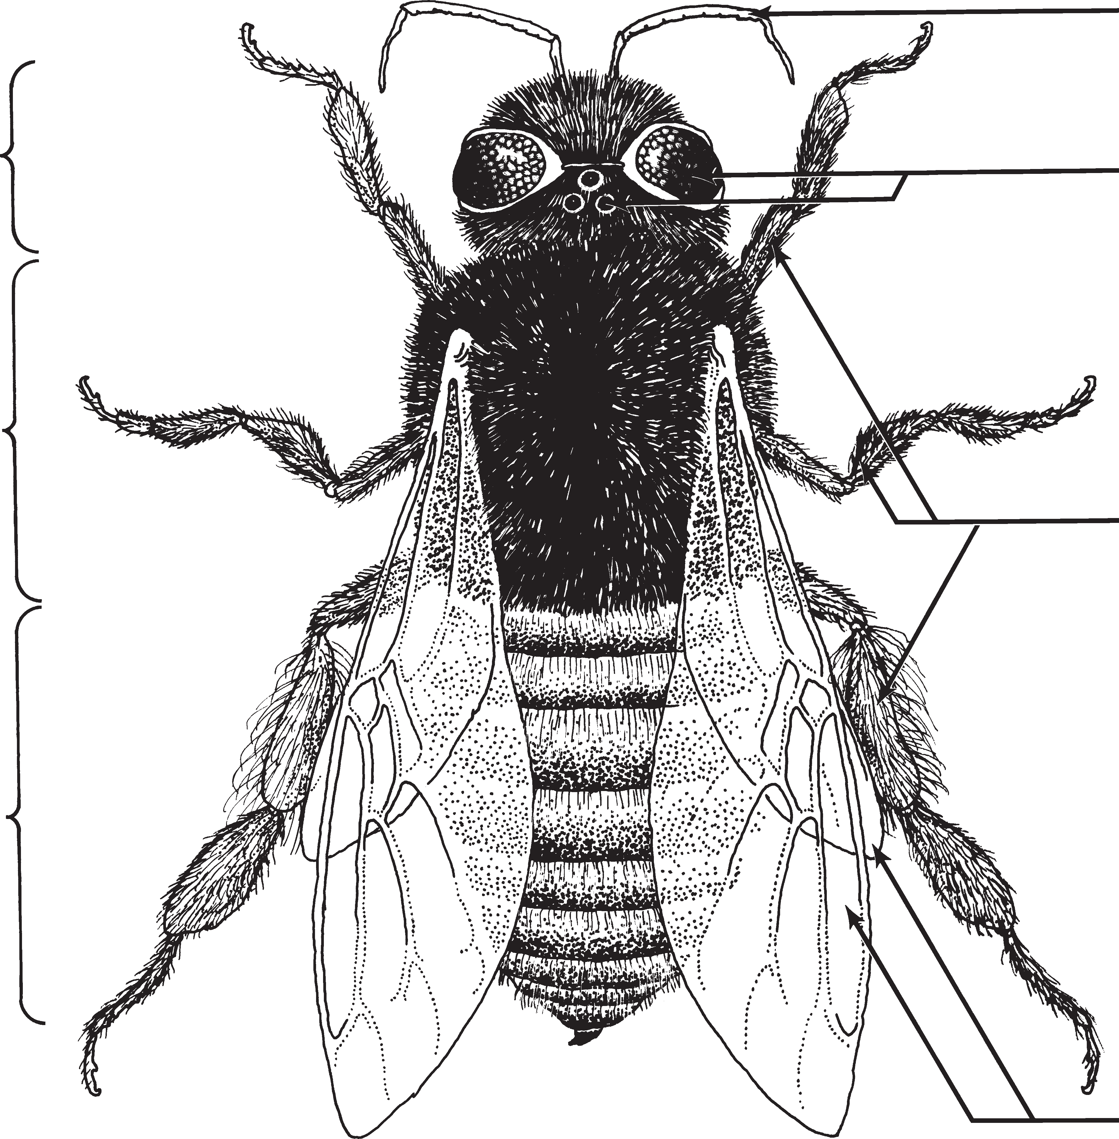

Models | can | be | used | to | identify | the | structures, | fun
of living |  | organisms.

STC™ / Plant Growth and Development Subconcept 3 / Qu

DISCUSSION

Choose three body parts from the Word Bank below. Tell how each part helps a bee pollinate a flower.
honey stomach
antenna
eyes
wings
legs
Word Bank: hairy body
tongue

Body Part How it Helps the Bee Pollinate a Flower

Models can be used to identify the structures,functions,and behaviors of living organisms.

DISCUSSION

Multiple Choice: Circle the letter of the best answer or answers to the question.

Use the notebook entry below to answer the question.
- She lands on a yellow petal.
- Her body brushes against the sticky anther and pollen sticks to her.
- Her honey stomach is not full yet, so she is off to another flower.

A student wrote the notes shown above while learning about an organism. What organism was the student studying?
- Cricket
- Bee
- Bird

Records, notes, and graphs help people understand how plants move through the life cycle and what factors affect their growth and development.

DISCUSSION

This data table shows how many seed pods developed on three Brassica plants. Study the table. Circle the letter of any sentence that is true.

Plant | Number of Seed pods on Plant | Number of Seeds per Pod
1 | 17 | 7
2 | 10 | 8
3 | 5 | 0

- Plant 3 may not have been pollinated.
- From 1 seed, plant 2 produces 80 seeds.
- Plant 2 may not have been pollinated.
- Plant 2 produced more seeds than plant 1.

Records, notes, and graphs help people understand how plants move through the life cycle and what factors affect their growth and development.

DISCUSSION

Use data from this table to make a graph. The Word Bank lists the parts of a complete graph.

Plant | Number of Seed pods on Plant | Number of Seeds per Pod
1 | 17 | 7
2 | 10 | 8
3 | 5 | 0
Word Bank: axis title key labels numbers

Records, notes, and graphs help people understand how plants move through the life cycle and what factors affect their growth and development.

DISCUSSION

Look at the graph. Then circle the letter of any correct sentence.

Seeds I Ate Today
Type of Seed

Corn
Lima beans
Peanuts
 | 1 | 2 | 3 | 4 | 5
Number of Seeds

- The graph shows that I ate no lima beans.
- I ate more peanuts than corn seeds.
- I ate fewer peanuts than corn seeds.
- Lima beans are all I like to eat.

Records, notes, and graphs help people understand how plants move through the life cycle and what factors affect their growth and development.

DISCUSSION

Multiple Choice: Circle the letter of the best answer or answers to the question.

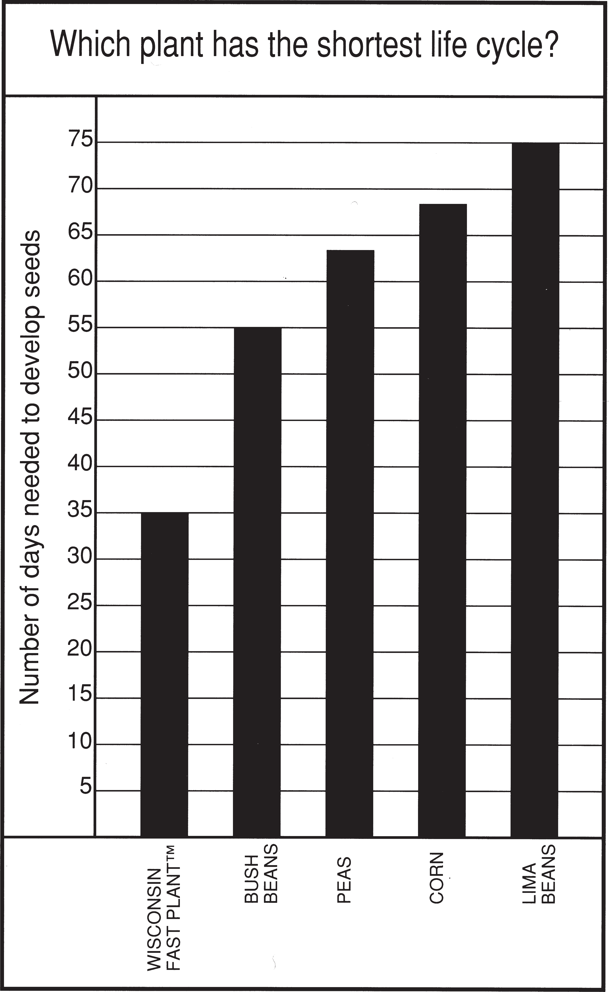
Look at the graph. Then circle the letter of any correct sentence.
- The graph shows that lima beans grow taller than Fast Plants.
- It takes about 69 days for corn seeds to develop.
- Another good title for this graph would be “Which Plant Has the Longest Life Cycle?”
- If someone planted lima beans in May, they could eat them in June.

Records, notes, and graphs help people understand how plants move through the life cycle and what factors affect their growth and development.

