**A Crucifer Survey**

The crucifers are an important food crop in many parts of the world. Which ones have you tasted?

Cabbage Turnip Collard Watercress Kohlrabi Choy Sum Cauliflower

**CRUCIFERS**

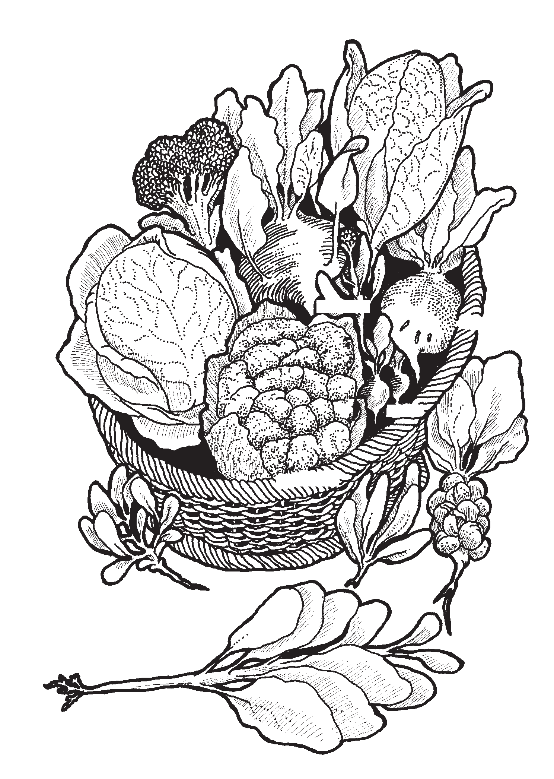**Broccoli**

**Cabbage**

**Kohlrabi**

**Chinese cabbage**

Broccoli Rutabaga Radish Kale

Horseradish

Pak choi

(Chinese mustard)

Brussels sprouts Mustard greens

**Pak choi**

**Collards**

**Choy sum Turnip**

**Radish**

**Cauliflower**

**Mustard**

**greens**

**Brussels sprouts**

**59**



Some crucifer seeds are crushed for their oil. Others, like turnips, kale and rutabagas, are good food for sheep and cattle as well as for people. Still others, like alyssum and candytuft, are known for their beautiful flowers. There is even a branch of “bad guys” in the family, some pesky weeds!

**Lesson 10 / Looking at Flowers**