LESSON
10
58
LESSON
10

The Crucifer Family
Reading Selection
It may seem odd to you that your plant belongs to a family, but it’s true. Of course, it’s not the kind of family with aunts and cousins and sisters. Think of it more as a group of plants that are alike in some ways.
Your Brassica plant belongs to the crucifer family. Crucifers have one thing in common. This feature gives the plants their family name. Here is a hint. The shape of their flowers is always like this:

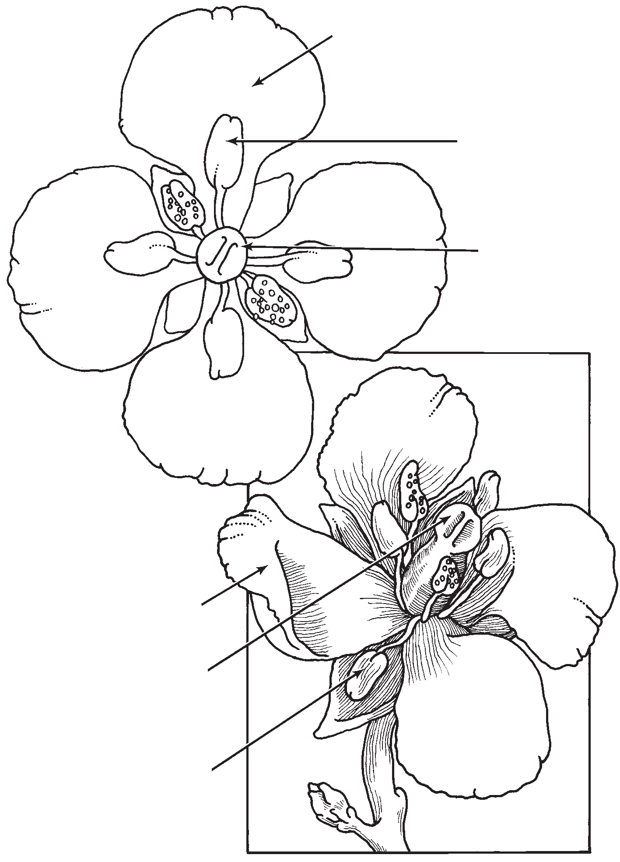Did you figure out how the crucifer family got its name? The reason is that the crucifer flower always has four petals arranged in a cross. Scientists group all these flowers into the crucifer family.

Petal

Anther

Stigma

Pistil
Petal Stigma

Anther

STC™ / Plant Growth and Development

