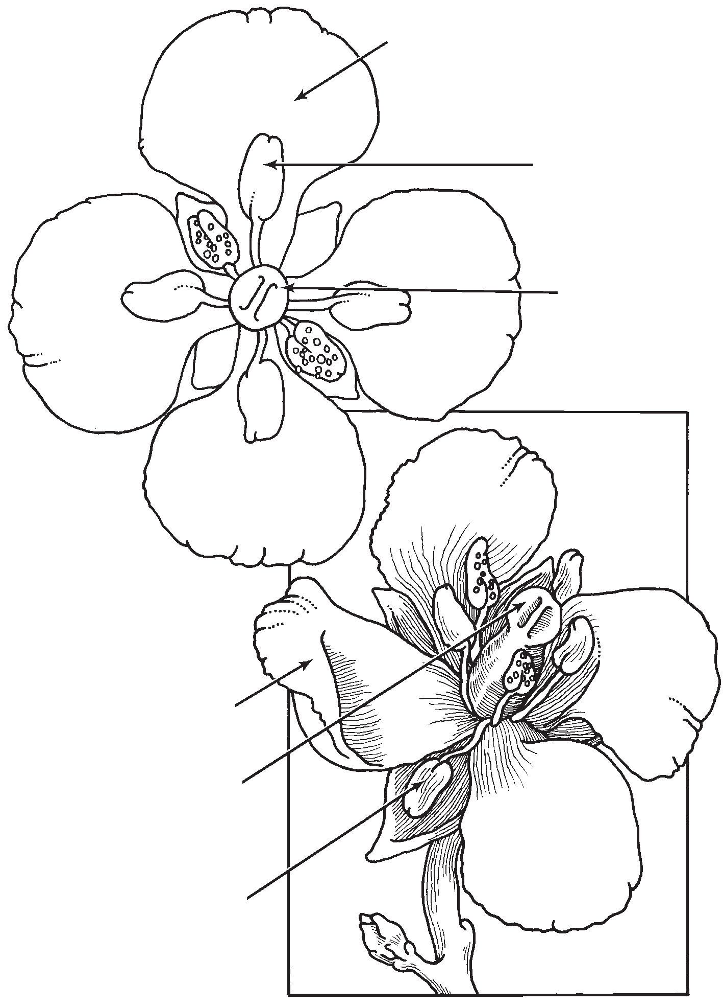
67
LESSON
11
Anther

Petal

Stigma
Pistil
Stigma
Anther
Petal

The Bee and the Brassica: Interdependence
Reading Selection
Bees and Brassica plants need each other in order to live. Each one takes something from the other and gives something in return. You might say that they have a real partnership.
Why does a flower need a bee? The main reason is so that the flower can make seeds. The Brassica flower holds both the male and the female parts of the plant. The male parts, the filament and anther, produce the pollen, which looks like fine yellow powder. Pollen must travel to the female parts, the pistil and stigma, of another flower on a different Brassica plant. Unless the pollen from one plant can reach another plant,
no new seeds form. Then, no new
Brassica seedlings will grow.
So it is very important that the pollen get from one plant to another. But the problem is that the pollen is sticky and cannot easily travel in the wind. How can the pollen travel? That’s where the worker bee comes in. With its bright yellow color and sweet perfume, the flower lures the bee and offers not only one but two kinds of food: nectar and pollen.

Lesson 11 / Pollinating Flowers

Figure 11-1
Bee pollinating a
Brassica flower
The bee’s body is covered with feathery hairs. As the bee dips her head into the flower to sip the sweet nectar deep inside the blossom, her hairy body rubs against the anthers holding the
pollen. Her body traps some of it. When the bee flies off to the next flower, some of the pollen on her body sticks to the stigma there.
Now the bee has done her job. The bee has collected two kinds of food from the flower. At the same time, it has carried pollen from one flower to another. New seeds will form. Soon new flowers will bloom.

Reading Selection
68
LESSON
11

STC™ / Plant Growth and Development

