How to Plant Wisconsin Fast Plants™ Seeds: Activity Sheet 2 Instructions and Checklist
Name Date

Wisconsin Fast Plants™ are special in many ways You must follow special directions when planting the seeds It is very important to follow the directions carefully Do one step at a time Check off each step when you finish it
- 1 Pick up all of your supplies from the distribution station Be sure you have these items before you begin planting:

 | 1 | planter quad
 | 1 | spoon
 | 1 | cup of potting mix
 | 4 | wicks
 | 12 | fertilizer pellets
 | 8 | Wisconsin Fast Plants™ seeds
 | 1 | toothpick
 | 1 | planter label
 | 1 | pair of forceps
 | 1 | paper towel
- 2 Place one wick in each section of the planter quad Use your forceps to pull the wick through the hole until the tip sticks out about 1 centimeter
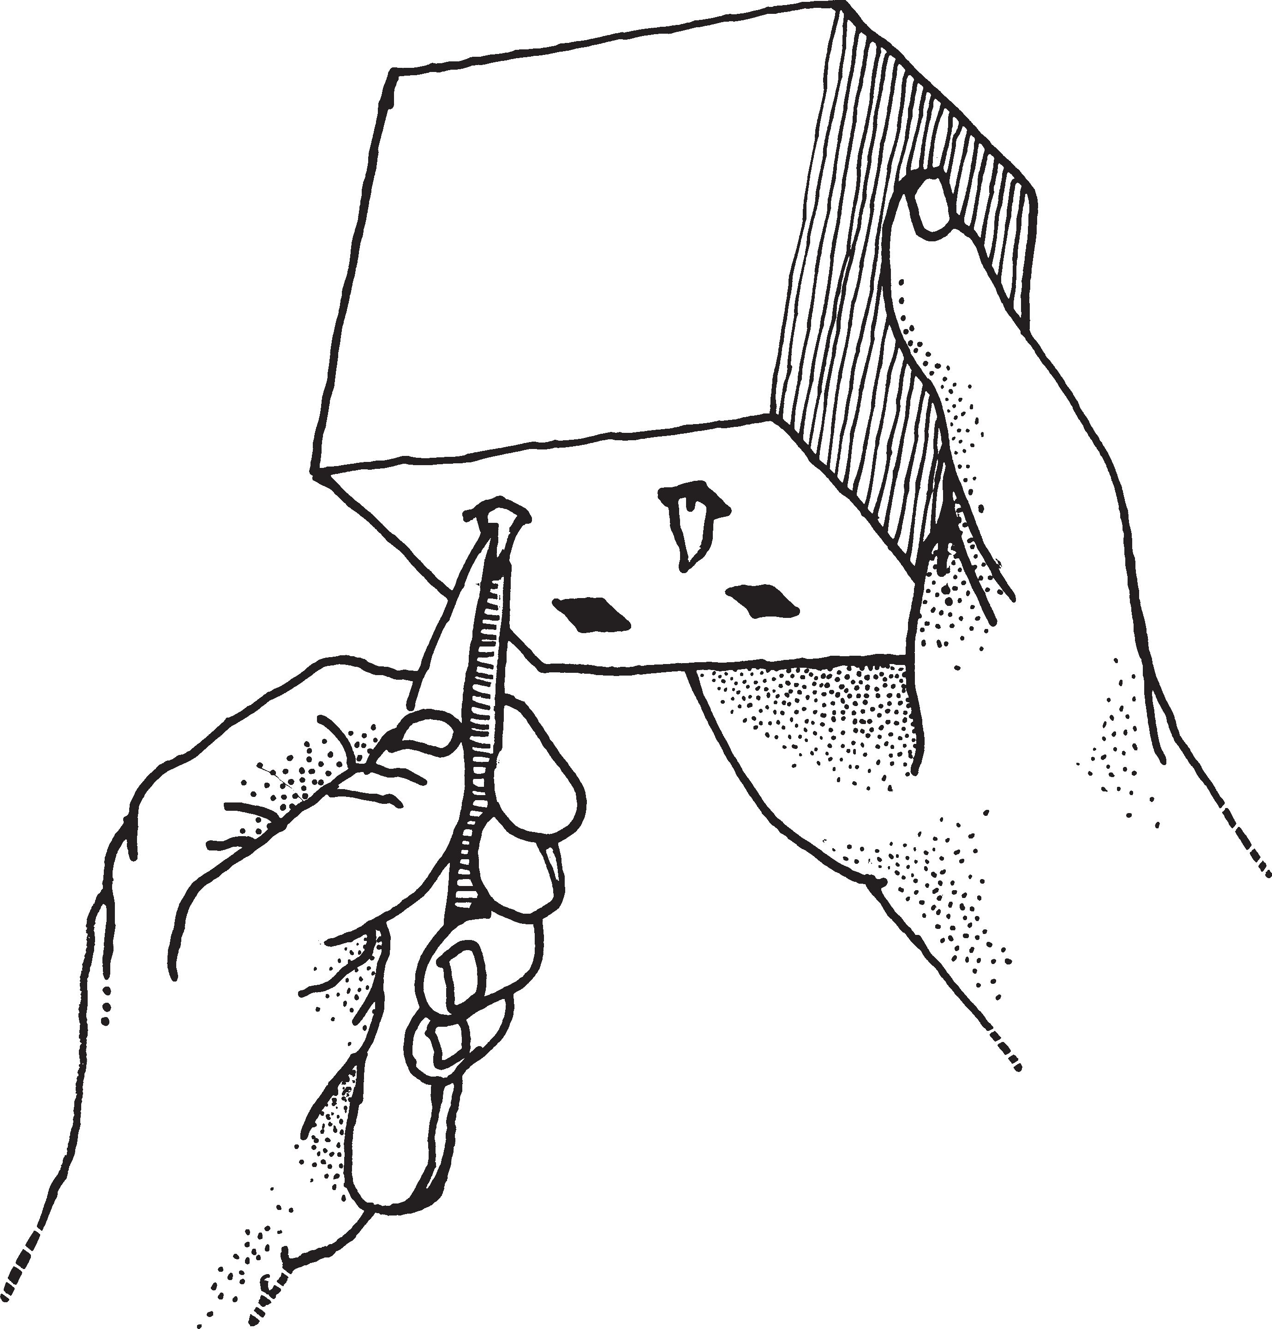

  - 3 Fill each section of the planter quad halfway with potting mix
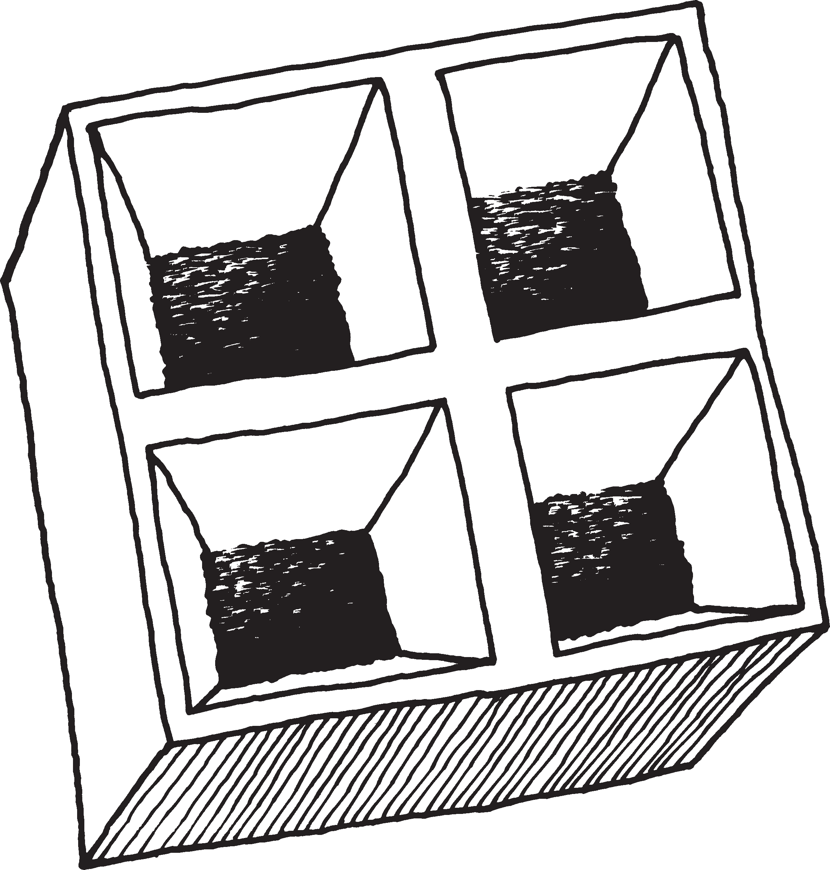
  - 4 Add three fertilizer pellets to each section Look closely The fertilizer pellets are much larger than the seeds
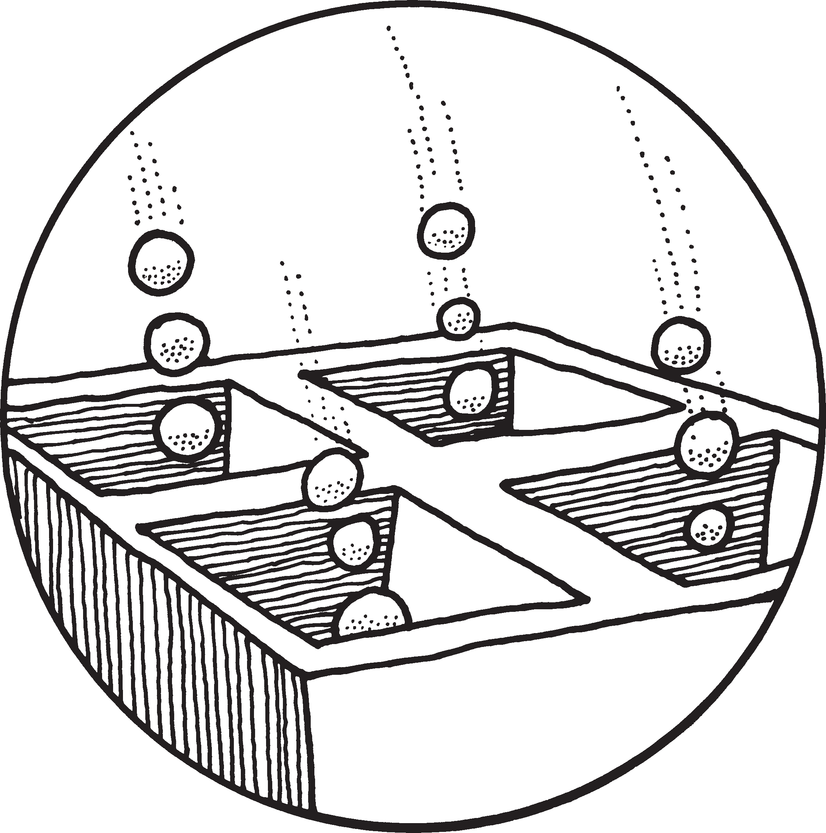
  - 5 Fill each section of the quad to the top with potting mix Press it down a little with your fingers
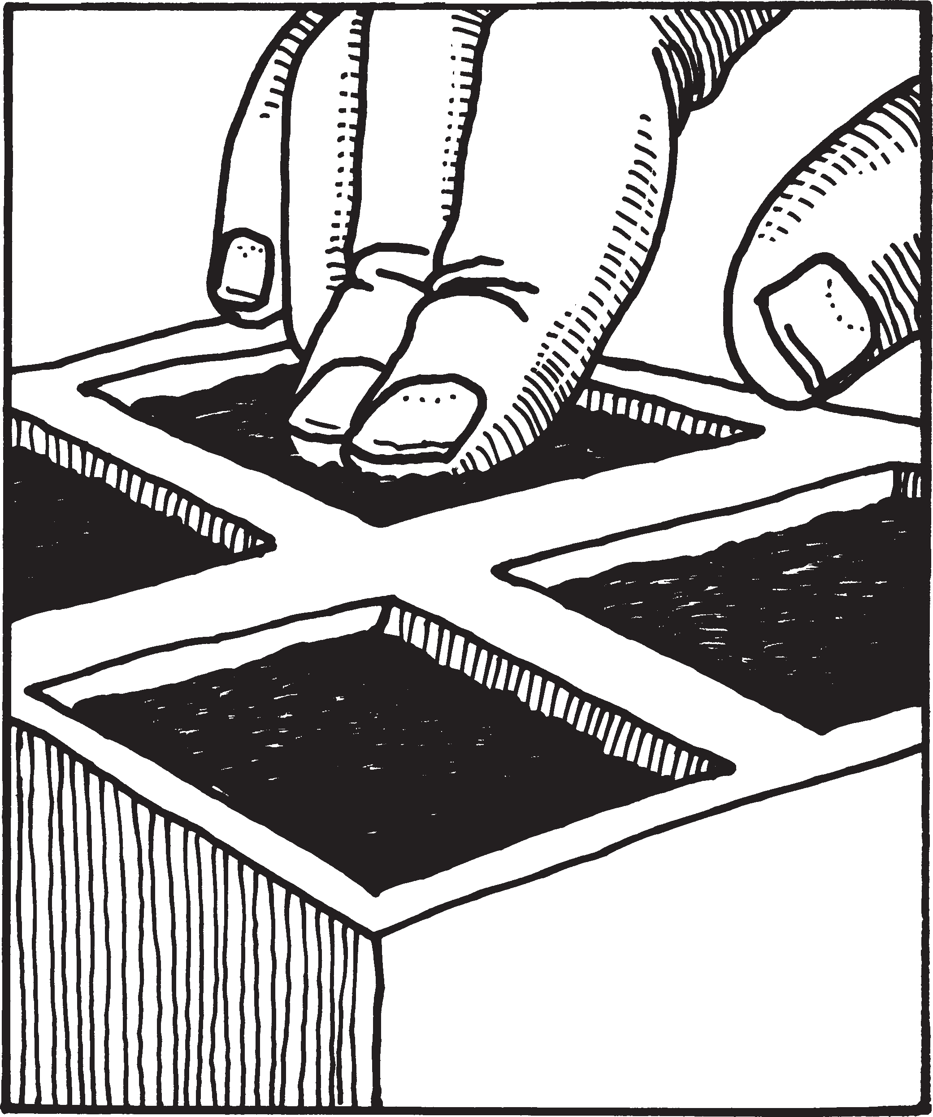

- 6 Put a drop of water on your tray and dip your toothpick in it Use the wet toothpick to pick up one seed Place the seed just below the potting mix and cover it Plant
a second seed in this section in the same way Repeat until there are two seeds in each section of the planter
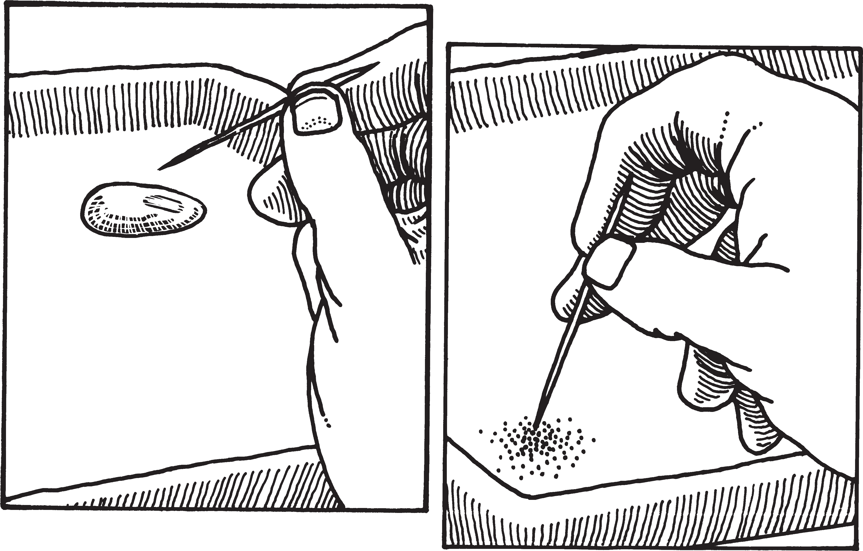
- 7 Water very gently, a drop or two at a time, until water drips from the bottom of each wick
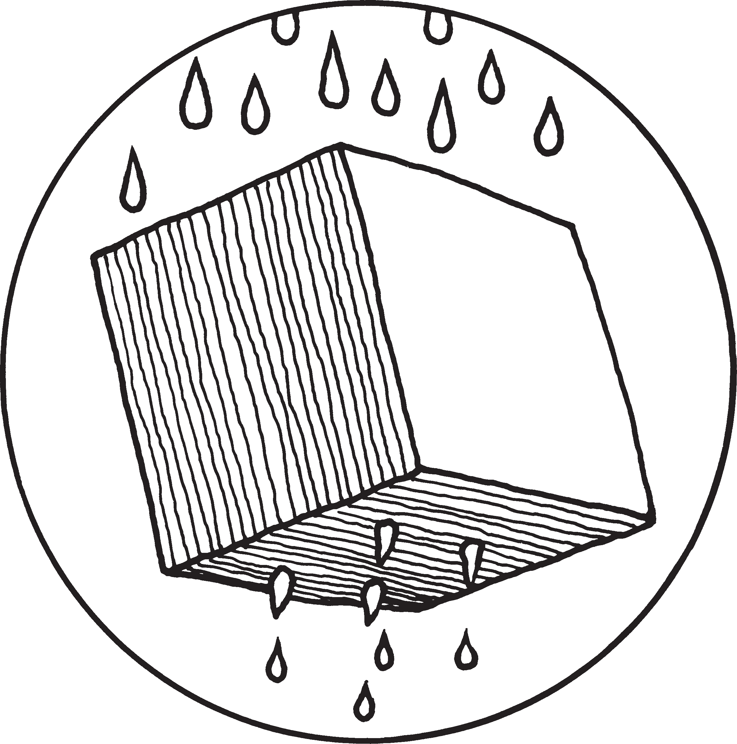
- 8 Write your name and today’s date on the planter label and place it in the planter
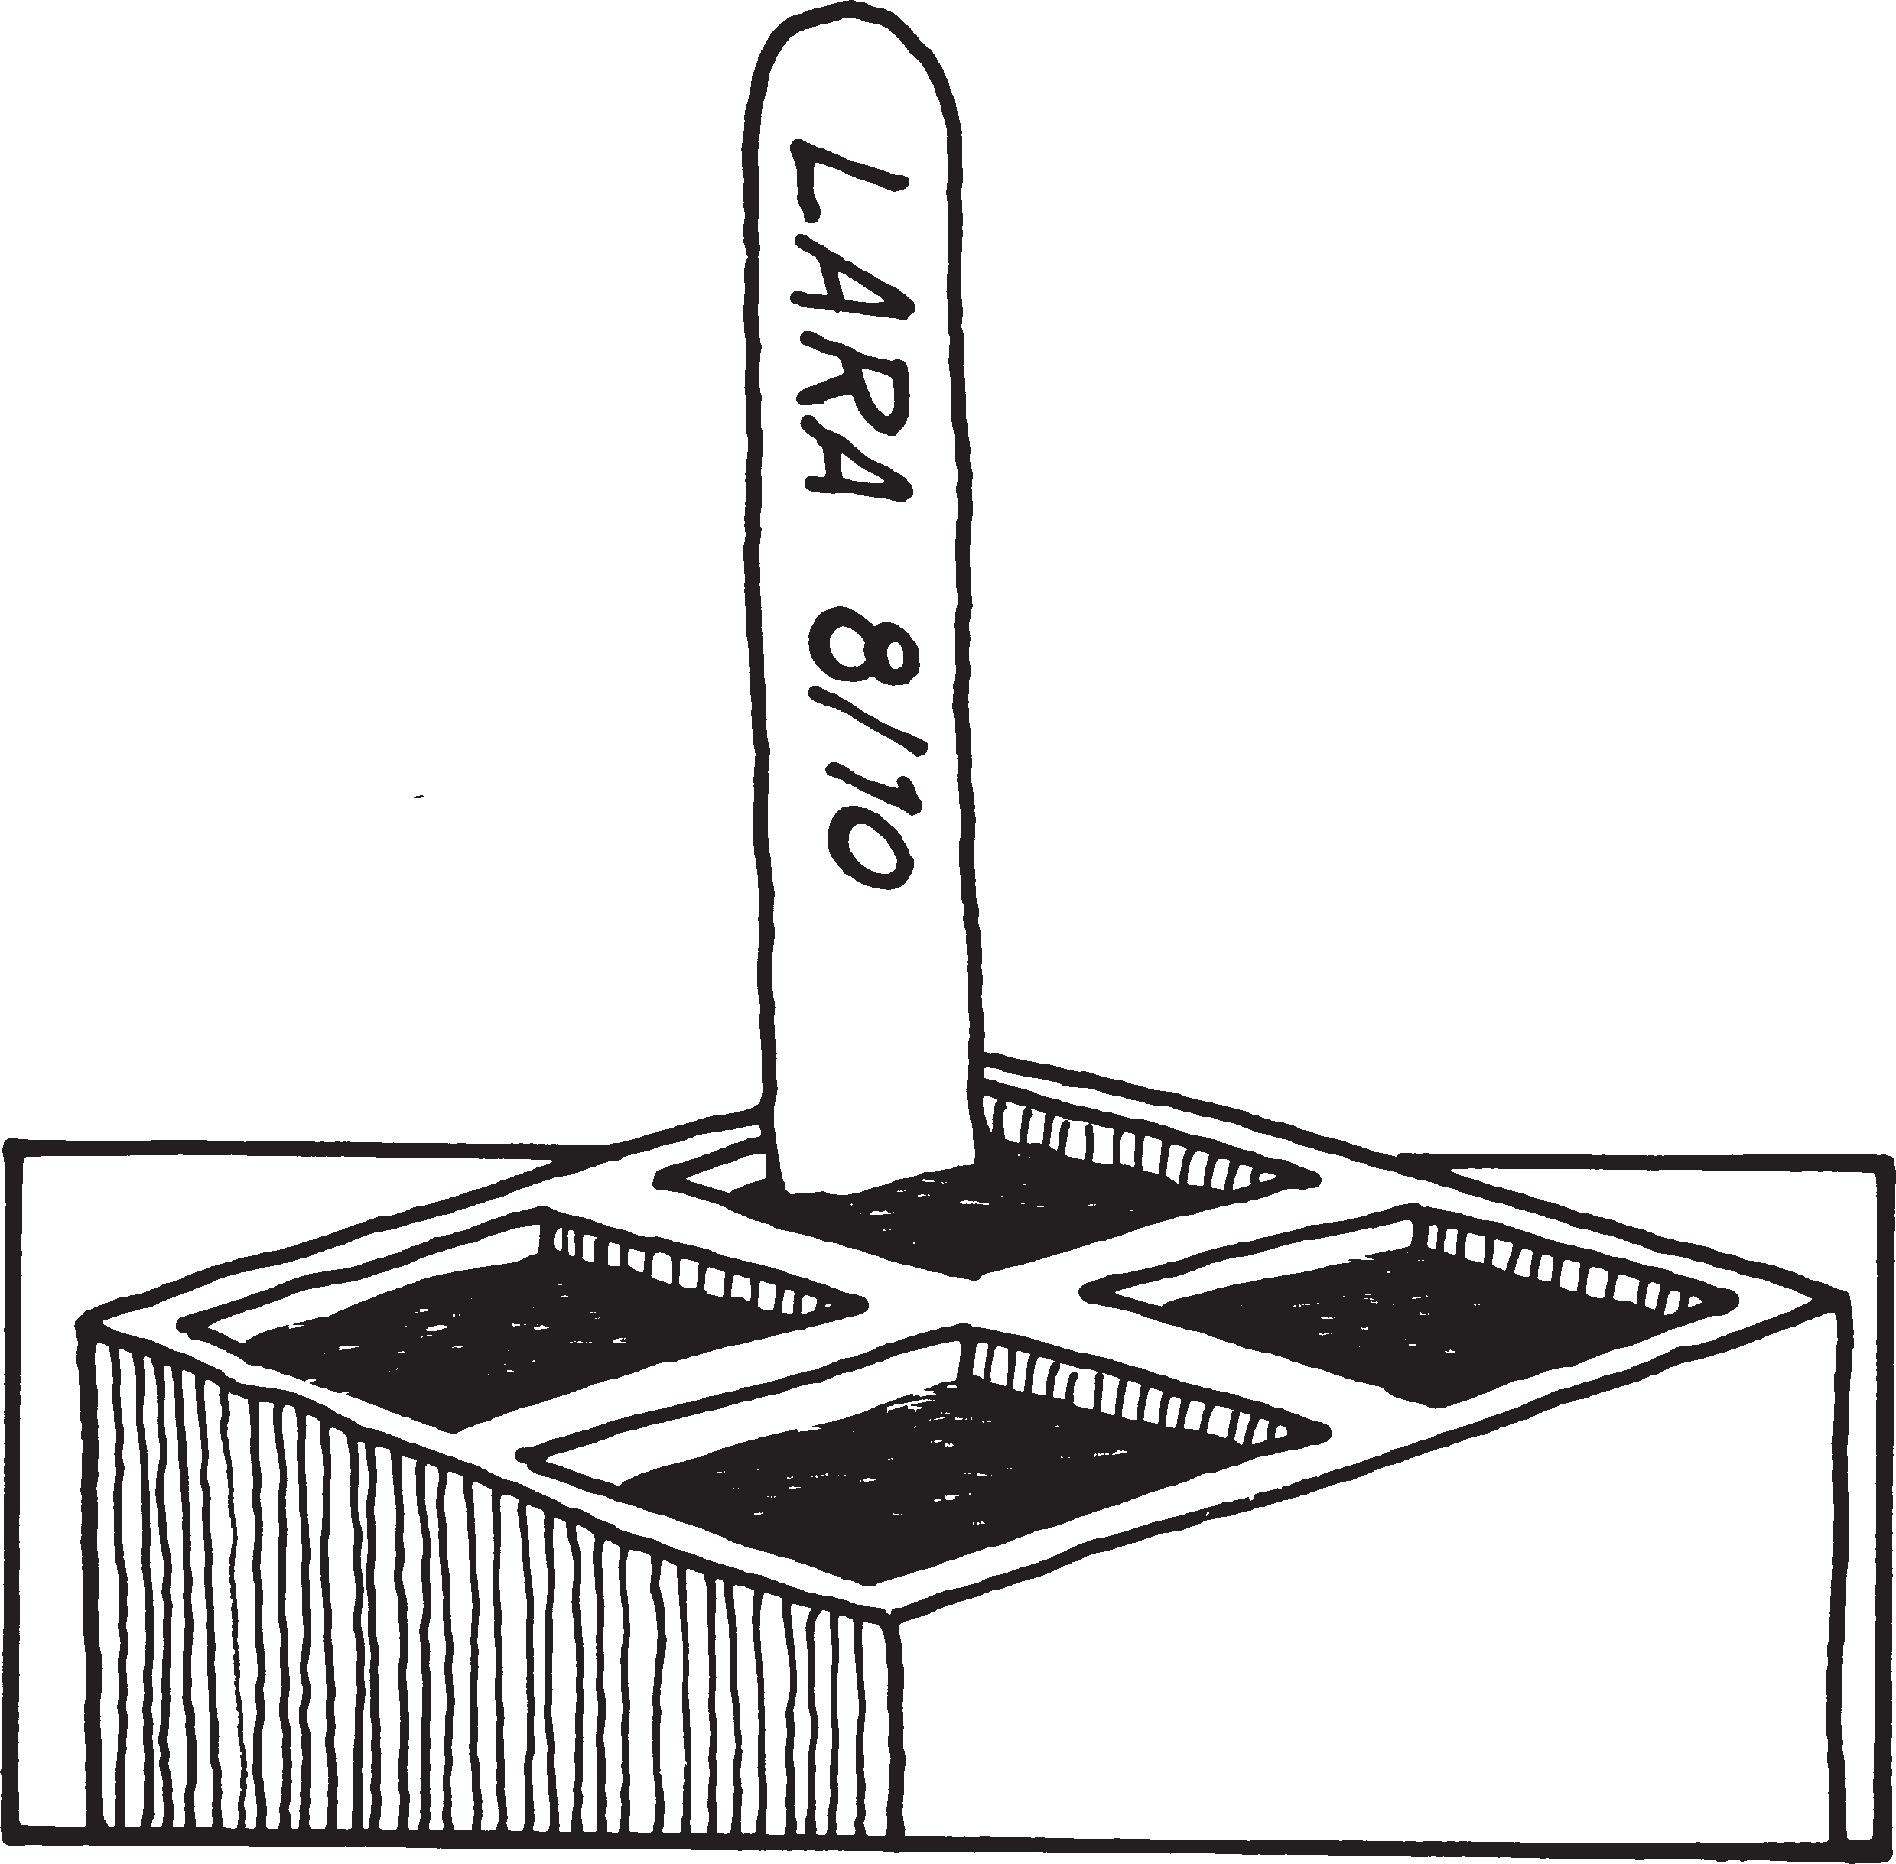

  - 9 Place your quad under the light bank with the label facing out Double-check to see that your planter is completely on the water mat and that the quad is about
2 to 3 inches from the lightbulbs If you could see inside of each planter this is what it would look like

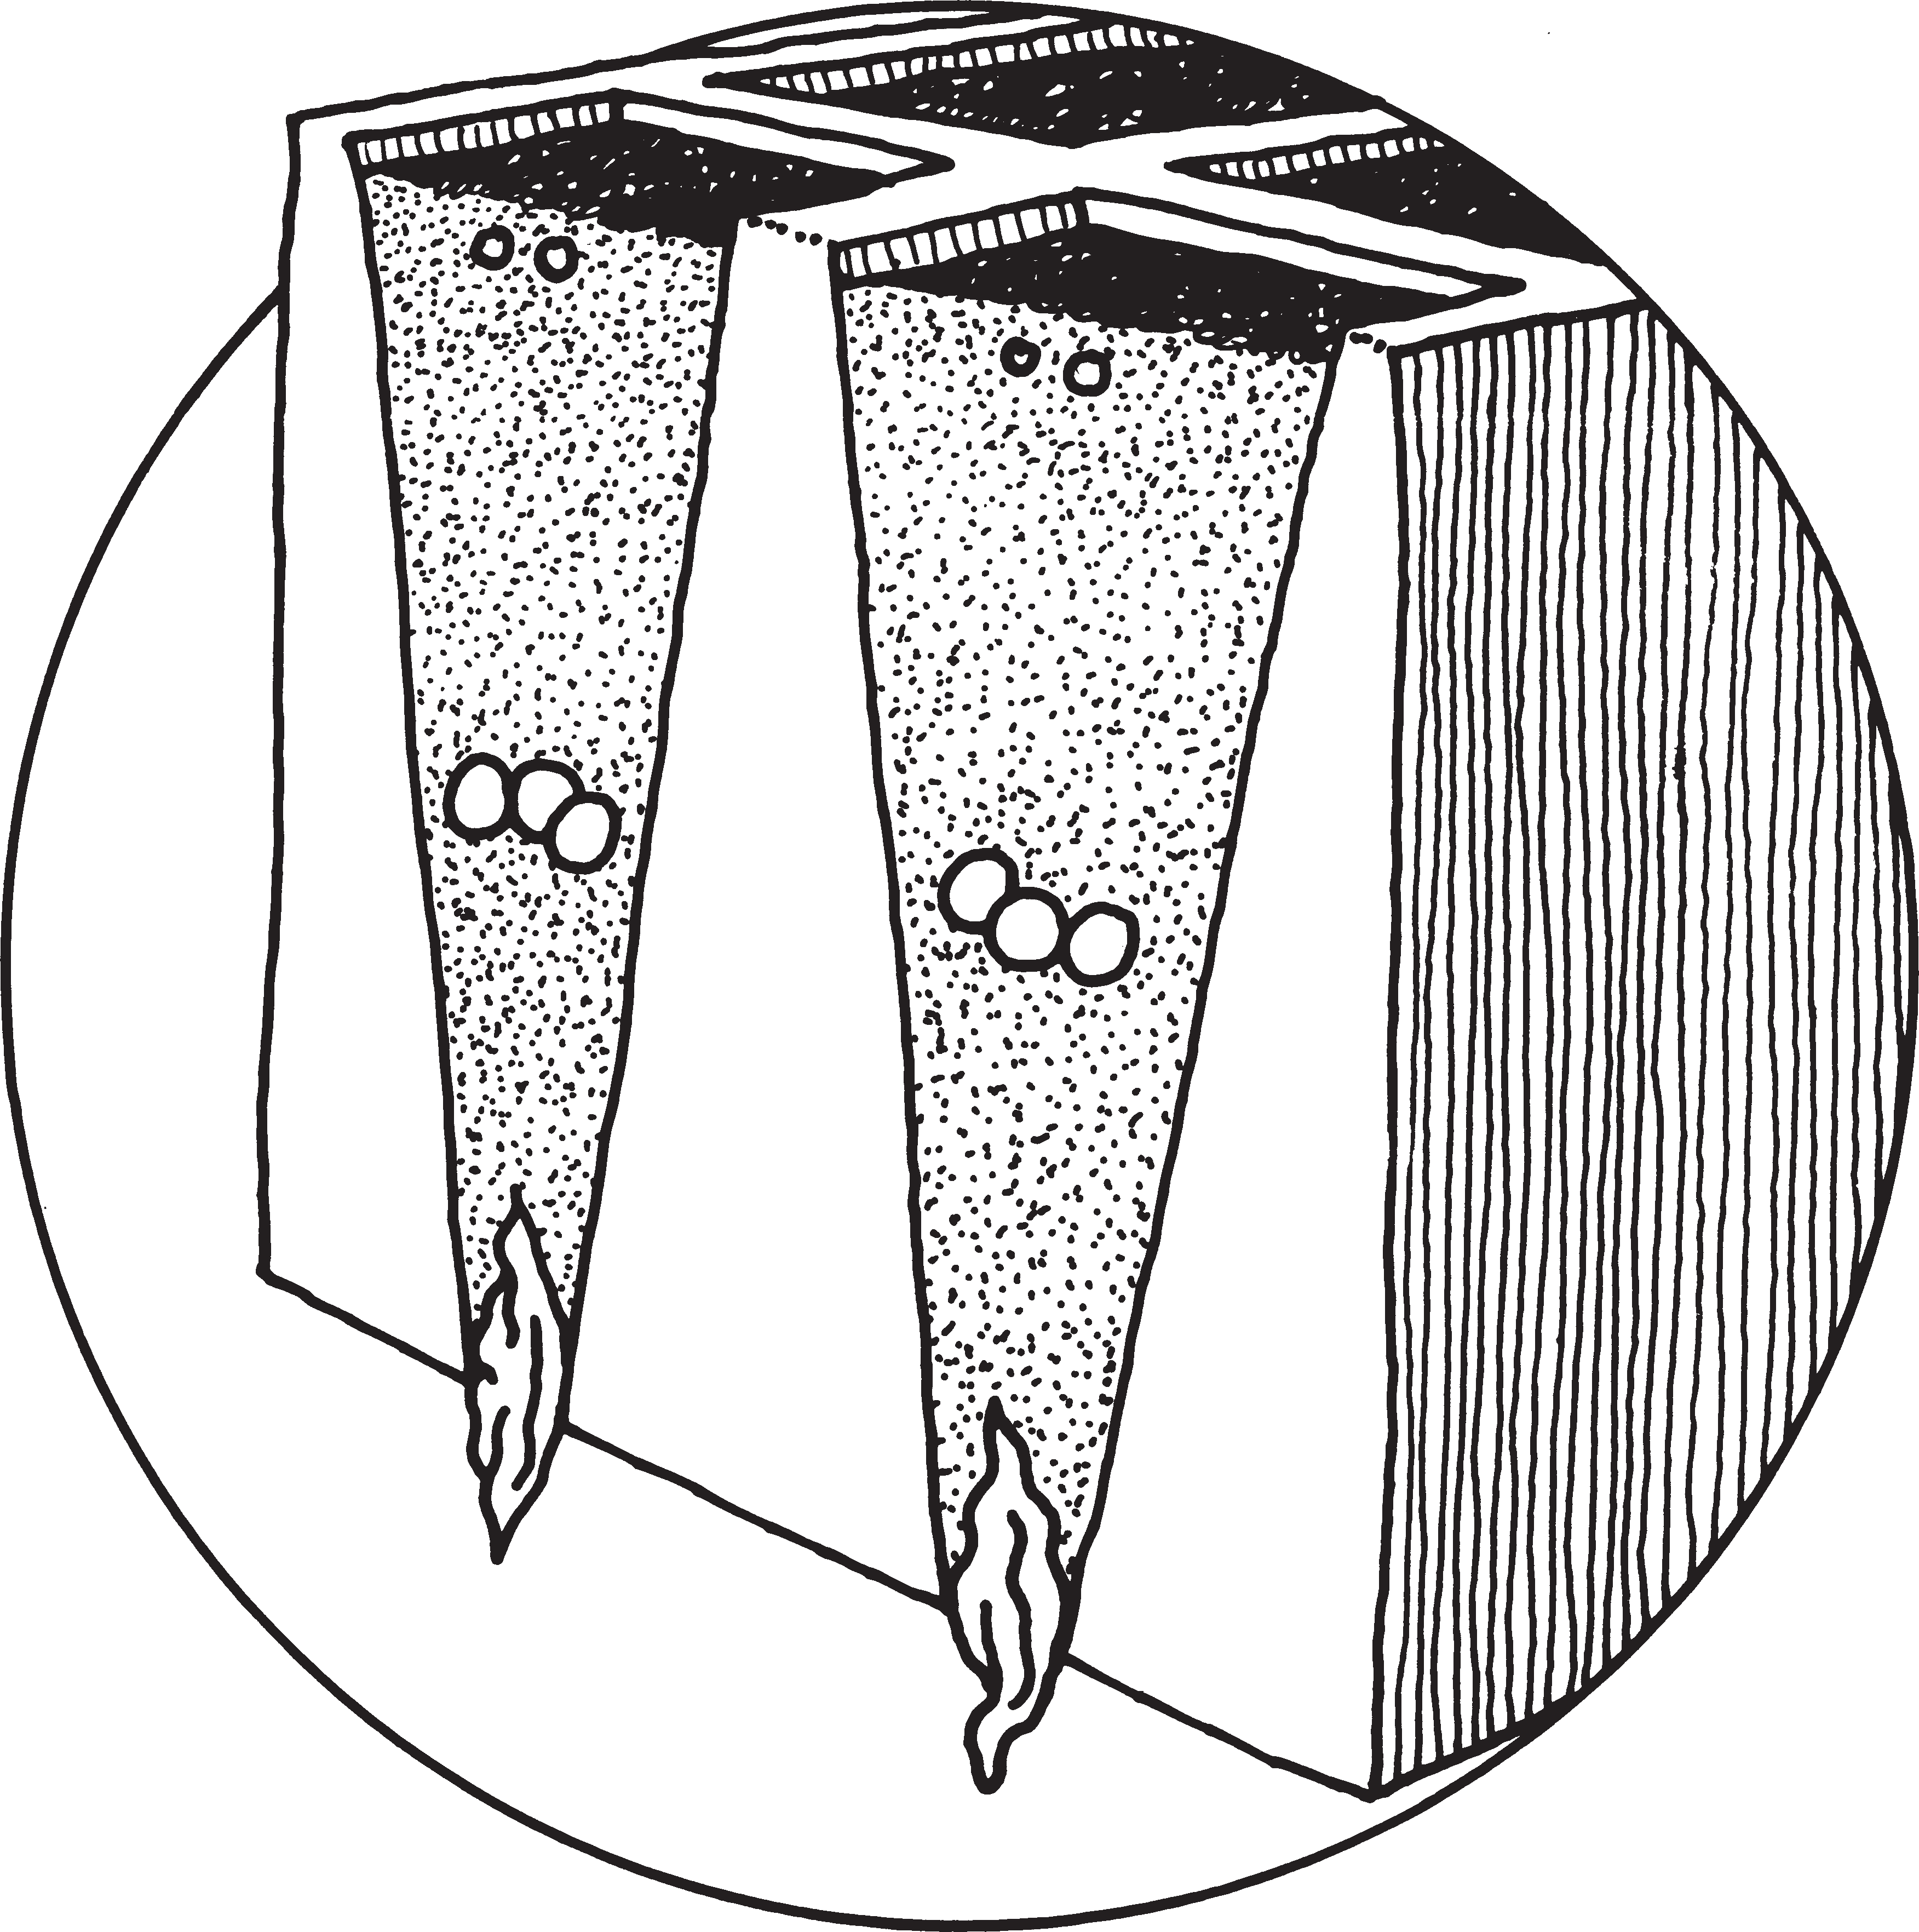Two seeds

Potting mix

Three fertilizer pellets

Potting mix

Wick

  - 10 Return all leftover supplies to the distribution station

11 Clean up your work space.

