How to Make a Bee Stick Activity Sheet 4
53
Name Date

- 1 Check off each item on the supply list to be sure you have everything you need before beginning

1 dried bee 1 cup of glue (for table)

1 toothpick 1 hand lens

1 pair of forceps 1 cup (for table)

- 2 Observe the bee with the hand lens Turn the bee over Find the place where the legs are attached
- 3 Put a very small drop of glue on one end of the toothpick
- 4 Glue the underside of the bee (where the legs are) to the toothpick Make sure the head is at the end
- 5 Let the glue dry for a few minutes Be careful that the bee does not slip down the stick
- 6 Now, take the time to really observe the bee closely How many body parts can you find? Check off each one
Note: Some bees may be damaged and not have all parts Ask a classmate to share if your bee is not complete
- 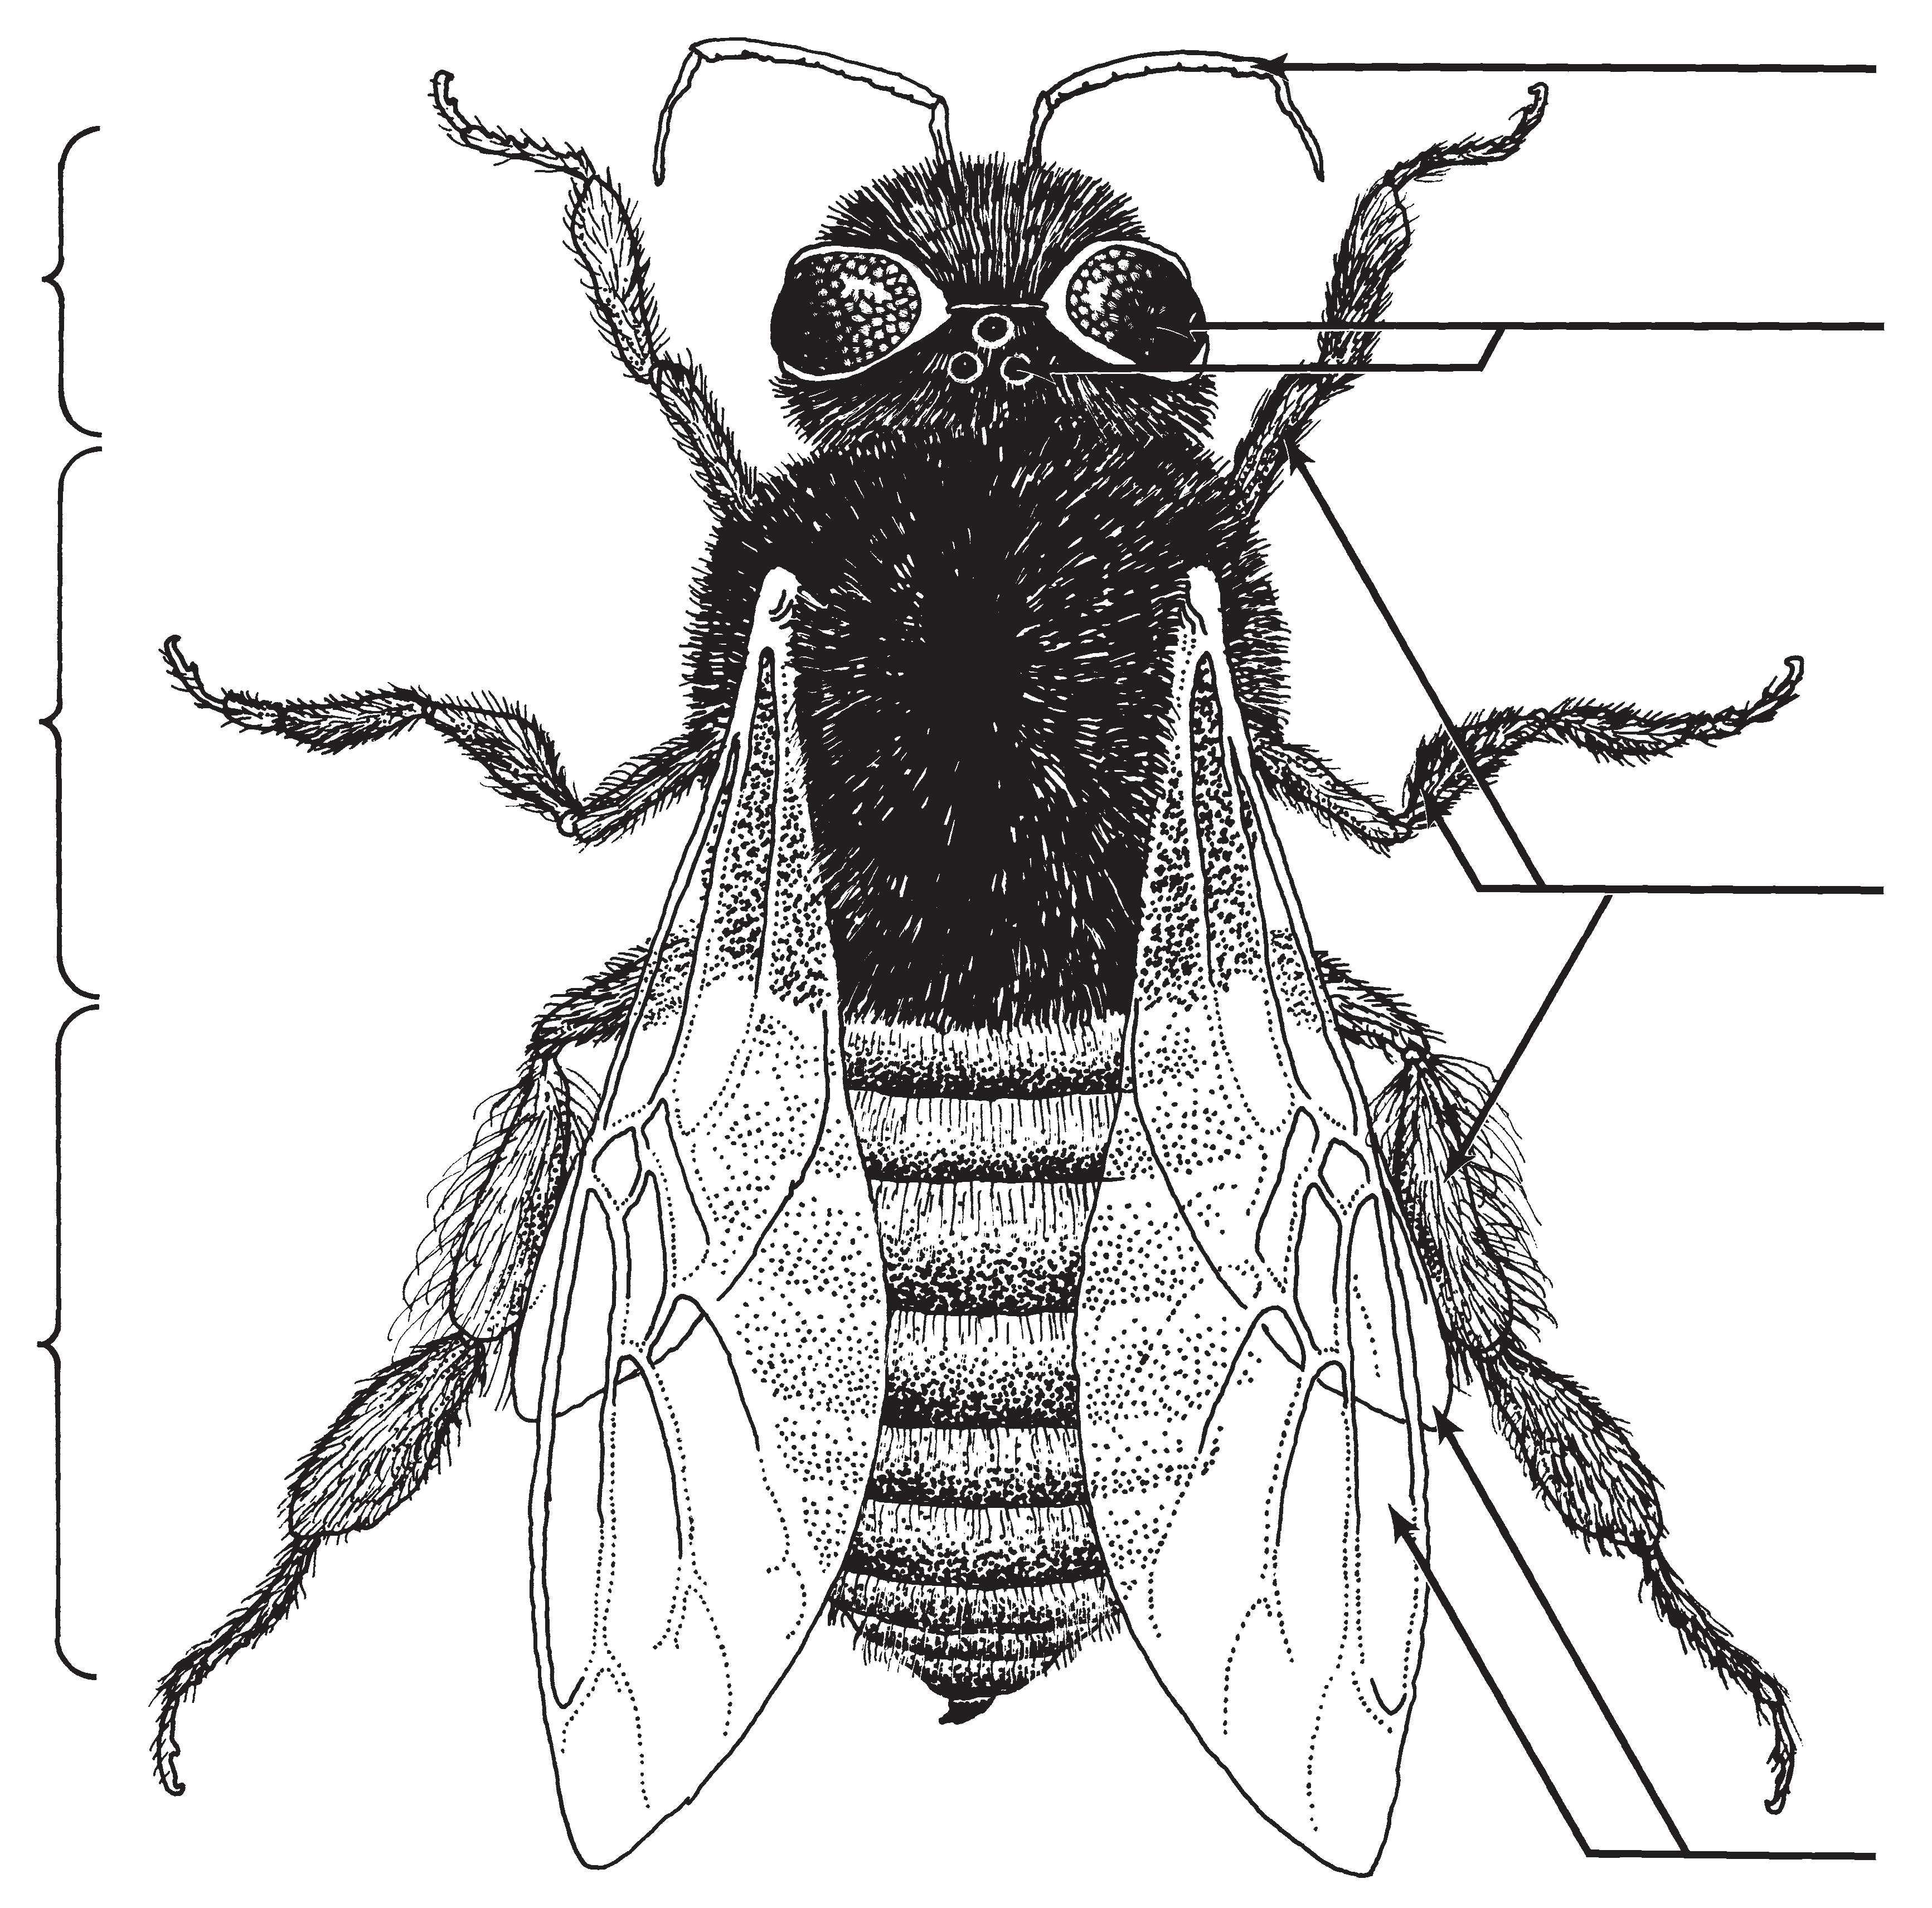7 Push the bee stick into the bottom of an upside-down paper cup There is one cup for each table Leave the cup at your table Your teacher will store the cups
Wings
Abdomen
Legs
Thorax
Antenna

Eyes
Head
- 8 Place all supplies neatly on the tray in the center of your table

Lesson 9 / Getting a Handle on Your Bee

