Plant Growth and Development
Summative Assessment

Tab 5 / Summative Assessment 45

Name
Date
Class

Look at the diagram of a bean seed. Use it to answer questions 1, 2, and 3.

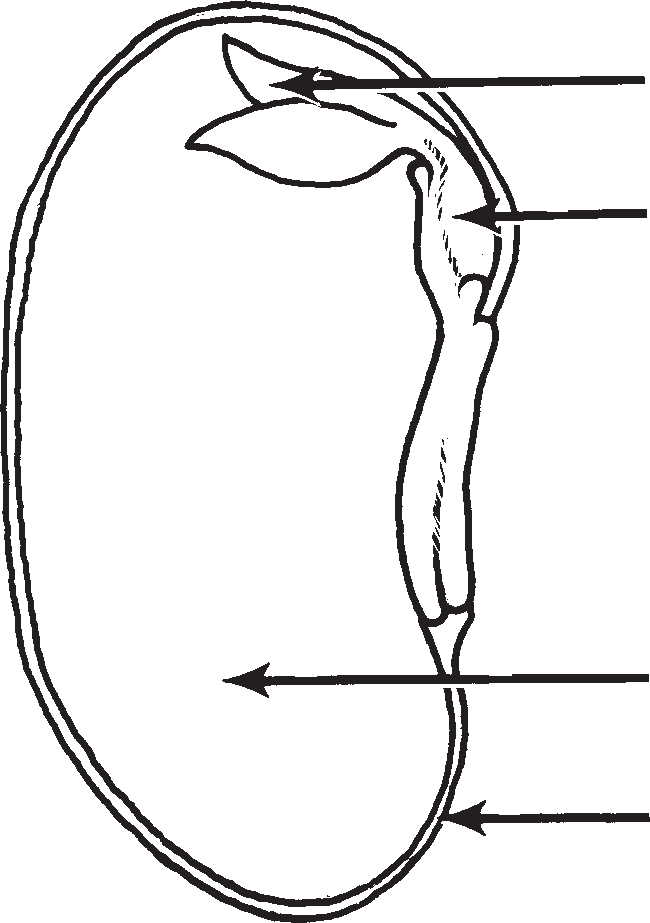
1
2

3
4

- Where is food stored?
  - 1
  - 2
  - 3
  - 4

- Which of these is true about the part of the seed that arrow 4 points to?
  - It becomes the cotyledon.
  - It grows into leaves.
  - It is the baby plant.
  - It protects the seed.

- What is arrow 2 pointing to?
  - Cotyledon
  - Embryo
  - Leaves
  - Seed coat

Use the pictures below to answer questions 4, 5, and 6.
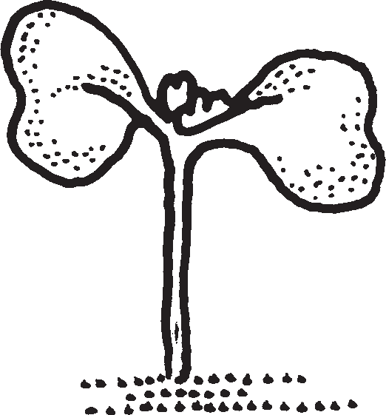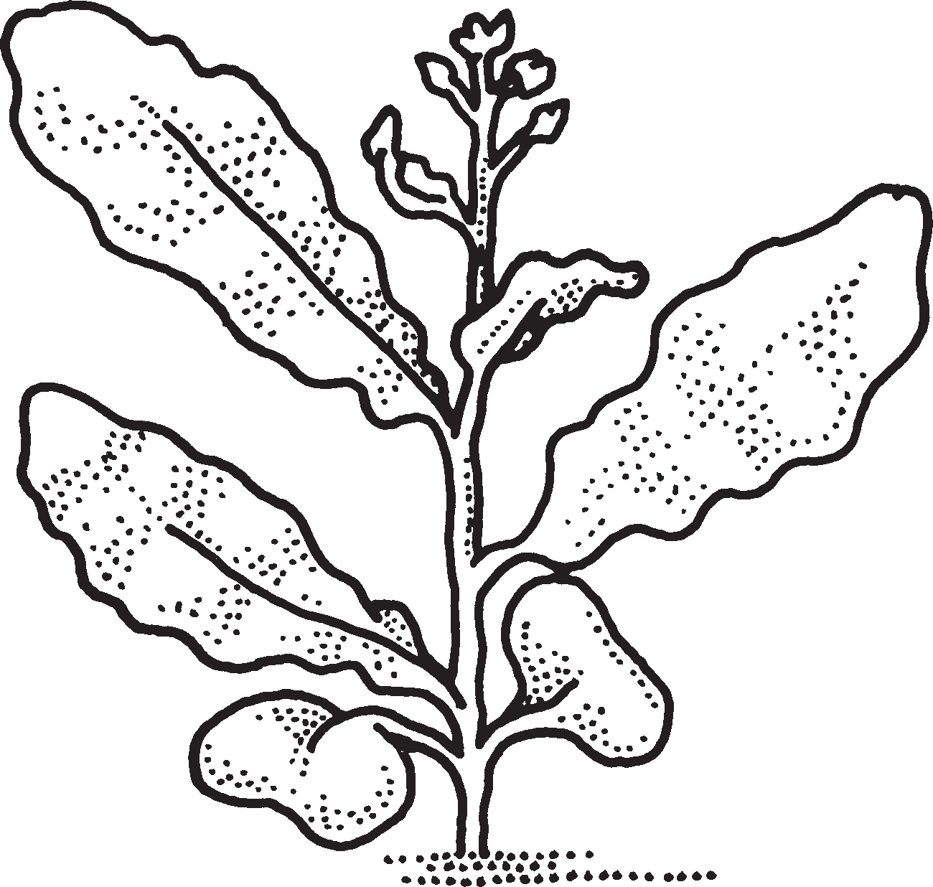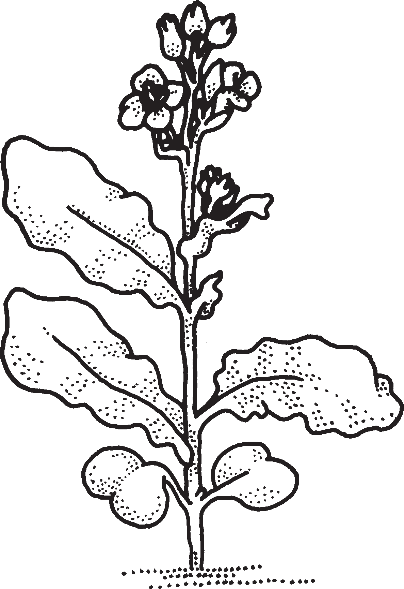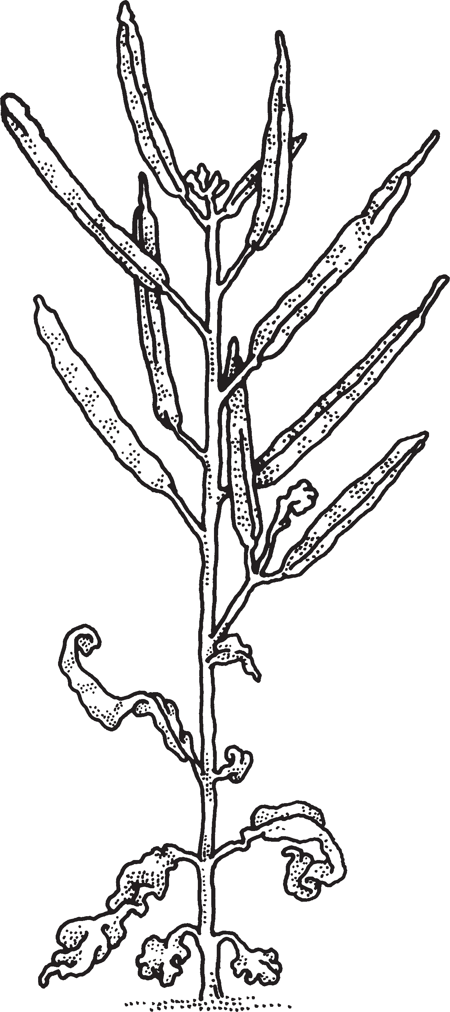
1 2 3 4

- Which picture shows the oldest plant?
  - 1
  - 2
  - 3
  - 4

- Which picture shows seed pods?
  - 1
  - 2
  - 3
  - 4

- Which picture shows the youngest plant?
  - 1
  - 2
  - 3
  - 4

- Look at the diagrams below. Match the part of the flower with what it does to help the flowering plant. Write the letter on the line. The first one has been done for you.

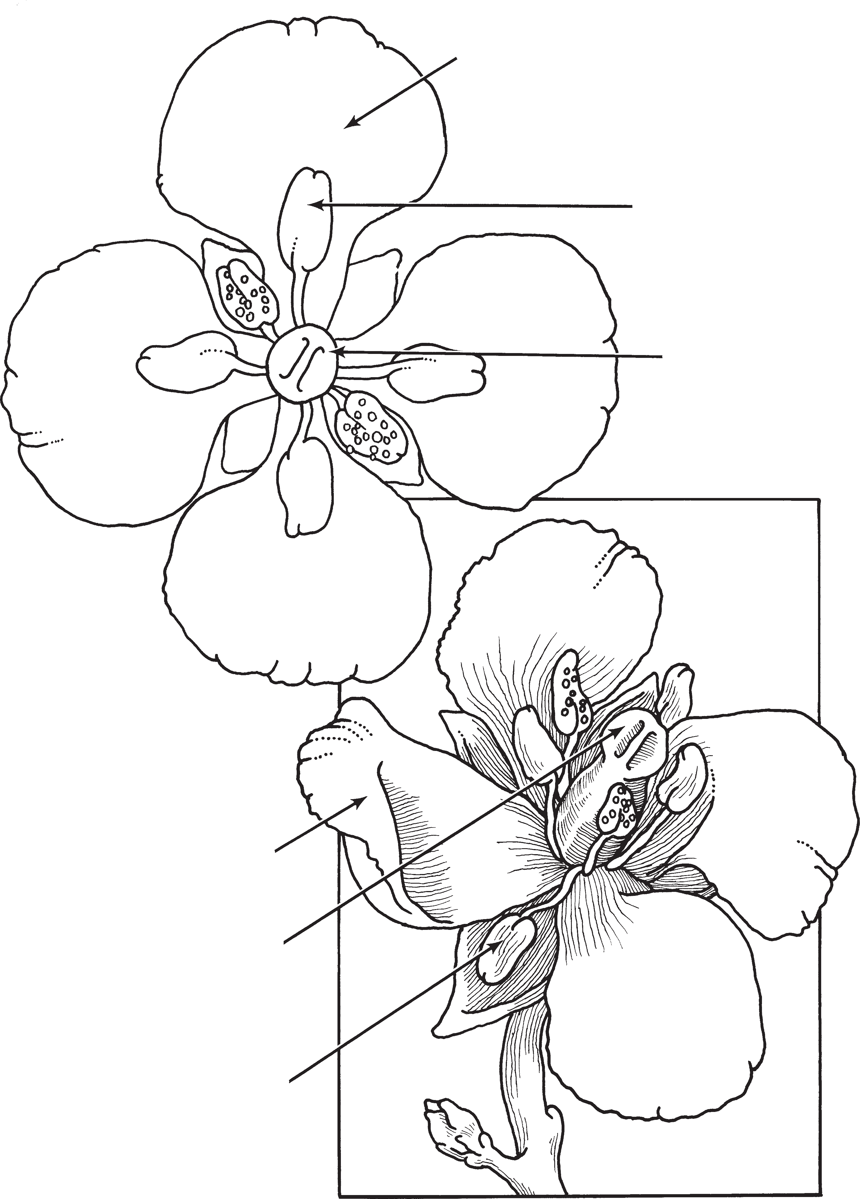Pistil (D)
Petal (A)
Anther (B)
Stigma (C)
Petal (A) Stigma (C)

Anther (B)

Flower Part How It Helps the Flowering Plant
Example C Pollen sticks to it.

It attracts bees.
It makes pollen.

- Jon’s plant has flowers. What must Jon do so that the plant will have seed pods?
  - Keep the plant watered
  - Remove the flowers
  - Raise the lights higher
  - Pollinate with a bee stick

- Bianca is growing Wisconsin Fast Plants. After two weeks, the plants seem very crowded. Each plant is weak looking. What might have caused Bianca’s plants to grow poorly?
  - She didn’t thin the plants.
  - She didn’t pollinate the plants.
  - She left the light on too long.
  - The bee sticks were close to her plants.

- Below is a timeline in the life of a developing Wisconsin Fast Plant. Use the Word Bank to help you complete the timeline. Write the name of each stage in the correct box.
Word Bank: pollination
flowering
germination
growth and development

Days 0–2 Days 3–12 Days 13–15

Days 16–17 Days 18–35
Fertilization and Seed Development

- Which is food for a bee?
  - Leaves
  - Seeds
  - Roots
  - Pollen

- Sheila is harvesting seeds. She counts about eight seeds in every pod. Sheila has nine pods. About how many seeds can she expect to harvest?
  - 8 seeds
  - 80 seeds
  - 800 seeds
  - 9 seeds

Helen visits her grandpa. When she is there she measures her height. She records it on a graph.
Use the graph to answer questions 13, 14, and 15. Choose the correct answer or answers by circling the correct letter.
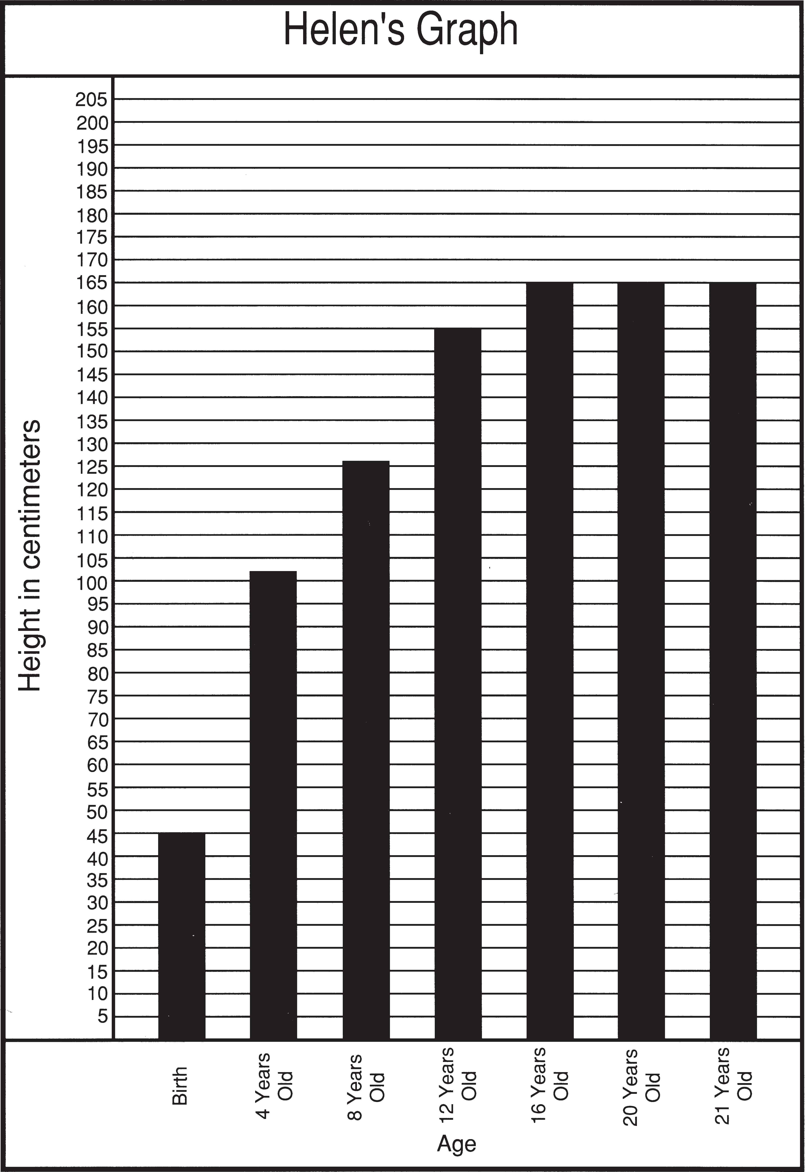

- When did Helen seem to stop growing taller?
  - 8 years old
  - 12 years old
  - 16 years old
  - 21 years old

- Helen must be 140 cm tall to use a riding lawn mower. How old was Helen when she was first tall enough to mow the grass?
  - 6 years old
  - 8 years old
  - 12 years old
  - 16 years old

- What would be another good title for this graph?
  - Helen Grows Like Corn
  - Helen Grows Taller Than Grandma
  - Helen’s Height at Grandpa’s
  - How Tall Is Grandpa?

- Below is a story of how bees and flowers depend on each other. Use the Word Bank to help you complete the story. Write the letter of the missing word on the lines below where it best fits to complete the story. Not all words will be used.

Word Bank: | (A) antenna | (D) hairy | (G) pollination | (J) honey stomach
 | - eyes  - pollen | - legs  - tongue | (H) wings  (I) pistil | - nectar  - seed pods

One summer day, a bee was flying over a field when her spotted some bright yellow flowers. The bee flew with her to land on the yellow petals. She wanted to sip some sweet through her straw-like . Her body brushed against the anther of the flower, and some stuck to her.
Because her was not yet full, the bee flew to another flower. When she got to the second flower, some pollen stuck to that flower’s stigma. The bee was helping the flower to go through . This process helps the flower make healthy full of seeds to make new plants.

- Measure the height of the Wisconsin Fast Plant shown below using a centimeter ruler or centimeter cubes. Choose the closest measurement from the choices given.
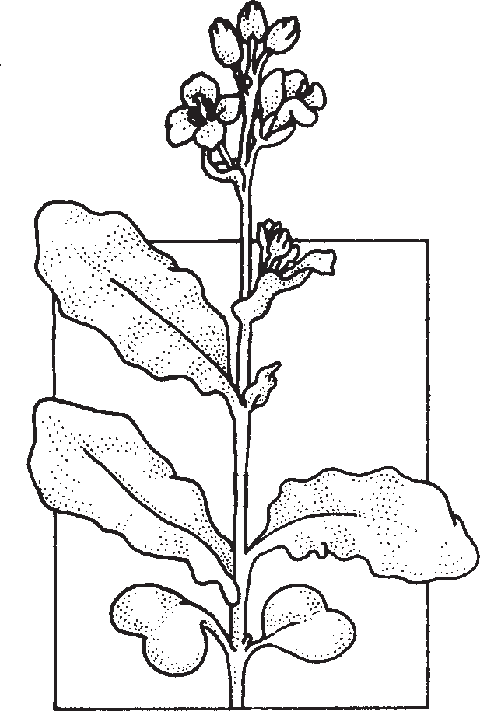
  - 7 cm
  - 70 cm
  - 2 cm
  - 11 cm

