PHOTOSYNTHESIS AND RESPIRATION

STANDARDS:
• 3.2.10.B.3, 3.2.10.C.4
- 3.3.10.B.4 Westminster College

INTRODUCTION

Plants make sugar, storing the energy of the sun as chemical energy, by the process of photosynthesis. When they require energy, they can tap the stored energy in sugar by a process called cellular respiration.

The process of photosynthesis involves the use of light energy to convert carbon dioxide and water into sugar, oxygen, and other organic compounds. This process is often summarized by the following reaction:

6 H2O + 6 CO2 + light energy → C6H12O6 + 6 O2

Cellular respiration refers to the process of converting the chemical energy of organic molecules into a form immediately usable by organisms. Glucose may be oxidized completely if sufficient oxygen is available by the following equation:
C6H12O6 + 6 O2 → 6 H2O + 6 CO2 + energy
All organisms, including plants and animals, oxidize glucose for energy. Often, this energy is used to convert ADP and phosphate into ATP. Using a CO2 Gas sensor, you will attempt to monitor the carbon dioxide consumed or produced by plants.

GUIDING QUESTIONS
- What are photosynthesis and respiration?
- What are the reactants and products in these metabolic processes?
- How are you able to measure the rate of the light and dark reaction?

MATERIALS

CO2 sensor (Vernier) Forceps
Respiration chamber Tinfoil
LabQuest with power cord Thermometer
Spinach leaves, fresh Light source
1 L square bottle Tap water

PROCEDURE

- Programming the LabQuest to Record Data

- Plug the CO2 Gas Sensor into Channel 1 of the LabQuest.

- Press the oval power button on the top left of the LabQuest to turn it on. The operating screen will light up. Select the Meter mode if it is not already the mode being displayed.

- The LabQuest has an auto-identify feature that should recognize the CO2 sensor and display its name and units (ppm) in a red box on the screen. If the correct probe name does not appear on the screen, you will have to set up the sensor manually, using the following directions.

a. Under Sensors on the Menu bar, select Sensor Setup. Select the appropriate channel for the probe and scroll through the sensor selection until you find the one you are using. The probes are listed in alphabetical order, so
Figure 1. Example of LabQuest Screens and Sensor Set-Up

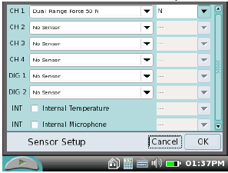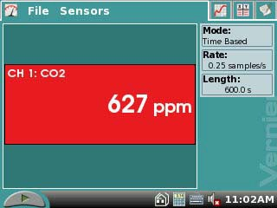
a. Sensor set-up screen b. Meter mode screen

CO2 is near the top of the list.

- Use the stylus to click on the CO2 sensor.

- You may also select the units to be displayed. For this application, you will want parts per million (ppm). If this is not displayed, tap the box next to the sensor box and choose ppm from this list. The probe should have a flashing light on its barrel when it is on and connected properly.
- Set up the data collection. In the Meter mode 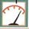, tap the Length box on the right hand side of the screen. Change the data collection time to 300 seconds (5 min) using the touch keyboard. Select OK when you are finished.
.
- Dark Reaction or Respiration

PREDICTION: Will the CO2 level increase or decrease during this part of the reaction? Explain.

- Measure the temperature (in Celsius,ºC) inside the respiration chamber using a thermometer. Record the temperature in Table 1.

- Obtain 5-10 g fresh spinach leaves and blot them dry between two pieces of paper towel. Use whole leaves only! Record the amount of spinach that you use in grams on the data sheet.

- Place the leaves gently into the respiration chamber, using forceps if necessary. Wrap the respiration chamber in aluminum foil so that no light reaches the leaves.

- Place the CO2 Gas Sensor into the bottle as shown in Figure 1. Gently push the sensor down into the bottle until it stops. The sensor is designed to seal the bottle without the need for unnecessary force. Wait 3 minutes before proceeding to Step 5.

- After the 3 minutes, tap Start to begin data collection. The LabQuest screen will appear as a graph with CO2 (ppm) as the y-axis and Time (s) as the x-axis. Data will be collected for 5 minutes. The LabQuest will automatically stop collecting data after the 5 min have elapsed. When the data collection has finished, remove the CO2 probe and measure the final temperature in the flask (Tf) and record it in Table 1.

- When data collection has finished, a graph of carbon dioxide gas (ppm) vs. time (s) will be displayed.

- Store the data from the dark reaction run by tapping the File Cabinet icon . This is Run 1.

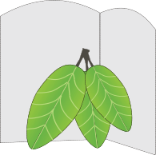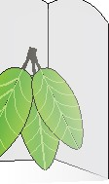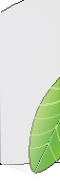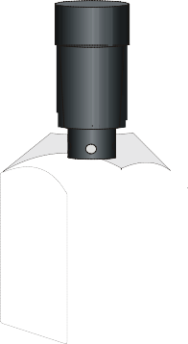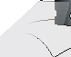
Figure 1

- To examine the data pairs on the displayed graph, tap on any data point. As you move the examine line, notice that the amount of CO2 and time values of each data point are displayed on the top and bottom of the screen to the right of the graph.

- Determine the rate of respiration for the curve of CO2 (ppm) vs. time. To help make comparisons between experimental runs, choose your data points at similar time values.
  - 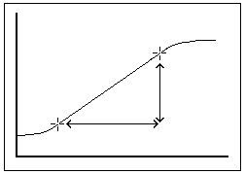Examine the graph and determine the most linear region. Tap a data point at the start of the linear portion of the graph. The CO2 and time values for this point will appear to the right of the graph. Enter these values as the initial CO2 amount, PPMi, and initial time, ti, in Table 3.
  - Tap a data point at the last point of the linear region. Enter the values that appear as the final CO2 amount, PPMf, and final time, tf, in Table 3.

- Remove the aluminum foil from around the respiration chamber. Gently remove the CO2 probe, if you have not already done so.

- Light Reaction or Photosynthesis

PREDICTION: Will the CO2 level increase or decrease during this part of the reaction? Explain.

- Fill the 1 L square bottle (not the respiration chamber) with water, and cap the bottle tightly. Place the square bottle on its side between the respiration chamber and the light source you are going to use. The water will act as a heat shield to protect the plant leaves during the light reaction portion of the experiment.

- Turn the lamp on. Place the lamp as close as possible to the side of the square bottle, without touching. Note the time. The lamp should be on for 3 minutes prior to beginning data collection.

- Just before you start data collection, measure the temperature in the respiration chamber. Record this Ti in Table 1.

- Gently place the CO2 probe into the top of the respiration chamber.

- After the 3 minutes, tap Start to begin data collection. Data will be collected for ten minutes. When the data collection has finished, remove the CO2 probe and measure the final temperature in the flask (Tf) and record it in Table 1.

- When data collection has finished, a graph of carbon dioxide gas (ppm) vs. time (s) will be displayed.

- Store the data from the light reaction run by tapping the File Cabinet icon . This is Run 2.

- Determine the rate of photosynthesis for the curve of CO2 (ppm) vs. time.
  - Examine the graph and determine the most linear region. Tap a data point at the start of the linear portion of the graph. The CO2 and time values for this point will appear to the right of the graph. Enter these values as the initial CO2 amount, PPMi, and initial time, ti, in Table 3.
  - Tap a data point at the last point of the linear region. Enter the values that appear as the final CO2 amount, PPMf, and final time, tf, in Table 3.

- To display both graphs simultaneously, tap the box and select All Runs. The results of both the dark and light reactions will appear on the graph.

- When you have gathered all the data necessary to complete the lab Data Sheet, select File → Quit to exit the LabQuest application. Turn the LabQuest off by holding down the Power button for 2-3 seconds, or until the screen goes dark.

10. Remove the plant leaves from the respiration chamber, using forceps if necessary. Clean and dry the respiration chamber before putting it and the CO2 sensor back in the box.

DATA SHEET

Name: Group: Date:

Weight of Spinach Leaves (g):

Table 1. Average Reaction Temperature

Type of Reaction | Ti (ºC) | Tf (ºC) | Avg T (ºC)
CO2 Respiration (dark)
CO2 Photosynthesis (light)

Table 2. Data Points for Dark and Light Reaction
The actual data points can be found by tapping the Data icon at the top of the screen. If you are instructed to do so, record the CO2 (ppm) for each of the time points listed below.

Dark Reaction Light Reaction
Time (s) | CO2 (ppm)
0
30
60
90
120
150
180
210
240
270
300

Time (s) | CO2 (ppm)
0
30
60
90
120
150
180
210
240
270
300

Table 3. Rate of Respiration and Photosynthesis
Type of Reaction | Avg. T (ºC) | PPMi | ti (s) | PPMf | tf (s) | Slope = PPMf - PPMi  tf - ti
CO2 Respiration (dark)
CO2 Photosynthesis (light)

QUESTIONS

- Did your predictions about the CO2 gas levels before each experiment match the data you obtained? Why or why not?

- You repeat this experiment using a sensor which detects the levels of O2 gas. Draw a sketch of what you think the graph would look like for the respiration and photosynthesis reactions. Explain

Respiration Photosynthesis

O2
(ppm)

O2
(ppm)

0
Time (s)
300
0
Time (s)
300

- List three factors that might influence the rate of CO2 production or consumption in leaves. Explain how you think each will affect the rate.

