TEACHER NOTES
Westminster College

PHYSICAL PROPERTIES OF WATER
GUIDED INQUIRY VERSION
From Vernier Investigating Chemistry through Inquiry

OVERVIEW

In the Preliminary Activity, your students will learn how to measure temperature using a Temperature Probe and gain experience using data-collection software.

During the subsequent Inquiry Process, your students will first learn about physical properties of substances and the physical properties of water in particular using the course testbook, other available books, and the Internet. They will then generate and investigate researchable questions concerning the physical properties of water. (In the guided inquiry approach, students will plan and conduct investigations of the researchable question(s) assigned by you.)

This experiment can well serve to introduct your students to the use of probeware and/or the inquiry approach.

LEARNING OUTCOMES

In this inquiry experiment, students will
- Identify variables, design and perform the experiment, collect data, analyze data, draw a conclusion, and formulate a knowledge claim based on evidence from the experiment.
- Gain experience using probeware.
- Gain incrased understanding of the physical properties of substances.

CORRELATIONS

Topic 4 – Bonding
Topic 4.5 – Physical Properties

THE INQUIRY PROCESS

Suggested Time to Complete the Experiment
See the section in the introduction, Doing Inquiry Experiments, for more information on carrying out each phase of an inquiry experiment.

 | Inquiry Phase | Open Inquiry | Guided Inquiry
I | Preliminary Activity | 20 minutes | 20 minutes
II | Generating Researchable Questions  (Omitted in Guided Inquiry Approach) | 10 minutes
III | Planning | 15 minutes | 15 minutes
IV | Carrying out the Plan | 40 minutes | 35 minutes
V | Organizing the Data | 10 minutes | 10 minutes
VI | Communicating the Results | 15 minutes | 10 minutes
VII | Conclusion | 10 minutes | 10 minutes

MATERIALS

Make the following materials available for students to use. Items in bold are needed for the preliminary activity.

Data collection interface (Labquest or LabPro) water
Vernier Temperature Probe others as requested by students

- Preliminary Activity
This inquiry begins with an activity to reinforce prior knowledge of the use of Vernier data-collection technology and to introduce a method for collecting temperature data.

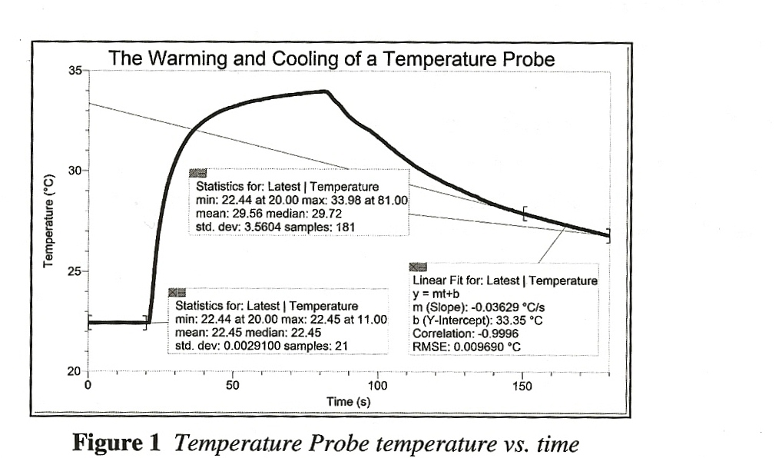
Sample results

Answers to the Questions

Answers to the Questions
- Use the Statistics function to determine the minimum and maximum temperatures measured during the 180-minute data-collection period. What was the minimum temperature? What was the maximum temperature?
Answers will vary. The minimum temperature measured in the Sample Results above was 22.4°C. The maximum temperature measured was 34.0°C.

- Select the portion of the graph corresponding to the first 20 seconds of data collection, and then use the Statistics function to determine the mean tempeartuare during this period. What was the mean temperature during the first 20 seconds of data collection?
Answers will vary. The mean temperature measured during the first 20 seconds of data collection was 22.5°C.

- You can see at a glance that the cooling portion or the curve is not linear. To gain some helpful experience, however, let us assume that the curve for the last 30 seconds is linear and determine its slope. Select the last 30 seconds of the graph, and then use the Linear Fit function to determine its slope. This slope corresponds to the cooling rate of the Temperature Probe during this period. What was the cooling rate for your Temperature Probe?
Answers will vary. The cooling rate for the last 30 seconds of data collection -0.036°C/s.

- List at least one researchable question concerning the physical properties of water. (Not applicable for Guided Inquiry approach.)
Answers will vary. See Researchable Questions list below for some possible answers.

- Generating Researchable Questions
Note: Researchable questions are assigned by the instructor in the Guided Inquiry approach. See the Doing Inquiry Experiments section for a list of suggestions for generating researchable questions. Some possible researchable questions for this experiment are listed below:

Recommended for Open or Guided Inquiry (sample results provided)
- What is the boiling temperature of water?
- What happens to the temperature of a pure substance as it freezes?
- How does the melting temperature of water compare with its freezing temperature?
- How much energy does it take to melt a gram of ice? (What is the heat of fusion of water?)

Recommended for Open or Guided Inquiry (no sample results provided)
- What is the freezing temperature of water (lauric acid, t-butanol)?
- What is the melting temperature of water (lauric acid, t-butanol)?
- What happens to the temperature of a pure substance as it melts?
- What is the boiling temperature of water (ethanol, 2-propanol)?
- What happens to the temperature of a pure substance as it boils?
- How is the boiling temperature of water affected by weather conditions? By altitude?
- How do impurities affect the freezing temperature of water?
- How do impurities affect the boiling temperature of water?

There are many more possible researchable questions. Students should choose a researchable question that addresses the learning outcomes of your specific standards. Be sure to emphasize experimental control and variables. (Instructors using the Guided Inquiry approach select researchable questions to be investigated by their students. We encourage you to assign multiple researchable questions because this strategy enhances student interaction and learning during phases IV-VII.)

- Planning
During this phase students should formulate a hypothesis, determine the experimental design and setup, and write a method they will use to collect data. Circulate among the student groups asking questions and making helpful suggestions.

- Carrying Out the Plan
During this phase, students use their plan to carry out the experiment and collect data. Circulate among the student groups asking questions and making helpful suggestions.

- Organizing the Data
See the Doing Inquiry Experiments section for suggestions concerning how students can organize their data for their inquiry presentations.

- Communicating the Data
See the Doing Inquiry Experiments section for a list of inquiry-presentation strategies.

- Conclusion
See the Doing Inquiry Experiments section for a list of suggestions concerning assessment and ways to utilize the results in subsequent instruction.

SAMPLE RESULTS
Student results will vary depending on experimental design.

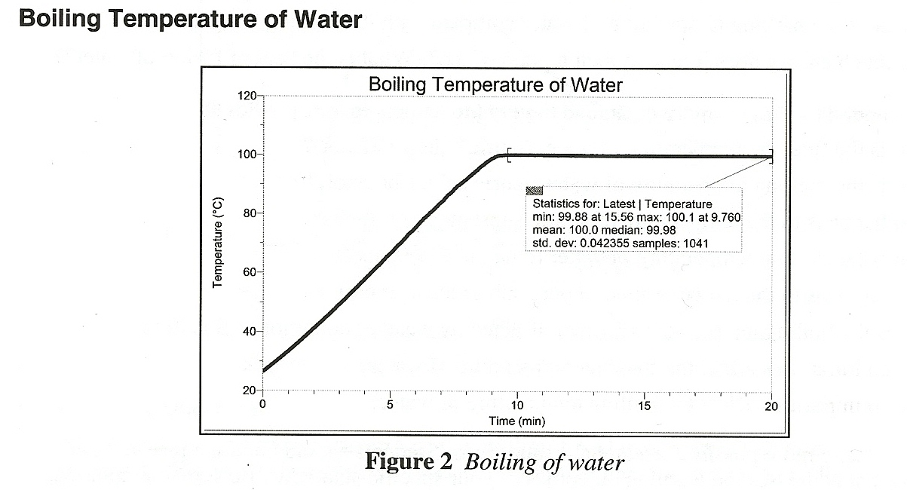

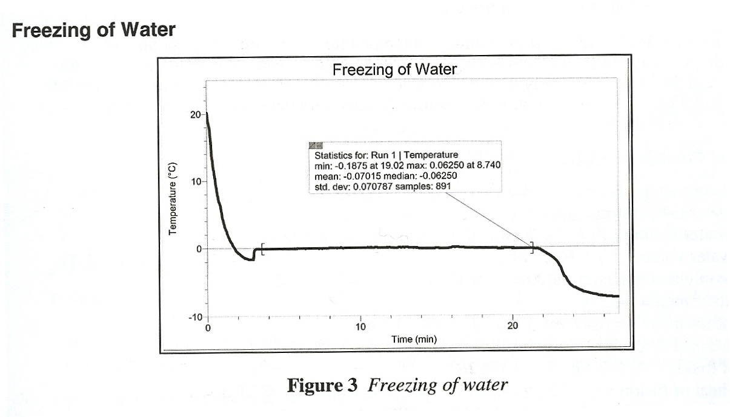
This investigation addresses the question, “What is the boiling temperature of water?” A Temperature Probe was suspended in a water sample as it was heated. The mean temperature measured as the water sample boiled was 100.0°C. Boiling temperature is pressure dependent and is affected by altitude and weather. See the Tips section for more details.

This investigation addresses the question, “What happens to the temperature of a pure substance as it freezes?” In the graph above, the temperature of water stayed essentially constant, at a near -0.1°C, during freezing.

A Temperature Probe was used to monitor the temperature of a 5 mL water sample in a test tube suspended in an ice-saltwater bath as the freezing temperature data were collected. The water sample and the bath were gently stirred. See the Tips section for more details.

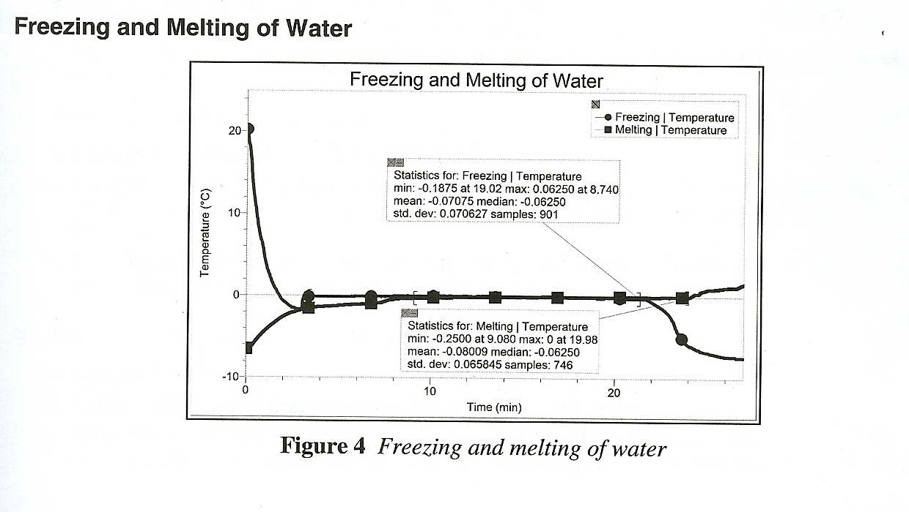
Run 1, above corresponds to the freezing of water, and the Latest run corresponds to the melting of water. This investigation addresses the question, “How does the melting temperature of water compare with its freezing temperature?” In the graph above, the mean freezing temperature (-0.1°C rounded to the nearest 0.1°C) is essentially the same as the mean melting temperature (also -0.1°C rounded to the nearest 0.1°C).

A Temperature Probe was used to monitor the temperature of a 5 mL water sample in a test tube suspended in an ice-saltwater bath as the melting temperature data collected. The water sample and the bath were gently stirred. The test tube containing the frozen water sample was suspended in air, without stirring, as the melting temperature data were collected. See the Tips section for more details.

Heat of Fusion of water
Initial water temperature, t₁ = 53/0°C
Final water temperature, t₂ = 1.9°C
Initial water volume, V₁ = 100.0 mL
Final water volume, V₂ = 164.5 mL
Change in water temperature, Δt = 51.1°C
Volume of melt = 64/5 mL
Mass of ice melted – (64.5 mL (1.00 g/mL) = 64.5 g
Heat released by cooling water = (4.18 J/g°C) (100 g 51.1°C) = 21400J
Heat of fusion – 21400 J/64.5 g = 332 J/g
Molar heat of fusion = (332 J/g) (18.0 g/mol) – 5980 J/mol – 5.98 kJ/mol
Percent error = [(6.01 – 5.98)/6.01] x 100 = 50%

This investigation addresses the question, “how much energy does it take to melt a graph of ice? (What is the heat of fusion of water?)” Temperature was monitored to determine the initial temperature of 100.0 mL of water, 7 or 8 large ice cubes were added, the mixture was continuously stirred, the ice cubes were removed when the temperature reached 4°C, the temperature was monitored until the minimum temperature was determined, and then the final water volume was determined. See the Tips section for more details.

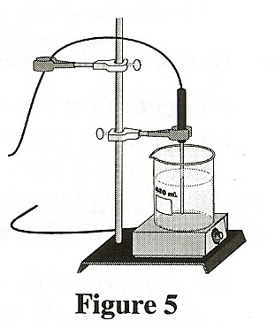
TIPS
- The boiling temperature of water can be determined using burners, but we recommend the use of hot plates. A 250 mL or 400 mL beaker 2/3 filled with water works well. See Fig 5 for a possible setup.

- Tips for determining the freezing and melting temperatures of water:
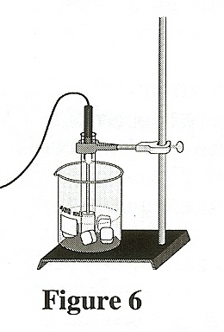
- See Figure 6 for a possible setup.
- Test tubes size 20 x 100 mm work well. Sizes 25 x 150 mm and 18 x 150 mm work, too.
- A water sample size of 5 mL works well. Larger supplies will take more time. To shorten data-collection periods, you can suggest that students stop stirring the sample after 10 minutes during freezing. Similarly the sample can be immersed in room temperature water after 12 minutes during melting.
- As in the Sample Results, many water samples will supercool. Stirring will bring the super-cooled water to the freezing temperature plateau.
      - A more detailed procedure can be found in Experiment 2, Freezing and Melting of Water, in the lab book Chemistry with Vernier.

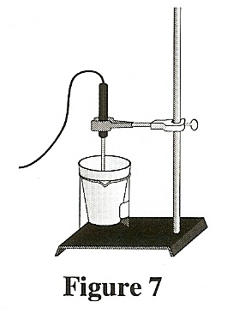
- Tips for determining the heat of fusion of water.
- See Figure 7 for a possible setup.
- Water warm enough to give a beginning temperature of 50°C is recommended to provide equal temperature ranges above and below room temperature.
- Use plenty of large ice cubes. They should be wet; that is, at melting temperature. They therefore need to be removed from the freezer 15-20 minutes before they will be used.
- A detailed procedure can be found in Experiment 4, Heat of fusion for Ice, in the lab book Chemistry with Vernier.

- Directions for obtaining Statistics.
- Logger Pro: Click the Statistics button.
- LabQuest: Select Statistics on the Analyze menu, and then check Temperature. (To remove results, again select Statistics on the Analyze menu and then uncheck Temperature.)

- Directions for selecting a graph region.
- Logger Pro: Drag the cursor across the desired region.
- LabQuest: Tap and drag the stylus across the desired region.

- Directions for obtaining a Linear Fit for a selected region of a graph.
- Logger Pro: Click the Linear Fit button.
- LabQuest: Choose Curve Fit from the Analyze menu, and then choose Linear as the Fit Equation. Select OK. The Curve-Fit coefficients will be displayed on the screen.

- The plans that your students submit for approval should list laboratory safety concerns, including chemical safety concerns, and specify how they will address these safety concerns during their investigations.

