
PLANT PIGMENTS
Westminster College
From Vernier Investigating Biology through Inquiry
GUIDED INQUIRY VERSION

LAB 14

INTRODUCTION
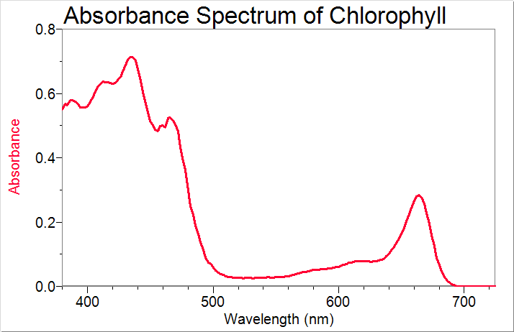
Plants contain many different molecules directly or indirectly involved with photosynthesis, which may also impart color to the plant. The mixture of chlorophyll molecules found in spinach, for example, absorbs several wavelengths of visible light, with distinct absorbance peaks in the blue range (400–500 nm) and in the yellow-red range (600–700 nm). The combination of visible light that is not absorbed appears green to the human eye. Chlorophyll contains a porphyrin ring in its structure with a magnesium ion in the center. The porphyrin ring accounts for much of the molecule’s light absorbance. Chlorophyll is found in the thylakoid plate of a plant chloroplast.

Figure 1

Carotenoids, accessory pigments produced in chromoplasts, are associated with many colors observed in vegetation. There are hundreds of different types of carotenoids. Carrots get their color, which is often orange but is not restricted to orange, from carotene. Carotene is a family name for several compounds that also go by the name terpene.
Another type of carotenoid phyto-pigment is called anthocyanin. The purplish color of a red cabbage and the rusty red of the flesh of a blood orange are a result of the presence of anthocyanins, which also have the property of changing color with changes in pH. Anthocyanins absorb UV light, which is used by plants to perform two important functions: to attract insects, which augment pollination, and as a “sunscreen” to protect the other parts of the plant cells such as DNA from harmful UV radiation.
Chlorophyll is a fluorescent substance. Fluorescent substances can absorb light of one wavelength and then reemit a new and longer wavelength of light. As can be seen above in Figure 1, chlorophyll absorbs light in the violet and blue regions of the visible spectra. If a violet or blue light is shined through a sample of spinach extract, the solution turns red in color. The intensity of the red color is an indication of how much chlorophyll is in the sample.
In this Preliminary Activity, you will use a SpectroVis Plus spectrophotometer to determine and analyze the visible light absorbance spectrum of spinach extract. You will also determine and analyze the fluorescence spectrum of the same spinach extract sample. In fluorescence spectroscopy, a sample can be “excited” with a chosen wavelength of light and the resulting fluorescence from the sample can be measured and quantified.
After completing the Preliminary Activity, you will investigate your assigned researchable question. Use reference sources to find out more about plant pigments, visible light spectra, and fluorescence before planning and conducting your investigation.

MATERIALS
Labquest two small beakers
Spectrophotometer funnel
Fresh spinach filter paper
Balance ring stand with ring
Mortar and pestle cuvette with lid
25 mL graduated cylinder disposable beral pipet
70% Isopropyl Alcohol

Procedure
1. Obtain and wear goggles.
2. Prepare the spinach extract.
- Measure out 0.5 g of fresh spinach and cut or tear the spinach into tiny pieces.
- Grind the spinach pieces with a mortar and pestle.
- Add 20 mL of 70% isopropyl alcohol (IPA) and transfer the mixture to a small beaker.
- Allow the mixture to sit for about ten minutes.
- After ten minutes have elapsed, use a funnel and filter paper to filter the spinach extract into a clean beaker.

3. Connect the SpectroVis Plus spectrophotometer to the USB port of LabQuest or a computer. Start the data-collection program, and then choose New from the File menu.
Part I Collect a Visible Light Spectrum of Spinach Extract
4. Calibrate the spectrophotometer.
- Prepare a blank by filling an empty cuvette 3/4 full with 70% isopropyl alcohol and place it in the spectrophotometer. Make sure to align the cuvette so that the clear sides are facing the light source of the spectrophotometer.
- Choose Calibrate from the Sensors menu of LabQuest or the Experiment menu of Logger Pro.
- Select Finish Calibration, and then select OK.

5. Conduct a full spectrum analysis of the spinach extract.
- Empty the blank cuvette and rinse it twice with small amounts of the spinach extract. Fill the cuvette 3/4 full with spinach extract.
- Place the cuvette containing the spinach extract into the spectrophotometer.
- Start data collection. A full spectrum graph of the spinach extract will be displayed.
- Stop data collection.
- Examine the graph, noting the absorbance peak ranges for chlorophyll described in the introductory remarks. If any of the peak absorbance values are greater than 1.5, dilute your sample to an extent that will bring the peaks below 1.5 and repeat the data collection.
6. Before continuing with data collection, answer Question 1. Print or save your experiment file as directed.
Part II Collect a Fluorescence Spectrum of Spinach Extract
7. Ensure that the cuvette containing the spinach extract is in the cuvette slot of the spectrophotometer.
8. Choose New from the File menu.
9. Set up the SpectroVis Plus to measure fluorescence.
- In Logger Pro, choose Change Units ►Spectrometer from the Experiment menu of and select Fluorescence 405 nm.
- In LabQuest App, choose Change Units ► Fluorescence 405 nm from the Sensors menu.

10. Adjust the Sample Time.
- In Logger Pro, choose Set Up Sensors ►Spectrometer from the Experiment menu. Change the Sample Time to 150 ms.
- In LabQuest App, choose Data Collection from the Sensors menu. Change the Sample Time to 150 ms and choose OK.

11. Start data collection. A full spectrum graph of the fluorescence of the sample will be displayed. Note that one area of the graph contains a peak at approximately 675 nm. This peak is from chlorophyll.
12. Stop data collection. The height of the peak should be between 0.6 and 1.0. If necessary, adjust the sample time to increase or decrease the size of the fluorescent peak and repeat the data collection.
13. Answer Question 2 below.
14. Print or save your experiment file as directed.

Questions
1. Describe the visible light absorbance spectrum of the spinach extract, identifying the absorbance peaks and other distinguishing features.
2. Describe the fluorescence spectrum of the spinach extract, identifying the fluorescence peaks and other distinguishing features.
3. List five colorful plant flowers, fruits, leaves, or other parts whose extracts might contain plant pigments of interest in visible light spectra and/or fluorescence spectra investigations.

