Titration of Polyprotic Acids

LAB
From Juniata College, Science in Motion

Introduction

One method a chemist can use to investigate acid-base reactions is a titration. The purpose of a titration is to determine the unknown concentration of a solution by adding a specific volume of a solution with a known concentration to the solution of unknown concentration. After finding the concentration of this unknown solution, one can proceed to find the pH of the solution, given information (or by calculating) about the acid dissociation constant(S). A pH titration is performed by adding small, precise amounts of strong base (titrant) to a weak acid (analyte) solution of unknown concentration using a piece of glassware known as a buret. As the base is slowly added to the acid, the pH of the acid solution is methodically recorded, using a pH sensor, and is plotted vs. the volume of base added to the acid solution. As the acid is titrated, an equivalence, or stoichiometric, point emerges when the moles of base added equal the moles of acid present. The result of this plot is an “S” shaped curve. A single “S” curve is observed for a monoprotic acid and multiple “S” curves are observed for polyprotic acids.
Monoprotic acids are acids that possess a single ionizable hydrogen atom in each molecule, yielding a single H⁺ per molecule of acid. A polyprotic acid; however, is an acid that has more than one ionizable hydrogen atom. Polyprotic acids have the ability to undergo more than one dissociation reaction, and therefore, produce “S” titration curves with multiple equivalence points (one point for each ionizable hydrogen atoms present).
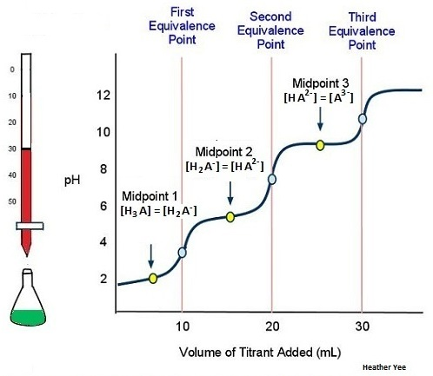
Phosphoric acid (H₃PO₄₎, for example, has three acidic protons and undergoes three dissociation reactions. The inflection point of each “S” curve (the middle of the “S”) is indicative of the endpoint. These points occur when the dissociated proton from the acid and the OH⁻ from the base are stoichiometrically equivalent in solution. The equivalence point is needed to determine the concentration of an acid or base.

Purpose
The purpose of this experiment is to titrate an unknown concentration solution of a polyprotic (phosphoric) acid with a known concentration of NaOH solution. The titration curve will be plotted and the concentration of the acid will be determined.

Equipment/Materials

polyprotic acid (H₃PO₄) pH meter and electrode
250 mL beaker buret
NaOH solution (0.50 M) pH buffer solutions
buret clamp pipet and pipet bulb
magnetic stirrer (if available) distilled water

Safety

- Always wear an apron and goggles in the lab.
- Avoid contact with solutions. Wash thoroughly if any solution touches the skin.
- Report any spills so they may be cleaned up.

Procedure

- Follow your instructor’s directions for standardizing the pH meter. Since the directions vary from instrument to instrument, no specific directions are provided here.

- Measure out a 10.0 mL sample of the unknown acid using a pipet or a buret. Place the acid in a 250 mL beaker, and add enough water so the bulb on the pH electrode is covered.

- If a magnetic stirrer and stir bar are to be used, make sure the bulb of the electrode is above the stir bar. The bar should be spinning at a slow rate so that the electrode is not hit.

- Clean a buret and fill with the NaOH solution. Adjust the level of the NaOH solution so that it is at the 0.00 mL mark and that the tip of the buret is filled.

- Begin titrating, by adding NaOH in 1 mL increments. After adding each mL allow the solution to mix thoroughly and record the pH.

- Continue the titration until the titrant in the buret reaches 50.0 mL.

- Plot pH (y-axis) vs. volume of NaOH (x-axis). A graphing program such as Graphical Analysis may be used for this process.

- Determine the equivalence points of the titration (inflection points on the graph). This can be done by estimating the midpoint of each region where the sharpest increases in pH are observed. The first derivative function of Graphical Analysis program may also be used for this step.

- Repeat as instructed.

- Determine the average molarity of the acid solution by using the difference in volume of NaOH added between the first inflection point and the second inflection point.

- (Optional) Calculate the dissociation constants (K_{a} values) for each of the inflection points on the graph.

Titration of Polyprotic Acids
Data
Name of Acid Used: _________________________
Concentration of NaOH ______________________
Volume of Acid sample ______________________
Titration Data:
mL NaOH added | pH |  | mL NaOH added | pH

Calculations

- From the graph, find the volume of base needed to reach the first equivalence point.

- Subtract the volume of NaOH needed to reach the first equivalence from that needed to reach the second equivalence point. Use this as the volume of the base.

- Find the moles of base.

- Write and balance the equation for the reaction between the acid used and NaOH.

- Calculate the moles of acid required to react with the calculated moles of NaOH.

- Determine the concentration of acid in moles per liter.

- Repeat for all trials and average.

Questions

- How would the following affect your results?

- The buret is dirty and drops of NaOH cling to the side walls of the buret as it is drained.

- The buret is not rinsed with NaOH prior to filling.

- The buret tip is not filled at the start of the titration.

- 30 mL of unknown acid are used instead of 10 mL.

- The buret is not read at eye level.

- The base is added too rapidly in the region of rapid pH change.

- 150 mL of distilled water is used instead of 90 mL.

- The original volume of base is not at 0.00 mL and a student assumes it is.

