Westminster College
REACTION RATES
From Vernier Investigating Chemistry through Inquiry
GUIDED INQUIRY VERSION

LAB 22

INTRODUCTION

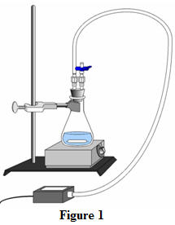
The decomposition of hydrogen peroxide in aqueous solution proceeds very slowly. A bottle of 3% hydrogen peroxide sitting on a grocery store shelf is stable for a lengthy period. The decomposition takes place according to the reaction below.
2 H₂O₂(aq) → 2 H₂O + O₂(g)
A number of catalysts, one of which is potassium iodide, can be used to speed up this reaction. In the Preliminary Activity, you will use a Gas Pressure Sensor to monitor the pressure increase due to the production of oxygen gas inside an Erlenmeyer flask as potassium iodide catalytically decomposes hydrogen peroxide.
Before data collection begins, there is no product, and the pressure is the same as atmospheric pressure. Shortly after data collection begins, oxygen accumulates at a rather constant rate. The slope of the curve at this initial time is constant and is called the initial rate. As the peroxide is decomposed, less of it is available to react and the O₂ is produced at lower rates. When no more peroxide is left, O₂ is no longer produced. When data collection is complete, you will perform a linear fit on the resultant graph to determine the initial reaction rate.
After completing the Preliminary Activity, you will investigate your assigned researchable question. Use reference sources to find out more about reaction rates and factors that influence them before planning and conducting your investigation.
SAFETY
Hydrogen Peroxide solution is an oxidizer and is a skin and eye irritant.
Cooper II Nitrate Trihydrate, Iron Chloride and Potassium iodate are somewhat hazardous

MATERIALS
Labquest 3% Hydrogen Peroxide-H₂O₂ solution
Gas Pressure Sensor 0.5 M Potassium iodide, KI solution
Temperature Probe distilled water
50 mL graduated cylinder ring stand
Two 10 mL graduated cylinder utility clamp
125 mL Erlenmeyer flask tubing with two Luer-lock connectors
Magnetic stirrer two hole rubber stopper assembly
Stir bar

PROCEDURE
1. Obtain and wear goggles.
2. Connect a Gas Pressure Sensor and a Temperature Probe to the data-collection interface. Start the data-collection program.
3. Set up the experiment apparatus.
- Measure out 45 mL of distilled water into a 125 mL Erlenmeyer flask.
- Measure out 10 mL of 3% H₂O₂ into the flask. Note: Assuming a 3.0% concentration and a density of 1.00 g/mL, the concentration of H₂O₂ is 0.88 M.
- Carefully place a stir bar into the flask.
- Place a magnetic stirrer on the base of a ring stand. Use a utility clamp to fasten the flask to the ring stand as shown in Figure 1.
- Position the flask at the center of the magnetic stirrer. Test the stirrer speed. Select a moderately slow stirring speed that you will use throughout this experiment, including your work on a researchable question, and note the position of the control knob.
- Stop the stirrer and place the Temperature Probe into the flask. Determine the temperature of the water and H₂O₂ mixture and record the result in your data table. Remove the Temperature Probe.
- Use the plastic tubing with two Luer-lock connectors to connect the two-hole rubber stopper assembly to the Gas Pressure Sensor, as shown in Figure 1. About one-half turn of the fittings will secure the tubing tightly. The valve connected to the stopper should stay closed during this experiment.
- Measure out 5 mL of 0.5 M KI solution into a 10-mL graduated cylinder. Assume that it is at the same temperature as the water and H₂O₂ mixture.

4. Prepare to start data collection.
- Transfer the 5 mL of KI solution into the flask.
- Tightly seal the flask with the two-hole stopper connected to the Gas Pressure Sensor.
- Ensure that the flask is properly positioned. Turn the stirrer on to the predetermined setting.

5. Start data collection. Note: If the pressure exceeds 130 kPa, the pressure inside the flask will be too great and the rubber stopper is likely to pop off. Carefully remove the stopper from the flask if the pressure exceeds 130 kPa.
6. When 300 seconds have elapsed, stop data collection.
7. Carefully remove the stopper from the flask to relieve the pressure. Dispose of the contents of the flask as directed.
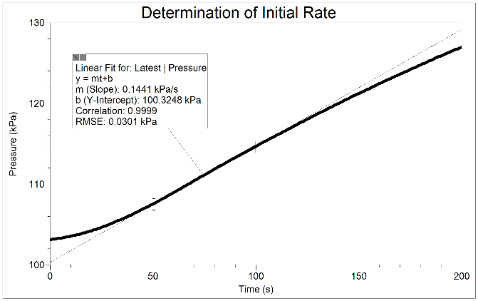

Figure 2
8. Examine your graph, and select its steepest 50-second segment. Perform a linear fit on this part of the graph—see Figure 2 above. Record the slope of the line, m, as the initial rate of the reaction, in kPa/s.

QUESTIONS
1. What was the initial reaction rate?
2. Calculate the concentration of the H₂O₂ solution immediately after it was mixed with water and KI solution. Assume that you started with 0.88 M H₂O₂.
3. List two factors that could possibly affect the rate of the reaction investigated in the Preliminary Activity.
Note: The plan that you submit for instructor approval should list laboratory safety concerns, including chemical safety concerns, and specify how you will address these safety concerns during your investigation.

