RECYCLE

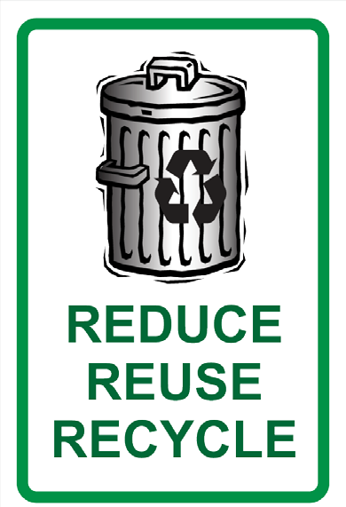
A Teacher’s Guide

Created by Maile Kirkpatrick
and Delta Science Modules Kit: Pollution

RECYCLE
Table of Contents
~ Lesson #1: A Lot Of Litter 3
~ Lesson #2: Measure The Trash In Your Classroom 8
~ Lesson #3: Recycle Paper 17
~ Lesson #4: Making Recycled Paper 22
~ Lesson #5: Making Your Own Compost 25
~ Materials Needed For Lessons 28

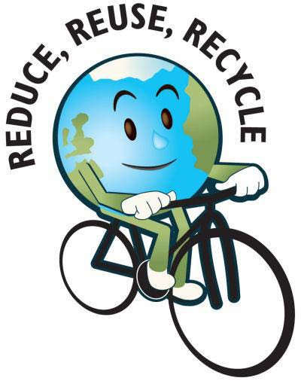

LESSON #1

A LOT OF LITTER

Content
Littering is not a new phenomenon; it has been around for over one hundred years. People throw many things on the ground such as gum, food wrappers, water bottles, paper, ext. In the past, walkways of many streets were often blocked because of all the sooty refuse from chimneys and furnaces that had been dumped. We need to hurry and think of some ways to stop littering before our earth becomes covered completely with litter.

Standards:
4.2.4.D Identify those items that can be recycled and those that cannot.
      - Identify litter and its effect on the environment.

OBJECTIVES:
The students will collect litter found on or near the school grounds.
The students will classify the types of litter found.
The students will record data about the amount and types of litter found.
The students will list items that were found and come up with an idea (s) of how to recycle the piece of litter.
MATERIALS:
        - 1 Large Plastic Garbage Bag (per group: 4 students)
        - 1 Plastic Glove (per student)
        - Newspapers *
        - Worksheet Activity 1 *

PROCEDURE:
- Discuss and explain the vocabulary word Litter.
Litter = unwanted materials in the environment that could harm living things. Trash that is left lying around that can hurt the environment and can harm living organisms.
- Explain to the class that we will be doing an outdoor activity. Give details about the activity; as a class we will be going outside staying close to the school building picking up litter that we find. Before we go outside, on the worksheet Activity 1, students will predict what types of materials of litter they will find out on the school grounds. Discuss and list, as a class, the predictions on the board.
- Pass out one glove to each student and place students in groups of four. Once students are in the groups, pass out one garbage page per group. WARN: students to be careful picking up objects, some items may be sharp.
- Once outside, remind students to look for litter lying around and to pick it up with the hand that has the glove so germs are not spread from the object and then place in the garbage bag. (Have a race with the students and see what group can collect the most trash in a certain amount of time – say go and then stop when time runs out. Once back in the classroom count objects and the group with the most wins the race.)
- Allow students several minutes to walk around the school yard as well as close by; if allowed, go off school grounds only if students are supervised by a teacher or adult for safety.
- After several minutes and many objects have been collected, head back into the classroom. Place garbage bags with garbage on the floor. Now, pass out newspapers and have students spread them out on their desk and floor. (Remind students they need a large flat area to work). Once the newspaper is out, have students take objects out of the garbage bag and place on top of the newspaper. (Explain that objects are full of germs and we do not want to put them on our desk or touch them bare handed).

- Once all objects are out of the bag, begin sorting objects by different consistency or texture. Note how many different categories have been collected. Remember to record the information on worksheet Activity 1.
- Discuss objects that were found and whether the class predictions were correct or not.
- Next, have each group look at the items that they have collected and make a list on the back of their worksheet of how they can use the object in a different way than its original use and littering. (example: A one sided used piece of paper: use it for scratch paper or even wrap a present in it and color and decorate the paper to look like wrapping paper). BE CREATIVE!!
- Discuss the importance of recycling and saving our earth; the need to reduce the amount of litter that we find. Talk about how landfills are eventually going to be overflowing and then what will happen?

Extension Activities Math:
Have the students use graph paper to make a bar graph of the different categories of trash that were collected to find out what categories were littered the most.

Art and Writing:
Students can draw a picture of how the school grounds looked when they first went out with all the litter on the ground. Next, the students can write about what materials they found and include some ideas from their chart of better ways to get rid of the materials such as informing the audience of ways to reuse specific items.

History and Technology:
Explain to the students that many years ago, Archaeologists studied trash to help them learn about life during the ancient times. Have students research what items may have been found during the past and how Archeologists studied them to learn about life. (Monitor students when they are on the computers making sure they are on appropriate and educational sites.)

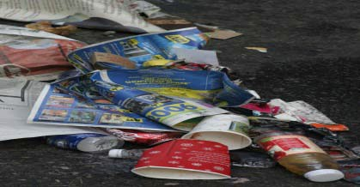
ACTIVITY 1

Name: Date:

Predict What Objects You Think You Will Find and Record:

Objects | Texture or Consistency

What I Collected Outside – Group In Chart By Similar Consistencies

Objects Found | Texture or Consistency

Think about additional ways you can use the objects listed on the other side besides throwing them out on the street and hurting our environment. Is there a way you could recycle or reuse a product? List as many ways you can think of to reuse a specific object.

OBJECT | WAYS TO REUSE
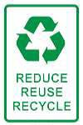

LESSON #2

MEASURE THE TRASH IN YOUR CLASSROOM

Content
Everyone must start paying closer attention to garbage that they throw out every day. We must begin to recycle more of our belongings. Landfills are holes in the ground for dumping trash; however, eventually these landfills will be filled and overflowing. Another issue we are running into currently is some of the layers in the landfills are leaking into the soil and contaminating the waters. What will happen if they continue to leak or we run out of room to throw our garbage? So always think twice before you throw something out, can you reuse it for something or can it be recycled. We must reduce the amount of garbage.

Standards:

    - A1 Describe basic landforms and identify the layers of the earth.

    - A1 Describe how landforms are the result of a combination of destructive forces such as erosion and constructive erosion, deposition of sediments, ext.
4.2.4.D Identify those items that can be recycled and those that cannot.

OBJECTIVES:
The students will learn what items are capable of being recycled and sort the trash in their classroom.

Students will measure the amount of trash produced daily in their classroom for a week without doing any recycling.

Students will sort trash for a week and measure how much trash they have compared to the trash in the recycling bin.

The students will calculate how long it would take to fill their entire classroom with trash.

MATERIALS:

- 1 Measuring Stick
- 2 Plastic Garbage Bags (12 Gallons)
- 1 Cardboard Box*
- Pictures of a Landfill
- Worksheet Activity 2 *

PROCEDURE:

- Discuss: What is a landfill?
  - Tape the pictures of the landfill on the board and ask the students to predict what they think a landfill might be.
  - Explain that a landfill is a waste disposal site especially designed to protect the surrounding land, air, and water from the trash it contains.
  - In most sanitary landfills, trash is compacted, spread over a small area, and covered with a layer of dirt. The bottom of the landfill site is lined with plastic or concrete to prevent liquid waste from leaking into the surrounding soil and into the water table.
  - Even with careful planning landfills can release particles and gases into the air that can be harmful to others and chemicals can leak through holes or cracks that form in the liner and leach into the soil and water. Luckily, most landfills have monitors to detect such leaks but they are hard to fix.
  - Since landfill space is at a premium, it is increasingly important for each and every one of us to reduce that amount of trash we produce.

- How much trash do you think you make each day?
  - Write students estimates on the board
  - Point out that Americans average approximately four pounds of trash per person, per day. However, studies have shown that over 80 percent of household waste could be recycled.

- As a class we are going to measure how much trash we make each day for ten days. We will measure our trash at the end of every day and record our reading on our worksheet.

- Then, after ten days we will separate our trash into two garbage bags throughout the day. We will have one bag for all the items that are recyclable and the other bag for all other items that cannot be recycled. We will then calculate how much we can reduce our trash each week by if we take the time to RECYCLE.

- Now, for the next ten days we will be measuring how much trash we produce as a class and fill in the information correctly on our worksheets. At the end of the day two student volunteers will measure the volume of the trash produced by the class that day.

- Students will need to set the plastic garbage bag of trash into the cardboard box and compact the bag so it conforms to the shape of the box.

- In order to find the volume of trash, have the students measure the length, width, and height of the trash in the cardboard box and multiple these numbers together. Record answer on the worksheet.
(length x width x height)
- When finished take the garbage back out and dispose of the trash properly so you can start over tomorrow with an empty garbage bag.

- After ten days, calculate the total volume of trash produced. Then divide by 10 to find the average daily volume of trash produced.

- Next, you will need students to help measure the length, width, and height of the classroom. Again, multiple the figures all together to fine the volume of the classroom.

- Finally, divide the classroom volume by the average daily volume of trash produced. The answer will be the number of days it would take the students to fill their classroom with trash.

- Now repeat steps 4 through 11. This time remind students that there will be two garbage bags and that we need to separate our trash from items that can be recycled. This will show us that if we take the time to recycle we will be saving our environment and it will take much longer to calculate as much trash as before.

- Compare results from the two experiments with all the trash and then when the recyclable items are removed from the trash. Which one would take longer for the classroom to fill up with trash? How would this experiment relate to our landfills?

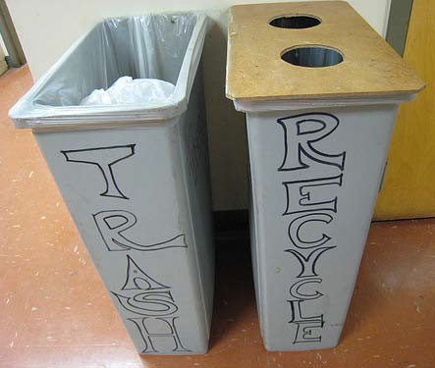

Extension Activities

Technology:
Use the computer to research landfills in the area. Discuss the location of the landfills in comparison with other businesses and homes? Are there any other buildings close by?

Writing:
If your school does not have a recycling program write a persuasive letter to your principal or superintendent on the benefits of recycling and how it helps our environment. Share your data that you have received to show evidence.

Math:
Draw a bar graph to show each day’s volume of trash and then another chart to compare trash when you remove the recyclable items.

Research and History:
Research what materials are allowed to be recycled and what items are not. Also, research to find out if there is any other ways to get rid of trash besides throwing it into landfills. What about burning trash? Additionally, research the common problems with landfills. Finally, you can create a list of ways to dispose of trash and list the advantages and disadvantages to each method.

Worksheet Activity 2

Trash Produced
Day | Volume
1
2
3
4
5
6
7
8
9
10
Total
Average Daily Volume =

Trash Produced Without Recyclable Items
Day | Volume
1
2
3
4
5
6
7
8
9
10
Total
Average Daily Volume =
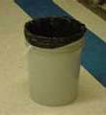
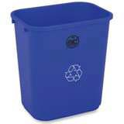

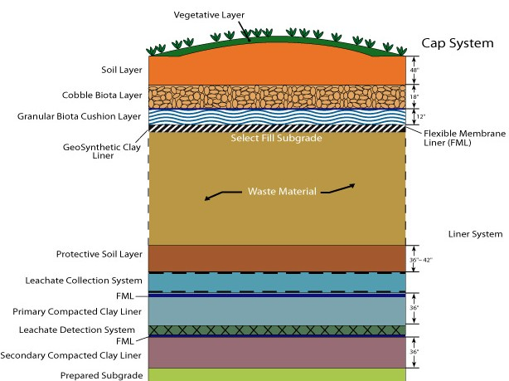

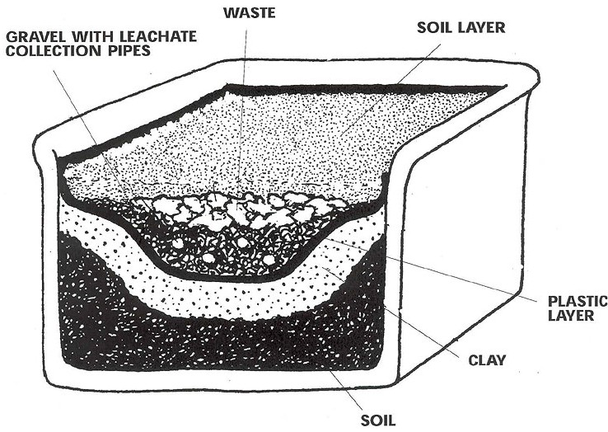

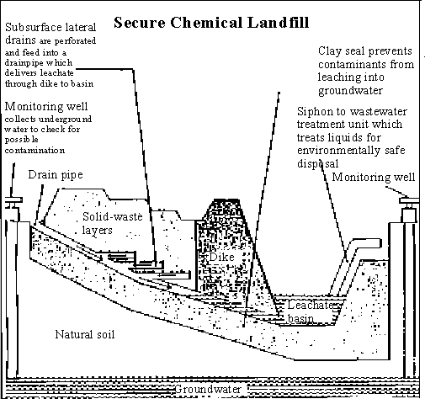

LESSON #3

RECYCLING PAPER

Content
Don’t be selfish; take the time to help save the environment. It is very simple, be smart when throwing out your trash. Before throwing out garbage take a minute to really make sure it is truly garbage. Think if there is any way you can reuse the product, maybe if it is an old towel, save it and turn it into a dishrag or old magazines and newspapers can be saved for craft projects as we are going to do in this lesson. If you think there is no way to reuse the item then still don’t rush out the door to throw it in your trash can; before doing that see if you can recycle the item. Paper, Plastic, Glass, and Aluminum are all able to be recycled and help save the environment by reducing the amount of trash that is taken to landfills as well as let factories burning pollution into the earth to make new products from new materials. Be smart: Reduce, Reuse, and Recycle!!!

Standards:
3.4.4.A Know that combining two or more substances can make new materials with different properties.
      - Identify uses of reusable products.

OBJECTIVES:
The students will examine the properties of paper to determine its suitability for other uses.

The students will brainstorm ideas for other recycled-paper products and activities.

The students will understand how to recycle old newspaper into papier- mâché.

MATERIALS:

        - 1 Bottle Cooking Oil
        - 1 Pail
        - 1 Package Wallpaper Paste / Elmer’s Glue
        - Tap Water *
        - Egg Cartons

For Each Team of Four:
        - 1 Balloon
        - 1 Cotton Ball
        - 1 Stack of Newspapers *
        - 1 Plastic Cup per group
(please rinse cups out and save)

PROCEDURE:
- Ask the students: What does the word RECYCLE mean?
- To use a material again in the same or in a new way.
Explain: That the material may retain its original form or be changed in some way to make something totally new. Recycling is an excellent way to reduce waste, but that recycling only works if there is someone who will buy those products made from recycled materials. The new product must be useful and affordable and there must be a demand for it.
Show how egg cartons are made out of recycled paper.
- Today we are going to experiment with one way to recycle old newspapers. First, the teacher needs to divide the class into teams of four.
- Explain that we are going to make recycled bowls. We need some little containers around the room so we can keep pencils, erasers, and other miscellaneous classroom supplies, so instead of going out to buy new ones I thought it would be great if we made some ourselves.

- Now, pass out worksheet Activity 3 and read the instructions together on how to make a papier-mâché bowl. Demonstrate each step while the students watch and ask clarifying questions.
- Next, call one group member of each group to pick up the supplies they will need to get started. As the students are working make sure to walk around and monitor their work. Remind the class periodically of each step to make sure they are doing the project correctly so the end result will turn out. (The teacher can continue to finish the one she started or give it to one of the groups to finish working on.)
- Helpful hints:
- While some members of the team are tearing the newspaper into strips, tear the paper with the grain and about 2 inches wide, have another member blow up the balloon and tie it and remember to wipe the rounded end with the oil-soaked cotton ball.
- While students are applying the strips of paper to the balloon, have students take turns holding and turning the balloon and dipping the strips into the paste and applying them to the mold. (It may be easier to lay the paper around the balloon and dip your fingers into the glue and rub over the paper.) Pay close attention to the pattern of laying the strips; refer to worksheet Activity 3 for a diagram.
- Once the students have at least 5 layers of paper strips on the mold, the bowls are ready to dry. First, pop the balloon with a pencil, remove it from the inside of the bowl. Quickly, reshape the bowl if need be, flatten the bottom so it will sit on table and leave it to dry (do not touch while drying). Most bowls should be dry in about a day, bowls will vary on how much paper and glue was used. If the bowl feels cool to touch, do not pick it up, it is still wet – make sure it is completely dry before lifting.
- While the bowls are drying, have the students clean up the materials that were used. Throw away the used cotton balls, popped balloons, and unused paste into the wastebasket. Rinse out the pail, cup, trays, and containers. Make sure to recycle unused newspapers.

- Take a minute to ask the students,
What are some properties of newspaper that made it easy to form into bowls?
  - Students should realize that they were able to form the bowls because wet paper conforms to any shape.
  - Point out if students don’t that newspaper is absorbent, can take on color, is a good insulator, burns when exposed to heat and flame, and dissolves when wet.
- Based on these properties and the recycling technique that was used today, what are some additional products that could be made from recycled newspapers?
(Important to take all suggestions serious and write all answers on the board)
  - building blocks, trays, storage boxes, aprons, toys

Extension Activities

Art:

Have students work together in their teams of four and decorate their bowls once they are completely dry.

Technology and Research:
Have student’s research items that are currently being made out of recycled items. Do they think the products are something that a lot of people would need or want?
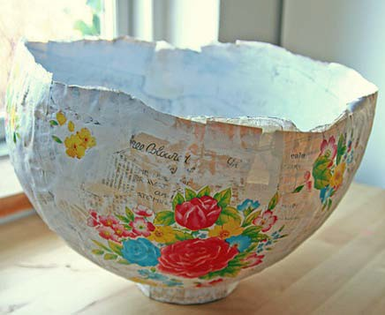
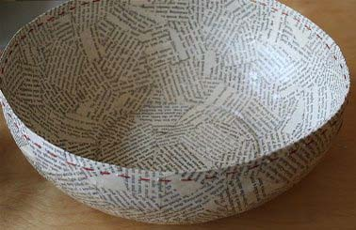

LESSON #4

MAKING RECYCLED PAPER

CONTENT
Paper is one of the most versatile and important materials used in homes, schools, offices, and businesses throughout the world. Each day we enjoy the benefits of paper products. The newspaper we read in the morning, the box that holds our cereal, the paper we use for homework and business purposes and the documents that mark the significant achievements of our lives all contribute to our daily quality of life.

Paper dates back over 2,000 years. Hand-made production methods were used until the 19th century. The industrialization of the paper making process helped to bring education and books to a broad spectrum of people, and continued advances have resulted in better and more efficient products that meet our daily needs, while leaving a smaller footprint on our environment.

( P ape r r e c y c l i ng ge t t i ng s t a r t e d . R e tr ie v e d f r o m h t tp :/ /e a r t h 9 1 1 . c o m .)

STANDARDS:

3.4.4.A Know that combining two or more substances can make new materials with different properties.
4.9.4.A Explain how the recycling law impacts the school and home. OBJECTIVES:
Students will understand the process of making recycled paper.
Students will know the importance of recycling and the how it benefits the environment.
Students will examine the properties of paper to determine its suitability for other uses.
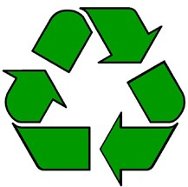

MATERIALS:

- Old Blender
- Cup or Ladle
- Wire Screen
- Wood Screen
- Plastic Screen
- Felt Pieces
- Rolling Pin
- Water *
- Newspapers *
- Large Tubs for mixing

Optional Materials: (NOT PROVIDED IN KIT)
  - Food Coloring
  - Electric Iron

DISCUSS:
Make a list of several different things you can use re-use old paper for.

PROCEDURE:
*Before you begin to work, make sure you have a place to work where you can make a big mess!!

Important: If you are using paper that has been printed from color-inkjet printers the ink will run and bleed off and become part of your newspaper. This may be an interesting effect – explore!

- Take several pages of the newspaper and begin ripping the pages into small pieces of paper (about the size of a penny). Allow every student to rip one or two pages of the paper; that way there will be plenty of paper for each student to make a piece of recycled paper.

- Put a cup or two of the torn paper into the blender. Then poor a little bit of water into the blender. Next, begin to blend the mixture on low and then on high until the paper becomes mushy. (You may have to pour more water if the consistency is not mushy.)

- Keep adding pieces of the torn paper to the blender until you have a big gray blob in the blender. Water will need to be added, slowly, a little bit at a time.

Keep the blender on until all the paper has disappeared and is in the form of a gray liquid blob.

Optional: During this step you may add food coloring if you wish to make colored paper or try adding a few leaves or lint to make an interesting texture for the paper.

- Once all the paper has disappeared continue to blend the mixture for another minute or two.

- Pour out the paper pulp from the blender you just made into the large yellow mixing containers. Mix the pulp together with your hands. If the pulp is very thick then add a little bit of warm water to the container.

- Now, grab the wire, wood, and plastic screen. Pick up the plastic screen, then on top of the plastic screen put the wire screen, and on the very top place the wood screen. Next, scoop the screens into the bottom of the mixing container, then SLOWLY lift. (Count to 20 slowly while you are lifting) Let the water drain out for about a minute while holding the screen over the mixing container. Tilt the screens at about a 45 degree angle to get extra water off.

- Next, carefully and slowly remove the wood screen. Place a piece of felt on top of the wet paper and then remove the plastic screen and place another piece of felt on the back.

- Cover the working area with newspapers or towels. Grab the rolling pin and begin to roll back and forth over the felt to help drain the extra water and flatten the paper.

- Once all the water is removed, carefully remove the felt and wire screen. Place the wet recycled paper carefully somewhere flat to dry.

(Repeat: Scooping the screen through until all the paper pulp is used, if all is used and you want more pulp repeat directions from the beginning.)

8. Congratulations – you have just made your very own recycled paper!! Optional Step 9:
Plug in the iron and place it on the hottest setting so you can steam your paper.

LESSON #5

MAKING A CLASSROOM COMPOST

Content

Why waste money buying soil and fertilizers for your flowers and gardens, save your vegetable and fruit scraps and make your own compost; it’s easy and free. Compost is one of nature’s best mulches and soil amendments due to the rich nutrients that decompose into the soil from left over scraps. All most any organic material can be used, however, some materials should be excluded such as meat scraps, dairy products, non- vegetarian animal manure and pet feces are not suitable for garden composting since most backyard composts are not able to maintain high enough temperatures to kill off all pathogens.

Standards:

3.3.3.A1. Explain and give examples of the ways in which soil is formed.

3.4.5.A. Identify the composition of soil as weathered remains and decomposed organic remains.

      - Identify the use of compost, landfills and incinerators.

OBJECTIVES:

The students will learn how to make a compost.

Students will understand what materials are needed for a compost and what materials are not able to be added to the mixture.

The students will explore the ways that soil is formed.

MATERIALS:

        - Large Container with Lid
        - 1 Bag of Soil
        - Newspapers *
        - Red Wiggler Earthworms (Request order from SIMS or order from any commercial worm farm)
        - Leaves or Grass Clippings *
        - Tap Water *
        - Vegetable and Fruit Scraps *
        - Pieces of plastic *
        - Meat Scraps *

Ask students to bring in a few small scraps of leftover meat, vegetable and fruit from dinner or even from their lunch. You may be able to
ask the cafeteria for a few scraps after lunch. Save a plastic water bottle and carefully cut a few pieces off of the bottle.

PROCEDURE:

- First, fill the container about two-thirds full of soil.

- Shred some newspaper into small pieces and then mix into the container with the soil.

- Now, throw in some leaves or grass clippings. Make sure to mix up the materials evenly when throwing them into the container.

- Next, moisten the soil. Pour in a little bit of water until the soil is damp.

- Finally, add some scraps of plastic, meat, vegetable and fruit into the container. Before throwing in the scraps, make sure the pieces are small. Mix into the soil.

- Lastly, add the worms to the container. Watch the container for the next few days and observe as a class what objects that were thrown into the container that the worms will and will not eat. From time to time throw in a few more pieces of the materials that the worms will eat (vegetables and fruits).

- Explain that Red Wiggler Earthworms are specifically bred to eat almost all types of fruits and vegetables cut into small pieces – they are breaking down the food and turning it into composted soil which can be used for houseplants or added to an outdoor garden. Soil made this way has lots of nutrients and again is a great way for us to save money and reduce the need of buying soil from stores and lets us recycle our uneaten fruits and vegetables.

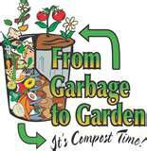

MATERIALS NEEDED FOR RECYCLING KIT

Lesson #1: A Lot Of Litter

~ 1 Large Plastic Garbage Bag (per group: 4 students)
~ 1 Plastic Glove (per student)
~ Newspapers *
~ Worksheet Activity 1 *

Lesson #2: Measure The Trash In Your Classroom

~ 1 Measuring Stick
~ 2 Plastic Garbage Bags (12 Gallons)
~ 1 Cardboard Box*
~ Pictures of Landfills
~ Worksheet Activity 2 *

Lesson #3: Recycling Paper

~ 1 Bottle Cooking Oil
~ 1 Pail
~ 1 Package Wallpaper Paste/ Elmer’s Glue
~ Tap Water *
~ Egg Cartons

For Each Team of Four:
~ 1 Balloon
~ 1 Cotton Ball
~ 1 Stack of Newspapers *
~ 1 Plastic Cup per group

Lesson #4: Making Recycled Paper

~ Old Blender
~ Cup or Ladle
~ Wire Screen
~ Wood Screen
~ Plastic Screen
~ Rolling Pin
~ Felt Pieces
~ Water *
~ Newspapers *
~ Large Tubs for mixing

Optional Materials: (NOT PROVIDED IN KIT)
~ Food Coloring
~ Electric Iron

Lesson #5: Making A Classroom Compost

~ Large Container with Lid
~ 1 Bag of Soil
~ Newspapers *
~ Red Wiggler Earthworms (Request order from SIMS or order from any commercial worm farm)
~ Leaves or Grass Clippings *
~Tap Water *
~ Vegetable and Fruit Scraps *
~ Pieces of plastic *
~ Meat Scraps *

