REFLECTION, DIFFRACTION, REFRACTION
GLOSSARY
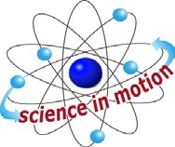
Westminster College

Angle of incidence | The angle between an incoming ray of light and the normal line
Angle of reflection | The angle between the reflected light ray and the normal line
Angle of refraction | The angle between a refracted light ray and the normal line
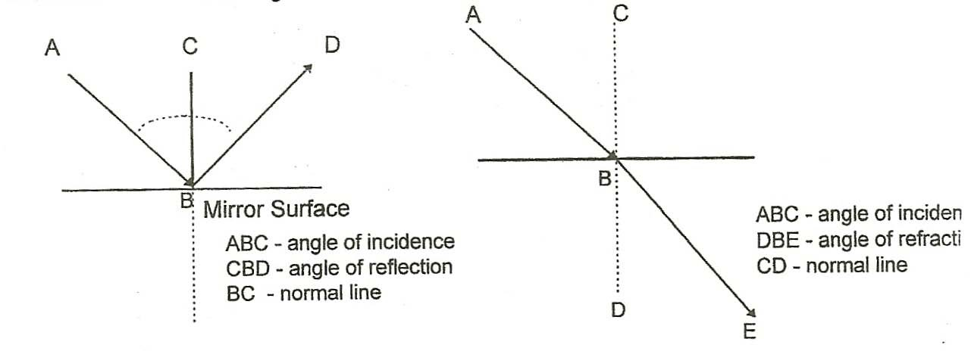

Concave lens | Lens with an inward curving surface that causes light rays to diverge, or spread out; this lens is thicker at the edges than at the Center.
Convex lens | Lens with an outward curving surface that causes light rays to converge, or meet a focal point; this lens has a thick center and thin edges.
Diffraction | The spreading out of light or any wave after it passes through a small opening or slit. Diffraction can cause interference among waves when waves spreading out form one light meet waves spreading from another.
Diffraction grating | Metal, glass or plastic plate with thousands of parallel lines per inch; the interference that results when light passes through the grating causes light to seem to be broken into a “ rainbow” or spectrum of all the different colors in the light.

GLOSSARY

Diffraction grating, reflection type | Transparent acetate with a thin coating of aluminum on the groove side that leaves the grating semi-transparent and able to reflect a spectrum.
Diffraction grating | Diffraction grating made of transparent acetate; embossed
Transmission type | With at least 13,4400 grooves per inch, it diffracts light and produces a spectrum
Dispersion | Separating of a light ray into the color spectrum.
Focal point (focal length | Distance from the center of a lens or mirror to the point where light rays converge, or appear to converge.
Light ray | A beam of light
Luminous | Source of light energy
Nonluminous | Does not give off light; visible only when object reflects light back to our eyes
Normal | A line drawn perpendicular to another line or to a surface
Opaque | An object that absorbs, or stops, light rays
Perpendicular | At right angles to a given plane or line
Plane mirror | Smooth, polished, flat surface that reflects light
Prism | Transparent solid that refracts and/or reflects light rays; the standard prism has equal, parallel triangles at the ends and 3 rectangular sides
Real Image | Image formed when light rays intersect; a real image can be focuses on a screen.
Reflection | The action of light striking a surface and bouncing off
Refraction | The bending of light rays as they pass throughout different mediums
Spectroscope | Instrument used to produce an/or observe the spectrum
Spectrum | Range of colors produced when light passes through a prism or diffraction grating; white light produces the ROY G BIV color sequence (Red, Orange, Yellow, Green , Blue, Indigo, Violet)
Translucent | Light rays are diffused as they pass through an object; although light goes through the object, a real image cannot be seen

GLOSSARY

Transparent | Light rays are easily transmitted through an object; a real image can be observed through the object
Virtual Image | An image that appears to be formed by the intersection of light rays, but the image doesn’t actually exist and cannot be focused on a screen. For example: when you look in the mirror you see a virtual image of yourself that appears to be standing behind the mirror. But there is really no image behind the mirror

