REFLECTIVITY OF LIGHT

STANDARDS
• 3.2.7.C.6
• 3.3.7.A, 3.3.7.B INTRODUCTION

Westminster College

Light is reflected differently from various surfaces and colors. In this experiment, you will be measuring the percent reflectivity of various colors. You will measure reflection values from paper of the various colors using a Light Sensor and then compare these
values to the reflection value of aluminum foil. You will then calculate percent reflectivity using the relationship:

% Reflectivity =
value for paper
value for aluminum X 100

How light is reflected from different colored surfaces has become an important factor in the rate of melting of snow and ice in the Arctic polar cap. Traditionally, Alaska, Russia, Canada, and Nordic countries had northern regions which were covered in snow and ice year round. Close to 70% of sunlight hitting these regions was reflected because of the white surface. In recent decades, a world-wide temperature increase attributed to global warming has resulted in the melting of large portions of this snow and ice, exposing more open water and land. These darker surfaces absorb and hold heat better, causing the ice and snow to melt even faster. As portions of the permafrost (soil at or below the freezing point of water for two or more years) thaw, another greenhouse gas, methane, is being released. The addition of methane to the atmosphere is also accelerating the greenhouse effect, helping to trap more heat and raise global temperatures.

GUIDING QUESTIONS

- What colors reflect the most light? The least?
- How do you calculate the percentage of light reflected?
- How does reflectivity of light affect melting of the Arctic ice caps?

MATERIALS
LabQuest | aluminum foil
LabQuest App | 2 other pieces of colored paper
Light Sensor | ring stand
white paper | utility clamp
black paper | Light source (optional)

PROCEDURE

- Connect the light sensor a channel port at the top of the LabQuest. Turn on the LabQuest by pressing the oval button at the top left of the device. Choose New from the File menu.

- Use a utility clamp and ring stand to fasten a Light Sensor approximately 5 cm above a piece of colored paper as shown in Figure 1. The classroom lights should be on.

- There are two different types of light sensors that come with the Reflectivity of Light lab. The following directions will help you set up both types so that they read in equivalent units. The two types of light sensors are:

  - Clear, with blue plastic tip and black settings box – These are older, read in lux units, and are not automatically recognized by the LabQuest
  - Gray plastic – These are newer, and are auto- identified by the LabQuest, but need to be reset to read in lux units.

- For the older blue-tipped sensors, perform the following:
- Set the switch on the black box to the 0- 6000 Lux range.
- The LabQuest screen will appear blank. (Fig.2A). To identify the light sensor, select the Sensors menu → Sensor Set-up…. The Sensor setup screen will appear (Fig. 2B).
- Select the channel port you are using and tap the arrow to the right of the box to show the Sensor list (Fig. 2C). The sensor list is alphabetical; use the scroll arrows to get to

Figure 2. Screens for Sensor Set-up
- Opening Screen

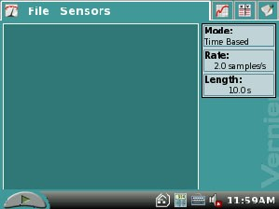
- Sensor Set-up

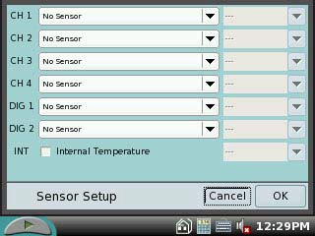

- Sensor list

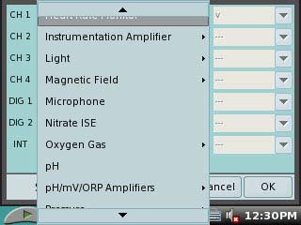
- 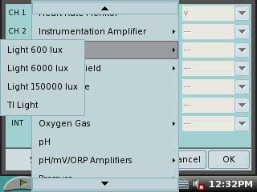Light sensor choices

Light sensor. E. Light sensor main screen
- 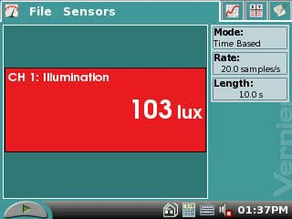When you select Light, you will be given a
choice of 4 different light sensors (Fig.2D). Choose “Light 6000 lux” for this experiment.
- Select the OK key when you are finished. The LabQuest screen should now display a red

box that shows the channel being used, Illumination and a reading in lux units (Fig. 2E).

- The gray light sensors need to be set up essentially the same way as the blue, with just a couple of differences. The opening screen will initially be reading as Light Level. Use the Sensor setup directions (Steps 4b-4e) to reset this probe to read in the “Light 6000 lux” mode.

- Place the sheet of aluminum foil, shiny side up, beneath the light sensor. Wait for the reading to stabilize. Record the reflected light value (in lux) in the Calculations for % Reflected Light table on your Data Sheet. This is the value you will use as 100% reflectivity.

- Repeat Step 5 for the black, white and colored pieces of paper. Record the reflected light value (in lux) in the Calculations for % Reflected Light table on your Data Sheet.

- When you are finished recording all the data, select File>Quit on the LabQuest menu. Press and hold the oval button at the top left of the device to shut off the LabQuest.

- Go to the Data Sheet and follow the instructions for calculating the percent reflectivity of each color.

REFERENCES
Donald L. Volz and Sandy Spartka. Middle School Science with Vernier. (2007) Vernier Software & Technology, 13797 SW Millikan Way, Beaverton, OR. p.p.7-1 to 7- 23, 7-1T to 7-2T.

USA Today, May 29, 2006. http://www.usatoday.com/weather/climate/2006-05-29- alaska-globalwarming_x.htm

World Wildlife Federation: http://www.panda.org/about_our_earth/search_wwf_news/?169801/Melting-permafrost- is-a-growing-climate-threat-study

Science Channel: http://science.discovery.com/stories/week/melting-permafrost.html

CREDITS
Special thanks to Kim Schmidtke, Portersville Christian School, Portersville, PA for testing, editing and reviewing this protocol. This lab was revised and adapted from the above references by Dr. Stephanie Corrette-Bennett.

DATA SHEET

Name: Group: Date:

DATA ANALYSIS

- Calculate the percent reflectivity of each color using the formula given in the introduction. Use the table below to show your work. Record your final data in the Reflected Light Values table.

- To calculate the percent reflectivity:
  - Divide the Reflected Value (Column A) by the Aluminum reflected value. Record this value in Column B.
  - Multiply the value in Column B by 100. This is your % Reflectivity (Column C).
  - For each color, record the value in Column C in the Reflected Light Values table. This is your final data for % Reflectivity for each different color.

- Use these data to answer the questions below.

Calculations for % Reflected Light
Color | (A) Reflected Value (lux) | (B) reflectiveVal alu min umVal | (C) % Reflectivity  (B) X 100
Aluminum
Black
White

Reflected Light Values
Color | Aluminum | Black | White
Percent (%) reflectivity | 100

QUESTIONS

- Which color, other than aluminum, has the highest reflectivity?

- Which color has the lowest reflectivity?

- What surfaces might give a planet a high reflectivity? Explain.

- Does the planet Earth have high reflectivity? Why or why not?

