RESISTORS/CAPACITOR CIRCUITS

LAB ELEC 8
REFERENCES: College Board AP
AP Physics B Exam 2007 Question 3

INTRODUCTION
The given circuit involves an ε =emf with resistance RA=2R in series and also in series two parallel resistances RB=2R and RC=R. Note the circuit schematic as shown in Figure 1.

This AP Physics B Exam 2007 question 3, parts (a) and (b) with the switch closed is based on this circuit and involves ranking the current and voltage magnitudes in and across resistance RA, RB, and RC. Included here as page 3 is the list of Electricity and Magnetism equations and symbol definitions, given with the exam.
Values are then given for ε and R to be used in calculating (c), the equivalent circuit resistance, and (d), the current in RC; and also for answering (e).

For (e), the schematic of Figure 1 is changed in removing resistance RB and replacing it with a capacitor with its capacitance given. Then with the switch closed and steady state currents, the charge on the capacitor is to be calculated.

PURPOSE

To analyze and understand the electrical function and behavior of a direct current (DC) circuit with a power supply and resistors in series and in parallel according to Figure 1. Further, to analyze and understand the resulting behavior when the resistor, RB, in the one parallel branch is replaced by a capacitor.

MATERIALS

Battery pack (6 volts) Capacitor, ~11.5 x 10-6F
5:220 Ω resistors Switch
8: Clip leads Multimeter

PRELIMINARY QUESTIONS

- Compare and explain the total resistance of two “identical” resistors is series and in parallel.
- Considering the circuit shown in Figure 1 with RB replaced with a capacitor, give and explain the total resistance of the circuit in terms of R just as the switch is closed.
- For the resistance/capacitance circuit (of question 2); with the switch closed for “some” time, give and explain the total resistance of the circuit in terms of R.

PROCEDURE/ANALYSIS

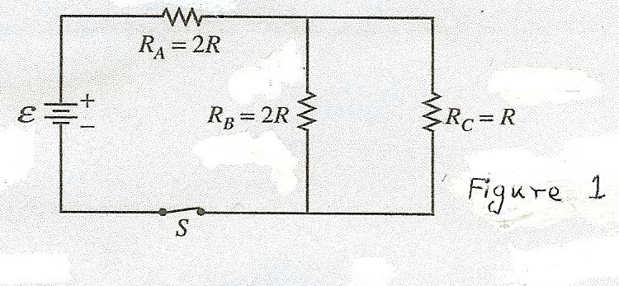
The circuit above contains a battery with negligible internal resistance, a closed switch S, and three resistors, each with a resistance of R or 2R.

(a)

- Rank the currents in the three resistors from greatest to least, with number 1 being the greatest. If two resistors have the same current, give them the same ranking.

IA IBB IC

(b)
- Justify your answers.

- Rank the voltages across the three resistors from greatest to least, with number 1 being greatest. If two resistors have the same voltage across them, give them the same ranking.

VA VB VC

- Justify your answers.

For parts (c) through (e), use = 6V and R = 220 Ω.

- Calculate the equivalent resistance of the circuit.
- Calculate the current in resistor RC.
- The switch S is opened, resistor RBB is removed and replaced by a capacitor of capacitance ~11.5 x 10-6 F, and the switch S is again closed. Calculate the charge on the capacitor after all the currents have reached their final steady-state values.

For parts (a), (b), (c), (d), and (e); use the multimeter taking measurements to check your answers. Record, discuss and compare your results.

F = 1
4πε 0
E = F
q

q1q2
r 2

1

ELECTRICITY AND MAGNETISM

A = area
B = magnetic field
C = capacitance
d = distance
q q E = electric field

UE

Eavg

V
r
= qV =

= − V
d
1
1 2
4πε 0 r

qi
ε = emf
F= force
I = current
l = length
P = power

= ∑
4πε 0 i i
C = Q
V
ε A
C = 0
d
- = 1 QV = 1 CV 2
Q = charge
q = point charge
R = resistance
r = distance
t = time
U = potential (stored) energy
V = electric potential or

c

I avg

R =
2 2
= ⊗Q
⊗t
ρl

A
potential difference
v = velocity or speed
ρ = resistivity
θ = angle
φ m= magnetic flux

- = IR
P = IV
Cp = ∑Ci
i
1 = ∑ 1
Cs i Ci
RS = ∑ Ri
i
1 = ∑ 1
Rp i Ri
FB = qvB sinθ
FB = BIlsinθ
μ I
B = 0
2π r
φm = BAcosφ

ε avg
= − ⊗φm
equation⊗t

ε = Blv

