DETECTIVE LAB

SECTION 1: A TALKING PICTURE
From Science in a Nutshell

OBJECTIVE:
To create a talking picture of yourself.

MATERIALS:
camera Identification Sheets
Journal Page for Activity 1 tape measure

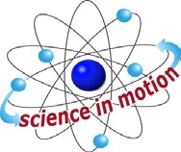
Westminster College

BACKGROUND:
A talking picture is a method of identifying people. Over one hundred years ago, police used this method to identify criminals.

In this activity, you will take several body measurements and make a talking picture of yourself and of several friends.

EXPERIMENT:
- Stand in front of a mirror and carefully examine the features of your face. On an Identification Sheet, fill in as much information about yourself as you can.

- Ask your partner to use a tape measure to take your body measurements. Record these measurements on your Identification Sheet.

- Remove another sheet from the pad of Identification Sheets. Now take your partner’s measurements and record the information requested on the sheet. Be sure to enter your partner’s name at the top.

- Remove eight sheets from the pad of Identification Sheets. Take and record the measurements of four people and ask your partner to measure and record the information from four other people.

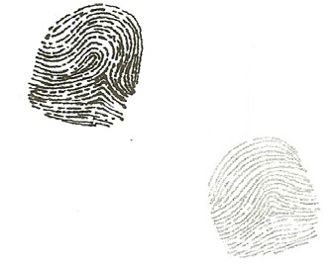
- If possible, take a photograph of yourself and the other people and attach the photo to each Identification sheet.

- Try to identify each person by looking only at the information written on the sheet. Working with one identification Sheet at a time, cover the name and try to identify the person. Take body measurements again, if necessary.

- An agency of the United States’ government photographs the ear of each foreigner living in the U.S. Add a drawing of the right ear of each person to the identification sheet for that person.

A TALKING PICTURE

- Can you correctly identify each person using only the drawing of the ear? Try it.

- On your Journal page for Activity 1, list any other measurements or features that can be used to identify a person. Also record any features or measurements that can be changed.

IDENTIFICATION SHEET
Name Male or Female: Complexion (pale, brown, freckled): Hair Color: Shape of Face (round, square): Eye Color: Shape of Nose (pointed, pug, crooked): Height ft. in. Special Features (birthmarks, scars, tattoos): Circumference of Head (distance around head in inches): Arm Span (arms spread apart in inches): Arm Length: Right Arm (in.): Drawing of Right Ear:
Left Arm (in.): Foot Length: Right Foot (in.):
Left Foot (in.):

IN A NUTSHELL:
The odds of two people having the same body measurements are almost 300,000 to 1.

CRACKING THE NUT:
Which of the descriptions and body measurements on the Identification Sheets can be changed by an individual? Which cannot be changed? Record your ideas n the journal.

